Photographic Chemicals

The analysis of the content of photographs has provided meat for discussion of family life and the domestic environment as well as the role of photographs in them, but surprisingly little has been written about the people who built darkrooms at home, as the literature review showed. There are many facets of social history, histories of science and technologies, that could be explored through studying domestic darkrooms. This chapter is not the place to attempt to cover everything related to this practice, but processing photographs was certainly an activity that brought chemicals into the British home and is an interesting scenario to examine when considering users of chemicals in the home.

100 years of photography were marked in 1939, and although still in the chemical era, the experimentality that had been a large part of the pursuit in the 1800s had settled down. From the 1930s onwards, users had at their convenience the products of a whole industry and progressive developments which aimed to make all aspects of photography ever easier. For those who did want to prepare their own mixtures from scratch, for whatever reasons, there were tested, published and discussed formulae at their disposal. The timespan that this thesis focuses on captures this period of chemical convenience, before the electronic era which replaced it and ultimately rekindled interest in chemical methods.

The development of one’s own photographs, instead of sending them to a mass production outfit, was not a necessity during the period this thesis interrogates, instead it was an opportunity for further creativity. This is where, multiple writers stressed, the magic and true enjoyment lie, considering it “a pity” that so few people consider processing their own images.[1] Historian Erika Hanna suggested that the technical aspects of 20th century home processing allowed men to carve out a niche in a hobby where manufacturers had been perceived increasingly as catering to women, with lighter, easier to use cameras and frivolous colour snaps.[2] Adding this extra layer to the pursuit of photography was also a way photographers differentiated themselves from trivialised, feminised snap-shotting of the “You press the button, we do the rest” variety.[3] While heavy advertising campaigns such as Kodak’s succeeded in their aim to increase camera ownership and the number of photographs taken, the ease and simplicity offered by the idea did not translate to processing. In fact, campaigns like this reinforced the division of activities, that processing the image was *not* an activity for most people. This exclusivity, despite repetitive protestations from manufacturers and practitioners that anybody could do it, was in part derived from the use of chemicals, the technical and intellectual skills they demanded and the space required to store and use them.

**Which chemicals are we talking about?**

Similarly to the other case study chapters, this chapter will focus on a couple of examples of specific chemicals. Photographic chemicals, particularly cyanide of potassium, worried a former president of the British Pharmaceutical Society E.T. Neathercoat so much that he urged photographers in 1926 to 'let your local chemist deal with all dangerous photographic solutions'.[4] The preoccupation with acute poisoning that was associated with photographers who kept strong acids and cyanide products in the darkroom had diminished due to these being replaced by easier to use and safer processes.

As mentioned previously, much of the rapid experimentation had settled by the 1930s and there was no vital need for photographers to get their hands blackened with silver nitrate preparing sensitive material, or to attempt to remove these stains with potassium cyanide. However, one of the main questions in this thesis is whether chemicals became harder to get because of regulatory constraints which reflected user behaviours, or whether they became displaced by other products which met user needs better, so I want to address this in my approach to photographic chemicals. Sales catalogues provide a snapshot of commonly available chemicals, so are an opportunity to track changes in what was offered, which can be viewed in the light of legislative amendments and provide something of a chemical context for the practice to be considered in.

Hydroquinone has been an important component of alkaline developers for over 100 years. It has a function outside of photography as a skin lightening agent in cosmetics, which invites questions about the warnings about the effects of this chemical. Who did manufacturers think their users were? Was there any significant crossover between the two uses?

Metol was another component of developers, also marketed under the brand name Elon by Kodak. Phenidone, discovered by researchers at Ilford was marketed as a hypoallergenic option to replace metol. This pairing provides another compact case study of chemicals, which covers two of the major photographic companies, health effects and branding.

For the purposes of comparison with other (potential) explosives encountered in this chapter, I will include flash powder and magnesium. Carbon tetrachloride which was encountered in the housework chapter also had a photographic use, so it will be discussed here.

# Who used photographic chemicals at home?

While instruction manuals and magazines portrayed a domestic darkroom as being not necessarily being permanently static, large or expensive, in an attempt to encourage more photographers to try developing their photographs at home, it remained a minority activity that was thought to be most often pursued by adolescent and young men. Neathercoat imagined “innocent-looking” cyanide sticks “in the hands of an enthusiastic, unsuspecting schoolboy” and the “possible calamity to himself and to others”.[5] Although photography was stressed as not having to be an expensive hobby which made it suitable for schoolboys, it did require investment in camera, film, measures, a thermometer, trays, bowls, clips, as well as paper and chemicals and the space in which to work, which restricted the pastime to people who could afford to make this outlay. Zoe Dominic was given a camera as quite a young child in the late 1920s and described her "solid middle class family" complete with day and night nurseries and a battery of live-in staff. Similarly, as the son of two doctors Oliver Sacks cultivated a childhood passion for developing and colouring photographs at home in the 1940s,[6] fits the profile of a typical middle to upper middle class twelve year old with pocket money for whom this type of expenditure was not problematic.

To demonstrate that photography and home processing was not the preserve of the financially secure, Dennis Morris was growing up in impoverished 1960s Hackney he found his passion for photography aged nine through the camera club at his church, where he also found a benefactor and mentor in Donald Paterson. Morris borrowed cameras and Paterson gave him equipment, books and magazines to help him on his journey. From an early age he worked to fund his interest.[7] Clubs and individual generosity gave people who might not otherwise have the opportunity to try out photography and darkroom work.

Deciding to process photographs at home was by no means implicit in the pursuit of photography during the period that this thesis is concerned with. Composed of sequential steps, the enthusiast could decide to involve themselves in as many or as few stages as they preferred. For those who did want to develop and print images at home, they could either choose to make up solutions from raw chemicals, or to use the ready made powders and liquids on offer to them. Even if ready prepared chemicals were chosen, their instructions could be followed exactly, or the user could include their own additions or tweaks, much like a boxed cake mix can form the basis of any number of variations. They could develop negatives and print from them, or they could send away film and process the photographs from the negatives that were returned. As well as this conventional processing, some photography enthusiasts wanted to explore alternative historical processes such as kallitypes, that required the use of raw chemicals rather than pre-prepared commercial mixtures.

These decisions are based on a number of factors including the users’ own interests, knowledge, confidence, curiosity, experience and situation which might include time and space set aside, as well as the expense of the chemical and its availability, which might depend on the helpfulness of the retailer approached. “DC” wrote to the AP (Amateur Photographer magazine) in 1944 puzzled that they could not find chemists with the necessary supplies to make up formulae printed. The response was that some of the items were only used in photography, not medicine or pharmacy, so a dedicated photographic dealer or direct from suppliers were the best route. That it might have been a local problem was rubbed in by the remark that magazine staff never had problems getting the chemicals.[8] Assertiveness on the part of the would-be chemical user was encouraged “If you cannot obtain ferric oxalate, potassium oxalate or potassium ferric oxalate from your local chemist, we suggest that you instruct him to order them for you.”[9]

This boldness that photographers were expected to demonstrate in demanding particular products, was linked to the photographers’ “mind’s eye” being the reason that they should at least print if not develop their own films, as a process lab would never know or be able to execute what the photographer had imagined when they took the picture.[10] However, this did type of persuasion did not convince everyone. Dissatisfaction with the results of trade printing most often led to changing printers rather than setting up a darkroom at home.[11] The desire for creative control or to see the processes of photography as completely as possible, was not something that gripped all home processors.

Johnsons of Hendon highlighted chemicals as the great leveller of photography in their adverts, and hammered home that “Chemicals always have the last word”, even above the quality of the camera used to capture the image.

It is no doubt very satisfying to be able to acquire the best that money can buy, but even the wealthiest amateur cannot obtain photographic chemicals better, purer or more perfectly compounded than JOHNSONS CHEMICALS

You can luxuriate in the knowledge that, here at any rate, you and the millionaire are on an equal footing. The fixed selling prices of all the chemicals made by Johnsons of Hendon are modest in the extreme and in the reach of everyone who uses a camera.[12]

Tension over affordability and discussions about whether it was more economic to make up basic developing and printing solutions were a consistent feature of any writing on the the subject of photographic processing throughout the 1930s to the 1980s. The stepwise process of taking a photograph, developing the negative then printing from it meant that people first had to have access to a camera, before they were likely to be keen on working in the darkroom. This explains the absence of advertisements for photographic chemicals, raw or mixed, in publications other than specialist journals or advertisements which only carried adverts for the cameras themselves.

However, photographers who handed off their films for developing and printing were described by home processing devotees as "lazy" or "ignorant".[13] By inference, users of photographic chemicals could be classified as not-lazy, and not-ignorant, as well as careful, meticulous and methodical. The obsessiveness displayed by Oliver Sacks’ approach to the hobby, for instance working his way through his chemistry set trying out toning prints with each metal, was by no means the only way to carry out the hobby.[14]

It might have been expected that the war would have disrupted supplies for hobbyists and doom-mongering articles prepared photographers for shortages of potassium bromide, potassium metabisulphite, potassium permanganate (all substitutable with the sodium equivalent), borax, boric, citric and tartaric acids. Household chemicals were not suggested, and photographers keen to find alternatives were advised to find developer formulae that used the photographic grade chemicals they had, rather than attempt to substitute ingredient they lacked.[15] Substitutions for Metol suggest that this was also in short supply, though without Metol the entire developer formula had to be changed.[16] Kodak who had to announce that their plates, papers, film, cameras and accessories (though they did not mention chemicals) were under the Limitations of Supplies Orders, so were harder for civilians to obtain.[17] Ilford too apologised for reduced supply to civilians, although they did not list what products had been diverted to “work of national importance”.[18] But Johnsons’ were keen to emphasise that shortages were not the case and advertised heavily, often on the front page of The AP, promoting the scales logo as the brand to look out for, as well as proclaiming their chemicals availability and affordability.[19] Selo turned night-time confinement to their advantage, and urged people to “Make Black-out Time your Photograph Time".[20]

This was also a time when purity of chemicals was emphasised in advertising with images of laboratories and scientists, an aspect that diminished nearing the end of the chemical era. The Kodak advertisement (Illustration ) does not suggest that users seek raw chemicals, but lists the reasons why photographers should choose the compounded products made from Kodak’s pure, tested chemicals. Domestic users are rarely represented in adverts, although military users did appear.

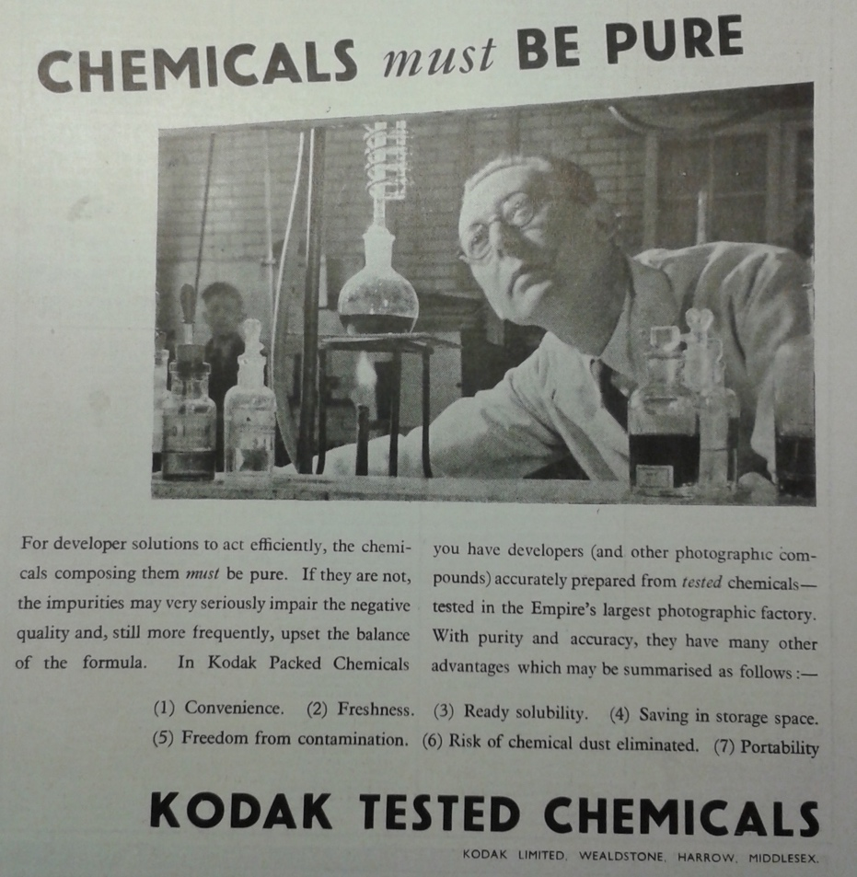

Figure 1 Scientific, producers, masculine. (Advertisement AP 30 April 1941 front page)

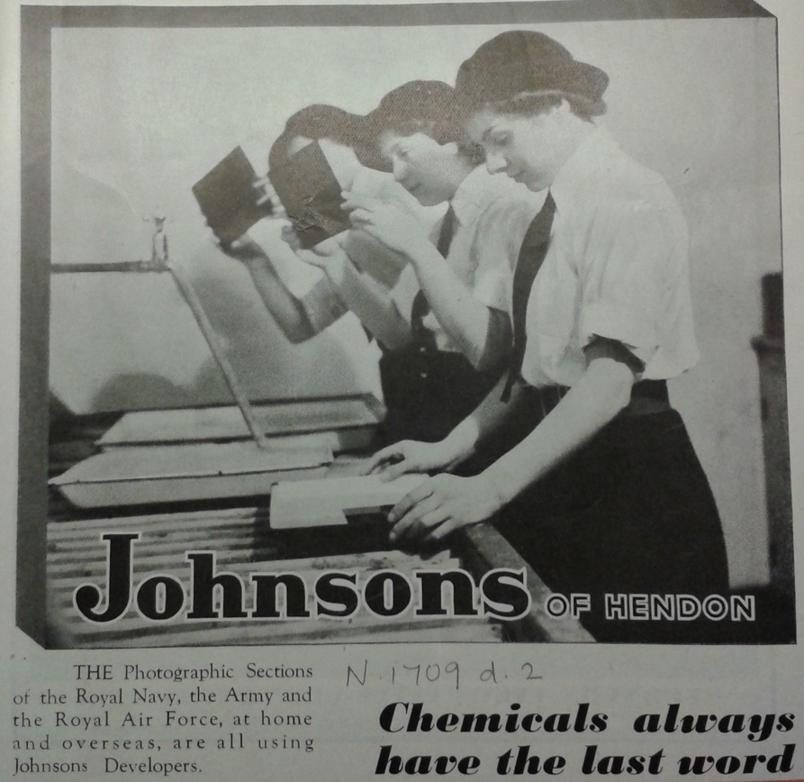

Figure 2 Domestic, users, feminine (Advertisement AP 29 March 1944 front page)

Post-war sales of military surplus included darkroom equipment and photographic supplies.[21]

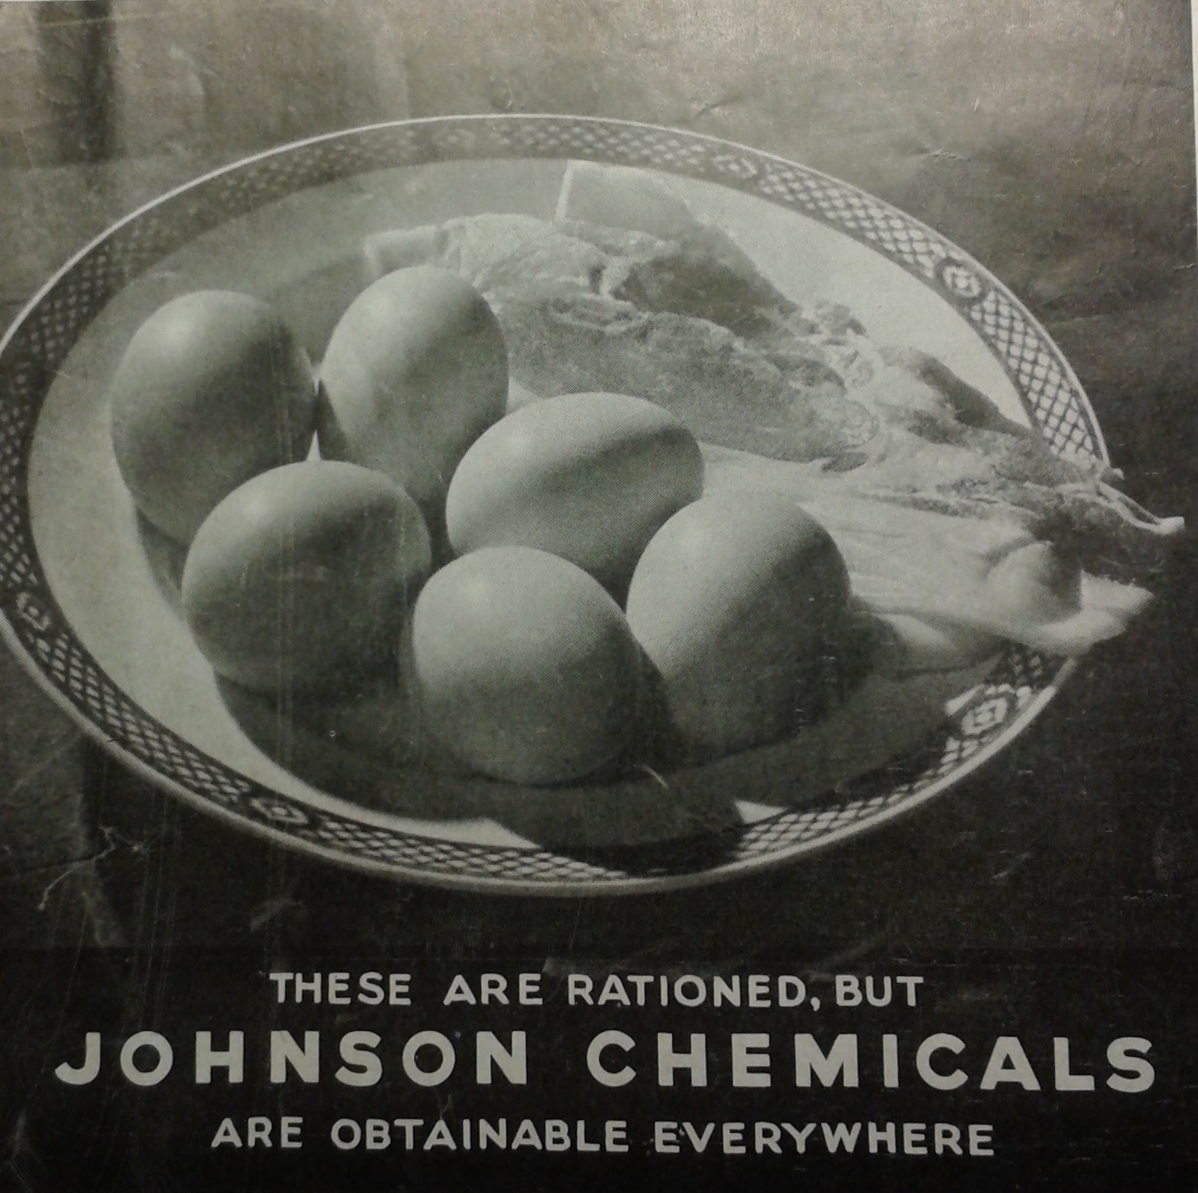

Figure 3: Although staple food items were rationed, Johnson assured users they could continue their hobby unhindered.

Attempting to compile a list of chemicals used in photography is not as simple as it first appears, despite books containing apparently straightforward lists of “photographic chemicals”. Subsequent editions get thicker as new products are added and further information is included, rather than thinner as chemicals become unavailable. The formulae and instructions contain other, apparently non-photographic but necessary chemicals for processes such as desensitising, bleaching, intensifying, not to mention toning. Hydrogen peroxide and oxalic acid were other chemicals that were not included on the photographic chemicals list. Their household uses were never mentioned, so it cannot be presumed that photographers had them on hand for other uses. In this situation, the historical researcher is possibly at a disadvantage of a past novice who just wanted to get it done and might not have attempted to consult so many sources. The impression I am left with is that the number of different common chemical names, subtle changes of true chemical names and available trade names is overwhelming, especially when added to choosing and using the correct form – anhydrous or not. If I wanted to get started with home processing, I would definitely head for easy to use sachets or concentrates from a well-known company even if I could easily obtain all the raw chemicals even if I had to instruct my local chemist to order them for me, just to reduce the number of variables that faced me. This is convenience. The confusion is not created by manufacturing companies to bamboozle users, it is just the nature of chemistry that knowledge is refined and names change, as well as the nature of progression and the invention of new compounds, such as phenidone.

At NMeM darkroom users are depicted in association with photographic competitions run by societies. The layer of complexity that home processing opened up, increased creative scope beyond composition and lighting. This helps to build a picture of artistic, competitive users, who skilfully manipulated images, as well as chemicals. NMeM show that women were members of some photographic societies, but emphasised their minority status and stated that "relatively few had the time or money to devote to photography as a serious hobby". This statement was not supported by an accompanying image of a woman working in a well equipped darkroom, although she could have been employed to work there.

The technicality of home processing is one that can be engaged with on various levels. However, testimonies from photographers suggest that girls and women could be just as enchanted or obsessed by darkroom processes. For example, Zoe Dominic was given a camera as a child and kept her chemicals in her bedroom. She set up darkrooms wherever she lived as a young adult in the 1950s, squeezing into wardrobes full of clothes to load films and using bathrooms to process images.[22]

“Magic” is a word often used to encapsulate the appeal of home processing, the magic of the darkroom as experienced by Paul Carter, or what Zoe Dominic thought of as “pure magic”, being “the best moment in the darkroom when the first traces of the image begin to come up”.[23] Chemical magic experienced by these photographers is quite substantially different and more wondrous than any claims that cleaning or gardening products had to work like magic. Additionally, the makers of photographic chemicals did not give magical or mystical names to their products, leaving the user to conjure the magic themselves. PU80 (anonymised interviewee: Photochemical User who started in the 1980s) on the other hand was not especially interested in this emergence of the image, while seeing and understanding that other people get excited about this process, he explained that this cliché was not what attracted him to continuing wet processing from the 1980s to the present day. What he found most appealing about developing and printing photographs was the end product, the depth and richness of the blacks, and the colours which seemed to be more true to the world at least compared to the ultra crisp and bright digital images he could work with now.[24]

Changes are indicated by the inclusion of a book published in 1950 "Photography for Boys and Girls" with a cover illustration of an aproned girl watching as a boy inspects a section of film that he has been developing. Inside the book, there are no similar illustrations although the images included of children composing and taking photographs are all of girls, presumably Pog, Celia and Judy to whom the book is dedicated to. If children could pursue this activity with pocket money, the costs must have declined and the author was making an effort to say that it is not simply the domain of serious adults. Indeed, in anticipation of broadening their sales base, children and young people were directly addressed by chemical manufacturers Ilford.[25] People taught themselves using books at home, making every mistake possible, perhaps spending a day observing in a professional darkroom as 17 year old Grace Robertson did, arranged through her father who worked at the Picture Post or tutored by a more experienced photographer, as Zoe Dominic learned from Michael Wallace in his darkroom in the garage under his mews cottage in Chelsea.[26]

This transition from a hobby pursued by wealthy adults with abundant leisure time to one that could be taken up by children is interesting not only because of the changing financial costs, but also because this was occurred with a parallel development in the presentation of ready mixed chemicals that were simpler and more convenient to use. Kits were advertised with the slogan "No more messy chemicals", a demonstration of how measuring out, mixing and pouring chemicals was considered to be messy and possibly even preventing someone beginning or continuing the practice of home processing. The author of Photography for Boys and Girls thanked Ilford and Johnsons of Hendon for help preparing the book, as well as recommending their concentrated liquid products or ready-mixed powder preparations by name, with no mention of the option of making up formulae.[27] Similar to strategies used to promote hardware as simple where women and children demonstrated how easy and foolproof cameras were to use, the direction of books on home processing to children also highlights the ease of use of these new formulations and kits. Magazines engaged young adult novices for articles to show that “Working in the darkroom is no more difficult than shooting a portrait or a landscape” and assured readers that “You don’t need an ‘O’ or ‘A’ level in chemistry. It involves simply measuring specified amounts and adding the required amount of water.”[28] Patterson advertised their colour darkroom as not needing a “science degree” and containing everything needed “minus the water”.[29] The only danger was that the extreme simplicity of processing kits could make it boring, although the product reviewer found the silver lining of this possible downside which was that it could lead to experimenting more readily with different effects.[30]

Developing one's own photographs not only gave control over the end product, but could also avoid processors seeing, and judging, the content of the photographs. Those photographers who developed images at home did not have to concern themselves with the eyes of others, and coupled with the nude studies were printed in photographic magazines, this lent home developers as a group of users an air of seediness. Not all of those photographs would have been so tasteful. In Kenyon's study of AP magazine, he described nudes as appearing rarely, but I was naively surprised at the regularity of nudes and swimwear shots, as well as those that experimented with light and texture of diaphanous fabrics over a nude body, not to mention the advertising from the 1970s and 80s that gratuitously used the female body to demonstrate products. Social historian Erika Hanna wrote of self-censorship with respect to subject matter, when she discovered a collection of photographs that did not include any of a long term, same-sex partner, contrasted to the use of photographs made to frame and present previous heterosexual relationships.[31] If the photographer had also developed her own photographs would this have allowed her more freedom to portray her long lasting, intimate relationship? Perhaps that person was simply not keen on being photographed, but it is an interesting point to consider especially with the advent of digital photography, where images are instantly available to view without the mediation of any external organisations or individuals to judge and censor.

Many professional photographers operated home darkrooms throughout the period that this thesis examines, 1930s into the 1980s, an aspect which interviews for the British Library Oral History of British Photographers captured well. In addition, The Hardman's House is an interesting example of both a home and a photographers' portrait studio business. Chambre and Margaret Hardman had two permanent darkrooms, one in the basement for the business, and another which they named the Barnston darkroom, upstairs near their living quarters that they used solely for their leisure pursuits. Although this duplication of equipment and chemicals may initially seem unnecessary, the space needed to process the portraits prevented the pursuit of leisure photography, as well as providing financial clarification when it came to accounting for the use of consumables. A description of the commercial darkroom as "cramped and cluttered" contrasts with the orderly appearance of the Barnston room and lends weight to the idea of this space as something of a sanctuary that the Hardmans spent most of their free time in.[32]

# Using photographic chemicals at home

Processing photographs needed a dedicated space, at least temporarily dedicated, if not a permanently set up dark space. Clean running water was desirable, but not a requirement, and diagrams of rigs that would fit over baths or utility room sinks, then could be packed away were published along with more more permanent installations. In the Kodak gallery at NMeM visitors can view a Pepper's Ghost illusion, where pressing a button reveals the transformation of a domestic bathroom into a darkroom. Hobby magazines demonstrated receptiveness to users' different needs and means, and published letters requesting details of modest darkrooms for domestic spaces as well as letters from those who wanted to share the pared down, portable arrangements that home processors had created themselves. During WW2, dedicated home processors turned air raid shelters into darkrooms, and darkrooms into bed-sits that still had to accommodate developing.[33] Even so, the time and effort required to set up and pack away temporary darkrooms was “a palaver”, one that could result in people seeking out public access darkrooms especially in London where people often live in small flats or shared housing and simply do not have the space to store and erect a temporary darkroom. [34] Still, when young Dennis Morris’s family moved into a bigger flat and he got his own bedroom “the first thing I did was I completely black out my room – the windows – with bin-liners and … I built like a work surface. I had my enlarger and trays full of chemicals. So I was basically sleeping, breathing chemicals twenty-four hours a day… you know, I was just living in a darkroom.”[35]

Similarly, Grace Robertson recalled sleeping in her darkroom,[36] while other photographers chose to invent projects that included living in close proximity to work. In the 1970s there was a fashion for mobile darkroom projects; Paul Carter spoke about his plans to convert a camper van and travel around documenting British life which were ultimately scuppered by breakdowns and insurance costs, although the prospect of living in such close proximity to chemicals was not a topic that bothered Carter.[37] Nor did it concern Daniel Meadows Free Photographic Omnibus, a double decker bus toured around the country as combined gallery space, living accommodation and darkroom funded by grants from arts councils. Chemicals barely feature in Meadow’s accounts of that time, listed only in his cost estimates for sponsors as “60p per week” totalling £31.20 for what seems to be around 700 films, plus colour processing for 50 films sent away at £32.50. Of more concern to Meadows was water, which he “carried upstairs to the darkroom in jerry cans, sometimes used sinks in public lavatories to wash the film or taps at filling stations, failing that rainwater from the bus's guttering, even water I gathered from streams.” Anticipating this problem, he chose a type of paper that did not need so much washing.[38]

In contrast to these cramped conditions, the Hardman's chose their property on Rodney Street, referred to as the Harley Street of Liverpool, not only with respect to the city's geography and accessibility to clients, but also with darkroom suitability in mind. As the house had formerly been used as a doctors' premises sinks with running water were installed throughout, allowing the Hardman's to easily accommodate their profession and pastime. Their private darkroom, the Barnston room, was situated towards the back of the house and its single, small window could be simply blacked out with a blind. With their permanent darkrooms, the Hardman's stored all their chemicals on wall mounted shelves, in glass fronted cabinets and on shelves under the processing sinks. Photographic chemicals did not encroach on other domestic spaces in this household. However, domestic items did get stored in the private darkroom, as demonstrated by the bottles of preserved fruit lined up with trays and other equipment kept under the sinks.

What was striking about the visible packaging in the Barnston darkroom, was that it was all bottles and jars, there didn't appear to be any paper or cardboard packs as seen in the Science Museum group collections. Manuals advised never to keep the chemicals and reagents in paper bags and the professional photographers evidently made sure that their supplies were kept properly. It also suggests that they perhaps preferred to dilute concentrated liquids rather than to weigh and dissolve chemicals. Having finely powdered chemicals floating about in the darkroom air was considered a menace to the production of decent images. I could not spot any scales for weighing dry ingredients, but could see graduates and measures for liquids.

The collection at NMeM is dominated by paper and cardboard packets, some of which contain bottles, as they would have been retailed rather than as they would have been used. Typical packaging at NMeM is of thin cardboard sleeves around foil wrapped packets of preweighed reagents, which must be dissolved in water in the order given on the instructions. Or in the case of flash powder, a quantity of tube A to be mixed with tube B. Slim cardboard boxes contain similar foil packets. Also noteworthy on the subject of branded packages is that although the company and brand names appeared, the active chemical ingredients such as metol, hydroquinone, borax do appear. The formulae for these products were readily available, but their existence demonstrates that the convenience of being able to skip weighing out and storing constituent chemicals was appealing to many home processors.

Not everybody wanted to use raw chemicals. Zoe Dominic recounted that Vivienne, the photographer she worked for used them “I’m sure the the whole world knows we buy our chemicals in packets, packets and bottles and you mix them up. It tells you to mix the two together and that’s it. She wouldn’t have any of that. She bought the [raw] chemicals.” Vivienne did not use standard weights either “there was the balance, and then two old Egyptian buttons and, I don’t know, a bent hairpin or something… “I wonder what kind of soup we’re mixing here with all these chemicals… It taught me quite a lot, it taught me what I *didn’t* want to do.” Paul Carter started off preparing his own mixtures, but quickly found that the pace of business demanded he bought readymade to save time and ensure repeatability.[39] For people who were developing regularly, either as amateurs or professionals, the time that could be saved and standardisation gained from using convenient packets and bottles was priceless.

As well as the space and equipment to develop the photographs, a place to weigh out chemicals, dissolve powders or make dilutions was needed, as well as a place to store all the requisite bottles, mixtures and powders. Cleanliness was very important in getting a good end result, so the usability of the space chosen for making up developing solutions was described in terms of being able to wipe down and clear up any spills, to avoid contamination or spoiling the photographic solution, rather than being mindful of other potential users of the space. Some instructions deemed kitchens unsuitable, because they were used for so many different, dirty tasks that although they were inherently easy to wipe up, the risk of contaminating the photography solutions was too high. Utility rooms were preferred, with more limited laundry and hobby uses, or bathrooms, similarly with limited purposes related to becoming clean, their inherently dirty processes left unspoken. Towel fluff was considered the worst contaminant here,[40] showing that housewives met exhortations that bathrooms should always be scrupulously clean. Under the stairs was another domestic space commonly requisitioned as a darkroom, as were garages. As films, papers and developers were steadily simplified to use and accommodated less exactitude, instructions became more relaxed and the kitchen was considered fine to use, although a particular cautious user could put some sheets of newspaper down if they thought they might drip or splash anything.[41] Dripping was sure to cause “domestic trouble”[42] which was more problematic than any chemical damage or residue. When Ilford introduced a new developing chemical Phenitone, one of the advantages they promoted was that it was less likely to stain fingers and clothing than its predecessor Metol.[43]

Manufacturing companies were often the ones to highlight the “tedium” or desire to avoid “messy chemicals” in their promotional material for new, improved compounded products.[44] While tedium was not invoked as a reason for not weighing out one’s own chemicals in favour of prepackaged, not having the necessary equipment for accurate measurement was raised as something holding back home processors, remedied with instructions on how to construct a homemade balance. It is difficult to get an idea of the proportions of home processors who went through the entire process, as in Shearcrofts’ 1942 manual, containing chapters of detailed information on weighing out chemicals and mixing up solutions, but two years later AP described how "Many keen amateurs although they delight in carrying out their own processing never dream of weighing out and making up their own solutions."[45] This suggests that in the mid-1940s kits of prepackaged chemicals to be dissolved in a set order, or ready made concentrated solutions which the user diluted as appropriate were the main way that the chemicals were interacted with, rather directly buying and weighing out the individual chemical constituents. The magazine article's author identified a lack of a suitable weighing machine as the key factor holding photographers back from this stage, not that they did not want to engage with the chemicals for any reason, or that solutions were more convenient, attractive in terms of cost, more readily available or less intimidating or reliable.

Presentation of photographic chemicals could be an integral part of the brand reputation. Burroughs and Wellcome extended their Tabloid range into photographic chemicals, so that the user dissolved standard tablets instead of weighing out developer or toner. This was well established before the 1930s; Tabloid photographic chemicals were famously used during the British Antarctic Expedition, which demonstrated their reliability and ease of use in a British home away from home. Official photographer for the expedition Herbert Ponting, wrote to the company informing them that Rytol developer in tabloid form had "given every possible satisfaction" and he wanted "to commend to the notice of all travellers and explorers as well as to all APs, your Rytol".[46] Johnsons of Hendon became the sole distributor of this brand in 1949, although Burroughs, Wellcome & Co continued to make the product.[47] Johnsons also packaged some of their products as tablets, as the illustration of Amidol shows, but also found other ingenious ways to help the uses. This included the lid of a tin doubled as a measure, doing away with having to weigh out or mark up volumes for oneself. The provision of this type of product in their DIY outfit of around 1964 demonstrates that this user friendly presentation was particularly suitable for amateur home users.

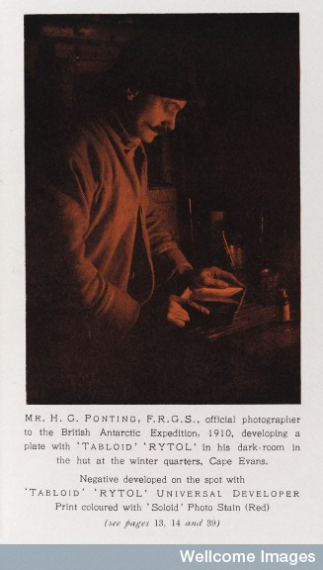

Figure 4: Burroughs Wellcome capitalised on their product being taken to the Antarctic with this advert for 'Tabloid' 'Rytol'. (Wellcome Library, London)



Figure 5 Advertisements from AP 24 September 1944, p2. Burroughs Wellcome Tabloid fine-grain developer show off their results at the top and below Johnsons aim to please a variety of users with Amidol in three different forms (liquid, powder, tablets) to make up developer.

Johnson's Pactum line of small paper packs of powder chemicals fully replaced Tabloid by 1965.[48] This indicates that perhaps for amateur users the ready weighed powders gave more reliable results than a tablet, despite Burroughs aim for easy solubility of their convenient portions. Instructions included with the tablets stressed that when they were added to liquid they must be immediately pulverised and stirred until fully dissolved. Users were advised against using a thin walled glass vessel, hinting at the vigour needed to crush and stir to get the tablet into solution.[49] In this case, powders which were easier to dissolve won over the tablet making technology that Burroughs and Johnson’s, had applied to these products. Alternative presentations of photographic chemicals were formulated and marketed. Despite the attempts of North Staffs Photographic Services /Photopia [changed to P in/around 1956] to market a gel format called Sigel, it appeared that users preferred to stick with familiar, tried and tested powders and concentrated liquids.[50]

Photographers got used to heavily branded packaging so when they encountered less “non-commercial looking” products they were hesitant. Nevertheless, the small formulator Speedibrews, set up by a retired analytical chemist Michael de Faulbert Maunder, who sent out his mail-order chemicals “If it’s legal we sell it” who described his products as “idiot proof” in plainly labelled chemical tubs and plastic bags, rather than professionally branded packaging quickly built up a reputation for quality.[51] This is not to say that users were unused to buying unbranded chemicals, but expected a slickness associated with large companies when they bought branded products. These small companies,

A reason for using preparing one’s own mixtures was that companies could alter or stop making a preferred brand, so being self reliant avoided this disruption and disappointment. This was also framed in terms of “independence from monopolistic companies”, if not by a majority of home processors at least by the collective operating under the name Photography Workshop. Terry Dennett extensively researched chemical formulae published in old journals and books, testing some of them with the aim to develop his own Photographer’s Vede Mecum which was to include an index of substitutes and alternatives from household and industrial products.[52] Ultimately this was not completed, and household chemicals are elusive in the twenty boxes of accumulated research, save for a tantalising photocopy of some water softening packaging, the mention of successful tests with adrenaline eye-drops and a report of an American photographer making a developer based on acetaminophen (paracetamol).[53] Americans rather than Britains seem to have taken the experimental “homebrew” aspect further, with a currently fashionable coffee based developer emerging from a class experiment in 1995.[54] This is not to say that users who chose prepared mixtures were restricted in how their used them. Keen home processors who did not want to buy “barrels of chemicals” but still wanted to personalise their results were free to adjust commercial mixtures with additives, providing they understood (or learned through experimentation) what effects the chemicals would have on the print.[55] However, this was by no means common practice, demonstrated by PU80’s declaration that he would only ever follow the directions.[56]

Evidence of domestic practices can be found in practical photography manuals and magazine articles. The airing cupboard was described as the most frequently chosen place of storage for the bottles of carefully prepared and labelled solutions that the home developers made up. To the author, this behaviour was inexplicable, who advised storing them instead on a windowsill where sunlight could kill moulds that could grow and spoil the solutions.[57] For chemicals that must be used for their purpose of developing photographs, in a specially constructed darkroom, putting them in direct light seems counterintuitive. The question remains though of why the airing cupboard was so popular, when any other cupboard would have provided this dark, protective environment without the additional warmth traditionally associated with airing cupboards.

Ventilation was a concern for these chemical users, but perhaps not an overwhelming one especially as the chemical processes were simplified. Historian Bill Jay documented that photographic journals for amateurs and professionals alike had been urging their readers to ventilate their workspaces properly since the 1890s, and regularly ran articles on health issues to do with improper ventilation, as well as effects on the skin from immersion in chemical solutions. These concerns were not always explicitly related to any specific chemicals, but more often referred to "stuffiness" which would make you sleepy, when the process required you to stay awake to get the best results.[58]

# Where were photographic chemicals available?

Photographic suppliers bought advertising space in photographic periodicals, including slips that readers could send away either direct for orders or for a larger catalogue of goods. Although hardware, rather than chemistry, dominated the pages, it was clear to home processors that that they had a variety of options available to them. They could shop in person from suppliers near them or they could send away for mail order supplies. S

Photographic dealers were encouraged to cultivate rapport with their customers. Ilford published a course in salesmanship, and emphasised knowing about the customers in order to best help them, as well as to encourage sales and repeat custom.[59] The advice appears applicable whether the salesperson is dealing with amateurs buying small amounts, or bulk buying professionals. PU80 recalled no difficulty in getting hold of the concentrated solutions he preferred over powders in the 1980s, walking into any local photographic dealer where he lived in Bournemouth would yield what was needed. A product of his time, PU80 was aware of generalised potential for chemicals to have unexpected, unknown effects on the body and for this reason chose not to work with powders, minimising inhalation of airborne chemicals at both his home darkroom and the public access one he manages.[60]

Photographic chemicals were also heavily branded from early on in the history of photography. Shearcroft urged his audience of 'practical chemists' to "BUY NOTHING BUT BRANDED CHEMICALS".[61] The emphasis in instruction manuals, such as Shearcroft's, on purity and thus on branded products, was directed so that the user could be sure they got what they needed and avoided disappointment with poor quality, but perhaps more readily available, substitutes. He gave the example of sodium carbonate, commonly known as washing soda, but strictly separated the menial tasks of washing up and cleaning floors for which a low grade chemical was good enough, from the skilled technical use of developing photographs, which necessitated a finer grade for satisfactory results. His book carried no warning about securing the photographic grade from being used for household tasks, suggesting that he did not consider this a likely scenario and the household photographer's supplies would be safe from anyone seeking a quantity suitable for cleaning.

However, Shearcroft was perhaps over-cautious, as AP magazine gave permission in 1917 for users to employ cheap washing soda crystals in making up developer, provided the photographer tested the solution to find out how it behaved before committing all their work to it. Here, the attitude was taken that if the risks of substituting washing soda were explained and could be accounted for, the user was free to employ the less pure variety of sodium carbonate if that was what was available to them. Washing soda was one of Terry Dennett’s chemicals of interested which he researched for a new practical photographer’s handbook, and although the project was not finished, he did begin to popularise the use of “photographically useful” chemicals that might already be found in the household.[62] Whether the motivation was scarcity, politics or simply trying to use what was at hand, the use of other household chemicals as photographic supplies was reasonably common. L.D. wondered whether Surgical Spirit BP could be used to dry films, but in this case the first aid cupboard staple was not suitable, as it would leave a residue of oil of wintergreen. Methylated spirit was suggested as a better household compromise.[63]

The Hardmans glass fronted chemical cabinets display rows of partially used up bottles from photographic chemical specialists Johnsons of Hendon and Kodak, local chemists such as Clay & Abraham on nearby Bold St (where they purchased many of the lotions and medications stored in their medicine cabinets) as well as chemical companies who did not specialise in photographic supplies, such as A. Gallenkamp & Company.

# What dangers, if any, are associated with storing or using them?

The dangers associated with using photographic chemicals can be divided into those that affect the user and those that affect the results. From reading magazines, manuals and talking to users, concern for the end product has tended to outweigh concern for the user, nonusers sharing the space or the wider environment. One of the principle dangers associated with processing and printing photographs is losing the images that were captured. Paul Carter explained that “Every photographer at some point in their career has poured their fix in first and completely wiped the film, so you know there’s always a danger.” From this particular danger, “the element of chance” stemmed a large part of the attraction to home processing. “When you actually pulled the film off the reel and looked at it, there was just that thrill, that wonder that you got anything at all, that you didn’t open the back of the camera at the wrong time, that you didn’t put the fix in first and so on.”[64]

If images were not totally lost, chemical contamination could lead to spotted, flecked or otherwise damaged and inferior pictures. Shearcroft stressed using dedicated equipment, not reused from kitchen duty and certainly not "chemically filthy" hands.[65] However, this is all with an eye to achieving the best possible results, rather than ensuring the comfort or safety of user (and those they shared the domestic space with). Carter echoed these concerns for the images when he talked about his darkroom practices between the 1960s and the 1980s.

Clear labelling of the contents of bottles was also paramount in Shearcroft's instruction, although he did not elaborate on why, leaving this as self-evident that the user should be able to quickly select the correct materials needed for photography, but not considering the non-users in the household and their curiosity or assumptions about the contents.

Although particular types of bottle, Winchesters, were recommended in some manuals to be obtained from chemists, others suggested jam jars,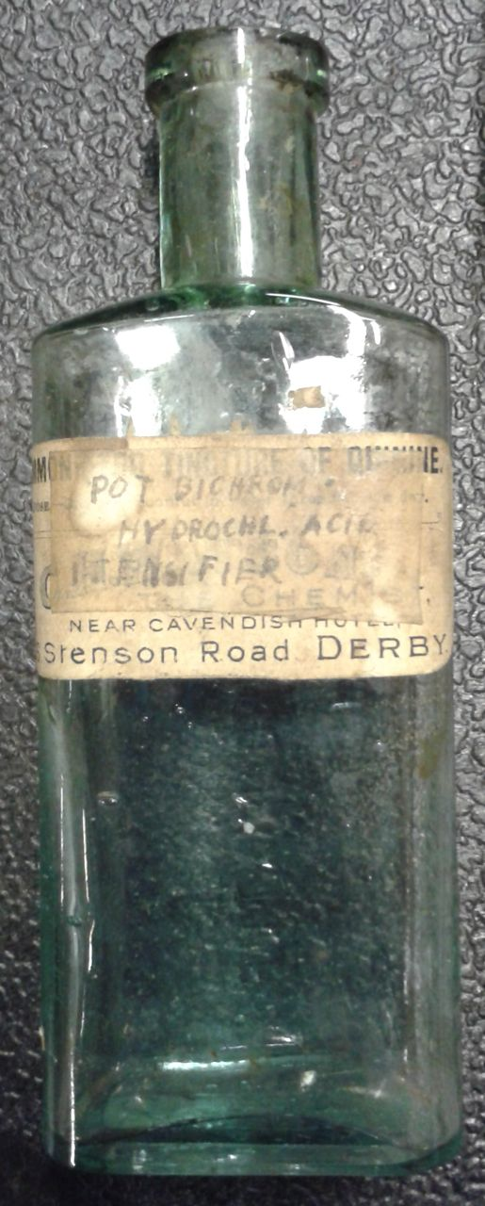[66] gin bottles and other drinks bottles. Gin was suggested for the tendency for it to be packaged in squared bottles, allowing to be easily distinguished by touch in dim light. It was interesting to note that that particular author added a disclaimer that it was not his fault if people drank from the bottle, which should be clearly relabelled.[67] Not everyone diligently followed this advice, as an example of a poorly labelled bottle kept at MOSI shows. The reverse of the bottle is embossed with "chest and lung mixture" and the chemists original label of tincture of quinine is still partially visible under the added label and faded pen inscription of "Pot. Bichrom, Hydrochlo. Acid Intensifier". Enthusiast CE Maney shared his “amusing experiences” and laughed off accidentally adding his used hypo solution to a three-quarters full bottle of sherry and wasting his drink, demonstrating that he had learned from disregarding advice to strictly separate beverages from darkroom materials by proclaiming that he had now moved his cocktail bar to a shelf further away from his work bench.[68]

Having highlighted the potential for accidental poisoning through mistaken contents, this type of mishap did not get reported in national newspapers, unlike the cleaning products and herbicides we looked at previously. The specialist photographic journals carried news of such accidents as ways of informing their likely users, but the absence of concern in mainstream newspapers suggests that this domestic use of chemicals was not a considered a problem that occurred frequently enough for these papers to educate or mobilise their readers about. This fits with the idea that photographic chemicals were only a hazard to the small number of people using them, that collateral damage or criminal misuse was not believed to be a problem.

Although photographic magazines had run editorials and articles about the dangers of photographic chemicals since the 1860s, and photographers had been connecting a variety of physical symptoms and general discomfort with their use of chemicals, generally in under-ventilated rooms,[69] methods of safe handling and use of these chemicals are generally not discussed in manuals from the 1930s to the 1960s. Odour was bothersome, but did not necessarily mean danger. Would-be home processor H.Y wanted to use their bedroom as a darkroom but worried “Is the odour usually found in darkrooms inevitable and, if so, is it injurious to health?”. The answer was reassuring “Ordinary chemicals have no fumes which can be dangerous to health” and the solution to the smell was straightforward “open the windows occasionally, bottle the fixer after use and throw away the developer, washing the dishes at the same time.”[70] However, this begs the questions, what were ordinary chemicals and how was H.Y. going to know if their chemicals were ordinary?

Smell, other than the almondy smell of prussic (hydrocyanic) acid, were rarely described by users although the “smelly chemical” epithet as well as the drive to develop low odour products, indicate that there were particular smells associated with the activity. Glacial acetic acid, akin to vinegar but stronger. Sulphurous, eggy smells associated with sulphur toning. Other than these is is hard to know what the chemical smells were, when contemporary users did not wax lyrical about them. Nevertheless, smell is something that is considered missing from photography as it is largely practiced today.

Users who worked from manuals such as Wall’s Photographic Darkroom may well have understood potassium cyanide to be an ordinary chemical, the way that Wall tried to dispel some of the “unnecessary fuss” regarding the use of dangerous chemicals. Potassium cyanide, he said, is not likely to be absorbed through the skin, although he warned about the hydocyanic vapour given off when it reacts with acid. He suggested that it should be used as little as possible and rationalised its continued use by explaining that photographers never have to use it in the dark, so they could open the door to improve ventilation or work outside the darkroom with it.[71] Keeping up to date with improvements meant that photographers did not have to work with potassium cyanide, rendering it not an ordinary chemical.

Evens , the focus was on a particular source of toxic gas, with special mention most often given to the possibility of the inadequate disposal of spent or contaminated solutions, and their tendency to lurk in U-bends and mix with disposed acids to form hydrogen cyanide which escaped into the darkroom and poisoned careless photographers. The common-sense solution to this problem was to flush the chemicals away with plenty of water. Not until the late 1980s was the destination or likely downstream effects of these waste chemicals discussed in magazines. When it was, at least in American publications, concern initially lay with the effect on the user’s own septic tank, rather than the wider waste water system.[72] In Britain, the small volumes of waste created by the casual domestic user did not require any special action, whereas people who produced 200L of waste from a single site in a year required registration and professional disposal of that waste.[73]

On the subject of mercuric chloride, while it could poison it was also used as a disinfectant during surgery. His “safeguard” against people taking chemicals from the darkroom was to only use chemical symbols, rather than plain names. He paid particular attention to labelling and advised about legibility in different storage situations, as well as safely opening bottles as stuck stoppers and corks were deemed the cause of many accidents encountered by the photographer.[74]

When users were alerted their need for responsibility and care when handling the chemicals, such as to not smoke, eat or drink in the darkroom, to wash one's hands well, these were all dealt with in terms of obtaining decent photographic results rather than personal safety. However, not everybody took these instructions to heart. Unless alcohols were used to dry negatives, most modern darkroom chemicals were not flammable, so smoking was simply bad practice with an eye to cleanliness, rather than necessarily dangerous. When Zoe Dominic recalled that during the 1960s she had a Baby Belling cooker in her home darkroom and used to have fry-ups in there, she declared that it was “appalling” behaviour, though her concern lay with safety of her negatives from sputtering grease.[75] PU80 mentioned an archived photograph that he had seen of a workshop for disabled children which showed chemicals being mixed beside people enjoying their tea, a scenario which would never happen now in his strictly segregated areas.[76] These comments clearly demonstrate the changes in awareness of the potential that chemicals had to impact the health of users.

In the correspondence from readers responding to articles about health impacts of chemical dangers, Jay detected hypochondria, as well as a tendency for the photographers to become very involved in their work, spending overly long hours in stuffy spaces. Despite the regular appearance of health concerns in these publications, voiced by chemical users as well as magazine editors, they have been given only passing mention in books from the 1930 to the 1970s. Despite this seemingly laissez-faire attitude in instructional books, the manufacturers of photographic chemicals have long been interested in their users' comfort and safety, as can be seen in the promotion of improved chemicals. For instance, in 1941 Johnsons advertised their new chemical Meritol as a replacement for toxic paraphenylenediamine used in miniature photography, to obtain a fine grain. Meritol was available by itself, for photographers to incorporate into recipes, or ready compounded into developers.[77]

Black and white processors were regarded as being more likely to "slosh about" in metol, notorious for causing dermatitis, whereas colour processors could not indulge in "such light hearted frivolity" as the chemicals required more respect and certainly the use of rubber gloves.[78] In fact, the threat of cancer was associated with dyes necessary in colour chemistry from early on, not that this put people off using it.[79] Health of researchers and processors does not garner a mention in Jack Coote’s history of colour photography.[80] Gloves were not included in Johnson’s B&W kit produced in the 1950s, although this did not mean they encouraged users to slosh about as tongs were part of the kit along with instructions to use them to transfer papers between solutions using them. Using tongs successfully required dexterity to manipulate the paper, tempting users to use their hands. Mastering one pair of tongs did not necessarily mean all tongs were sussed, as squeezing could either release or grip depending on the design.[81] However, difficulties handling the papers with tools were not the only motivation for reaching into the solution: “certain types of artistic person who want an organic connection with the process” would be banned from PU80’s darkroom for trying to achieve this by dipping their bare hands into the chemicals.[82]

Getting photographic chemicals on your skin was not advisable. Even if the long term effects might be questionable, they could get in at the nailbed and sting, or even cause nails to “shrivel up” and “fall off”, which happened to Paul Carter’s wife Henrietta after she was helped him to sepia tone prints to meet a deadline. Described as an “intrepid soul”, Henrietta stopped work for the night but continued the following day, wearing gloves. Paul considered himself lucky that he was not allergic to any of the chemicals he worked with, although they were not without additional effects. He recalled that even though he washed his hands as soon as he got anything on them in the darkroom (from the point of preventing cross contamination or finger prints on paper), his clothes and lab coats eventually developed holes where he wiped his hands dry afterwards, the result of the residues that slowly ate away at the fabric.[83]

The awareness of skin problems and sensitivity to metol was highlighted in Ilford's publicity for their new revolutionary chemical Phenidone in 1953, which they positioned as a substitute for metol. Phenidone did not require “obnoxious” caustic alkali, was described as “one of the least toxic” and “unlikely to cause dermatitis with normal users” as well as being usable by those already suffering from Metol poisoning.[84] Other than switching from Metol to Phenidone, using tools or protective gloves, the prevention of dermatitis also had a chemical answer: fingers should be rinsed before and during development in a dilute hydrochloric acid solution.[85] To be affected or become allergic to chemicals was unlucky but it did not necessarily deter or prevent people from working with them, they either changed products or took precautions such as wearing gloves more seriously. Paul Carter’s darkroom assistant worked with him for 20 years, despite being sensitive which shows that the issue is not insurmountable.

Descriptions of dermatitis or observable effects on skin were limited to reddening, itching, scaling, irritant types of interaction. This is interesting, as hydroquinone was known to lighten skin following industrial accidents in the 1930s and 40s, and used medically as well as cosmetically to bleach skin in lightening creams. Either the authors of instructions about photographic chemical hazards assumed the common sense behaviour of hand washing so that this effect was not thought relevant to mention, or they focussed on an audience of white users. However, this silence about skin effects other than painful dermatitis interested me. Would people make their own skin treatments using chemicals available for photography? It appears not. There is no published documentary evidence of people seeking to use photographic supplies in homemade skin treatments, and a British Skin Foundation survey did not uncover this non-photographic use of hydroquinone.[86]

Assuming white was normal was not unusual. Lorna Roth studied Kodak colour film and the use of standard “Shirleys” to achieve colour balance, in which she reflected on how the company viewed who its users were and process operatives adjusted methods according to those users.[87] Individual cameras (Polaroid’s ID-2 with boost flash) and entire companies (Polaroid which supplied equipment to the government of South Africa black citizens’ passbooks) have all been labelled racist.[88] Richard Dyer in his examination of movie technology and culture, wrote about the assumptions behind advice on photography and skin tone being for white people in front of the camera, the unquestioned use of the phrases “flesh tone” and “skin tone” have both been used without question in manuals and magazines. [89] race was not a topic raised on these pages with regards to either any side effects of chemical use, or in how to achieve the desired end result.

In the literature that started to be produced about chemical dangers and photography in the 1970s and 80s, the most striking thing that was absent was any sense of dose. Where there was dosage information, it was not presented in the context of the chemicals’ use as an agent in photography. The lack of certainty or clarity was translated by chemically confident users as scare mongering and not to be taken seriously, who instead called on personal experience to demonstrate that no ill effects had come about through normal use. Other more cautious users translated the possibility of adverse health effects into the message that all chemical exposure should be minimised. Colour chemistry was known to be carcinogenic from fairly early on in Cibachrome’s use, though it was the complexity and the end results that left room for improvement and put amateurs off using colour kits after the initial novelty wore off.

Even despite knowing that certain chemicals were potentially dangerous, some were considered too useful and without adequate substitutes to be given up. Instead, users were warned to use chemicals with "caution" or "extreme caution" in the case of developer component hydroquinone.[90] Eventually, when replacement of hydroquinone with ascorbic acid (vitamin C) had been thoroughly investigated and was deemed suitable, the substitution was described in terms of greater environmental friendliness, not a topic it had previously been linked to as problematic, rather than avoidance of personal harm.[91] This discrepancy is due to the different attitudes of authors towards the risk, where sensible behaviour and protective equipment effectively negated any chemical problems, especially when the chemical risks, such as human cancer through exposure to hydroquinone, were not certain.

Margaret Hardman's life ended in 1970, when she was 61, following breast cancer, is there any mention of any pondered connection in any of the documents? The collection of interviews conducted for the British Library's Oral History of British Photography documents experiences of respiratory diseases, cancers and leukaemia, but although some artists attributed their susceptibility to disease to long hours and hard work in general, photographic chemical exposure does not seem to have been singled out by the users themselves as a contributory or aggravating problem.[92] Long term health impacts of chemicals do not appear to have been at the forefront of users’ minds. Photojournalist Elisabeth Chat was working in the darkroom when she went into labour with her first child in 1952, having worked throughout her pregnancy and did not detail any concerns or special precautions that she took. Instead she relished doing continuing to work which very few women did at the time, and revelled in the idea that her grandmother would have been horrified.[93] Over twenty years later in 1974, a particularly peevish article on home processing in Spare Rib did not mention any health effects related to photographic chemicals, despite being a magazine which usually took special care to note any relationships, however tentative, to cancers and reproductive disorders.[94]

Printing B&W images on colour paper was suggested as a way to get a sepia effect without “messing about with nasty smelly chemicals”[95] but not until the 1980s was there any concerted movement of wariness regarding chemicals. Although safety data sheets had been available on request from manufacturing companies, the American initiative that resulted in the publication of *Overexposure* aimed to collate this information so that the possible toxicological risks faced by amateur and professional photographic processors were more readily accessible and comparable. American photographer John Pfahl endorsed the book with an open letter that gave his personal experiences of general malaise related to chemical sensitivity and non-Hodgkins lymphoma which he acknowledged as possibly attributable to the combination of toxins he voluntarily exposed himself to through his passion for processing photographs.[96] The desire to avoid health issues from photographic chemicals led to H&S minded PU80, who while claiming to not be an experimental user when it came to tweaking chemical formulae, demonstrated experimentalism when he switched strong-smelling stop bath for plain, clean water without telling any of his darkroom users. Their pictures were as good as ever and their exposure to chemicals was further reduced.[97] Odiferous chemicals did have the benefit of reminding users that they should ventilate their darkroom adequately, but low odour options were popular with users.

The packaging in the shop front of the dispensing chemist, dealer in photographic materials and pure chemicals, shows only films, papers and cameras. Off public display, but still available to visitors to the Insight collections centre, designed to make accessible the vast number of items that are not displayed in galleries, are samples of packaging for developer and fixers, along with bottles that once contained chemicals such as pyrogallic acid, displayed in a cabinet in one of the object stores.

**Flash chemistry**

Flash powders, along with magnesium strip and powder are over represented as almost the only chemicals on displays in NMeM’s Kodak gallery that relate to the period between the 1930s and the 1980s. In a display on flash photography, amateur photographic chemical users are described as "adventurous" and "keen", and willingness to use explosive illumination sources indoors does suggest adventurous, if not somewhat foolhardy as the powder could not always be relied on to behave as expected. However, should the flash powder injure the user, they were depicted as 'unfortunate' or 'unlucky' with the chemical purely held to blame, rather than user error in storing, measuring out or igniting it.

One of the products that should have been subject to scrutiny at the point of sale, at least during the second world war, was photographic flash powder. It was included on the list of Prohibited Chemicals compiled by the explosives group, an initiative we previously encountered in the section on gardening chemical sodium chlorate. It stands out on the list because flash powder is a mixture, not a chemical element, nor a compound. Also on the list was potash of nitrate, or potassium nitrate which was an ingredient in photographic flash powder. Magnesium powder, which when ignited burned with a bright white flame, good for illuminating photographic subjects, was not listed separately. However, flash powder itself did not seem to be the subject of much further discussion, its place on the list was not contested in the archived documents nor was any further information offered about the prevalence of its normal use, or the likelihood of it being used by a saboteur who had so many products to choose from.

By the outbreak of the second world war, flash powder already had competition from flash bulbs containing magnesium foil, generating brightness without an exposed flame. This proposed wartime tightening of sales did not generate discussion in the photographic press. Sales were not stopped, but the retailers were urged to consider the amount the were selling and to whom. In all probability, the amount photographers bought at a time were not large enough to constitute a significant threat. Tins of Johnson flashpowder contained 1, 4 or 8 ounces. 1 ounce of flash powder, could last around 43 portraits of individuals, as it was only used in small amounts at a time around two thirds of a gram. Larger groups demanded more illumination, using around 6 grams of powder. However, as even using these small amounts could be dangerous, and caused even experienced, frequent users of it to be wary of their safety, there does seem to be sense behind the concern about the use of flashpowder in sabotage. As described earlier, dampness was a particular problem especially if the powder was damp, which caused it to detonate "like a small grenade" rather than provide light. At the outbreak of hostilities [photographic flash powder] should be dealt with by legislation or Order to prevent general availability. List of 'prohibited chemicals'[98]

However, flash powder continued to be used by some photographers until the 1960s. Photography enthusiast Paul Godfrey reminisced about his experiences with flash powder in the 1970s. Though a network of contacts, he was given a Horlicks jar containing flash powder made up by an industrial chemist who worked at an oil company. He and other enthusiasts at an adult evening class had fun trying out the flash powder, but later panicked about keeping a jar of chemicals that he believed could spontaneously combust. In an effort to safely dispose of it, he tried to wash the powder down the sink, which clogged, and he subsequently found out that damp powder was more dangerous than it was when it was dry.[99] Indeed, historian of photography Bill Jay wrote that it was not just amateurs who could become nervous about keeping such chemicals, as a fatal industrial accident was caused by flash powder manufacturers washing their chemicals down the drain, in an attempt to rapidly dispose of them.[100] Although the incident Jay recounted occurred in 1889, both accounts show that the users' partial understanding of the chemistry caused worry and the desire to no longer have or to use those chemicals. As in the use of any domestically employed chemical product, there is no requirement for the user to fully understand how it works in order to get satisfactory results, but a more complete understanding may help people to avoid accidents.

A more reliable way than education to reduce accidents with flash powder was to present flash powder to the user in an easier way than mixing powders from tubes A and B. Flash buttons were portions of flash powder contained in cardboard that were set off electronically. These were marketed in 1952 by Photopia and the CEO Charles Strasser claimed that their success was what prompted price reductions in electronic flash that marked flash powder's death knell.[101]

## Carbon Tetrachloride

An interesting example of awareness about dangers of chemical use played out in the pages of AP, after an article suggested using CTC but did not mention any precautions. In an exchange through the letters pages readers who, at least in the edited letters we see published, did not identify themselves as being any other type of expert or user such as trained in physiology or toxicology, conversed about their perceptions of the chemical. Marcus Rowland, writing from London, warned others of the danger of 'an extremely dangerous chemical', of its potential to be absorbed it through the skin, of the possibility of it to form phosgene if the vapour was inhaled through a cigarette.[102] Paul Peronat from Sunderland poo-pooed this caution, identifying the previously listed dangers as relevant for chloroform, but not CTC, saying photographers only needed to worry if they had glue sniffing children who might damage their kidneys from enthusiastic solvent abuse with CTC. This letter was interesting, as he also claimed that CTC was stable, not forming phosgene, putting it on a par with nail varnish remover (which if he meant acetone, is rather good at starting fires) or spot remover, which in many cases was actually CTC.[103] Rowland got the last word in this exchange, where in the final letter printed on the subject he conceded that chloroform did share some of the same characteristics, but that neither should be used in poorly ventilated situation or by people who were smoking. He then linked CTC and its use in dry cleaning to deaths following inadequate airing of treated garments, a phenomena that had not emerged into the public domain in the research I carried out. However, in his direction of readers to the Institute of Science and Technology publication "The care, handling, and disposal of dangerous chemicals", a document that the average citizen would not have much special cause to read,[104] but as a school laboratory technician he encountered this publication as part of his working life, and was able to apply the information to his hobby.[105]

A visit to a locked chemical cabinet in another museum's storage area revealed several bulging tins, taped shut, apparently as a demonstration of why photographic chemicals tend to be disposed of and only the packaging, inert accessories such as scoops and measures and instructional inserts retained. When developer, flash powder and magnesium are collected, their catalogue records list their hazards as "unknown", "environmental", "oxidising" or "explosive".

## Expertise and Risk Perception

The question of perceived dangers from photographic chemicals is certainly one very much associated with greater awareness of the potential triggering of adverse effects from the presence of environmental chemicals in general.

Reader’s letters are a device used by magazines such as AP to educate the reader with problems posed either by real correspondents or made up ones to illustrate a point. Whatever the origin of them, they show topics that were relevant to the time. Addressing the use of ferricyanide H.S. wrote “I have the feeling it might be a deadly poison”. This turn of phrase suggests that the user, or the composite imagined user, based their actions only on the name rather than solid chemical understanding or backing this concern up with their own research from instructional manuals. This feeling associated with words, of half knowing but not managing to make out a definite reassuring answer from the information available is a significant problem with perceptions of chemicals. Everyone knows that cyanide is a poison so it is reasonable to see the word appended to or incorporated into a name and wonder whether this cyanide-plus is a poison too. It is met with the not terrifically illuminating “It is only the actual cyanides that are” and instructions to not bother with special precautions.[106] However, medical experts could also be unsure of the materials photographers were likely to use, demonstrated by the attempt made by Beards *et a*l to clarify why a particular cyanide treatment of a photographer was likely to be successful (that it was not potassium cyanide, but potassium ferricyanide which is less toxic). They also suggested that the yellow colour of the ferricyanide solution resembled lemonade, giving a reason why it may have been drunk.[107]

“I use mercuric chloride and potassium cyanide… but I understand that they are such intense poisons that mere contact of them with the skin is likely to be fatal” was answered with reassurances that the authors had used these without problems, having followed common-sense precautions. They listed these as making sure to ventilate the room (to prevent headaches from inhaling hydrocyanic acid), ensuring no abrasions on skin, not immersing fingers for a more than a few seconds at a time and rinsing off immediately.[108]

Dr Richard Henry typifies the response of a laboratory trained chemist to concerns about chemical risks. His 1986 second edition of his re-investigation of the fundamentals of black and white photography included a new chapter, or rather a tirade, rubbishing a number of publications from the 1980s concerned with the potential health hazards of photographic chemicals. His attitude was that safe laboratory practice was sufficient protection from harm, which for a book that was not necessarily targeted at only laboratory workers is unfair to his readers without this formal training. He conceded that women could wear labcoats or aprons if they wanted to, without going further into why they would require different protection from that used by men.[109]

Similarly to the other chapters, photographic chemicals were highlighted as suitable for gifts. May&Baker promoted their products as such, working their way into one of AP’s gift guides at the same time as running an advertising campaign. Recipients were expected to be “anxious to try” the latest products, Cobrol paper developer would “always find a use”, and giving the newest version of a trusted product was a safe bet.[110]

# Are these dangers related to their withdrawal/ restriction or concealment?

Unlike household or garden chemicals, there were no public campaigns dedicated to raising awareness of accidental poisoning, and photographic chemicals were not mentioned as hazards in lists of household dangers. Children were not repeatedly accidentally poisoned, so the mainstream media’s attention was not attracted. The low profile of accidents related to home darkrooms reflects home processing’s status as an activity carried out by relatively few people, who were, on the whole, careful about storing their materials properly. In the specialist periodicals directed to professional and APs, there were regular editorials and correspondence about preventing accidents.

Photographic chemicals do not seem to have been used in malicious ways. For instance, although acids were ingredients photographers or photographic suppliers were not implicated in acid attacks reported between 1930s and 1980s. Flash powder was not used by children in bangers, or bombs. Aside from accidental mistakes made in the dark room, there seems to have been little scope to use photographic chemicals for other things in the house. Medical uses of hypo extended beyond the flippant advice that if cyanide were drunk in the darkroom, hypo was the antidote. Regular summer advice to doctors, though this trick did not appear in any of the other publications I surveyed, was that drinking water abroad could be made safe by chlorinating water themselves with calcium hypochlorite, treatment which should be followed by the addition of sodium thiosulphate at the rate of 15mg to be added per gallon as treatment to make self-chlorinated water palatable when travelling abroad.[111] This was never referred to as “photographers hypo”, as sodium thiosulphate was a drug used routinely by doctors. However, it was not only holiday makers hoping to make a home from home free of stomach upsets who were interested in the chlorine levels of water. Aquarium keepers were also interested in neutralising chlorine to limit any potential damage or discomfort caused by chlorine, and in this case the chemical was also referred to a photographer’s hypo.[112] It was reported that putting cut flowers into hypo prolonged their life, but it was unlikely that people went out of their way to try this out when there were many other methods that were rumoured to work.[113] Hypo could “work like magic” to remove iodine stains from fabrics, being deemed safe for all fibres and not affecting colours.[114] Iodine was used for disinfecting cuts, grazes and minor skin infections at home but appears to have fallen out of use in favour of non-staining products. While acetic acid is vinegar, which has many cleaning uses, glacial acetic acid was never recommended for such uses. Indeed, solidified glacial acetic acid, even after dilution if it dried out so became concentrated again, was said to rot fabric.[115] This explains Paul Carter’s disintegrating darkroom clothes.

Although some of the chemicals were dangerous, between the 1930s and 1980s were apparently not deliberately misused to any great effect. Before this time, potassium cyanide suicides had featured regularly in newspapers, with potassium cyanide suicides vastly outnumbering accidental deaths at 121 to 21 between 1911 and 1916. The method had been used only among photographers, chemists and medical men, but following a pattern seen before in this thesis, that of media attention followed by deliberate action and yet more reporting, the practice spread beyond photographers.[116] Although media attention turned away from cyanide deaths, this does not mean they stopped though it is impossible to attribute them to any connection with photography. While industrial sites such as “labs” and an “electro-plating shop” were cited as the source of cyanide suicides, photographic processors was not flagged by medical professionals as a population of users that were particularly at risk from poisoning.[117]

Where there any public calls for action? No? useful to compare to other chemicals where people did feel outraged that they were available. Why, when these chemicals could be misused with fatal consequences, was there not any public concern? Could this be to do with the perception of the users themselves, ie nerdy, not a threat, hobbyists, competent? What about the list of prohibited chemicals re sabotage?

Could it be that the number of people requiring the chemicals was so low as to be unprofitable to continue? Is this a supply and demand problem?

Another factor to consider is the type of film used, and the needs associated with developing it. The introduction of colour film certainly had implications for the chemicals required, and it created even more interest in kits suitable for this more complex process. The continual improvement of camera film meant that developing techniques also had to adjust. This shows that it is not simply the availability of chemicals that is a factor, but also the suitability of films for amateur processing methods.

What is curious about photographic chemicals is that all the ready made solutions and powders had their formulae published, so were known and accessible to photographers interested in processing. Consumers bought branded preparations because they were available, they had often become familiar having been included in starter kits, for users processing a lot of images they would save time, for convenience and to ensure reliability and reproducibility. Retailers sold them because as prepackaged items they could be handled easily and quickly. Raw chemicals were of interest to the minority of photographers interested in historic processes, but even these did not seem impossible to obtain provided the user was willing to request then wait for a chemical to be stocked.

Oral history respondents, including the editor of an amateur photography magazine, asserted that the manufacturing companies were very much in charge and that as users they were not conscious of exerting power over the type of products that were on offer to them.[118] However, manufacturers were in contact with their users, gathering feedback and information about the issues faced so finding ways to tackle the real problems that their users faced. This can be seen by the activity of representatives from Kodak, Ilford and Johnson & Sons, broadcasting through specialist periodicals, being readily available at camera club meetings, as well as visiting retailers.[119] Patterson also relied on its staff to feedback about their products, including chemicals. As well as employing someone to test under real amateur conditions, staff were given an allowance of material to use as they wished.[120] Generosity like this built loyalty to the company, avoided thefts and provided a type of market research. This type of connection between manufacturer and user is not something that has been so apparent in the other chapters.

In the chapter on housework, gases and chlorine in particular, appeared to be a poorly explained a danger of using chemicals. In contrast, the consequences involved with using photographic chemicals were better outlined to users through specialist photographic magazines and instructional manuals. While there was tension over how photographers should interpret overall chemical safety data considering how they might use the chemicals, there was at least discussion about it and meaningful information relatively readily available.

Although I mentioned cake, the following of photographic formulae was never equated to following recipes for food or cleaning mixtures. Despite attempting to convey ease and that anyone could do it, this domestic activity was never invoked, highlighting again the tension between protestation that you did not need formal scientific training and the actual competence needed to handle chemicals to get good results. The consequences of not following a domestic recipe correctly could result in similar wastage of costly or scarce materials and time, but the parallels were not drawn, further insinuating a masculine-feminine divide.

1. andblished nature of the isoneD so the mainstream media'relessly stored chemicals, and ite reassuring answer from the informati Hayman, Rex. "Any Amateur Can Make Prints." *The Guardian (1959-2003)*, 1975 Nov 21 1975, 21.
2. Hanna, Erika. "Reading Irish Women's Lives in Photograph Albums." *Cultural & Social History* 11, no. 1 (2014): 89-109.
3. Taylor, John. "Kodak and the 'English' Market between the Wars." *Journal of Design History* 7, no. 1 (1994): 29-42; Olivier, Marc. "George Eastman's Modern Stone-Age Family: Snapshot Photography and the Brownie." *Technology and Culture* 48, no. 1 (2007): 1-19.
4. Neathercoat, E.T. "Poisons in the Home." *The Daily Mail*, 02 January 1926, 6.
5. Neathercoat, E.T. "Poisons in the Home." *The Daily Mail*, 02 January 1926, 6.
6. Dominic, Zoe. "Oral History of British Photography." By Shirley Read (1996), track 2 of 8, 12.00; Sacks, Oliver W. *Uncle Tungsten : Memories of a Chemical Boyhood*. 1st ed. New York: Alfred A. Knopf, 2001.
7. Morris, Dennis. "Staying Power Black Photographers Project." By H.J.; "Dennis Morris's Professional Portfolio." <https://www.ephotozine.com/pro-portfolio/dennis-morris-54.>; Jones, Josh. "Dennis Morris." <http://www.joshjoshjones.co.uk/projects/dennis-morris/.>
8. "Obtaining Chemicals." *The Amateur Photographer*, 27 December 1944, 884.
9. A.T.W.L. "Not Easily Obtainable." *The Amateur Photographer*  (07 May 1941): 427.
10. "Article on Home Processing for Beginners." *The Amateur Photographer*  (08 November 1980): 100-01
11. Avery, Keith. "Trade B&W Printing." *Amateur Photographer*  (06 January 1971).
12. Johnson & Sons Manufacturing Chemist. "Advertisement." *The Amateur Photographer* XCIV, no. 2882 (02 February 1944): front cover.
13. Bowler, Stanley W. *Photography for Boys and Girls*. A Junior Teach Yourself Book. Liverpool: English Universities Press Limited, 1950.
14. Sacks, Oliver W. *Uncle Tungsten : Memories of a Chemical Boyhood*. 1st ed. New York: Alfred A. Knopf, 2001.
15. Smith, Ivor. "Chemicals in Wartime." *The Amateur Photographer*  (06 August 1941): 636.
16. Jacobson, C.I. *All About Processing in Your Darkroom*. Krausz London: The Focal Press, 1945. p52
17. Kodak. "Advertisement: Control of Photographic Materials." *The Amateur Photographer*  (22 January 1941): ii.
18. Ilford. "Advertisement." *The Amateur Photographer*  (19 February 1941): p6.
19. Johnson & Sons "Advertisement." *The Amateur Photographer* XCIV, no. 2926 (06 December 1944): front page.
20. Selo. "Black-out Time Is Photograph Time." *The Amateur Photographer*  (01 January 1941): iv.
21. "Classified Ad 20 -- No Title." *The Manchester Guardian (1901-1959)*, 1948 Mar 20 1948, 8.
22. Dominic, Zoe. "Oral History of British Photography." By Shirley Read (1996)
23. Carter, Paul. "Oral History of British Photography." By Shirley Read (2006) track 1 of 4, 0:43:00; Dominic, Zoe. "Oral History of British Photography." By Shirley Read (1996) track 2 of 8, 12.35
24. Personal communication, PU80 30 July 2015.
25. Ilford Limited *No. 8 Salesmanship*. The Ilford and Selo Course of Photographic Salesmanship and Service. London: Ilford Limited.
26. Robertson, Grace. "Oral History of British Photography." By Alan Dein (1993) track 10 of 19, start. ; Dominic, Zoe. "Oral History of British Photography." By Shirley Read (1996) track 4 of 8, 09.09
27. Bowler, Stanley W. *Photography for Boys and Girls*. A Junior Teach Yourself Book. Liverpool: English Universities Press Limited, 1950.
28. Williams, David. "Printing in Mono." *The Amateur Photographer*  (18 October 1986): 62-66.
29. Patterson. "Advertisement: Just Add Water." *The Amateur Photographer*  (1980).
30. Barber, Lynne, and David Chamberlain. "What's Brewing at Speedibrews?". *The Amateur Photographer*  (11 October 1986): 58-60.
31. Hanna, Erika. "Reading Irish Women's Lives in Photograph Albums." *Cultural & Social History* 11, no. 1 (2014): 89-109.
32. Guide to property
33. Maney, C.E. "A.R.P. Shelter as Dark-Room." *The Amateur Photographer*  (03 February 1941): 135
34. Personal communication, PU80 30 July 2015.
35. Morris, Dennis. "Staying Power Black Photographers Project." By H.J.
36. Robertson, Grace. "Oral History of British Photography." By Alan Dein (27 September and 04 October 1993)
37. Carter, Paul. "Oral History of British Photography." By Shirley Read (2006).track 2, 50:00
38. Meadows, Daniel. *The Bus: The Free Photographic Omnibus, 1973 - 2001 : An Adventure in Documentary*. London: Harvill, 2001 p89-90; Meadows, Daniel, and Val Williams. *Daniel Meadows: Edited Photographs from the 70s and 80s*. Maidstone: Photoworks, 2011, p244.
39. Dominic, Zoe. "Oral History of British Photography." By Shirley Read (1996); Carter, Paul. "Using Photographic Chemicals." By Cat Rushmore (31 July 2015).
40. Lilley, Geoffrey. *Make Your Own Darkroom for Colour Printing*. Fountain Photobook. London: Fountain Press, 1962. p9.
41. "How to Use the Johnson 'Do-It-Yourself' Outfit." London: Johnsons of Hendon, c. 1957.
42. H.Y(Luton). "Bedroom as Darkroom." *The Amateur Photographer*  (18 October 1961): 610.
43. "Ilford Phenidone: A Remarkable New Developing Agent." In *Ilford Trade Lit*. United Kingdom: MOSI, 1953.
44. "Ilford Monophen." In *Ilford Trade Lit* 2: MOSI, 1960.
45. "A Home Made Chemical Balance." *Amateur Photographer*, May 1944, 71.
46. Ponting, Herbert. "Letter from Ponting to Burroughs Wellcome & Company, October 1911." Wellcome Foundation Archive, 1911.
47. Johnsons of Hendon Ltd. "Advertisement." *The British Journal Photographic Almanac*  (1949): 40.
48. Fisher, Maurice, and Richard Holzman. "The Johnson Photographic Year Book." http://www.photomemorabilia.co.uk/Johnsons_of_Hendon/JoH_YearBook.html.
49. "'Tabloid' Brand Photographic Developers." 1950? instructional leaflet
50. Strasser, Charles. *From Refugee to OBE*. AuthorHouse, 2012. p54
51. Barber, Lynne, and David Chamberlain. "What's Brewing at Speedibrews?". *The Amateur Photographer*  (11 October 1986): 58-60.
52. Spence, Jo. *Putting Myself in the Picture : A Political, Personal, and Photographic Autobiography*. London, England: Camden Press, 1986. p64-65
53. Dennett, Terry. "Vedus Mecum." Birkbeck University of London
54. Williams, Scott. "A Use for That Last Cup of Coffee: Film and Paper Development." <http://people.rit.edu/andpph/text-coffee.html.>
55. Hart, Russell. "Soup of the Day: Seasoning Print Developers to Taste." *Popular Photography*, Jan-Mar 1988.
56. Personal communication, PU80 30 July 2015
57. Shearcroft, Walter Francis Fairfax. *A Practical Guide to Photographic Chemicals and Their Uses*. 1 ed. London 1942. p35
58. Lilley, Geoffrey. *Make Your Own Darkroom for Colour Printing*. Fountain Photobook. London: Fountain Press, 1962. p17
59. Limited, Ilford. *No. 8 Salesmanship*. The Ilford and Selo Course of Photographic Salesmanship and Service. London: Ilford Limited.
60. Personal Communication, PU80 30 July 2015
61. Shearcroft, Walter Francis Fairfax. *A Practical Guide to Photographic Chemicals and Their Uses*. 1 ed. London 1942. p33
62. T.T.B. "War Chemicals." *Amateur Photographer and Photographic News*  (05 November 1917) p291 in Dennett, Terry. "Vede Mecum." Jo Spence Memorial Archive, Birkbeck University of London.
63. L.D.(Leeds). "Drying Films." *The Amateur Photographer*  (18 October 1961): p610.
64. Carter, Paul. "Using Photographic Chemicals." By Cat Rushmore (31 July 2015)
65. Shearcroft, Walter Francis Fairfax. *A Practical Guide to Photographic Chemicals and Their Uses*. 1 ed. London 1942.
66. Bowler, Stanley W. *Photography for Boys and Girls*. A Junior Teach Yourself Book. Liverpool: English Universities Press Limited, 1950. p25
67. Mannheim, Ladislaus Andrew. *Straightforward Developing: How to Get the Best out of Your Own Films*. London: Focal Press, 1949. p20
68. Maney, C.E. "A.R.P. Shelter as Dark-Room." *The Amateur Photographer*  (03 February 1941): 135
69. Jay, 1981. "Dangers in the Dark"
70. H.Y(Luton). "Bedroom as Darkroom." *The Amateur Photographer*  (18 October 1961): 610.
71. Wall, Edward John. *The Photographic Darkroom*. London: Chapman & Hall Ltd, 1934 p46-47
72. Kolonia, Peter, and Peter Krause. "Pollution Solution." *Popular Photography*, October 1989, 52,53,94.
73. Personal communication, PU80 30 July 2015.
74. Wall, Edward John. *The Photographic Darkroom*. London: Chapman & Hall Ltd, 1934 p46-47
75. Dominic, Zoe. "Oral History of British Photography." By Shirley Read (1996).
76. Personal communication, PU80 30 July 2015.
77. Chemist, Johnson & Sons Manufacturing. "Advertisement." *The Amateur Photographer*  (29 January 1941): 6
78. Lilley, Geoffrey. *Make Your Own Darkroom for Colour Printing*. Fountain Photobook. London: Fountain Press, 1962.
79. Carter, Paul. "Using Photographic Chemicals." By Cat Rushmore (31 July 2015)
80. Coote, Jack Howard Roy. *The Illustrated History of Colour Photography*. Surrey: Fountain Press, 1993.
81. Carter, Paul. "Using Photographic Chemicals." By Cat Rushmore (31 July 2015)
82. Personal communication, PU80 30 July 2015.
83. Carter, Paul. "Using Photographic Chemicals." By Cat Rushmore (31 July 2015)
84. "Ilford Phenidone: A Remarkable New Developing Agent." In *Ilford Trade Lit*. United Kingdom: MOSI, 1953.
85. Jacobson, C.I. *Developing: The Negative-Technique*. 2nd ed. London: The Focal Press, 1942 p267.
86. Personal communication, Bickerstaffe, Lisa. 18 June 2015.
87. Roth, Lorna. 2012. "The Fade-Out of Shirley, a Once-Ultimate Norm: Colour Balance, Image Technologies, and Cognitive Equity," in Ron Hall (ed.). The Melanin Millennium: Skin Color as the 21st Century International Discourse. Springer Publications.
88. Nesbitt, Francis Njubi. *Race for Sanctions : African Americans against Apartheid, 1946-1994*. Blacks in the Diaspora. Bloomington: Indiana University Press, 2004 p.90-96.
89. Dyer, Richard. *White*. London ; New York: Routledge, 1997.
90. Rempel, Siegfried, and Wolfgang Rempel. *Health Hazards for Photographers*. New York: Lyons & Burford, 1992.
91. Anchell, Stephen G. *The Darkroom Cookbook*. 1 ed. London: Focal Press, 1994 p88
92. Spence, Jo. "The Picture of Health." *Spare Rib*, no. 163 (1986): 19-24.; Spence, Jo. "Oral History of British Photography." By Val Williams (1991).; Dominic, Zoe. "Oral History of British Photography." By Shirley Read (1996).
93. Chat, Elisabeth. "Oral History of British Photography." By Alan Dein (1994) track 5 of 8, 26.39
94. Gilbert, Stephanie. "Developing Your Films." *Spare Rib*, no. 26 (1974): 30-31.
95. Jones, R. "Canny Chemistry." *The Amateur Photographer*  (01 November 1966): 35.
96. Shaw, Susan, and Monona Rossol. *Overexposure : Health Hazards in Photography*. 2nd ed. (1991) New York, N.Y. Saint Paul, MN: Allworth Press, p11-12
97. Personal communication, PU80 30 July 2015
98. <http://photography.tutsplus.com/articles/a-brief-history-of-photographic-flash--photo-4249>
99. <http://www.photomemorabilia.co.uk/Johnsons_of_Hendon/Johnsons_FlashPowder.html>
100. Jay, Bill. "Dangers in the Dark." Composite article: First published in two subsequent issues of The British Journal of Photography,3 and 10 October 1980; the section on poisons was published in Phoebus: A

     Journal of Art History in 1981
101. Strasser, Charles. *From Refugee to OBE*. AuthorHouse, 2012. p47
102. Rowland, Marcus L. "Chemical Threat from Cleaning." *Amateur Photographer*, 14 July 1976, p82.
103. Peronat, Paul. "Glue Sniffing and Chemicals." *Amateur Photographer*, 28 July 1976, 81.
104. Rowland, Marcus L. "Dangers of Carbon Tetrachloride." *Amateur Photographer*, 11 August 1976, p83
105. Personal communication, M. Rowland email 27 September 2014
106. Maude, Neville, and H.S(Southampton). "Using Ferricyanide." *The Amateur Photographer*  (1961): 530.
107. Beards, F.H.C., E.L. Knowles, and J.T.B. Bain. "Treatment of Cyanide Poisoning." *The British Medical Journal* 2, no. 5403 (25 July 1964): 247.
108. C.K(Feltham). "Poisons." *The Amateur Photographer*.
109. Henry, Richard J. *Controls in Black and White Photography*. 2nd ed. Boston: Focal Press, 1986.
110. "Gift Guide Editorial." *The Amateur Photographer*  (06 December 1961).
111. "Any Questions?". *The British Medical Journal* 1, no. 4928 (18 June 1955): 1487.; "Travellers' Troubles." *The British Medical Journal* 2, no. 5400 (04 July 1964): 2-3.
112.
113. Wright, Pearce. "Science Report." *The Times*, 19 January 1982, 2.
114. Moore, Alma Chesnut. *How to Clean Everything: An Encyclopedia of What to Use and How to Use It*. London: T Werner Laurie Ltd, 1954 p129
115. Redmayne, D. "Glacial Acetic Acid." *The Amateur Photographer*  (10 February 1971): 32.
116. Wynter Blyth, Alexander , and Meredith Wynter Blyth. *Poisons: Their Effects and Detection*. 5th ed. London: C. Griffin & Company, 1920.
117. Lee-Jones, M., M.A. Bennett, and Janet M. Sherwell. "Cyanide Self-Poisoning." *British Medical Journal* 4, no. 5738 (26 December 1970): 780-81.
118. Carter, Paul. "Using Photographic Chemicals." By Cat Rushmore (31 July 2015).; Personal communication, PU80.
119. "Newark Photographic Society 1948-49 Season Syllabus." Nottingham County Archive, DD NM 15/26/3.
120. Fisher, Maurice. "Paterson Products Ltd - Distributed by R.F. Hunter." <http://www.photomemorabilia.co.uk/Paterson/Paterson_Products.html.>