System Architecture Diagram
How power, sensors, and the main computer connect — Animatronic Figure Project
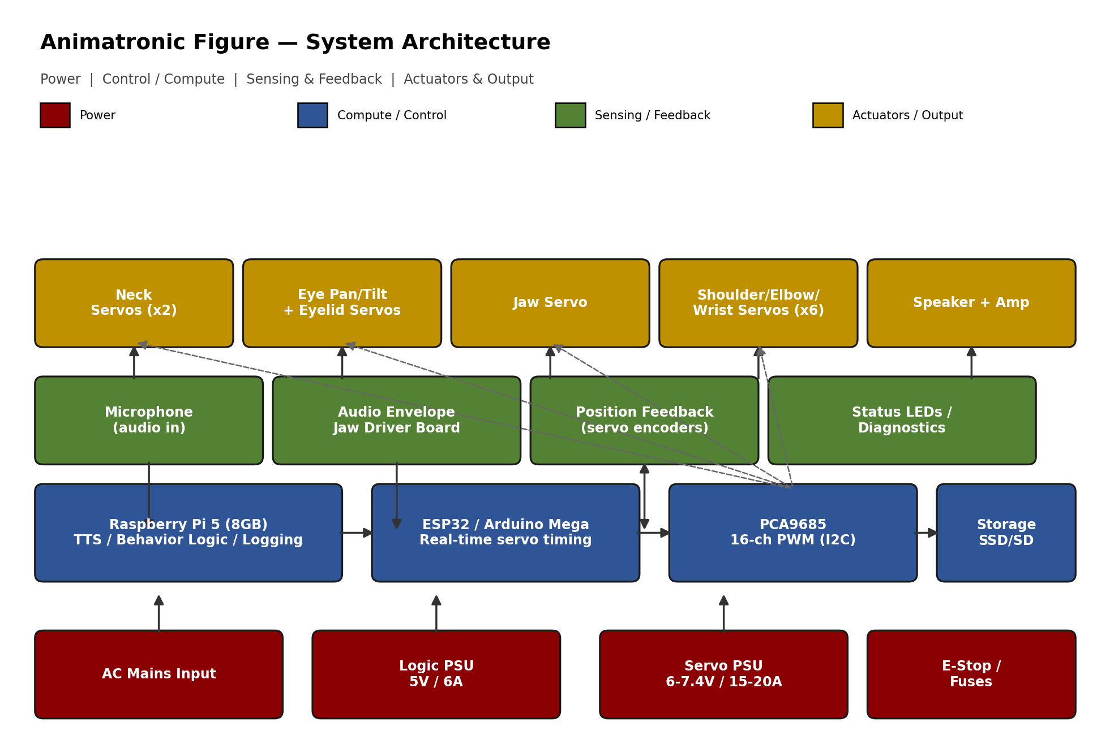

Layer Overview
The system is organized into four layers. Power flows upward; commands flow from the compute layer outward to actuators; sensor/feedback data flows back down into the compute layer.
Layer | Role | Key Components
Power | Supplies isolated logic and servo rails from mains or battery | AC-DC PSUs, fuses, E-stop
Compute / Control | Runs behavior logic, TTS, servo timing, and logging | Raspberry Pi 5, ESP32/Arduino Mega, PCA9685
Sensing / Feedback | Captures audio input and reports actuator state back to control | Microphone, jaw driver board, servo position feedback
Actuators / Output | Produces physical motion and sound | Neck/eye/jaw/arm servos, speaker + amp

Signal & Power Paths

Power distribution
Two separate DC rails run off independent supplies sharing a common ground: a 5V/6A logic rail for the Pi and low-current boards, and a 6-7.4V/15-20A servo rail sized to the total stall-current draw of all servos if they moved simultaneously. Fusing sits on both rails; the E-stop cuts the servo rail first since that's where a fault is most likely to cause damage or injury.

Control path
The Raspberry Pi 5 is the high-level brain: it runs the text-to-speech engine, decides what the figure should do next (a simple state machine or scripted timeline), and writes to the on-board log. It hands off real-time-sensitive work — precise servo pulse timing — to an ESP32 or Arduino Mega over serial, which in turn drives a PCA9685 PWM board over I2C. This separation matters because the Pi's OS is not a real-time OS; if it stutters (e.g. during a Wi-Fi hiccup or log write), you don't want that stutter to visibly glitch a servo.

Sensing / feedback path
Audio in from a microphone can be used to trigger canned responses if you want interactivity. The jaw driver board taps the outgoing audio signal (not the mic) to move the jaw in real time from amplitude — this is a one-way tap, not a closed loop. If you use position-feedback-capable servos (e.g. Dynamixel), their reported position feeds back into the ESP32/Mega for basic fault detection (stalled joint, unexpected load).

Actuator groups
Actuators are grouped by function on the diagram: neck (2 servos), eyes (pan/tilt + eyelids), jaw (1 servo), arms (shoulder/elbow/wrist, 6 servos total), and the speaker/amp for voice output. All servo channels route through the PCA9685; the speaker is driven directly by the amp board off the Pi's audio output.

Design Notes
- Keep the servo rail and logic rail grounds common but current paths separate — this is the single biggest source of noise/reset issues in animatronic builds.
- Route the PCA9685-to-servo wiring with connectors at each joint so limbs can be unplugged for shell maintenance without re-soldering.
- Leave a spare I2C address and a few spare PWM channels on the PCA9685 for future additions (extra facial servos, sensors).
This diagram is a functional/schematic view, not a wiring diagram — pin-level wiring should be worked out per component using its datasheet (see the Component Datasheets document).

