Mechanical CAD Models
Blueprints and modeling plan for the chassis, joints, and body panels — Height: 5'7" (170cm)
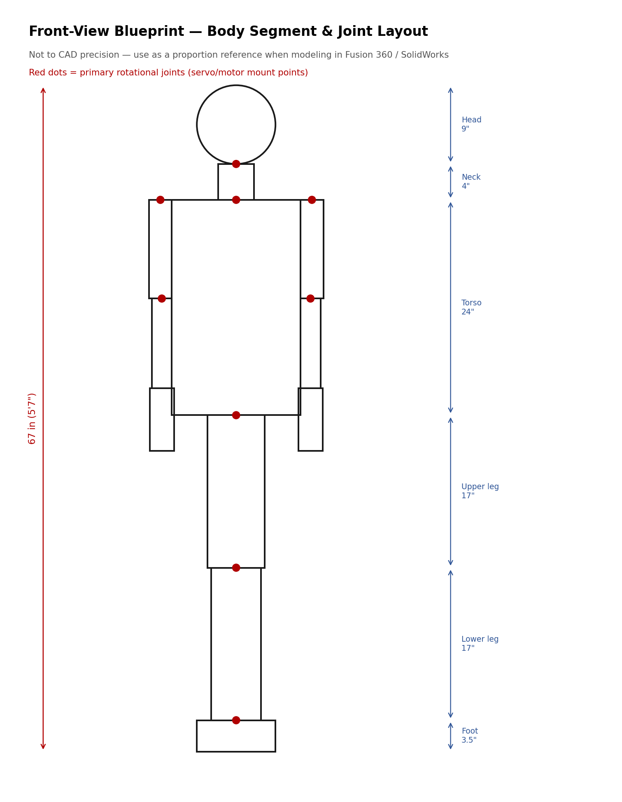

How to Use This Document
The sketch above is a proportion reference, not a CAD export — use it to block out body segment lengths before modeling. Actual CAD models should be built in parametric software (Fusion 360, SolidWorks, or FreeCAD) so joint spacing and mounting-hole positions can be adjusted without re-drawing everything.

Segment Dimensions (5'7" figure)
Segment | Length | Notes
Head (crown to chin) | 9 in | Modeled from 3D scan or sculpt; hollow for eye/jaw mechanism
Neck | 4 in | Houses 2-axis neck gimbal
Torso (shoulder to hip) | 24 in | Main electronics bay — Pi, PCA9685, amp, PSU mounts
Upper arm | 11 in | Shoulder pitch + roll servo mounts at top
Forearm | 10 in | Elbow servo at top, wrist servo at bottom
Hand | 7 in | Optional per-finger actuation
Upper leg | 17 in | Structural only unless leg motion is in scope
Lower leg | 17 in | Structural only unless leg motion is in scope
Foot | 3.5 in | Bolts to base/stand plate

Modeling Plan, By Assembly

1. Skeleton / frame
- Model the T-slot extrusion spine and limb tubes as a weldment/frame assembly first — this is the reference geometry everything else attaches to.
- Place joint bearing bores and bracket mounting holes as parametric features so you can move a joint's pivot point without rebuilding the part.

2. Shell panels
- Design shell panels as separate bodies offset ~3-5mm outward from the skeleton, split at natural seams (shoulder, elbow, waist) for printability and access.
- Add quarter-turn or magnetic latch bosses at seams — model these in from the start rather than retrofitting.

3. Head assembly
- Model the skull as a shell with internal bosses for: jaw hinge pivot, eye yoke mount, neck gimbal top plate, and speaker cavity.
- Leave a removable rear panel (occipital) for wiring access — this is the single most-opened panel during bring-up.

4. Gear/servo mounts
- Use the servo manufacturer's horn and case drawings (from its datasheet) to model exact mounting bosses — bolt patterns vary between servo brands and are not interchangeable.
- For any gear-reduction stages (e.g. jaw or neck), model gear centers using the actual gear module/pitch you plan to buy, not an approximation.

File Organization
Suggested folder structure for the CAD project:
/cad
/skeleton - frame, joints, bearing mounts
/shell - torso, arm, leg, head panels
/head - jaw, eye yoke, neck gimbal detail
/hands - finger linkages, palm structure
/fixtures - servo mounts, PCB brackets, cable guides
/assemblies - top-level assemblies referencing the above
/export - STL/STEP exports for printing and BOM sourcing
Once the skeleton assembly is modeled and dimensioned, export STEP files for any purchased hardware (bearings, servos) from the manufacturer's site rather than modeling them from scratch — most servo and bearing vendors publish STEP/STL models.

