

Version: 1.0.0

Release date: 20-12-2016

Riccardo Cattaneo 873647

Fabio Chiusano 874294

PowerEnJoy, ITPD

Table of Contents

1 Introduction 3

1.1 Revision History 3

1.1.1 Version 1.0 3

1.2 Purpose and Scope 3

1.3 List of Definitions and Abbreviations 3

1.4 List of Reference Documents 4

2 Integration Strategy 5

2.1 Entry Criteria 5

2.2 Elements to be integrated 5

2.3 Integration Testing Strategy 6

2.4 Sequence of Component – Function Integration 6

2.4.1 Software Integration Sequence 6

2.4.2 Subsystem Integration Sequence 8

3 Individual Steps and Test Description 11

3.1 Tests overview 11

3.2 Main Server tests description 12

3.2.1 I1 – Integration Test 1 12

3.2.2 I2 – Integration Test 2 12

3.2.3 I3 – Integration Test 3 12

3.2.4 I4 – Integration Test 4 12

3.2.5 I5 – Integration Test 5 13

3.2.6 I6 – Integration Test 6 13

3.2.7 I7 – Integration Test 7 13

3.2.8 I8 – Integration Test 8 13

3.3 Car tests description 14

3.3.1 I9 – Integration Test 9 14

3.3.2 I10 – Integration Test 10 14

3.3.3 I11 – Integration Test 11 14

3.3.4 I12 – Integration Test 12 14

3.3.5 I13 – Integration Test 13 15

3.4 Subsystems tests description 15

3.4.1 I14 – Integration Test 14 15

3.4.2 I15 – Integration Test 15 15

3.4.3 I16 – Integration Test 16 15

3.4.4 I17 – Integration Test 17 16

3.4.5 I18 – Integration Test 18 16

3.4.6 I19 – Integration Test 19 16

4 Tools and Test Equipment Required 17

5 Program Stubs and Test Data Required 18

6 Effort Spent 19

# Introduction

## Revision History

### Version 1.0

The first release, it is published online before the deadline.

## Purpose and Scope

This Integration Test Plan Document aims at pointing out how to accomplish integration tests. Developers, testers and, in general, all the people involved in the development of the PowerEnjoy System should read this document before starting testing of the integration of components.

This document aims at explaining to the development team what to test, in which sequence, which tools are needed for testing, and which stubs/drivers/oracles need to be developed.

## List of Definitions and Abbreviations

* BL: Business Logic
* ITPD: Integration Test Plan Document
* DD: Design document;
* ER: Entity-Relationship diagram;
* RASD: Requirements Analysis and Specification Document;
* JSE: Java Serial Edition;
* JEB: Java Enterprise Bean;
* REST: REpresentantional State Transfer;
* RESTful service: REST compliant service;
* UX: User eXperience;
* JEE: Java Enterprise Edition;
* JAX-RS: Java API for RESTful web Services;
* JBOSS: JEE open source application server;
* JPA: Java Persistence API;
* Cordova: mobile cross-platform development framework;
* PhoneGap: mobile cross-platform development framework that works over Cordova;
* JSP: Java Server Pages.

## List of Reference Documents

* Specification Document: Assignments AA 2016-2017.pdf;
* RASD v1.1 Document;
* Design Document v1.0;
* Example Design Documents from previous years;

# Integration Strategy

## Entry Criteria

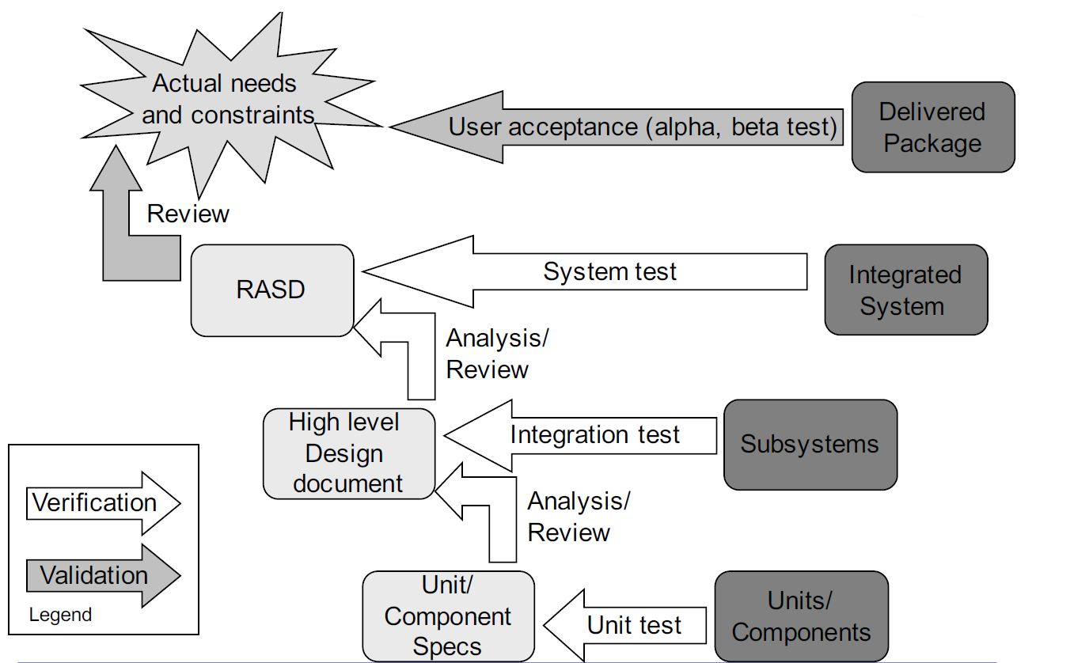

We are to design and plan the Integration Test, that aims to verify that software component work with each other and cooperate in the right and expected way.

Hence, it is supposed that each component works well individually and this can be formally proved with Unit Tests.

We assume that Low-level code is already tested, functions of every component are covered with unit tests, with mainly a white-box approach.

## Elements to be integrated

Starting from a high-level view, it is necessary to integrate and test software tiers in the main server: clients with the web tier, web tier with the business logic tier, and this one with the persistence manager and the database. It is also necessary to test interaction between external handlers and corresponding controllers.

In a more low-level view, it is necessary to integrate every controller with related ones for example the Search Controller with the Map Controller.

It is also necessary to test the interaction between controllers developed in the car software, and between cars and server.

Since the client side is light, it is only necessary to test the interaction with clients and server.

A more detailed list of components to be integrated and tested is present further in the document.

## Integration Testing Strategy

For testing, we choose the bottom-up approach. Since there is not an old system to support, the project will be built up starting from the ground up.

By choosing bottom-up approach, it is possible to test integration of components as they are ready, with no further delay. By testing in an incrementally fashion, we make it easier to track bugs. Another consequence of the fact that we use a bottom-up approach is that no stubs are needed.

## Sequence of Component – Function Integration

### Software Integration Sequence

Components have to start to be integrated starting from low-level ones.

This process brings to different higher-level and integrated sub-systems.

Every integration test in each section can be performed in parallel with the others.

We suppose that the communication with external handlers, namely between search-on-a-map handler and the Map Controller, and between Payment Handler and Payment Controller, has been already performed while testing single components.

#### Main Server Business Logic Components Integration

These are the main dependencies between software components in the main server business logic.

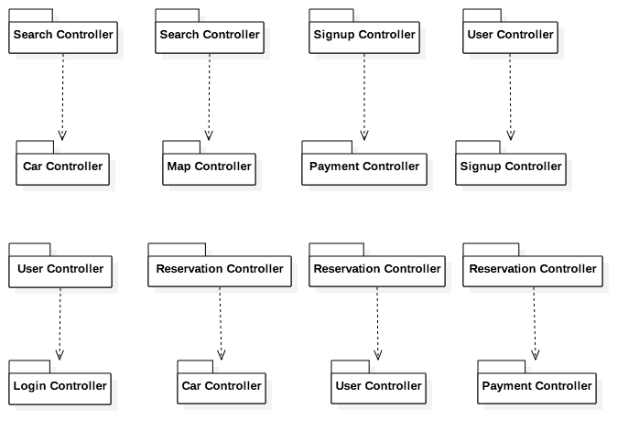

This is a possible order for the integration tests that is consistent with the dependencies previously found.

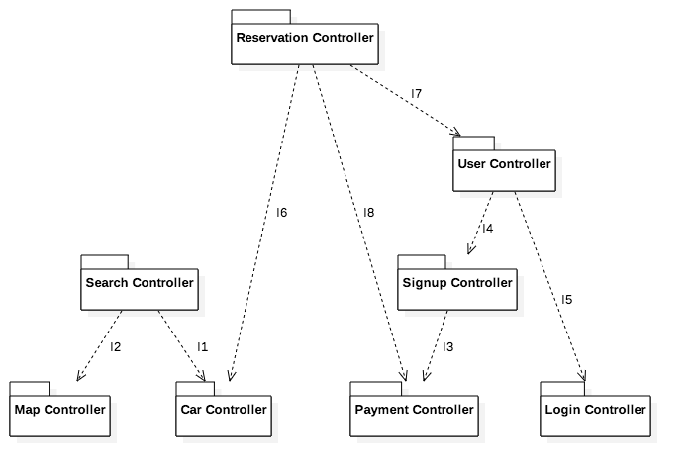

Thanks to the bottom-up approach, integration testing can be parallelized.

Some integration tests can be performed in parallel (e.g. I1 and I3), hence the order is not mandatory. They can be carried out as components are finished to be developed and unit tested.

#### Car Components Integration

Software components that run on the car software are centred on the main controller, called PEJControllerCar. These are the main dependencies.

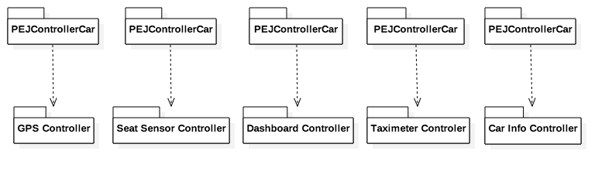

In order to test integration, the Car Controller has to be finished. When the other controllers are finished, they can be integrated and tested with the main one.

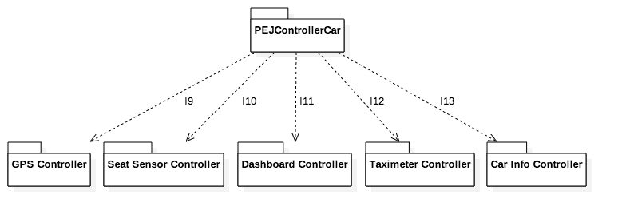

### Subsystem Integration Sequence

After having integrated and tested components in the main server and in the car, it is possible to move on higher-level software modules. It is possible to test the integration between tiers on the main server, client and server, server and database, and between car and server.

These are the main dependencies between subsystems.

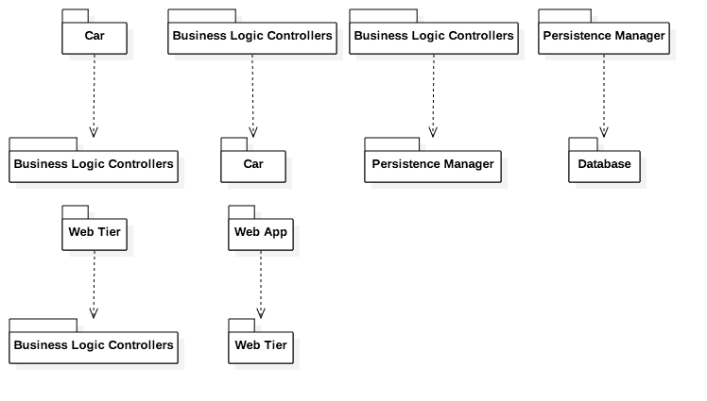

This is a possible order for the integration tests that is consistent with the dependencies previously found.

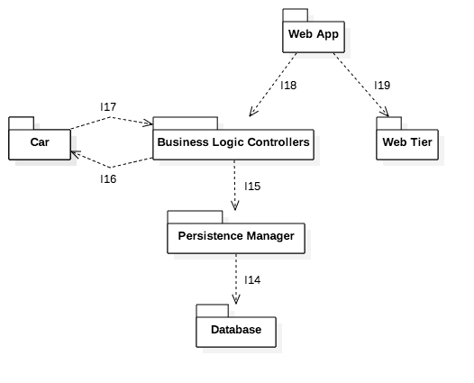

After doing this, it will be possible to move to the next phase and test the whole system.

# Individual Steps and Test Description

## Tests overview

These are the software integration tests for the main server that we propose along with the components involved.

|  |  |
| --- | --- |
| Integration test | Components involved |
| I1 | Search Controller → Car Controller |
| I2 | Search Controller → Map Controller |
| I3 | Signup Controller → Payment Controller |
| I4 | User Controller → Signup Controller |
| I5 | User Controller → Login Controller |
| I6 | Reservation Controller → Car Controller |
| I7 | Reservation Controller → User Controller |
| I8 | Reservation Controller → Payment Controller |

These are the software integration tests for the car that we propose along with the components involved.

|  |  |
| --- | --- |
| Integration test | Components involved |
| I9 | Car Controller → GPS Controller |
| I10 | Car Controller → Seat Sensor Controller |
| I11 | Car Controller → Dashboard Controller |
| I12 | Car Controller → Taximeter Controller |
| I13 | Car Controller → Car Info Controller |

These are the subsystem integration tests we propose along with the subsystems involved.

|  |  |
| --- | --- |
| Integration test | Subsystems involved |
| I14 | Persistence Manager → Database |
| I15 | Business Logic Controllers → Persistence Manager |
| I16 | Business Logic Controllers → Car |
| I17 | Car → Business Logic Controllers |
| I18 | Web Tier → Business Logic Controllers |
| I19 | Web App → Web Tier |

In the following test descriptions we will use the word “possibly” together with a stub to indicate that such stub must be developed if the related controller is not already finished and usable.

## Main Server tests description

### I1 – Integration Test 1

|  |  |
| --- | --- |
| Test Items | Search Controller SC → Car Controller CC |
| Type of Tests | • SC can retrieve correctly information of a car (position, battery level, isPluggled, status…) from CC  • SC and CC uses same address and coordinates formats  • the SC can find all and only the cars that are available in a given address within a certain range  • car status and address errors are handled correctly |
| Environmental Needs | Router Driver, possibly Map Controller Stub, Map Handler Stub |

### I2 – Integration Test 2

|  |  |
| --- | --- |
| Test Items | Search Controller SC → Map Controller MC |
| Type of Tests | • SC can retrieve correctly a map from MC  • SC and MC uses same address and coordinates formats  • the SC shows cars over the map in the right place  • map and address errors are handled correctly  • SC returns to the caller a right formatted map |
| Environmental Needs | Router Driver, possibly Car Controller Stub, Map Handler Stub |

### I3 – Integration Test 3

|  |  |
| --- | --- |
| Test Items | Signup Controller SC → Payment Controller PC |
| Type of Tests |  |
| Environmental Needs |  |

### I4 – Integration Test 4

|  |  |
| --- | --- |
| Test Items | User Controller UC → Signup Controller SC |
| Type of Tests | • SC can retrieve correctly users information from UC  • SC correctly identifies if a user is already registered to the system  • SC and UC uses same data formats  • signup errors are handled correctly |
| Environmental Needs | Router Driver |

### I5 – Integration Test 5

|  |  |
| --- | --- |
| Test Items | User Controller UC → Login Controller LC |
| Type of Tests | • LC can retrieve correctly user’s information from the UC  • LC and UC uses same data formats  • login errors are handled correctly |
| Environmental Needs | Router Driver |

### I6 – Integration Test 6

|  |  |
| --- | --- |
| Test Items | Reservation Controller RC → Car Controller CC |
| Type of Tests | • RC can retrieve correctly a car information from CC  • RC and CC uses same data formats  • RC can correctly set the car as reserved  • RC can correctly set and hide the reservation code on the reserved car  • RC and CC can correctly manage the lock and unlock of the car  • reservation and car errors are handled correctly |
| Environmental Needs | Router Driver, Car Handler stub |

### I7 – Integration Test 7

|  |  |
| --- | --- |
| Test Items | Reservation Controller RC → User Controller UC |
| Type of Tests |  |
| Environmental Needs |  |

### I8 – Integration Test 8

|  |  |
| --- | --- |
| Test Items | Reservation Controller RC → Payment Controller PC |
| Type of Tests | • RC can correctly make a payment via PC  • RC and PC uses same data formats  • PC can provide in an acceptable time the result of the payment  • payment errors are handled correctly |
| Environmental Needs | Router Driver, possibly Payment Handler Stub |

## Car tests description

### I9 – Integration Test 9

|  |  |
| --- | --- |
| Test Items | Car Controller CC → GPS Controller GC |
| Type of Tests | • CC can retrieve correctly actual location information from GC  • CC and GC uses same coordinates formats  • GC returns to the caller a right formatted coordinate  • GPS position errors are handled correctly |
| Environmental Needs | GPS System Stub |

### I10 – Integration Test 10

|  |  |
| --- | --- |
| Test Items | Car Controller CC → Seat Sensor Controller SC |
| Type of Tests | • CC can retrieve correctly seat information from SC  • CC can understand how many passengers there are inside the car  • CC and SC uses same data formats  • sensor errors are handled correctly |
| Environmental Needs | Seat Sensor System Stub |

### I11 – Integration Test 11

|  |  |
| --- | --- |
| Test Items | Car Controller CC → Dashboard Controller DC |
| Type of Tests | • CC can send and show correctly information to DC  • CC can show and hide the reservation code  • CC and DC uses same data formats  • dashboard errors are handled correctly |
| Environmental Needs | Main Server BL Driver, Dashboard System Stub |

### I12 – Integration Test 12

|  |  |
| --- | --- |
| Test Items | Car Controller CC → Taximeter Controller TC |
| Type of Tests | • CC can retrieve correctly taximeter information from TC  • CC can start and stop the taximeter  • Calculated fees are proportional to the time elapsed  • taximeter errors are handled correctly |
| Environmental Needs | Taximeter System Stub |

### I13 – Integration Test 13

|  |  |
| --- | --- |
| Test Items | Car Controller CC → Car Info Controller IC |
| Type of Tests | • CC can retrieve correctly car status information from IC  • CC can lock and unlock doors when is needed  • CC and IC use same data formats  • sensors and locking errors are handled correctly |
| Environmental Needs | Car System Stub |

## Subsystems tests description

### I14 – Integration Test 14

|  |  |
| --- | --- |
| Test Items | Persistence Manager → Database |
| Type of Tests | • SQL Queries are correctly formed and accepted by the DBMS  • Answers from the database are consistent  • The persistence manager keeps data updated and consistent with the Database  • Data errors are handled correctly |
| Environmental Needs | Possibly Business Logic Driver |

### I15 – Integration Test 15

|  |  |
| --- | --- |
| Test Items | Business Logic Controllers → Persistence Manager PM |
| Type of Tests | • Controllers can retrieve correctly persistent information through PM  • Controllers and PM have a compatible data format  • Controllers can save information correctly  • not compatible information (such as out of bound values) are managed correctly |
| Environmental Needs | Router Driver |

### I16 – Integration Test 16

|  |  |
| --- | --- |
| Test Items | Business Logic Controllers → Car |
| Type of Tests | • Controllers, located in the main server, can retrieve correctly information about the status of the car, its position, passengers on it, and others.  • Controllers and car uses same data formats  • The main server can correctly display information on the car  • The main server can understand when the ride is finished, and then perform consequent task  • the communication between server and car satisfy some performance constraints |
| Environmental Needs | Router Driver |

### I17 – Integration Test 17

|  |  |
| --- | --- |
| Test Items | Car → Business Logic Controllers |
| Type of Tests |  |
| Environmental Needs |  |

### I18 – Integration Test 18

|  |  |
| --- | --- |
| Test Items | Web Tier → Business Logic Controllers |
| Type of Tests | • All possible client request are correctly understood  • Controllers are called in the right order  • Controller answers are consistent and are correctly managed by the web tier  • Web tier answers are well formatted  • possible data error are handled correctly |
| Environmental Needs | Client Driver |

### I19 – Integration Test 19

|  |  |
| --- | --- |
| Test Items | Web App → Web Tier |
| Type of Tests | • The web tier, located on the main server, can manage all possible HTTP requests from the Web App  • The web app displays correctly the answer received  • communication protocols are correctly managed  • communication errors are handled gracefully  • HTML forms send by the server are consistent syntactically |
| Environmental Needs | User Driver |

# Tools and Test Equipment Required

The tools and test equipment needed to accomplish the integration are:

* Unit testing:
  + JUnit for Java;
  + Mockito for Java;
  + QUnit for JavaScript.
* Integration testing:
  + Mockito for Java components on the main server and on the car software;
  + Arquillian for Java components on the main server and on the car software;
  + Manual testing where other tools are not usable for some reasons (e.g. to test that the Web App subsystem correctly shows the Web Tier pages).
* Test coverage evaluation:
  + JaCoCo for Java;
  + Istanbul for JavaScript.
* Performance testing:
  + Apache JMeter.

# Program Stubs and Test Data Required

Consistently with the testing strategy and test design, we now identify any program stubs or special test data required for each integration step.

## I1 – Integration Test 1

|  |  |
| --- | --- |
| Test Items | Search Controller SC → Car Controller CC |
| Environmental Needs |  |
| Special test data |  |

|  |  |
| --- | --- |
| Test Items | Search Controller SC → Car Controller CC |
| Type of Tests | • SC can retrieve correctly information of a car (position, battery level, isPluggled, status…) from CC  • SC and CC uses same address and coordinates formats  • the SC can find all and only the cars that are available in a given address within a certain range  • car status and address errors are handled correctly |
| Environmental Needs | Router Driver, possibly Map Controller Stub, Map Handler Stub |

## I1 – Integration Test 1

Consistently with the testing strategy and test design, we now identify any program stubs or special test data required for each integration step.

## I1 – Integration Test 1

Consistently with the testing strategy and test design, we now identify any program stubs or special test data required for each integration step.

## I1 – Integration Test 1

Consistently with the testing strategy and test design, we now identify any program stubs or special test data required for each integration step.

## I1 – Integration Test 1

Consistently with the testing strategy and test design, we now identify any program stubs or special test data required for each integration step.

## I1 – Integration Test 1

Consistently with the testing strategy and test design, we now identify any program stubs or special test data required for each integration step.

## I1 – Integration Test 1

Consistently with the testing strategy and test design, we now identify any program stubs or special test data required for each integration step.

## I1 – Integration Test 1

Consistently with the testing strategy and test design, we now identify any program stubs or special test data required for each integration step.

## I1 – Integration Test 1

Consistently with the testing strategy and test design, we now identify any program stubs or special test data required for each integration step.

## I1 – Integration Test 1

Consistently with the testing strategy and test design, we now identify any program stubs or special test data required for each integration step.

## I1 – Integration Test 1

Consistently with the testing strategy and test design, we now identify any program stubs or special test data required for each integration step.

## I1 – Integration Test 1

Consistently with the testing strategy and test design, we now identify any program stubs or special test data required for each integration step.

## I1 – Integration Test 1

Consistently with the testing strategy and test design, we now identify any program stubs or special test data required for each integration step.

## I1 – Integration Test 1

Consistently with the testing strategy and test design, we now identify any program stubs or special test data required for each integration step.

## I1 – Integration Test 1

Consistently with the testing strategy and test design, we now identify any program stubs or special test data required for each integration step.

## I1 – Integration Test 1

Consistently with the testing strategy and test design, we now identify any program stubs or special test data required for each integration step.

## I1 – Integration Test 1

Consistently with the testing strategy and test design, we now identify any program stubs or special test data required for each integration step.

## I1 – Integration Test 1

Consistently with the testing strategy and test design, we now identify any program stubs or special test data required for each integration step.

## I1 – Integration Test 1

Consistently with the testing strategy and test design, we now identify any program stubs or special test data required for each integration step.

# Effort Spent