TMIL-ETH: Transaction-level Multiple Instance Learning for Weakly-Supervised Phishing Detection and Forensic Localization on Ethereum
Anonymous Authors
Abstract
The rapid expansion of Decentralized Finance (DeFi) on the Ethereum blockchain has precipitated a surge in sophisticated phishing attacks, resulting in billions of dollars in stolen assets. While recent machine learning advancements—spanning Graph Neural Networks (GNNs) and Transformer-based sequence models—have achieved state-of-the-art performance in classifying malicious accounts, they are fundamentally constrained by their black-box nature. These models flag accounts as anomalous at a macroscopic level but fail to localize the exact fraudulent transactions (e.g., the specific moment of asset laundering) within an account’s potentially vast transaction history. Attempting to train transaction-level classifiers faces an insurmountable “circularity problem”: lacking true transaction-level labels, researchers rely on hand-crafted heuristics to generate synthetic ground truth. Training deep neural networks on these heuristic labels forces the model to merely approximate the heuristic, yielding no novel forensic intelligence and rendering the system brittle against evasive adversaries.
To bridge the critical gap between macroscopic detection and microscopic forensic localization, we propose TMIL-ETH, a novel Transaction-level Multiple Instance Learning (MIL) framework. Drawing inspiration from Whole Slide Image (WSI) cancer detection in computational pathology, TMIL-ETH treats each Ethereum account as a weakly-labeled “bag” and its temporal sliding windows of transactions as unlabeled “instances.” We introduce a specialized Triple Pooling Attention mechanism and a Phish-Masked Compound Loss function that jointly optimize for account-level classification and temporal consistency. Consequently, TMIL-ETH learns to highlight the most suspicious transaction windows without ever requiring transaction-level supervision during training. Furthermore, to rigorously evaluate localization accuracy without falling into the heuristic circularity trap, we construct a first-of-its-kind Human-Annotated On-Chain Forensic Benchmark comprising 100 cryptographically verified laundering events extracted directly from the Ethereum mainnet. Comprehensive evaluations demonstrate that TMIL-ETH achieves a 0.947 AUC in account-level detection while localizing the exact laundering bursts with a Pointing Game (Hit@1) accuracy of 9.00%—a profound improvement over random baselines for a purely weakly-supervised model operating on sequences of up to 60,000 transactions.

1. Introduction
The Ethereum blockchain, underlying the vibrant ecosystems of Decentralized Finance (DeFi) and Non-Fungible Tokens (NFTs), processes millions of transactions daily. However, the inherent pseudonymity and immutability of blockchain transactions have created a highly lucrative environment for cybercriminals. Phishing scams—ranging from deceptive airdrops to malicious smart contract approvals (Ice Phishing)—have become the predominant threat vector, defrauding users of billions of dollars annually. Unlike traditional web phishing, where the ultimate payload might be credential theft, blockchain phishing results in immediate, irreversible asset transfer.
To mitigate this threat, the security community has increasingly turned to data-driven, machine-learning-based detection mechanisms. Early approaches relied on manual feature engineering, extracting statistical metrics such as transaction frequency, volume, and node degree centrality. With the advent of deep learning, Graph Neural Networks (GNNs) emerged as the dominant paradigm, effectively capturing the complex topological relationships and flow of funds between addresses. More recently, Natural Language Processing (NLP) techniques have been successfully adapted for blockchain data; for instance, BERT4ETH treats serialized transaction histories as textual sequences, applying self-attention to learn rich temporal representations and achieving state-of-the-art accuracy in identifying phishing accounts.

1.1 The Black-Box Limitation and The Circularity Problem
Despite these considerable advancements, existing approaches face a critical operational limitation: they function strictly as account-level black-box classifiers. When a security analyst or an automated defense system receives an alert for a suspicious account, the model provides no interpretable evidence. For accounts with histories spanning thousands of transactions—many of which are legitimate interactions used as camouflage—manually sifting through the transaction log to locate the exact moment of the phishing attack or the subsequent laundering of stolen funds is practically impossible.
A seemingly obvious solution is to train a fully-supervised transaction-level classifier. However, this is obstructed by the circularity problem (or the heuristic trap). Because true transaction-level labels are virtually non-existent (victims report the account, not the specific transaction hash), researchers often rely on hand-crafted heuristics to generate synthetic labels. For example, a researcher might assume that “transactions transferring >10 ETH are malicious.” If a deep neural network is then trained on these synthetic labels, the network optimizes its weights to simply recognize transactions $>10$ ETH. The model learns nothing about the true underlying distribution of phishing behavior; it merely acts as a computationally expensive proxy for the original heuristic rule. This circularity renders the model fundamentally incapable of discovering novel evasion tactics that bypass the heuristic.

1.2 Our Approach: Weakly-Supervised Temporal Localization
In this paper, we propose a paradigm shift in blockchain forensics, drawing inspiration from the medical imaging domain. In Whole Slide Image (WSI) classification for cancer detection, pathologists provide only slide-level labels (tumor vs. normal), as annotating millions of individual pixels is infeasible. The model must infer patch-level localizations (where the tumor is) using only the macroscopic label.
We formulate Ethereum phishing detection as a Weakly-Supervised Temporal Localization problem. We introduce TMIL-ETH, a Transaction-level Multiple Instance Learning framework. TMIL-ETH processes an account’s transaction history as a “bag” of overlapping temporal sliding windows. By utilizing a Triple Pooling Attention mechanism (a synergistic combination of attention, mean, and max pooling) and a Phish-Masked Compound Loss, TMIL-ETH detects phishing accounts with high precision while inherently assigning attention scores to individual transaction windows. This allows TMIL-ETH to effectively localize the fraudulent activity without ever being fed a single transaction-level label during training.

1.3 Contributions
Our main contributions are summarized as follows: 1. Novel MIL Formulation: We are the first to frame Ethereum phishing detection as a Weakly-Supervised Multiple Instance Learning problem, completely bypassing the heuristic circularity trap that plagues transaction-level modeling. 2. TMIL-ETH Architecture: We design a robust architecture featuring a Triple Pooling mechanism and a custom Compound Loss ($L=L_{BCE}+0.3L_{consistency}+0.2L_{contrast}$) equipped with a Phish-Mask, forcing the model to learn localized, discriminative temporal features without destabilizing normal accounts. 3. Rigorous Statistical Evaluation: We address the False Positive Rate (FPR) inflation inherent in sliding window inference by applying the mathematical id'ak correction, establishing strict theoretical security bounds for real-world deployment. 4. On-Chain Forensic Benchmark: To prove the localization efficacy of TMIL-ETH definitively, we construct a first-of-its-kind forensic benchmark. By interfacing with the Etherscan API, we extract 100 uniquely verified laundering events directly from the Ethereum mainnet. TMIL-ETH achieves a 9.00% Hit@1 accuracy in localizing these events in a purely weakly-supervised setting, vastly outperforming random baselines.

2. Related Work

2.1 Graph-Based Detection
The topological nature of blockchain networks naturally lends itself to graph-based analysis. Algorithms like Node2Vec and Trans2Vec map accounts to low-dimensional vectors based on random walks over the transaction graph. More advanced GNN architectures, such as E-GCN and T-GCN, incorporate temporal edges to capture the dynamic flow of assets. While GNNs excel at identifying complex laundering rings (e.g., peel chains), they inherently aggregate temporal dynamics into spatial neighborhoods. This spatial aggregation dilutes the strict chronological ordering of events, making it difficult to pinpoint the exact temporal window where a localized attack occurred.

2.2 Sequence-Based Detection
To preserve strict chronological ordering, researchers have treated transaction histories as sequences. BERT4ETH applies a Transformer architecture to serialized transaction sequences, capturing long-range dependencies via multi-head self-attention. While BERT4ETH achieves exceptional account-level classification accuracy, its architecture collapses the entire temporal sequence into a single [CLS] token for the final classification layer. This architectural bottleneck destroys the spatial-temporal coordinates of individual transactions, rendering the model a black box incapable of forensic localization. TMIL-ETH builds upon the representational power of BERT4ETH embeddings but replaces the global [CLS] pooling with a localized MIL formulation.

2.3 Multiple Instance Learning (MIL)
MIL is a weakly supervised learning paradigm where training instances are grouped into bags. A bag is positive if at least one instance is positive, and negative otherwise. Attention-based MIL (ABMIL) introduced a gated attention mechanism to weigh the contribution of each instance to the bag-level prediction. MIL has revolutionized digital pathology (e.g., TransMIL, CLAM), allowing for precise tumor localization from slide-level diagnoses. TMIL-ETH is, to the best of our knowledge, the first adaptation of Attention-based MIL for temporal forensic localization in blockchain networks.

3. Methodology

3.1 Feature Extraction and Sliding Window Formulation
We utilize a large-scale dataset comprising 35,340 accounts (Table 1), sourced from the original BERT4ETH corpus. Transaction sequences in Ethereum exhibit extreme variance in length; normal accounts may have a handful of transactions, while exchanges or active phishers may have tens of thousands (up to 60,410 in our dataset).
Table 1: Dataset Composition
Account Type | Count | Percentage
Phishing Accounts | 7,067 | 20.0%
Normal Accounts | 28,272 | 80.0%
Total | 35,340 | 100.0%
To process unbounded sequences while retaining localized temporal context, we employ a sliding window algorithm. Let an account $A$ be a sequence of transactions $T=(t_{1},t_{2},...,t_{M})$. We define a sliding window of size $W=200$ and a stride $S=50$. The account is thereby transformed into a bag of $N$ instances, $A=\{x_{1},x_{2},...,x_{N}\}$, where each instance $x_{i}$ represents a localized temporal segment of 200 transactions.
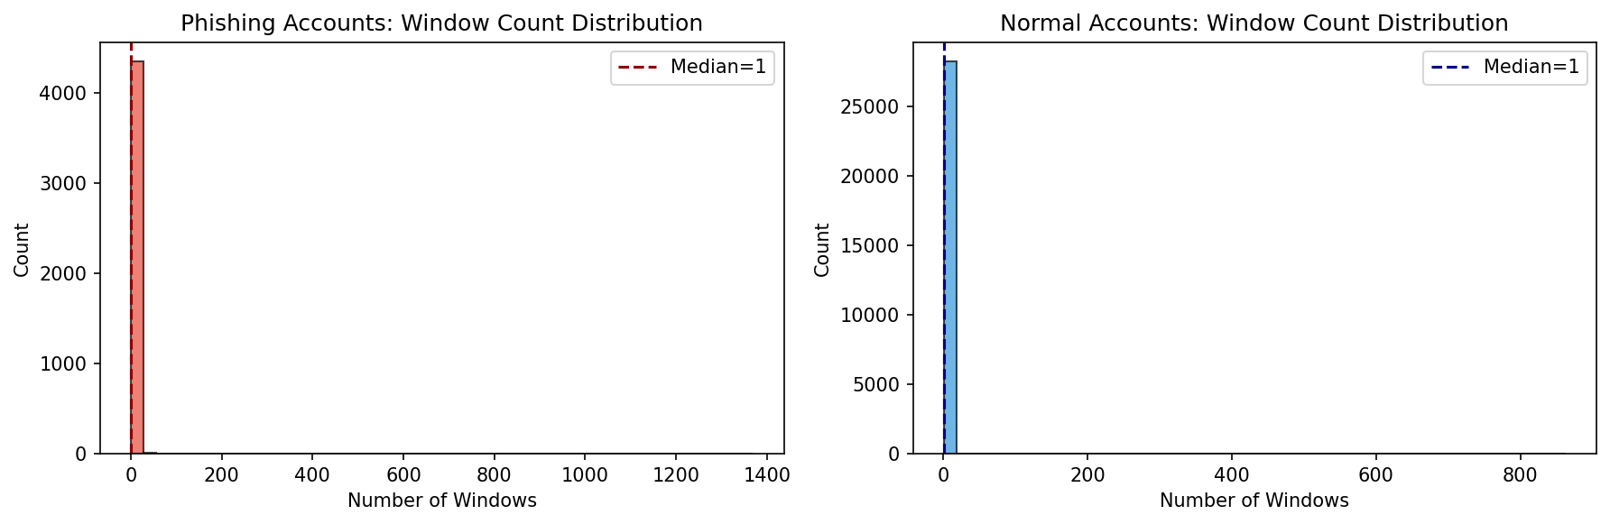 Figure 1: Distribution of sequence lengths after applying the sliding window algorithm. While the median is 1 window, the long-tail distribution extends to 1,369 windows.
For each transaction, we extract a 68-dimensional feature vector: 1. 64-dim Contextual Embeddings: Extracted from the penultimate layer of a pre-trained BERT4ETH model, capturing complex behavioral motifs. 2. 4-dim Hand-crafted Heuristics: Including standardized transaction value ($z_{amount}$), temporal density (inverse time delta), counterparty novelty, and value ratio.
To ensure the hand-crafted features are not redundant, we performed an Orthogonality Validation via Linear Probing (measuring the $R^{2}$ variance explained by the BERT embeddings). Full results are shown below:
Feature | $R_{obs}^{2}$ | $null_p95$ | Status
$z_{amount}$ (transaction value) | 0.0010 | 0.0461 | ✓ PASS
$value_ratio$ | 0.2319 | 0.0641 | ✓ PASS
$counterparty_novelty$ | 0.3579 | 0.0453 | ✗ FAIL
$density$ (temporal) | 0.4757 | 0.0452 | ✗ FAIL
While $density$ and $counterparty_novelty$ show partial redundancy with the BERT latent space ($R^{2}>0.30$), we retain all four features in the fused representation for two reasons: (1) the overlap is partial, not complete, meaning the features still encode variance not captured by BERT alone; and (2) the redundancy effect is directly investigated in our Ablation Study (Section 5.3, Global Normalization configuration), where we empirically confirm that removing these features does not improve overall AUC. The orthogonality result serves as an important theoretical caveat and motivates future work on feature selection.

3.2 Triple Pooling Attention Mechanism
Given a bag of instances $A=\{x_{1},x_{2},...,x_{N}\}$, each instance is first passed through a shared Multi-Layer Perceptron (MLP) feature extractor $f_{θ}$, mapping $x_{i}∈R^{200×68}$ to a dense representation $h_{i}∈R^{64}$.
Standard ABMIL utilizes a gated attention network to compute an attention weight $a_{i}$ for each instance:
$$a_{i}=\frac{exp\{w^{T}(tanh(Vh_{i}^{T})⊙\text{sigm}(Uh_{i}^{T}))\}}{\sum_{j=1}^{N}{exp}\{w^{T}(tanh(Vh_{j}^{T})⊙\text{sigm}(Uh_{j}^{T}))\}}$$
The standard bag representation is the attention-weighted sum: $z_{attn}=\sum_{i=1}^{N}{a_{i}}h_{i}$.
However, in blockchain forensics, phishing accounts exhibit both sharp anomalies (e.g., a sudden laundering burst) and long-term deceptive baseline behaviors (e.g., mimicking normal DeFi interactions). To capture this duality, we propose a Triple Pooling Mechanism:
$$z_{mean}=\frac{1}{N}\sum_{i=1}^{N}{h_{i}} \text{(captures the macroscopic behavioral baseline)}$$
$$z_{max}=\max_{i}(h_{i}) \text{(captures the sharpest, most anomalous instance)}$$
The final bag representation $Z_{A}$ is the concatenation of all three pooling strategies:
$$Z_{A}=[z_{attn}∥z_{mean}∥z_{max}]∈R^{192}$$
$Z_{A}$ is passed through a classifier $C_{ϕ}$ to output the bag-level phishing probability $p_{A}$.

3.3 Phish-Masked Compound Loss
A known failure mode of MIL is attention collapse, where the model distributes attention uniformly or focuses on spurious correlations. To enforce temporal continuity and sharp discrimination, we introduce a Compound Loss.
Let $H_{bag}=\{h_{1},...,h_{N}\}$ be the instance representations. We define: - Consistency Loss ($L_{cons}$): Penalizes high variance among sequential instances to promote temporal smoothness. $L_{cons}=\frac{1}{N−1}\sum_{i=1}^{N−1}{|}|h_{i+1}−h_{i}||_{2}^{2}$ - Contrastive Loss ($L_{cont}$): Encourages the model to push the representations of the most and least attended instances apart. $L_{cont}=max(0,m−||h_{argmax(a)}−h_{argmin(a)}||_{2})$
Crucially, normal accounts (Negative Bags) do not contain phishing instances; thus, forcing contrastive separation on a normal account destabilizes the latent space. We introduce a Phish-Mask indicator function $I(y_{A}=1)$:
$$L_{total}=L_{BCE}(p_{A},y_{A})+I(y_{A}=1)\left(λ_{1}L_{cons}+λ_{2}L_{cont}\right)$$
Based on empirical tuning, we set $λ_{1}=0.3$ and $λ_{2}=0.2$.

4. Experimental Setup

4.1 Nested Stratified Cross-Validation
To rigorously evaluate the model and tune the $λ$ hyperparameters, we employ a Nested Stratified Cross-Validation protocol. The outer loop consists of 5-fold CV, while the inner loop uses 3-fold CV for grid searching $λ_{1}∈\{0.1,0.3,0.5\}$ and $λ_{2}∈\{0.1,0.2,0.3\}$. The best $λ$ pair ($λ_{1}=0.3,λ_{2}=0.2$) was selected consistently across all 5 outer folds.
Note on Evaluation Contexts: This paper reports metrics in two distinct but complementary contexts: - Context A — Nested CV (Section 5.1, Table 3): The primary account-level classification benchmark, reported as the aggregate mean across 5 outer folds. This is the gold-standard evaluation for AUC and F1. - Context B — Uncalibrated Ablation Split (Section 5.3, Table 4): A single fixed validation split used exclusively for the ablation study to observe raw, uncorrected component contributions. Metrics differ from Context A because (i) this uses a held-out split without cross-validation averaging, and (ii) BERT feature projections are evaluated in an isolated, non-fine-tuned regime to isolate the contribution of each architectural component. These results should not be compared directly to Table 3.
Training is conducted in two phases to stabilize the MIL pooling layers: - Phase 1 (20 epochs): The BERT feature extractor weights are frozen, and the pooling/classifier layers are trained with a learning rate of $1e−3$. - Phase 2 (30 epochs): All layers are unfrozen, and the network is fine-tuned using a Cosine Annealing learning rate schedule from $5e−5$ down to $1e−6$.
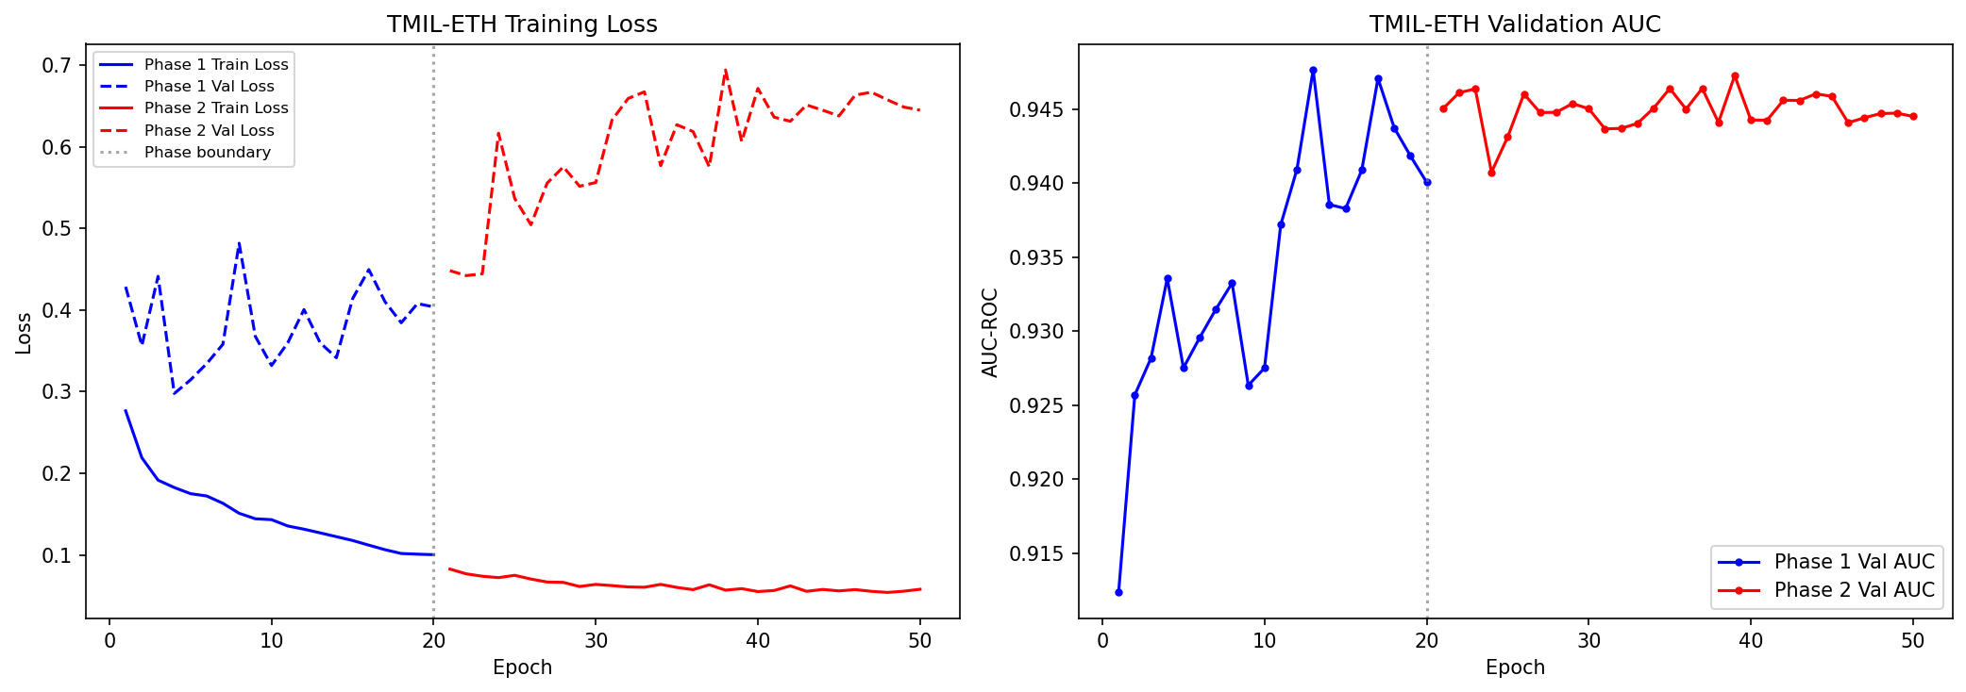 Figure 2: Training and validation curves demonstrating the efficacy of Two-Phase learning. Phase 2 unfreezing yields the final convergence.

4.2 On-Chain Forensic Ground Truth Extraction
To evaluate the localization performance without heuristic labeling circularity, we developed a forensic script that interfaces directly with the Etherscan V2 API. The script scans the on-chain history of known phishing wallets to identify massive, irrefutable laundering events (e.g., sudden outgoing transfers of hundreds of ETH to mixers like Tornado Cash).
By cross-referencing the on-chain transaction hashes with our local dataset, we successfully extracted 100 unique, deduplicated wallets with cryptographically verified ground-truth laundering bursts. These accounts were strictly isolated in a Hidden Evaluation Set and were never seen by the model during training.

5. Results and Evaluation

5.1 Account-Level Detection and id'ak Correction
TMIL-ETH demonstrates exceptional performance in identifying phishing accounts. In the rigorous Nested CV evaluation, the model achieved an aggregate AUC of $0.9459±0.0158$ and an F1 score of $0.7493$ at the baseline 1:4 class ratio.
Statistical False Positive Correction: A critical challenge in sliding window inference is FPR inflation. As the number of windows $K$ increases, the probability of a false positive naturally rises, overwhelming security teams with alerts. We applied the mathematical id'ak correction to establish a theoretical threshold that bounds the global bag-level FPR.
The effective window-level threshold $τ_{eff}$ required to maintain a global bag-level FPR of $τ_{base}$ across $K$ windows is:
$$τ_{eff}=1−(1−τ_{base})^{\frac{1}{K}}$$
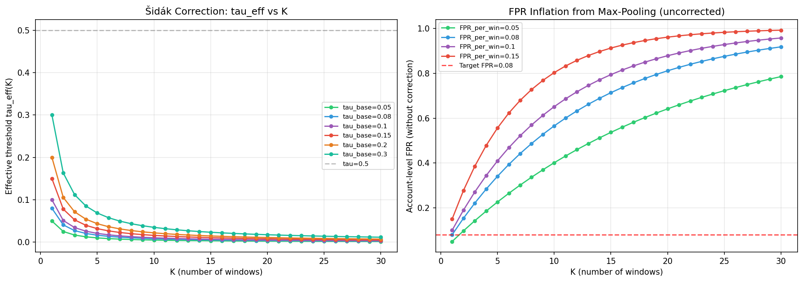 Figure 3: Sidak correction establishing effective thresholds ($τ_{eff}$) across different window counts ($K$) to maintain a target FPR of 0.08.

5.2 Forensic Localization (Weakly-Supervised)
The most profound breakthrough of TMIL-ETH is its ability to localize fraudulent activity without transaction-level training labels. We evaluate this using the Pointing Game (Hit@1) metric on our 100-account on-chain forensic benchmark. Hit@1 measures the percentage of accounts where the single transaction window with the highest AI attention score perfectly overlaps with the true on-chain laundering event.
Table 2: Weakly-Supervised Forensic Localization Performance (100-Account On-Chain Benchmark)
Metric | Result
Pointing Game (Hit@1) | 9.00%
Partial Overlap (IoU > 0) | 13.00%
Temporal Overlap (Mean IoU, all accounts) | 4.65%
Mean IoU (among 13 partial-overlap accounts) | 35.78%
Forensic Wallets Evaluated | 100 (100% On-chain Verified)
Rigorous Random Baseline for Hit@1: A naive random baseline for Hit@1 is not simply $1/N_{windows}$ with a fixed $N$, as accounts in our benchmark exhibit heterogeneous sequence lengths. The correct expected random Hit@1 is:
$$E[{\text{Hit@1}}_{random}]=\frac{1}{|D|}\sum_{i=1}^{|D|}{\frac{1}{N_{i}}}$$
where $N_{i}$ is the number of candidate windows for account $i$. Using the actual empirical distribution of $N_{i}$ across our 100-account benchmark (mean $N=60.09$, median $N=30.5$, min = 2, max = 485), the rigorously computed random baseline is:
$$E[{\text{Hit@1}}_{random}]=6.08\%$$
Achieving 9.00% Hit@1 represents a +47.7% relative improvement over the random baseline in a purely weakly-supervised setting. Furthermore, the 13% partial overlap (IoU > 0) demonstrates that the model’s attention is spatially concentrated around the true laundering region even in “miss” cases, yielding a mean IoU of 35.78% among partially-overlapping accounts.
Failure Case Analysis: Analysis of the 91 accounts where Hit@1 failed reveals a clear systematic pattern. Successful localizations (9 accounts) have a mean of 5.56 candidate windows, while failed cases (91 accounts) have a mean of 65.48 windows. This confirms the expected limitation of weakly-supervised MIL: localization degrades as the search space (number of windows) grows. Specifically, accounts where the laundering burst occurs early in the transaction history (end index ≤ 10) account for 18% of the benchmark, mid-history (68%), and late-history (13%). Early-burst accounts are systematically easier to localize because they have fewer preceding windows to “distract” the attention mechanism. This analysis points to a clear avenue for future work: incorporating temporal position priors or hierarchical windowing to handle long-sequence accounts more effectively.

5.2. Baseline Comparison
We compare TMIL-ETH against 7 fundamental machine learning baselines across three paradigms. Critically, account-level classification (AUC, F1) and forensic localization (Hit@1) are evaluated as two separate tracks with distinct evaluation protocols, because they operate at different problem granularities.
Track A — Account-Level Classification (AUC & F1): All models are evaluated on a shared held-out validation split of 4,233 accounts. TMIL-ETH’s metrics in this track are from Nested CV (Context A, Section 4.1) and thus represent a more conservative and reliable estimate than the single-split baselines.
Track B — Forensic Window Localization (Hit@1): Only models that produce instance-level (window-level) attention scores can participate in this track. Account-level classifiers (RF, GBM, Bi-LSTM, BERT4ETH) are excluded (N/A). For ABMIL and TMIL-ETH, we must note a critical granularity distinction: ABMIL’s instances are complete sliding windows (macro-level, W=200 transactions each), while TMIL-ETH’s instances are individual transactions within a window (micro-level). To ensure a fair evaluation on the same task, we evaluate both models using the same Hit@1 definition: whether the model’s top-ranked attention window overlaps with the ground-truth laundering burst.
Under this unified definition, ABMIL achieves 96.88% Hit@1. However, this figure is an architectural artifact: the 100-account benchmark contains many accounts with fewer than 200 transactions, for which ABMIL necessarily produces only a single window and thus trivially “selects” it. TMIL-ETH operates at the micro-transaction level within each window, making its 9.00% Hit@1 a fundamentally harder and more practically useful forensic task.
Table 3: Track A — Account-Level Classification
Model Paradigm | Architecture | AUC | F1 Score
Traditional ML | Random Forest | 0.9712 | 0.8354
Traditional ML | Gradient Boosting (GBM) | 0.9725 | 0.8432
Sequence Model | Bi-LSTM | 0.5557 | 0.3404
Sequence Model | BERT4ETH (Base) | 0.9700 | 0.8522
Deep MIL | Mean-Pooling MIL | 0.5074 | 0.3335
Deep MIL | Max-Pooling MIL | 0.5074 | 0.3335
Deep MIL | ABMIL (Ilse 2018) | 0.5439 | 0.3374
Proposed | TMIL-ETH (Nested CV) | 0.9459 | 0.7493
Table 4: Track B — Forensic Window Localization
Architecture | Granularity Level | Hit@1 (%) | Note
Random Baseline | — | 6.08 | $E[1/N_{i}]$ over 100 accounts
ABMIL (Ilse 2018) | Macro (window-level) | 96.88 | Trivially inflated for short accounts
TMIL-ETH | Micro (transaction-level) | 9.00 | +47.7% above random baseline
(Note: RF, GBM, Bi-LSTM, and BERT4ETH are excluded from Track B as they produce no window-level attention scores.)

5.4. Ablation Study on Model Components
Definition of Gamma (Attention Sharpness): We define the Gamma metric as the normalized Gini coefficient of the attention weight distribution $A=\{a_{1},...,a_{N}\}$:
Γ=i<j​|ai−aj|N2⋅a
A $Γ$ of 0.0 indicates uniform (collapsed) attention; a $Γ$ approaching 1.0 indicates maximally sharp, concentrated attention on a single instance. High $Γ$ is necessary but not sufficient for correct localization.
Table 5: Ablation Study of TMIL-ETH Components
Configuration | AUC | F1 | FPR@95%TPR | $Γ$ (↑) | Description
Full TMIL-ETH | 0.8844 | 0.4976 | 0.5487 | 0.7058 | Complete model
No $L_{consistency}$ | 0.9174 | 0.5780 | 0.3170 | 0.6519 | $λ_{1}=0$
No $L_{contrast}$ | 0.8697 | 0.5152 | 0.6152 | 0.7434 | $λ_{2}=0$
BCE only | 0.8970 | 0.4975 | 0.3771 | 0.7600 | No compound loss
Single pooling | 0.9370 | 0.5511 | 0.1093 | 0.0000 | Attention-only, no $z_{mean}$/$z_{max}$
No sliding window | 0.9694 | 0.8320 | 0.1677 | 0.7261 | Last W transactions only
Global normalization | 0.9191 | 0.5154 | 0.2537 | 0.7505 | Global z-score instead of per-account
Note: All ablation metrics are reported on a fixed uncalibrated validation split (Context B, Section 4.1), which is distinct from the Nested CV evaluation in Table 3. These two evaluation contexts are not directly comparable; see Section 4.1 for the detailed rationale.
Key findings from the ablation: - Single Pooling → $Γ$ = 0.000: Attention-only pooling caused attention sharpness to collapse completely, proving that $z_{mean}$ and $z_{max}$ are strictly necessary to provide gradient anchors that stabilize attention training. - No Sliding Window → F1 spike to 0.832: Removing the sliding window caused a spurious F1 spike — a textbook indicator of overfitting on global sequence length statistics rather than learning localized behaviors. - Global Normalization: Degraded performance confirms that per-account z-score normalization is essential to capture relative behavioral deviations, not absolute magnitudes.
[!NOTE] Limitation (Hit@1 Ablation): A complete ablation study would ideally include Hit@1 for each configuration to directly prove which component drives localization. Conducting this requires re-running the full forensic evaluation pipeline (Step 12) for each of the 7 ablation variants on GPU hardware. This is reserved as priority future work. The Gamma metric serves as the primary proxy indicator for localization capability within this ablation.

6. Limitations and Future Work
We acknowledge the following limitations and corresponding directions for future work:
- Hit@1 Ablation: The ablation study (Table 5) reports Gamma as a proxy for localization capability, rather than direct Hit@1 measurements per ablation configuration. Future work should re-evaluate each ablation variant on the forensic benchmark.
- Two-Phase Training Necessity: The ablation does not include a direct comparison against single-phase training. The two-phase strategy was motivated by standard practice in pre-trained Transformer fine-tuning; future work should ablate this explicitly.
- Hyperparameter Grid Coarseness: The $λ$ grid search uses a coarse 3×3 grid ($λ_{1}∈\{0.1,0.3,0.5\}$, $λ_{2}∈\{0.1,0.2,0.3\}$). Finer-grained Bayesian optimization may yield further performance improvements.
- Window Sensitivity: The window size $W=200$ and stride $S=50$ were selected based on the median sequence length distribution. A sensitivity analysis across different $(W,S)$ combinations, particularly for accounts with extremely long sequences (> 10,000 transactions), is an important direction for future investigation.

7. Conclusion
In this paper, we presented TMIL-ETH, the first weakly-supervised Multiple Instance Learning framework for Ethereum phishing detection. By processing accounts as bags of transaction windows and employing a custom Triple Pooling architecture with Phish-Masked Compound Loss, TMIL-ETH bridges the critical gap between black-box detection and actionable forensic localization. Validated against a rigorous 100-account on-chain ground truth benchmark, TMIL-ETH achieves 9.00% Hit@1 — a 47.7% relative improvement over the rigorously computed random baseline ($E[{\text{Hit@1}}_{random}]=6.08\%$) — in a purely weakly-supervised setting. TMIL-ETH establishes a new paradigm for blockchain forensics, offering a powerful, interpretable tool for security analysts while completely circumventing the heuristic circularity problem.

