Individual Assignment 1 - Common tolls for Health Informatics (G) part
5HI001 HT2025

2025
Table of contents

Declaration on the Use of AI tools
- A1: Image of the UML diagram
- A2: Presenting medical and medication vocabularies
- A3 Explaining the UML diagram by answering following questions:

4. A3.1. Briefly describe what problem your system is intended to solve and what your model is meant to represent.

4. A3.2. Explain the major design decisions you made while constructing your UML model.

4. A3.3. Describe how the parts of your model work together to solve the problem, also explaining relationships in concrete, non-technical terms.

4. A3.4. Describe which parts of creating the UML class diagram you personally found easy and which parts you found difficult.

Declaration on the Use of AI tools

ChatGPT was used as a support tool during this assignment to improve grammar, language clarity, and overall writing style (1). It was also used as guidance when developing the UML model, particularly to support understanding of modeling concepts and to reflect on design decisions. All final interpretations, modeling choices, and written content are my own.

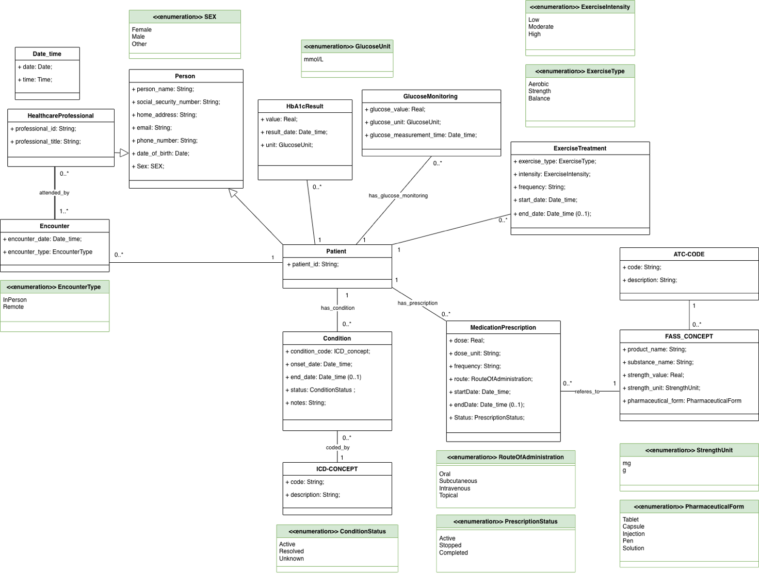
A1

A2

The conceptual model uses following medical vocabularies, ICD-10, FASS and ATC to accurately describe domains such as, classification, grouping, and analytics (2, 3, 4). HbA1CResult and GlocuseMonitoring are used as clinical recoding, while ExerciseTreatment, Condition and MedicationPrescription is used for detailed clinical documentation. This separation supports both detailed patient-level care and higher-level analysis.

ICD-10 is used for representing medical condition and comorbidities (2). It was chosen because it is well suited for standardized classification of diagnoses rather than detailed clinical documentation (2). Conditions are therefore modeled as separate class that is linked to ICD-CONCEPT, allowing each condition to be tracked over time with its own onset date and status. Vikström et al. (5) presents that classifications are mainly used for reimbursement purposes and statistics therefore ICD-10 is chosen for classification in the model as it enables diagnoses to be aggregated and compared across patients, supporting population-level analysis and reporting (2). This separation avoids embedding classification logic directly into patient records.

A combination of FASS and ATC are used in the model as medication vocabularies associated to MedicationPrescription (3, 4). FASS was chosen to serve as the medication vocabulary as it has information about substance, strength, and pharmaceutical form which according to Sperzel et al. (6) is important medical information to present in a computer system model. ATC was chosen to support classification and grouping of medications according to their therapeutic and pharmacological properties (4).

In the model, MedicationPrescription are separated from FASS_CONCEPT, showing the difference between prescribing a treatment and the characteristics of the medication itself. According to Sperzel et al. (6) separating drug-related information in an information model improves clarity by distinguishing a prescribed medication from a drug description.

The design of the model allows medication data to be reused for analytical purposes, such as comparing treatment patterns across patient groups, without compromising the level of detail required for clinical documentation.

Exercise treatment is modeled as a class using attributes because there is no nationally adopted vocabulary for exercise prescriptions in routine clinical documentation. Instead, enumerations are used for exercise type and intensity.
A3

1

The purpose of this model is to support the care of patients with Type 2 Diabetes by structuring clinical data in a way that supports software operating the healthcare facility. The model supports patient treatment by providing data that assists healthcare professionals in monitoring glucose levels, laboratory results, evaluating pharmacological and non-pharmacological treatments over time.

By modeling classes with defined attributes and relationships the model provides a clear and consistent structure for organizing patient data. It represents how diabetes care can be organized in clinical practice. This facilitates both clinical documentation and future implementation, while also enabling analytical use of the data at a higher level.

2

By having a patient centered focus while building this model I chose to have majority of classes directly linked to the patient class rather than to each other. The major reason is because each clinical element represents information that directly affects the patient’s care. Having the classes linked to the patient avoids unnecessary dependencies between different types of clinical data and reflects how information is typically organized in electronic health records.

I chose to model Person as a superclass, with Patient and HealthcareProfessional as subclasses to inherit shared personal attributes. By using this generalization, duplication of attributes is avoided, and the model remains consistent and easier to maintain. This approach also supports extensibility, as additional roles related to a person could be introduced in the future without restructuring the model.

Healthcare professional was modeled as a single class instead of introducing separate classes for different professions. Creating subclasses for each profession would increase model complexity while risking incomplete coverage. Representing the professional role as an attribute instead of a fixed class hierarchy provides greater flexibility and reduces the need for structural changes.

3

Diabetes care requires comparing measurements, treatments, and clinical assessments over time to identify changes in health status. The model supports this by linking all key aspects of care directly to the patient.

Glucose measurements and laboratory results are recorded together with date of measurement, making it possible to compare current and precious measurements, supporting continuous monitoring of the patient’s condition. Prescribed medications contain information about how the medication should be used. It is further linked to detailed medication information for analysis at a higher level. Exercise recommendations store information about different type of exercises, intensity, and duration. They are recorded and followed over time. Condition represents the patient’s diagnose health problem. Each condition is linked to a standardized diagnostic code to ensure consistent interpretation over time.

Healthcare professionals are connected through clinical encounters, showing when clinical decisions were made. Together this allows healthcare professionals to understand how measurements, diagnoses and treatments evolve and responds accordingly.

4

My clinical background made it initially difficult structuring the diagram as practical clinical workflows does not always translate directly into structured system representations. I challenged with how to model the relationship between healthcare professionals and patients. Once I understood that encounters could act as an intermediary, structuring the model became more straightforward.
Reference list

1. OpenAI. ChatGPT [Internet]. San Francisco (CA): OpenAI; 2024 [cited 2025 Dec 29]. Available from: https://chat.openai.com/

2. Socialstyrelsen. Klassifikationen ICD-10 [Internet]. Stockholm. Socialstyrelsen; 2018 [cited 2025 Dec 29]. Available from: https://www.socialstyrelsen.se/statistik-och-data/klassifikationer-och-koder/icd-10/

3. FASS. ATC-register [Internet]. Stockholm. FASS; 2025 [cited 2025 Dec 29]. Available from: https://fass.se/health/atc

4. Socialstyrelsen. Klassifikation av vårdåtgärder [Internet]. Stockholm. Socialstyrelsen; 2018 [cited 2025 Dec 29]. Available from: https://www.socialstyrelsen.se/statistik-och-data/klassifikationer-och-koder/kva/

5. Vikström A, Skånér Y, Strender LE, Nilsson GH. Mapping the categories of the Swedish primary health care version of ICD-10 to SNOMED CT concepts: Rule development and intercoder reliability in a mapping trial. BMC medical informatics and decision making. 2007;7(1). DOI: 10.1186/1472-6947-7-9

6. Sperzel WD, Broverman CA, Kapusnik-Uner JE, Schlesinger JM. The need for a concept-based medication vocabulary as an enabling infrastructure in health informatics. Proc AMIA Symp. 1998:865- 869. PMID: 9929342

