

Written Exam

User Needs, Requirements Engineering and Evaluation (10 hp) 5HI019

Q1

a) Personas are fictional representations of user groups, created to support user-centered design [2]. They are used to communicate users’ characteristics, goals, and needs [2]. A persona touches aspects such as users’ motivations, challenges, and constraints. A concrete profile helps the design team stay focused on real user contexts throughout the development process [2].

In Appendix 1 [1], the intended users are nurses, midwives, and midwife assistants working in geographically isolated healthcare centers in Sub-Saharan Africa. They have between one and three years of training, no physicians are available on site, and complicated cases must be referred to hospitals that are located two hours away. As a result, these healthcare professionals carry considerable responsibility in resource-limited settings [1].

These conditions shape the purpose of personas. The personas must reflect limited access to specialist support, reliance on clinical guidelines, and the need for decision support when managing high-risk maternal situations. Creating these personas will help ensure that the Clinical Decision Support System (CDSS) is designed to provide clear guidance, improve timely referrals, and support safe clinical decision-making.

Describe how you would design personas for this project

1. Collect user data
First, collect and review relevant information about the users, including their professional roles (nurses, midwives, and midwife assistants) and their level of experience (1to 3 years) [2]. It is also important to understand their responsibility for managing deliveries without physicians on site, their need to refer complicated cases to hospitals located up to two hours away, and how they interact with CDSS features such as assessment checklists and referral functions.

2. Analyze and identify patterns
Next, analyze the collected material to identify behavioral and work-related patterns [2]. Users would be grouped based on similarities in responsibilities, decision-making autonomy, and working conditions, while also noting differences in clinical responsibility.

3. Define personas based on behavioral patterns
Each identified behavioral pattern would form the basis of a persona. Common characteristics such as goals, challenges, workflow, and level of digital familiarity would be synthesized into representative user types [2].

4. Describe and refine persona profiles
Finally, develop detailed persona profiles. Each persona would include a background description, clinical experience level, typical tasks, goals, motivations, needs, and practical constraints to ensure that they realistically reflect the working realities.

A benefit of using personas in this context is that they help developers better understand who the system is being designed for [3]. Since nurses, midwives and midwife assistants have limited experience and often work independently without physicians on site, the system needs to match their level of experience. By reflecting their responsibilities and everyday challenges, personas can help the developers ensure that the decision support is clear, practical and not too complex, especially in situations where quick clinical decisions are required.

A limitation of using personas in this context is that they may oversimplify the diversity of real working conditions across different healthcare centers [4]. Even if users share similar professional roles, their technical skills, workload, and local resources may vary. If the personas are too general, they may not fully reflect these differences, which could result in a system that does not fit all settings equally well [4].

Stakeholders and End Users

First direct stakeholders: Healthcare professionals, specifically nurses, midwives, and midwife assistants working in rural primary healthcare centers. These individuals use the CDSS as a daily tool to support clinical assessments during maternal and perinatal care, helping them follow protocols, recognize complications, and make informed referral decisions. Because the system directly influences their clinical judgment and daily workflows, these professionals are direct stakeholders whose core responsibilities are closely tied to the system’s functionality.

Second direct stakeholder: Pregnant women receiving maternity care. These individuals interact with the system by completing an online form regarding their pregnancy history prior to their clinical appointments. They are considered direct stakeholders because the information they provide is integrated into the clinical assessment and directly influences the care they receive. Ultimately, the decisions supported by the system determine whether these women are monitored locally or referred to a hospital for further treatment, making the system a key factor in their health outcomes.

First indirect stakeholders: Healthcare professionals at referral hospitals, who receive electronic referrals through their electronic health record systems. These professionals are affected by the system because the referral decisions generated by the CDSS directly influence their patient intake and care.

Second indirect stakeholder: Health authorities, who are responsible for the quality of maternal healthcare and ensuring adherence to clinical guidelines. As the CDSS is built on these guidelines and implemented within public healthcare centers, these authorities are indirectly impacted by how effectively the system supports safe and standardized maternity care.

End Users

In the early requirements stage, nurses, midwives and midwifes assistants could be involved through interviews and small workshops where they describe and show their daily routines and challenges in managing deliveries. This involvement is important to understand the user’s actual workflow, decision-making responsibility, and referral processes before designing the system so it can mitigate their problems [5].

During the design stage, end-users could be involved by reviewing prototypes or mock-ups of the CDSS [2]. They could be asked to walk through common maternity scenarios and comment on whether the system fits their way of working. This is important because it allows design issues to be identified early and ensures that the structure of the system aligns with their clinical practice [5].

In the testing stage, healthcare professionals could participate in usability testing by performing simulated tasks, such as registering a patient or initiating a referral. Observing how they interact with the system would help identify usability problems. This involvement is important to ensure that the system is clear and easy to use [5].

During implementation, end-users could be involved through training sessions and feedback meetings. This is important to support adoption of the system and to identify practical challenges that may not have appeared during testing [5].

One potential challenge when involving end-users is that healthcare professionals may feel hesitant to provide critical feedback, especially if the system is introduced by health authorities. This could result in unaddressed usability problems. To address this risk, the users will be provided with anonymous online questionaries, including a free text bar where they can openly write their honest opinions [6].

Q2

Important use case 1: Perform maternal assessment
Actor: Health care professional
The healthcare professional performs a structured maternal assessment using the CDSS to evaluate the patient’s condition and identify potential risks. The outcome of the use case is a completed assessment that supports clinical decision-making.

Important use case 2: Fill in online form
Actor: Pregnant women
The pregnant women fill in an online form before meeting to provide relevant information about her current pregnancy and medical history. The outcome of the use case is a completed form that supplies the healthcare professional with structured background information for the upcoming assessment.
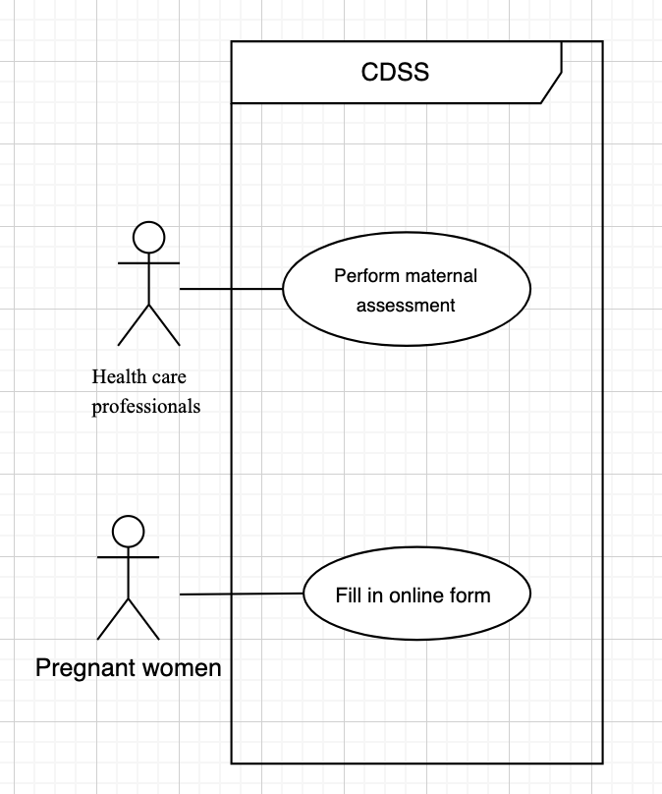

Table 1: Use Case Model

Normal Flow
1. The healthcare professional initiates a new maternal assessment in the CDSS.
2. The system displays a structured assessment interface with checklist items based on clinical guidelines.
3. The healthcare professional enters the required patient information.
4. The system provides guidance, such as highlighting risk factors or suggesting appropriate next steps.
5. The healthcare professional reviews the recommendations and completes the assessment.
6. The system stores the completed assessment in the patient's record.

Use case ends

Alternative Flow A1 - Branch from step 3
A1.1 During the assessment, the healthcare professional is interrupted by a clinical situation.
A1.2 The healthcare professional leaves the assessment before completion.
A1.3 The system automatically saves the entered data.
A1.4 When the healthcare professional returns, the system allows them to resume the assessment without losing previously entered information.

Return to step 4 of the normal flow.

b)
Requirement 1: The system shall display a structured maternal and perinatal assessment checklist when a healthcare professional starts a new assessment

Clarity: This requirement is clear because it specifies what the system must display and when.
Testability: It is testable by initiating an assessment and verifying that the checklist appears.
Feasibility: It is feasible since electronic checklists are technically implementable.
Traceability: It is traceable to the use case “Perform maternal assessment.”

Requirement 2: The system shall allow the patient to complete and submit an online pre-consultation form containing relevant pregnancy and medical history information before the clinical visit.

Clarity: This requirement is clear because it specifies what the system shall enable, what the form contains, and when it is used.
Testability: It is testable by verifying that a patient can complete all required fields and successfully submit the form prior to the consultation.
Feasibility: It is feasible since online forms and secure data submission are standard digital functionalities.
Traceability: It is traceable to the use case “Fill in online form,” as it directly reflects the actor’s goal and the expected system functionality.

If the requirement were written vaguely, for example “The system should support maternal assessment,” it could easily be interpreted in different ways. Developers might assume that simple data entry fields are sufficient, rather than providing a structured checklist based on clinical guidelines. This could lead to assessments being performed inconsistently and reduce the value of the decision support [7].
Q3

Key issue 1: Improved detection of complications
Motivation: It is important to evaluate whether the system improves detection of complications because healthcare professionals in these rural healthcare centers have limited formal training and work without physicians on site. Since the CDSS second approach is based on an algorithm-based decision support intended to flag high-risk situations, it is essential to assess whether the algorithm functions support accurate and timely identification of complications in real clinical practice.

Evaluation method:
Clinical analytics combined with hospital validation feedback [2].

How does the method work: Clinical records from maternity consultations are reviewed for a defined period before and after implementation of the CDSS. After implementation, system log data are collected and the evaluation measures:
- The time between patient assessment and complication detection.
- The number of correctly detected high-risk cases.
In addition, hospital clinicians who receive referred patients provide feedback on whether the referral was clinically appropriate or not.

Why it fits this issue:
The CDSS includes an algorithm intended to identify high-risk maternal conditions in settings without physicians on site. Since referral hospitals ultimately assess the patient’s condition, they can confirm whether the detection was clinically justified. Combining system analytics with hospital feedback allows evaluation of both detection speed and detection accuracy.

What evidence it would provide:
This data would show whether the system makes appropriate detections and how quickly complications are identified. By comparing results before and after implementation, it would be possible to see if detection happens earlier. It would also indicate whether high-risk cases are correctly identified, demonstrating the reliability of the algorithm.

Key issue 2: Reduced delays in referral
Motivation: It is important to evaluate whether the system reduces delays in referrals. Rural healthcare centers cannot provide full emergency obstetric care, and referral hospitals are located up to two hours away. In urgent maternal situations, delays can have serious consequences. Because the CDSS allows healthcare professionals to generate and send electronic referral summaries to the receiving hospital, it is relevant to assess whether this function improves coordination and shortens the time between identifying a complication and initiating hospital care.

Evaluation method:
Clinical analytics using time-stamp analysis [2].

How the method works:
System log data are collected over a period of time after implementation. The timestamps from the CDSS are used to measure:
- The time between detection of a complication and submission of the referral.
- The total time from initial assessment to referral initiation.

These time intervals can be compared to clinical data captured before implementation.

Why it fits this issue:
To evaluate whether the CDSS reduces referral delays, system log data can be analyzed to compare timestamps before and after implementation. Specifically, the time between initial patient assessment, detection of a complication, and submission of the electronic referral can be measured. By comparing these time intervals pre- and post-implementation, it becomes possible to determine whether the system shortens the referral process.

What evidence it would provide:
This method would provide quantitative data on referral timing, such as average time from complication detection to referral submission. This would indicate whether the CDSS improves coordination and supports faster clinical decision-making in time-critical situations.

References
1, Zakane S. The use of computerised clinical decision support system in maternal and neonatal care in rural Africa: enthusiasm and concerns [Internet]. Stockholm: Karolinska Institutet; 2017 [cited 2026 Feb 25]. Available from: https://hdl.handle.net/10616/46114
2. Rogers Y, Sharp H, Preece J. Interaction design: beyond human-computer interaction. 6th ed. Hoboken (NJ): Wiley; 2023.
3. Cooper A, Reimann R, Cronin D. About face: the essentials of interaction design. 4th ed. Indianapolis (IN): Wiley; 2014.
4. Dominello A, Cheek C, Clay-Williams R. The use of personas to involve consumers in healthcare co-design: a scoping review. BMC Health Serv Res. 2025;25:649. doi:10.1186/s12913-025-12786-7.
5. International Organization for Standardization. Ergonomics of human-system interaction – Part 210: human-centered design for interactive systems (ISO 9241-210:2019). Geneva: ISO; 2019.
6. Koo M, Yang SW. Questionnaire use and development in health research. Encyclopedia. 2025;5(2):65.
7. Wiegers KA, Beatty RJ. Software requirements. 3rd ed. Redmond (WA): Microsoft Press; 2013.

