**第六周任务**

熟练Tuple、Dict、Str、Set的使用

1. 给定一个列表，含有若干个数字，这些数字可能有重复的。请设计一个函数能够删除列表中的重复数字，并且降序输出剩下的不重复数字。例如，一个数组 a = [3, 2, 1, 4, 2, 3, 5]，输出结果，[5, 4, 3, 2, 1]

Hint: set()? list()?

1. Write a function that accepts a list of strings as input and prints the lines after making all characters in the sentence capitalized.

Suppose the following list of strings is supplied to the program:

Hello world

Practice makes perfect

Then, the return should be:

HELLO WORLD

PRACTICE MAKES PERFECT

1. Given two sorted list a, b, merge them into a new sorted list c.

def merge(a, b): # return c

Example: [1, 2, 3], [-1, 2, 4] return [-1, 1, 2, 2, 3, 4]

(这个题有标准的复杂做法，不过这里实现出函数功能即可，不用考虑复杂做法。）

1. Write a Python program to count the number of even and odd numbers from a series of numbers.
2. Write a Python function to check the validity of password input by users.

Validation :

1. At least 1 letter between [a-z] and 1 letter between [A-Z].
2. At least 1 number between [0-9].
3. At least 1 character from [$#@].
4. Minimum length 6 characters.
5. Maximum length 16 characters.

def is_valid(input->str): # return True or False

1. Write a Python function to check whether an alphabet is a vowel or consonant.
2. Write a Python function to convert month name to a number of days.
3. Write a Python function to check a string represent an integer or not.
4. Write a Python function that accepts two integers representing a month and day and prints the season for that month and day.
5. Write a Python function to display the sign of the Chinese Zodiac for given year in which you were born.
6. Write a Python function to get next day of a given date.

Input a year: 2016

Input a month [1-12]: 08

Input a day [1-31]: 23

The next date is [yyyy-mm-dd] 2016-8-24

1. For the following speech, please write a program to
2. Remove all unnecessary “--” “.” “,”
3. Transform all the words into lowercase
4. Count the words appeared in the speech
5. Count the letters appeared in the speech

Four score and seven years ago our fathers brought forth on this continent, a new nation, conceived in Liberty, and dedicated to the proposition that all men are created equal.

Now we are engaged in a great civil war, testing whether that nation, or any nation so conceived and so dedicated, can long endure. We are met on a great battle-field of that war. We have come to dedicate a portion of that field, as a final resting place for those who here gave their lives that that nation might live. It is altogether fitting and proper that we should do this.

But, in a larger sense, we can not dedicate -- we can not consecrate -- we can not hallow -- this ground. The brave men, living and dead, who struggled here, have consecrated it, far above our poor power to add or detract. The world will little note, nor long remember what we say here, but it can never forget what they did here. It is for us the living, rather, to be dedicated here to the unfinished work which they who fought here have thus far so nobly advanced. It is rather for us to be here dedicated to the great task remaining before us -- that from these honored dead we take increased devotion to that cause for which they gave the last full measure of devotion -- that we here highly resolve that these dead shall not have died in vain -- that this nation, under God, shall have a new birth of freedom -- and that government of the people, by the people, for the people, shall not perish from the earth.

Abraham Lincoln

November 19, 1863

## Linux学习

目前为止， 我们学习了初步的Linux使用命令， 可以进行一些Linux的Python程序开发， 譬如采用Python3 + Nano + shell的配置。200行以内的程序，用nano足够。

现在Linux环境已经成了软件开发事实上的标准。虽然大家采用的开发电脑配置不一，平台也丰富多彩，但大家常用的开发模式是一致的，即从本地远程登录到服务器上面运行程序。

首先我们解释几个术语：

本地(local)—就是你手上使用的电脑。

服务器—物理上布置上某个地方的计算设备，可能在你现在的房间，或者在贵州某个大山山洞里面（这不是笑话，贵州山多水电丰富，很适合放置服务器，譬如大名鼎鼎的贵州国家大数据工程实验室）。我们不能物理接触服务器，或者物理接触服务器太麻烦。访问服务器一般是通过网络IP访问。

网络IP—可以理解为我们的手机号码。通过IP，我们可以和任何人进行通信。我们安装的虚拟机也是一台服务器，虽然我们过去都是直接登录虚拟机进行操作，但是虚拟机具备服务器的一切技术特点，具有独立的IP，可以远程访问。

ifconfig：查看计算机的网络配置

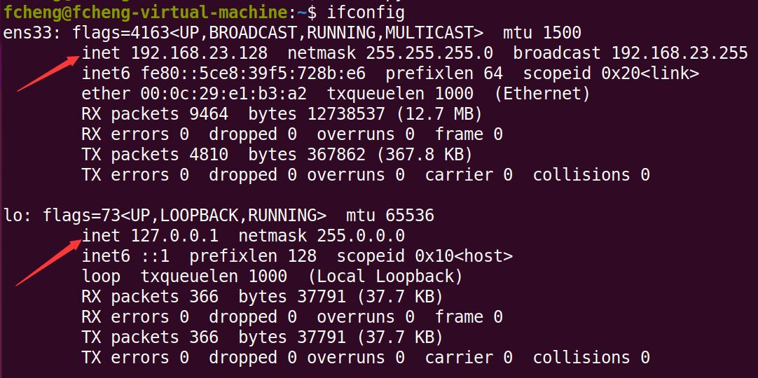

我们可以看到两块网卡的情况，其中第一块ens33上面的IP才是我们所需要的IP地址，第二块网卡lo的ip地址 127.0.0.1 用来特指本台虚拟机，不具有网络服务功能。从中可以看出， inet地址为 192.168.23.128 (每台机器的IP地址可能不一样，但是都是这个格式，即4位整数)

下面我们**回到本地，即离开虚拟机，回到你当前的计算机**。Windows下面，可以打开powershell，mac下面可以直接打开shell。

远程访问的命令是： ssh 用户名@IP地址

(注意：此处用户名是你的虚拟机用户名)。SSH, also known as Secure Shell or Secure Socket Shell, is a network protocol that gives users, particularly system administrators, a secure way to access a computer over an unsecured network. SSH会对网络信息加密，是访问服务器的必备程序。

ssh [fcheng@192.168.23.128](mailto:fcheng@192.168.23.128)

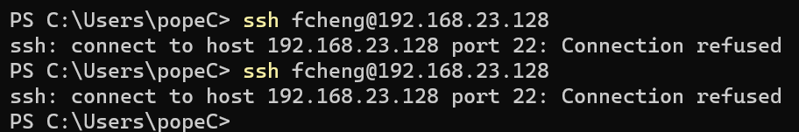

结果表明，连接不上。原因是，Ubuntu平台上面，我们没有打开SSH服务程序。SSH

在Ubuntu上面安装SSH服务器程序，openssh-server

sudo apt install openssh-server

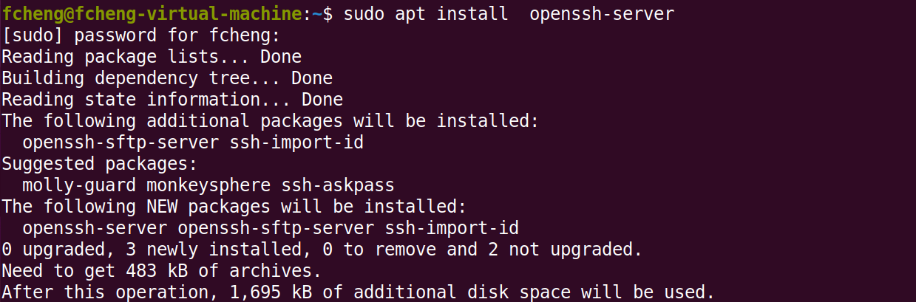

安装完成后，回到本地的powershell，继续ssh [fcheng@192.168.23.128](mailto:fcheng@192.168.23.128)

发现已经可以正式 远程登录 虚拟机，可以进行Ubuntu的操作了。

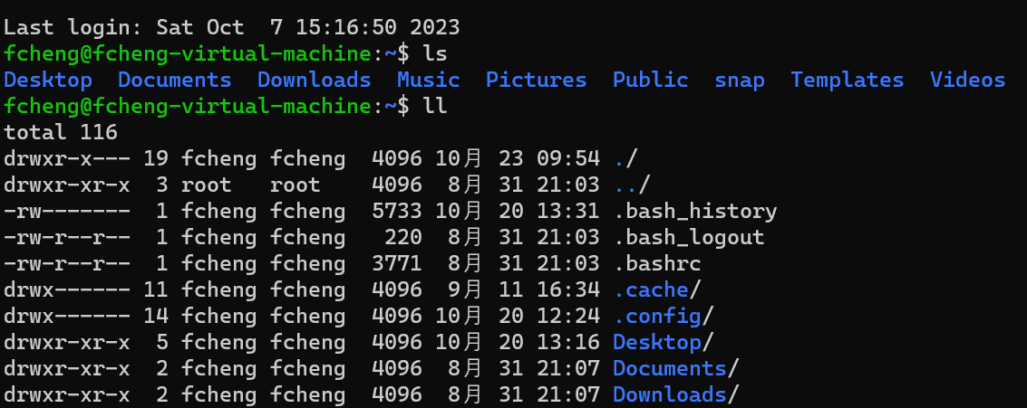

在远程登录模式下，只适合使用命令行来操作，这也是为什么我们着重强调Ubuntu命令的原因。

可以输入 exit 命令退出远程登录。

通过ssh远程连接服务器，我们可以在任何本地平台操作Ubuntu服务器，这也是现在开发工作的基本范式。

VS Code 提供了一个Remote – SSH的扩展插件，可以用来进行vs code远程SSH连接服务器的操作。安装这个插件后，就可以用vs code在linux环境下远程执行程序了。

使用方式—在命令面板(快捷键ctrl+shift+p打开)中，输入ssh，选择创建新服务器，输入服务器ip信息。然后在命令面板中选择ssh连接服务器，既可以访问服务器。

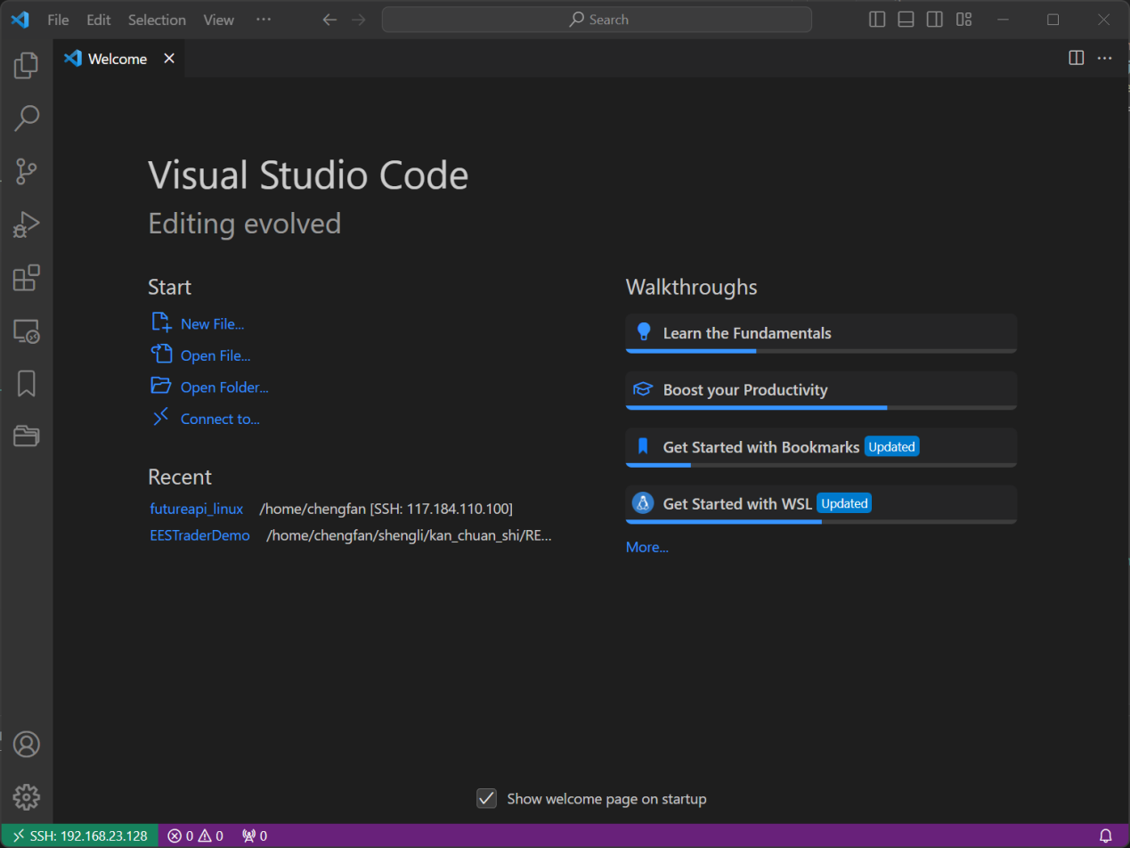

注意左下角的SSH信息。可以用vs code打开服务器端的文件，进行修改和运行。

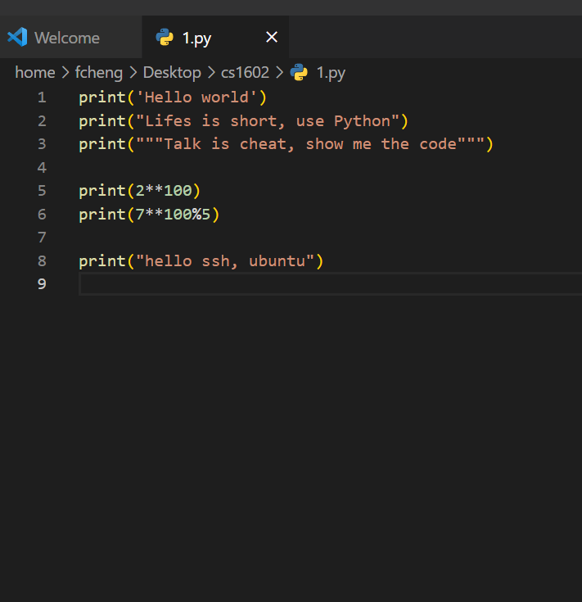

现阶段，大家学会SSH登录ubuntu就已经足够，可以尝试体验vs code远程开发，但不做太多要求。

由于VS Code的便捷性，所以现阶段vim似乎可以被取代。

---------------------------------使用Mac系统的同学注意-------------------------------------

Mac中没有apt命令，mac采用了brew安装程序包，所以请参考brew的基本操作，其它命令大部分都相同。有些小的细节，mac中可能不是用python3，而是直接使用python，请注意。

Brew主页：https://brew.sh/

安装 brew install xxx

卸载 brew uninstall xxx

清除 brew autoremove

更多请查看：https://docs.brew.sh/Manpage