# Development Logs

## Decomposition

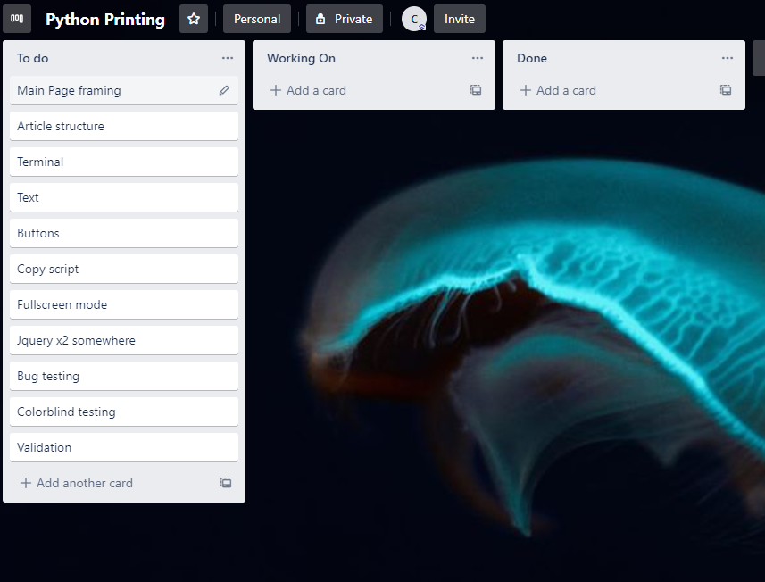

GitHub Logs (Some of them) 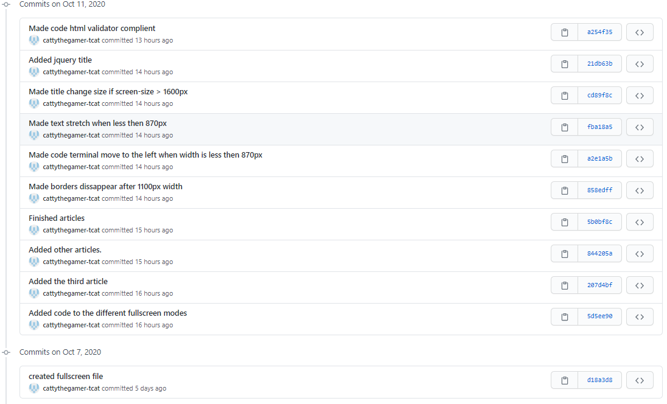

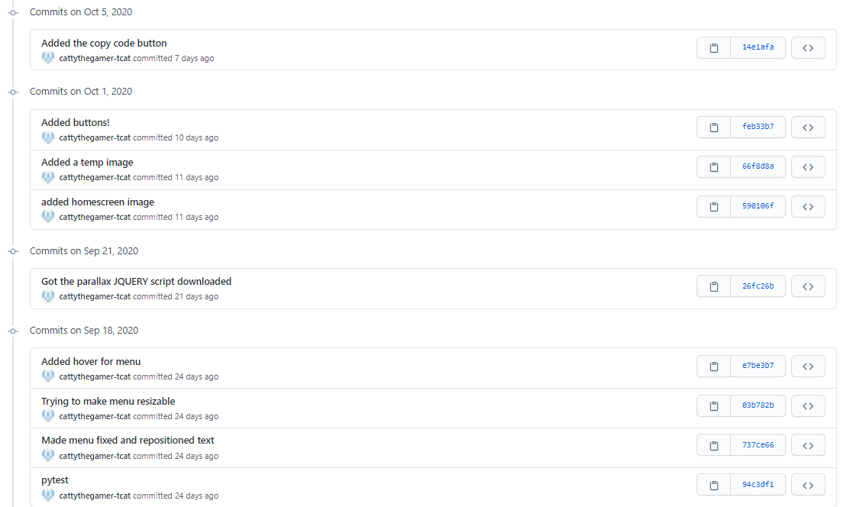

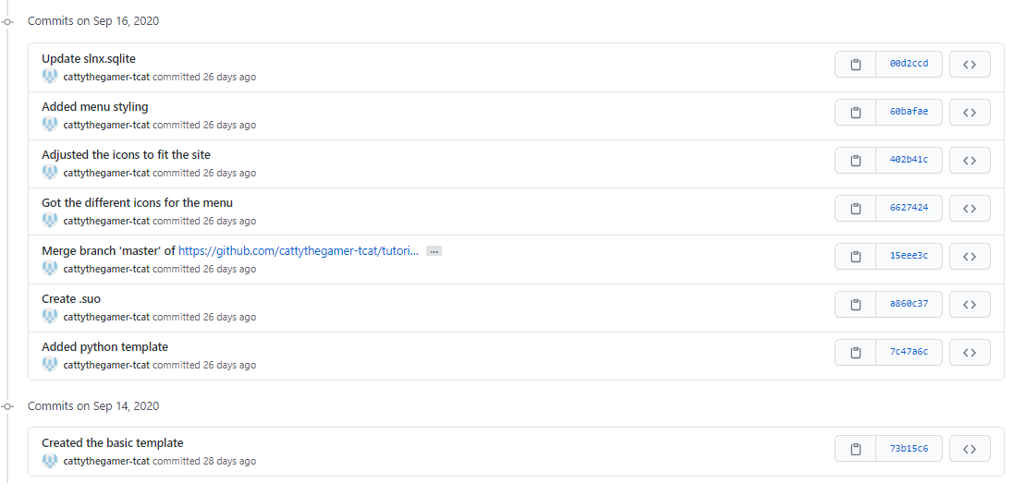

The link to the entire GitHub repository is https://github.com/cattythegamer-tcat/tutorial_website

## Colour-blind Tests

## Bug Testing

|  |  |
| --- | --- |
| **Testing** | **Result** |
| 16:9 screen size | Adjusts to full scale, everything is visible. |
| Moto G4 size | Thins out the padding and adjusts correctly. |
| Surface Duo size | Thickens out more than Moto G4. |
| Min browser size | Text bugs as shown in the Image, so added some media queries to automatically adjust the website to fit the width. |
| Chrome browser | All jQuery, scaling and JavaScript works. |
| Edge browser | All jQuery, scaling and JavaScript works. |
| Firefox browser | All jQuery, scaling and JavaScript works. |
| Internet Explorer browser | All jQuery, scaling and JavaScript works. |
| Article 1 View Input button | Correct code appears. |
| Article 1 View If/else button | Correct code appears. |
| Article 1 View Output button | Correct code appears. |
| Article 1 Default Copy Code button | Copies comment. |
| Article 1 Input Copy Code button | Copies input code. |
| Article 1 If/else Copy Code button | Copies if/else code. |
| Article 1 Output Copy Code button | Copies complete code. |
| Article 1 Fullscreen button | Shows correct code. |
| Article 1 Fullscreen Copy Code button | Copies entire code. |
| Article 1 Fullscreen Back button | Takes the user back to the main page. |
| Article 2 View Print button | Displays correct code. |
| Article 2 Print Copy Code button | Copies print statement. |
| Article 2 Fullscreen Button | Takes user to the Fullscreen mode. |
| Article 2 Fullscreen Copy Code Button | Copies complete code. |
| Article 2 Fullscreen Back Button | Takes the user to the main page, but the start of the page instead of where the user left off. So adjusted the back button to link back to that location. |
| Article 3 View Input button | Code wasn’t appearing, the problem was I had forgot to change the third terminals ID from terminalB to terminalC. |
| Article 3 View Int button | Displays Int adjusted code. |
| Article 3 View Try button | Shows Try/Except statement. |
| Article 3 Input Copy Code button | Copies the correct code. |
| Article 3 Int Copy Code button | Copies Int Code. |
| Article 3 Try Copy Code button | Copies the Try/Except Code. |
| Article 3 Fullscreen button | Redirects the user to Fullscreen mode. |
| Article 3 Fullscreen Copy Code button | Copies the completed code. |
| Article 3 Fullscreen Back button | Works and scrolls the user to the correct location. |
| Article 4 View Import button | First part of the code appears correctly. |
| Article 4 View Print button | Print statement appears. |
| Article 4 View Time button | Sleep script appears. |
| Article 4 Import Copy Code button | Article 3 Code was copied instead. Forgot to adjust the 4th copy code JavaScript Function. |
| Article 4 Print Copy Code button | Copies the correct code. |
| Article 4 Time Copy Code button | Copies the correct code. |
| Article 4 Fullscreen button | Didn’t display the completed code, forgot to change the fullscreen_a4.html file to have the completed code. |
| Article 4 Fullscreen Copy Code button | Copies the entire code. |
| Article 4 Fullscreen Back button | Redirects the user to the correct location. |
| Article 5 View Sys button | First part of the code is displayed correctly. |
| Article 5 View Write button | Displays the correct code but had small capitalization problem in button. |
| Article 5 View Alt button | Changes “STRING” to “COMMENT” |
| Article 5 Sys Copy Code button | Copies the first part of the code. |
| Article 5 Write Copy Code button | Copies the correct code. |
| Article 5 Alt Copy Code button | Copies the completed code. |
| Article 5 Fullscreen button | Redirects to the correct Fullscreen mode. |
| Article 5 Fullscreen Copy Code button | Copies the relevant code. |
| Article 5 Fullscreen Back button | Scrolls to the bottom of the page. |
| Menu Home Icon | Scrolls to the top of the page. |
| Menu Info Icon | Goes to the info article. |
| Menu Print Icon | Goes to the print article. |
| Menu Input Icon | Goes to the input article. |
| Menu Scroll Icon | Goes to the scroll article. |
| Menu Colour Icon | Goes to the colour article. |

## HTML Validator

|  |  |
| --- | --- |
| **Page** | **Result** |
| index.html | 0 Errors, 81 Warnings (Auto fixed) |
| fullscreen_a1.html | 0 Errors, 3 Warnings (Auto fixed) |
| fullscreen_a2.html | 0 Errors, 3 Warnings (Auto fixed) |
| fullscreen_a3.html | 0 Errors, 3 Warnings (Auto fixed) |
| fullscreen_a4.html | 0 Errors, 3 Warnings (Auto fixed) |
| fullscreen_a5.html | 0 Errors, 3 Warnings (Auto fixed) |