Introduction

It is well known that protein-protein interactions are the fundamental essential to explain virtually all the cellular processes. Investigating the protein-protein interaction network promotes better understanding towards the protein functions as well as deeper cognition to the regulation bioprocess, which leads to a high-level causality between molecular mechanisms and certain phenotypes. Fortunately, with the fast growth of the new ideas and technologies in high throughout experiments, large-scale genome-wide profiling researches of many most studied species have been reported such as Homo sapiens, Arabidopsis thaliana, Drosophila melanogaster, Saccharomyces cerevisiae and Caenorhabditis elegans (#cite#). Meanwhile, with a number of interactome databases established such as Intact (#cite#), BIND (#cite#), TAIR (#cite#), BioGRID (#cite#), the number of curated experimental interactions keeps growing explosively (#figure##table#).

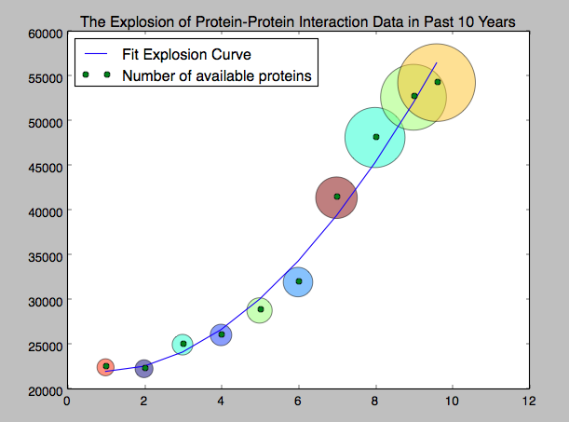

However, the scale of experimental research of interactome, as compared with that of all the possible interactions actually exist, is but a drop in the ocean, even for the most-studied model plant, Arabidopsis thaliana, only about 23000 trustable experimental interactions can be found through all the major resources while XXX around interactions are estimated actually exists (#cite#). Therefore, the urgent challenge becomes deciphering protein-protein interaction network by mining the large amounts of existing data, which is still growing fast, instead obtaining them.

Traditionally,