Human Interactome Resource and Gene Set Linkage Analysis for the Functional Interpretation of Biologically Meaningful Gene Sets

Supplemental Text

Overview of Human Interactome Resource
As detailed in the main text, the human interactome resource (HIR) was established as a largely homogenous functional interactome, which consisted of both experimentally reported protein interactions and inferred functional interactions that have functional interaction strengths similar to functional interactions between physically interacting proteins. Technically, our approach for inferring functional interactions was similar to predicting physical protein interactions from evidence of functional associations. “Protein interactions” predicted in this way were essentially pairs of genes that are, in terms of the multiple lines of evidence suggesting functional associations, most similar to those pairs of genes encoding physically interacting proteins. Therefore, in this text, for reasons described in the main text, we use the terminologies for protein interaction prediction to describe our procedures for inferring functional interactions. For example, the inferred functional interactions will be referred to as predicted protein interactions, and they will be evaluated as predicted physical protein interactions.
The experimentally reported protein interactions were collected from four major interaction repositories – HPRD , IntAct , BioGRID and MINT – resulting in 69,586 non-redundant physical protein interactions (Supplemental text table 1). These interactions, as estimated in later sections, were expected to cover 11.6% of the total human interactome with a per-interaction reliability of 48.2%.
The predicted protein interactions were predicted using a support vector machine (SVM) prediction model trained from reliably known interactions reported in more than one study. Interactions were predicted based on five lines of evidence of functional associations, i.e., gene co-expression, domain interaction, phylogenic profile similarity, homologous interaction in other species, and shared annotation. A total of 90,208 interactions were predicted, which were expected to cover 11.4% of the total human interactome with a per-interaction reliability of 36.6%.
The HIR database integrated the experimental and the predicted protein interactions, resulting in an interactome of 155,974 non-redundant interactions that were expected to cover 22.1% of the total human interactome with a per-interaction reliability of 41.0%.

Supplemental text table 1. Composition of the experimentally reported interactions in HIR.

Source  database | Number of interactions | Number of  proteins | Retrieval  date
IntAct | 28,012 | 7,721 | Jan 10th, 2011
BioGRID | 33,886 | 8,683 | Jan 10th, 2011
HPRD | 38,518 | 9,470 | Apr 13th, 2010
MINT | 11,425 | 4,812 | Dec 12th, 2010
Total | 69,586 | 11,368
HIR is accessible at http://www.cls.zju.edu.cn/hir/. The interactions in HIR can be queried at the website or downloaded as compressed archives. The experimental evidence supporting the known interactions and the functional association evidence supporting the predicted protein interactions are provided along with the other interaction details.

Gold-standard data
Known pairs of interacting proteins (positive examples) and non-interacting proteins (negative examples) were used to train the SVM prediction model. To collect known protein interactions, interaction data in the four major repositories, i.e., IntAct, BioGRID, HPRD and MINT, were retrieved. The protein identifiers in the respective databases were mapped to the HUGO Gene Nomenclature Committee (HGNC) identifiers . There were 19,225 HGNC IDs assigned to protein-coding genes.
The majority (73.5%) of the literature-curated interactions were identified by high-throughput experiments (i.e., experiments that identified more than 20 interactions in one batch). High-throughput interactions are known to be less reliable than low-throughput interactions, which are typically guided by the assumed physiological significance of the interaction . In addition, literature curation is an error-prone process. Misinterpretation of the original publication is inevitable in all large-scale curation efforts. A notable incidence was that in the release version 138 of the IntAct database, there was a 44% decrease in the number of human interactions from its previous release, version 137 (28,012 vs. 50,114 human interactions, respectively). The reason for this decrease was that the IntAct curators misinterpreted the findings in , and 22,102 interactions were retracted upon the authors' request. More minor errors affecting just a few interactions may remain unnoticed. Therefore, we considered interactions reported in more than one study as reliably known interactions and used these interactions as our gold-standard interaction examples. Before Jan 2011, there were 8,249 reliably known interactions between 4,110 proteins (Supplemental text table 2).

Supplemental text table 2. Composition of the reliably known interactions used for model training.
Source  database | Number of  interactions | Number of  proteins | Retrieval  date
IntAct | 1,205 | 771 | Jan 10, 2011
BioGRID | 4,421 | 2,489 | Jan 10, 2011
HPRD | 4,538 | 2,575 | Apr 13, 2010
MINT | 8,74 | 512 | Dec 12, 2010
Total | 8,249 | 4,110

Because scientists do not usually report negative results of non-interactions identified in experiments, it is difficult to assemble a reliable dataset of non-interactions as negative examples. Previous studies have addressed this problem with different approaches, e.g., by choosing pairs of proteins localized in different cellular compartments or simply by choosing random protein pairs . Using pairs of proteins from different cellular compartments, though potentially more reliable than other methods, may introduce a bias into the distribution of negative examples and interfere with the learning objective (i.e., the contrast between positive and negative examples may by itself represent another learning objective: distinguishing pairs of proteins that are from the same or different cellular compartments). For this reason, we followed the method described in to assemble random pairs of proteins as non-interaction examples. In yeast, the rate of interaction is 1/775 per random pair of proteins . Therefore, random pairs of proteins were reasonably accurate non-interaction examples.
The most challenging part of interaction prediction is to obtain high specificity, i.e., accuracy in identifying non-interactions. There are an immense number of protein pairs, the dominant majority of which are non-interactions. A very small decrease in specificity will therefore produce a large number of false positives, and consequently a significant decrease in the reliability of the predicted interactions. Our previous studies suggested that the SVM algorithm typically showed higher accuracy for the class of examples that were either more abundant or had greater diversity in the training dataset. In the prediction of the Arabidopsis interactome, a 1:100 positive-to-negative ratio was observed to boost specificity to a satisfactory level . Therefore, the same ratio was used in this research to assemble the training dataset. The final training dataset included 8,249 reliably known interactions as positive examples and 824,900 random protein pairs as negative examples.

Evidence of functional association
Five lines of evidence of functional associations were used for interaction prediction. These lines of evidence were shown in previous studies to indicate a higher probability of protein interaction . Twenty-five features were computed to measure these five lines of evidence with different mathematical characterizations (Supplemental text table 3). Thus, each protein pair, regardless of exhibiting interaction or non-interaction, was represented by a 25-dimensional feature vector. The five lines of evidence are described below.

Supplemental text table 3. Composition of the features describing a protein pair.
Evidence  type | Number of  features
Gene co-expression | 3
Domain interaction | 15
Shared annotation | 3
Phylogenetic profile similarity | 2
Homologous interactions | 2
Total | 25

Gene co-expression: Interacting proteins are often co-expressed. A large gene expression repository of transcriptional responses to a variety of compounds, the Connectivity Map , was used in calculating the gene co-expression features. The Connectivity Map provided 6,100 genome-wide expression profiles of five human cell lines treated with different dosages of 1,309 compounds. Using the expression profiles of each cell line, for each pair of genes, a Pearson’s correlation coefficient between their expression changes under all treatments was computed as the gene co-expression feature. Although five cell lines were available in the Connectivity Map, most of the expression profiles were measured in the three cell lines MCF7, PC3 and HL60. Therefore, we focused on these three cell lines and computed three gene co-expression features.
Domain interaction: Protein interactions involve physical interactions between protein domains. Therefore, novel protein interactions may be suggested by known domain interactions. The domain composition of each protein was retrieved from the Pfam database (release 24, 2009-10-01) . Known domain interactions were retrieved from the DOMINE database (v2.0, 2010-09) . DOMINE provided two domain interaction datasets predicted from the PDB entries (iPfam and 3did) and 13 domain interaction datasets predicted by a number of approaches (ME, RCDP, Pvalue, Fusion, DPEA, PE, GPE, DIPD, RDFF, KGIDDI, INSITE, DomainGA and PP). Using each of the datasets, the number of interacting domains in a protein pair was counted as its feature value. This resulted in 15 domain interaction features.
Shared annotation: Interacting proteins typically share similar functions, are involved in the same biological processes, and are found in the same cellular compartments. Gene ontology (GO) terms provide a consistent way to annotate proteins with respect to these characteristics. GO terms are structured as a directed acyclic graph . Strongly related terms are expected to have a shared parent term that is low in the term hierarchy and narrow in concept. The fraction of proteins annotated to this shared parent term and all its child terms therefore reflect the unexpectedness of two proteins sharing this particular parent term. In other words, this fraction (denoted the similarity score) measures the functional similarity between two GO terms. The smaller the similarity score, the more similar the two terms are. Extending the concept of term similarity, we defined the "annotation similarity" of two proteins as the smallest term similarity score between the terms annotated to these two proteins. Based on the three categories of GO terms, i.e., molecular function, biological process, and cellular component, we computed three shared annotation features.
Phylogenetic profile similarity: Interacting proteins are more likely than non-interacting proteins to co-evolve , i.e., to exhibit co-presence and co-absence across different genomes. The phylogenetic profiles of all genes in 1,807 genomes were retrieved from a large-scale orthology database, Roundup , as of Jun 2009. The degree of phylogenetic profile similarity was measured by both a mutual information score and a Pearson's correlation coefficient, resulting in two phylogenetic profile similarity features.
Homologous interactions: Homologous interactions found in other species may indicate a higher probability of interaction for a human protein pair . Protein interactions in five species, i.e., Arabidopsis thaliana, Caenorhabditis elegans, Drosophila melanogaster, Mus musculus and Saccharomyces cerevisiae, were retrieved from the four major interaction data repositories IntAct, BioGRID, MINT, and DIP as of Jan 10, 2011. Two homologous interaction features were computed. The first one characterized the support of a human interaction using the equation
where 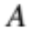 and 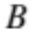 are human proteins, and are proteins in other species, 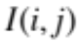is an indicator function that has the value 1 when proteins and are known to interact, and 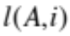is the negative log E-value for the blast match between and .
The second homologous interaction feature was computed using a similar equation, as follows:
where 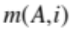 is the ortholog mapping score between and found in the InParanoid database .

Predictive strength of functional association evidence
All lines of functional association evidence are weak. None of them alone can be used for accurate prediction of protein interactions. Previous studies that examined individual lines of evidence typically concluded that these lines of evidence were of limited value in interaction prediction. Nevertheless, these studies all showed certain levels of association between individual lines of functional association evidence and probabilities of protein interaction. For example, although a homologous interaction in another species is not a very strong indicator of interaction, the presence of a homologous interaction provided additional support for the validity of an interaction identified in a high-throughput experiment . Consistently, the analysis described below showed the weakness of these lines of functional association evidence. The feature strength diagrams indicated that individual features could only be used to reliably identify a very small fraction of interactions for which the features approached extreme values. Therefore, the predictive strengths of individual lines of evidence need to be combined with an evidence integration model, so that individual features are no longer required to take extreme values in a reliable prediction. Instead, the prediction model relies on all lines of evidence to identify potential interactions with more power.
A feature strength diagram measures the power of a feature to distinguish positive and negative examples. An informative feature is expected to show differences between its value distributions in positive and negative examples. To plot a feature strength diagram, the value range of each feature was divided into 20 equal bins. The fraction of positive examples and the fraction of negative examples within each bin were calculated to create the corresponding distribution histograms. These distribution histograms were plotted with likelihood ratio (LR) curves to create the feature strength diagrams. The LR for each bin is defined as the fraction of positive examples above the bin divided by the fraction of negative examples above the bin, where "above the bin" means that the feature value of an example is expected to more reliably indicate an interaction than all the feature values in the bin. For features describing co-expression, homologous interaction, phylogenetic profile similarity, and domain interaction evidence, "above the bin" means values that are larger than the largest value in the bin; for features describing shared annotation evidence, it means values that are less than the lowest value in the bin. In the feature strength diagrams, the horizontal axes normally show the feature values; however, for features describing shared annotation evidence, the horizontal axes were plotted as (1 - feature value) so that all the LR curves would appear as increasing from left to right. Supplemental text figure 1 shows four typical feature strength diagrams. A complete set of the feature strength diagrams for all 25 features can be found at the website.
No sharp differences between the feature value distributions in positive and negative examples could be found in any of the feature strength diagrams. The Pearson’s correlation coefficient between the feature value distributions in positive and in negative examples ranged from 0.324 to 1. The Kolmogorov-Smirnov test also indicated that these distributions were not significantly different (distribution distances ranged from 0.1 to 0.4, corresponding to p values ranging from 0.313 to 1, indicating no significance to reject the null hypothesis of the two distributions being the same). However, there were always clear deviations between the feature value distributions when a feature approached its extreme values. In the best-case scenarios (the rightmost point), these features always had large LRs.
Therefore, as discussed above, these features were weak but useful. An evidence integration model that exploits their combined predictive strength is necessary for accurate interaction prediction.

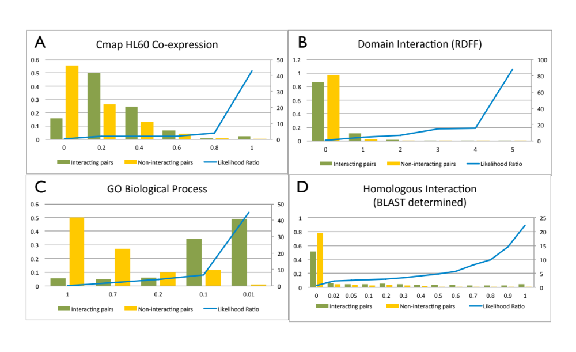
Supplemental text figure 1. Typical feature strength diagrams. For each feature, the green columns and the yellow columns show the fraction of interaction examples and the fraction of non-interaction examples, respectively, that fall into each bin. The blue curves show the likelihood ratio (LR) for a protein pair to interact when its feature value is no lower than the value shown on the horizontal axis. The horizontal axis shows the feature value, the left vertical axis shows the fraction of protein pairs, and the right vertical axis shows the LR.

Prediction of interactions
The support vector machine (SVM) algorithm is an evidence integration algorithm noted for its accuracy . Therefore, we used SVM for our interaction prediction. The SVM algorithm is well documented . For implementation, the public software package LIBSVM version 3.0 (http://www.csie.ntu.edu.tw/~cjlin/libsvm/) was used. The radial basis kernel function was chosen based on its superior performance (data not shown). Two model parameters, the regularization parameter C and the kernel width parameter γ, were optimized using a grid search in an empirical range ([0.001, 1,000] for C and [0.001, 1,000] for γ), maximizing the F1 measure as defined below. The accuracy of the model trained with each set of parameters was estimated by 10-fold cross-validation.
The prediction result for each protein pair can be divided into four categories: true positive (TP), when a real positive example is predicted correctly; true negative (TN), when a real negative example is predicted correctly; false positive (FP), when a real negative example is predicted as positive; and false negative (FN), when a real positive example is predicted as negative. The fractions of these four types of results are collectively known as the confusion matrix. Many accuracy measurements are defined on the basis of the confusion matrix, e.g., sensitivity [or recall; TP/(TP+FN)], specificity [TN/(TN+FP)], and precision [TP/(TP+FP)]. For interactome prediction, the predicted interactions are expected to be both comprehensive and reliable. Therefore, precision and recall are the most relevant measurements. Recall reflects the proportion of real interactions recognized by the model; precision measures the reliability of the predicted interactions. The F1 measurement is defined as the harmonic mean of precision (p) and recall (r), 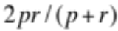.
The resulting SVM model was evaluated with a more reliable 100-iteration bootstrap assessment. In each iteration, 1/10 of the training data were randomly omitted, and this 1/10 of the training data was used to test the model and compute the confusion matrix. After 100 iterations, the mean and standard deviation (SD) of the confusion matrix were computed (Supplemental text table 4). The confusion matrix indicated that the optimized SVM prediction model had 11.40%±0.31% sensitivity and 99.97%±0.0028% specificity. Using this model, a total of 90,208 interactions between all human proteins were predicted.

Supplemental text table 4. Confusion matrix of the SVM prediction model.
 |  | Actual
 |  | Positive | Negative
Predicted | Positive | TP: 941.20±5.15 | FP: 322.15±1.20
Predicted | Negative | FN: 7307.82±7.51 | TN: 824578.80±5.13

Evaluation of the predicted interactions
The SVM prediction model was further evaluated using newly curated interactions. Newly curated interactions refer to interactions curated after the date (Jan 2011) when all the data used for interaction prediction had been collected. The Oct 2012 version of BioGrid and IntAct included 3,277 new interactions supported by more than one study. Of these, 354 interactions (10.8%) were successfully recognized by the prediction model. This sensitivity observed with this independent testing dataset that consisted of new interactions was comparable to the sensitivity observed with the training dataset (11.4%). Therefore, the prediction model was unlikely to suffer from a severe over-fitting problem.
The above analysis showed that the sensitivity estimated with training data was reliable in generalization. If the specificity estimated with training data were also generalizable, we could have an estimate of the total human interactome size based on the number of predicted interactions. The equation "True positives + False positives = All predicted interactions" can be re-written as
where 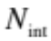 is the human interactome size; 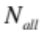 is the number of all possible protein pairs (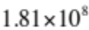 pairs between 19,043 HGNC protein coding genes); 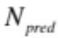 is the number of predicted interactions (90,208); and 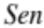 and 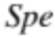 are the sensitivity and specificity, respectively, of the prediction model. Solving this equation gave an estimated human interactome size of 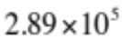. In other words, 1/626 of the human protein pairs were expected to interact. This rate of interaction is similar to that observed in yeast (1/775) .
The reliability of the predicted interactions can be calculated as 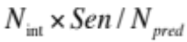. Based on the above estimated human interactome size, the reliability of the predicted interactions was estimated to be 36.6%.

Evaluation of experimentally reported interactions
The prediction model recognized 3,820 interactions out of a total of 69,586 experimentally reported interactions. If all experimentally reported interactions were reliable, the prediction model would be expected to recognize 7,932 (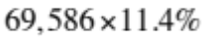) experimentally reported interactions. Therefore, the reliability of the experimentally reported interactions was estimated to be 48.2% (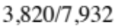). This estimate was consistent with a previous estimate . Based on the calculated reliability and the estimated human interactome size (), the coverage of the experimentally reported interactions was estimated to be 11.6% (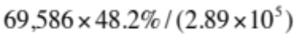).
In Arabidopsis, a predicted interactome that covered 24% of the total interactome was able to satisfactorily support the analysis of functional linkages within and between biological processes . Therefore, the predicted and experimentally reported interactions were integrated to create the human interactome resource (HIR), which were expected to cover 22.1% of the human interactome. HIR included 155,974 non-redundant interactions. The reliability of individual interactions in HIR was expected to be 41.0% (i.e., 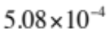 false-positive interactions per pair of genes).

Evaluation of HIR as functional interactions
Previously we evaluated the HIR as predicted physical interactions. This is because when GSLA identifies a functional linkage between gene sets, it will also present the functional interactions between individual genes that supported this gene set level functional linkage. It was expected that many of the predicted functional interactions would actually represent true protein interactions, as they have similar strengths of functional interaction. Protein interactions were relatively easy to confirm with experiments. Therefore, we wanted to develop an idea that if a gene set level functional linkage were identified, how much proportion of the evidence (i.e., functional interactions between individual genes) might be easily confirmed as protein interactions.
In the manuscript, we discussed that the functional interactions involving bridge proteins are under-represented in a protein interaction network, and inferring functional interactions from multiple lines of evidence might alleviate this problem. In the protein interaction network consisting of the 69,586 experimentally reported protein interactions, there were 626 proteins having only two interactions. Among them, 497 were bridge proteins (i.e. having betweenness centrality > 0 ), and 129 were non-bridge proteins. On average, 16.11 functional interactions were predicted for a two-interaction bridge protein. However, only an average of 11.42 functional interactions were predicted for a two-interaction non-bridge protein. This difference is significant (p = 0.01, Kolmogorov–Smirnov test). In other words, the functional interactions involving bridge proteins were indeed better represented in the predicted functional interactions.
The predicted functional interactions (hereafter referred to as the "predicted interactome") and the experimentally reported interactions (hereafter referred to as the "experimental interactome") each covered about 1/10 of the true protein interactome, i.e., they each represented an even smaller fraction of the true functional interactome. However, GSLA requires a fair coverage of the true functional interactome to reliably detect functional linkages between small gene sets. Functional linkages between smaller gene sets (which correspond to more specific biological concepts) are usually more useful in practical research. Therefore, we projected that an integration of the predicted interactome and the experimental interactome might better support the analysis of GSLA. The integrated interactome would likely to double the coverage of the individual interactomes. Moreover, the predicted interactome and the experimental interactome might complement each other to create a more unbiased sample of the true functional interactome.
Before the predicted interactome and the experimental interactome were integrated, we examined whether the overall strengths of functional interactions in these two interactomes were roughly equivalent. Although there is no rigorous way to measure the strength of a functional interaction between two genes, it is nonetheless possible to indirectly assess the overall strength of functional interactions in an interactome. Interactomes group functionally associated genes, making it possible to predict the functions of a gene as the functions most shared by its neighbors. Such a "guilt-by-association" strategy has long been used to predict novel gene functions . If two interactomes consisted of edges that represented functional interactions with similar strengths, they would support the prediction of gene functions equally well. Here again, an existing approach that predicts gene functions was re-used for another purpose: measuring the overall strength of functional interactions in an interactome.
To compare the abilities of the predicted interactome and the experimental interactome in supporting the prediction of gene functions, we focused on the prediction of gene ontology (GO) biological process terms, because these terms represent the largest and most complex division in the GO concept hierarchy. Among these terms, the larger and more general biological processes conceptually include the smaller and more specific biological processes. Intuitively, predicting smaller (more specific) biological processes will be more difficult. Therefore, the conceptual hierarchy associated with GO biological processes could complicate the evaluation of prediction accuracy. Using the approach described in , we selected 642 processes as the targets of prediction (Supplemental table S4). These biological processes involved all annotated genes with minimal conceptual overlap. An older version of GO annotation (retrieved as of Jan 2011) was used to predict the biological processes. As detailed in the methods section, a p value was calculated to assess whether a biological process was enriched in the annotations of the neighbor genes of a target gene. With different thresholds for the p value, we obtained larger or smaller numbers of predicted biological processes for a target gene. Therefore, we used an approach that does not depend on a specific p threshold, the precision-recall curve, to evaluate the effectiveness of an interactome in supporting the prediction of gene functions.
To calculate precision and recall, a newer version of the GO annotation (retrieved as of Oct 2012) was used. Precision measured the fraction of predicted processes included in the actual annotation, and recall measured the fraction of new biological processes that were successfully predicted. New biological processes were those included in the newer version of GO annotation but not in the older version. The use of altered p-value thresholds resulted in different pairs of precision and recall, which were used to define a precision-recall curve. The area under the curve (AUC) was therefore a threshold-independent measurement of the prediction accuracy, or in other words, the effectiveness of an interactome in supporting gene function prediction.
As shown in Supplemental text figure 2, in the higher-recall area, the precision-recall curve of the predicted interactome matched that of the experimental interactome. For reference, another set of predicted interactions retrieved from the PIPs database as of Jun 20, 2011 was notably less effective in supporting the prediction of gene functions. Of note, in the precision-recall curves, the lower-recall areas might exhibit bias favoring the experimental interactome, due to the fact that many biological processes were actually annotated based on these experimentally reported interactions. When the prediction method aimed only at re-discovering old biological processes (i.e., in the low-recall areas), an experimental interactome might thus appear to be more effective. Judging by the higher-recall areas of the precision-recall curves, the predicted interactome showed effectiveness similar to that of the experimental interactome. Therefore, the interactions in the predicted interactome and those in the experimental interactome likely represented functional interactions of similar strengths. This observation was consistent with previous evaluations: as physical interactomes, the predicted interactome was slightly less accurate than the experimental interactome (with similar coverage but lower per-interaction reliability, at 36.6% vs. 48.2%, respectively, as in Supplemental Text). However, the predicted interactions were all predicted from evidence of functional association. Some of the false-positive predictions when evaluated as physical interactions could well represent functional interactions with strengths as strong as physical interactions. Therefore, as functional interactomes, the predicted interactome and the experimental interactome had similar overall strengths of functional interaction.
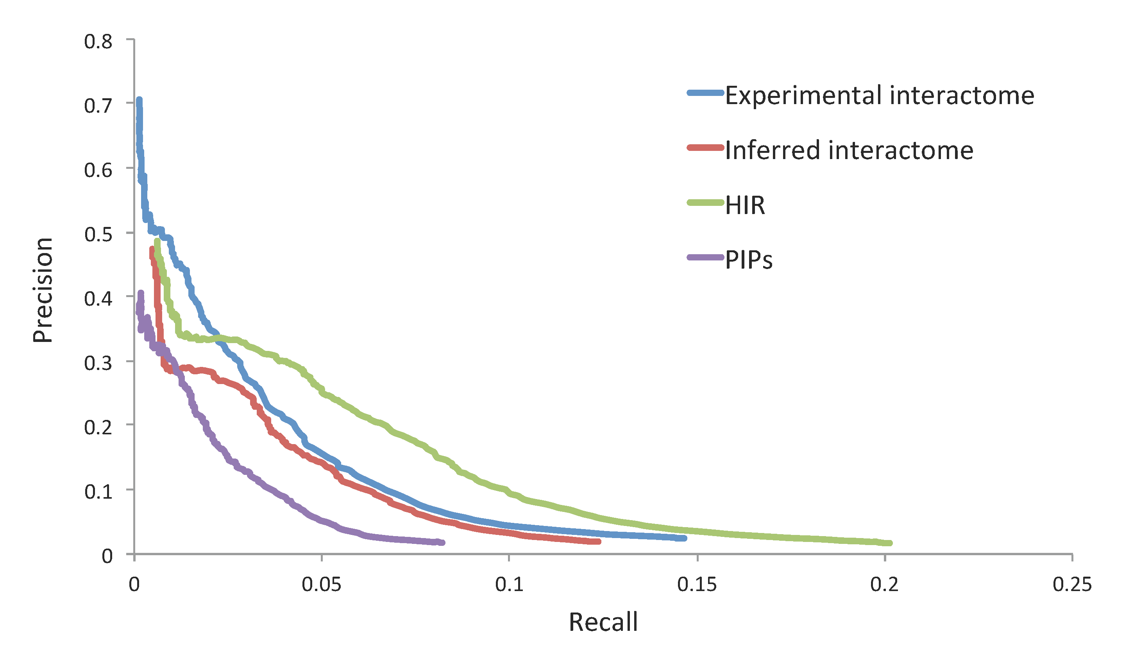Supplemental text figure 2. Precision-recall curves for the predicted biological processes inferred from four interactomes

A case study to assess the quality of functional interactions in HIR
In the above analysis, the "precision" of predicted biological processes were typically low (e.g. < 30%). However, this "precision" did not reflect the reliability of the predicted biological processes. "Precision" measured the fraction of predicted processes that were included in the GO annotations, although many biological processes that involved a gene were not yet included in current annotations. Therefore, a case study was conducted to assess the reliability of the predicted biological processes, which were expected to provide an intuitive idea on the quality of functional interactions in HIR: how they could accurately group functionally related genes together, so that biological process annotations could be predicted for a gene based on its neighbors.
It was reported that the inhibition of a series of enzymes, mediators, and key transcription factors that contribute to the inflammation process might decrease the incidence and spread of cancer. The major cancer-related inflammation genes include the enzymes PTGS2 and RET; the cytokines TNF and IL1B; and the transcription factors NFKB1, HIF1A and STAT3 . The top 10 predicted biological processes for these seven genes were assessed. As shown in Supplemental table S5, in the 70 predicted biological processes, 24 were found in the GO annotations (i.e., 34.28% precision). On the other hand, 92 "new" biological processes were annotated to these seven genes in the newer version of GO annotation. Four of the "new" biological processes were successfully predicted (i.e., 4.34% recall). This pair of precision and recall was consistent with the precision-recall curve of the HIR interactome (Supplemental text figure 2). Therefore, they represented typical prediction accuracy.
Among the 70 biological processes predicted for the seven genes, 46 were not included in the GO annotations. However, many of these predictions were supported by literature evidence. For example, RET was known to participate in axon guidance (GO:0007411) and Ras protein signal transduction (GO:0007265) . Some predictions were supported by indirect evidence. For example, PTGS2 was predicted to participate in the G1/S transition in mitotic cells (GO:0000082). PTGS2 overexpression was shown to alter cell cycle in mouse neurons; and antagonism of its enzymatic product, prostaglandin E2, was shown to prevent cancer cell proliferation through cell cycle arrest at the G1-S or G2-M checkpoints . Our literature search indicated that 28 (40.0%) of the predicted biological processes outside GO annotations were supported by direct or indirect experimental evidence. In total, 52 (74.3%) of the predicted processes were supported by annotation or literature evidence (Supplemental table S5).
Of note, RET was predicted to participate in the T-cell receptor signaling pathway (GO:0050852). The finding that T-cell receptor signal transduction involves the Src tyrosine kinases supported this prediction. Two Src tyrosine kinases, CSK and FYN, were known to bind RET . However, in the experimental interactome, these interactions were not yet included. Consequently, the neighbors of RET in the experimental interactome did not have any annotation of "T-cell receptor signaling pathway". Nonetheless, these two interactions between RET and Src tyrosine kinases were included in HIR as inferred functional interactions, which provided the basis for the successful prediction of "T-cell receptor signaling pathway" for RET. This is therefore an example of how our inferred functional interactions can help group functionally associated genes together.
It was also noted that the biological processes predicted for a gene often summarized its major functions. For example, STAT3 has a central role in inflammation signaling. As shown in Supplemental text figure 3, STAT3 is phosphorylated by tyrosine kinases that are activated by both oncogenic (intrinsic) and environmental (extrinsic) inflammation pathways, through the epidermal growth factor receptor, the platelet-derived growth factor receptor, and cytokine receptors. Phosphorylated STAT3 dimerizes and translocates to the nucleus, where it regulates gene expression . The top 10 predicted biological processes of STAT3 included protein phosphorylation (GO:0006468); epidermal growth factor receptor-signaling pathway (GO:0007173); platelet activation and blood coagulation (GO:0030168 and GO:0007596, these two processes are closely related to the release of platelet-derived growth factors ); and cytokine-mediated signaling pathway (GO:0019221). In addition, STAT3 restrains anti-tumor immune responses by antagonizing the expression of anti-tumor T helper-1 (TH1) cytokines . In our analysis, the T-cell receptor-signaling pathway (GO:0050852) was predicted within the top 10 biological processes for STAT3 to account for this cancer-related function.
To summarize, this case study illustrated that the annotation terms enriched in the neighbors of a gene often defined its major functions in a usefully accurate manner. Manual annotation of genes tends to lag much behind the production of scientific data suggesting its functions. These data can be in the form of molecular interactions, expression profiles, protein structures, phylogenetic profiles, etc. As discussed above, the HIR interactome integrated these scientific data, providing an up-to-date view of the functional interactions between genes. Therefore, it was not surprising that in HIR, the neighbors of a gene could provide information about its functions before these functions are annotated. If the functional interactions in HIR were reliable and up-to-date, they would also be able to provide an updated view of the functional linkages between biologically meaningful gene sets.
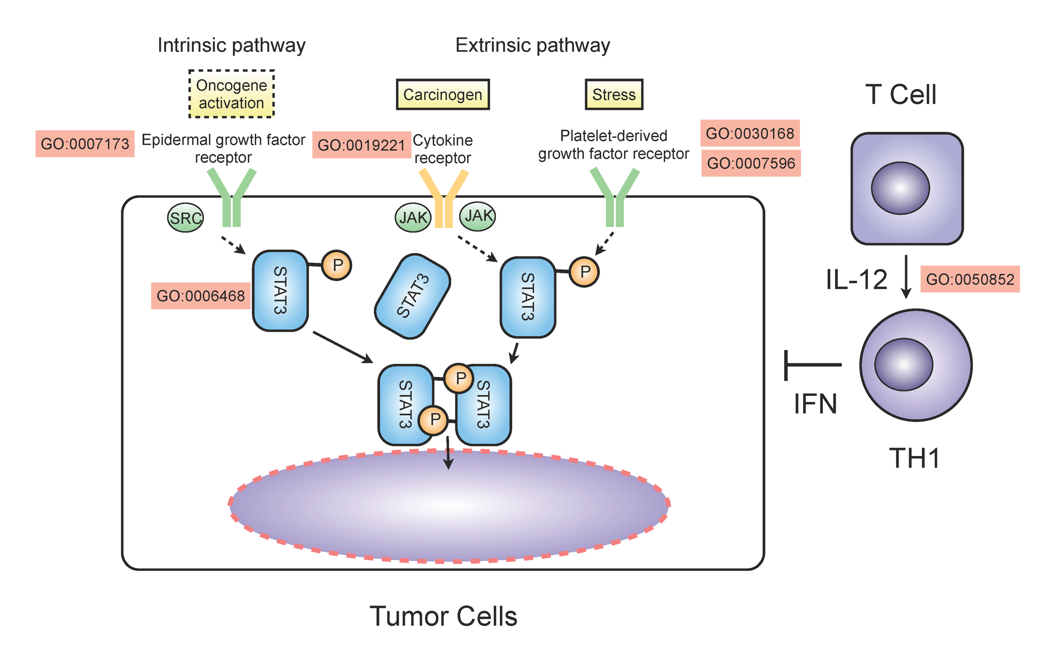 Supplemental text figure 3: The top 10 predicted GO biological processes for the STAT3 gene that are supported by the literature. The known functions of STAT3 are indicated according to the review .

A case study to assess the reliability of functional connections identified between GO biological processes
As discussed in the main text, GSLA was able to identify functional linkages between GO biological processes that were largely consistent with their semantic hierarchy and with our knowledge about their member genes. To develop an intuitive idea about the actual reliability and usefulness of these functional linkages, we conducted the following case study, which examined the functional linkages involving biological processes related to the c-Jun N-terminal kinase (JNK) cascade.
The JNK cascade is an important component of the signal transduction pathways that are active in cancer-related inflammation. JNKs were originally identified as kinases that phosphorylate c-Jun at the Ser-63 and Ser-73 sites in the transcriptional activation domain . There are three JNK-related biological processes in GO: "JNK cascade" (GO:0007254), "negative regulation of the JNK cascade" (GO:0046329), and "positive regulation of the JNK cascade" (GO:0046330). In the GO-BPLN, 184 other biological processes were identified to connect with these three biological processes (Supplemental table S6). As shown in Supplemental text figure 4, 161 (87%) of these functional linkages were supported by direct or indirect evidence in the literature. These 161 biological processes could be grouped into four categories: upstream pathways (purple nodes), downstream pathways (red nodes), overlapping pathways (green nodes), and induced physiological responses (blue nodes). The 23 (13%) functional linkages for which no supporting evidence was found were indicated in white.
The upstream pathways involved many receptors located in the cell membrane, e.g., Toll-like receptor (GO:0002224) , epidermal growth factor receptor (GO:0007173) , and transforming growth factor beta receptor (GO:0007179) . The JNK cascade can be activated by cytokines, including IL1A (interleukin-1) (GO:0070498) , or activated by external stresses, such as lipopolysaccharides (GO:0032496) and ionizing radiation (GO:0071479) . Furthermore, some less well established functional linkages were identified, e.g., the linkage between the JNK cascade and "negative regulation of type I interferon production" (GO:0032480). Type I interferon was shown to induce the conjugation of filamin B and lead to the prevention of JNK cascade activation .
The downstream pathways included the well-known “activation of JUN kinase activity” (GO:00007257) and subsequent transactivation of target genes (GO:0051091, GO:0051090) . In addition, the JNK cascade was found to connect with many semantically unrelated biological processes, e.g., the chromatin modification processes (GO:0046329 and GO:0016568). Histone acetylation was shown to be regulated by the CBP/p300 transcriptional initiation complex, whose activation is controlled by JNK-activated transcription factors .
The overlapping pathways included many "intracellular receptor-mediated signaling pathway" (GO:0030522), such as the "activation of NFKB-inducing kinase activity" (GO:0007250) and the "protein ubiquitination process" (GO:0051865) . Moreover, some non-intuitive connections were identified, such as the functional linkage between "negative regulation of the JNK cascade" (GO:0046329) and "negative regulation of cholesterol storage" (GO:0010887). This linkage was supported by the existence of protein interactions between the PPAR receptors (annotated to GO:0046329) and the enzyme histone deacetylase 3 (HDAC3) (annotated to GO:0010887) . Other evidence that supported this functional linkage included that PPARs were shown to control fatty acid and cholesterol storage in macrophages and activate the JNK cascade to induce inflammation response and atherosclerosis . In addition, deactivation of the JNK cascade, suppression of PPARG expression, and reduction of cholesterol uptake can all be induced by the 1,25-dihydroxyvitamin D3 treatments of macrophage cells .
At the physiological level, the JNK cascade was known to induce a series of biological responses, including cell proliferation, differentiation, growth, and survival. These biological responses were all identified by GSLA (Supplemental table S6). For example, “positive regulation of the JNK cascade” was found to connect with “negative regulation of fat cell differentiation” (GO:0045599) and “positive regulation of osteoclast differentiation” (GO:0045672). It was reported that in bone marrow stromal cells, activation of JNK could stimulate osteogenic differentiation and inhibit adipogenic differentiation .
A review article summarized the major functions of the JNK cascade as follows: it is activated by environmental stress, growth factors, and inflammatory cytokines; it targets transcription factors and other effectors; it cross-talks with the NFKB, p38 and ubiquitination pathways; and it regulates cell proliferation, differentiation, growth and survival . As illustrated above, these major functions were all indicated by the 184 biological processes identified to have functional linkages with the JNK cascade (Supplemental table S6). In this case study, GSLA displayed its potential to reliably identify functional linkages between established biological processes.
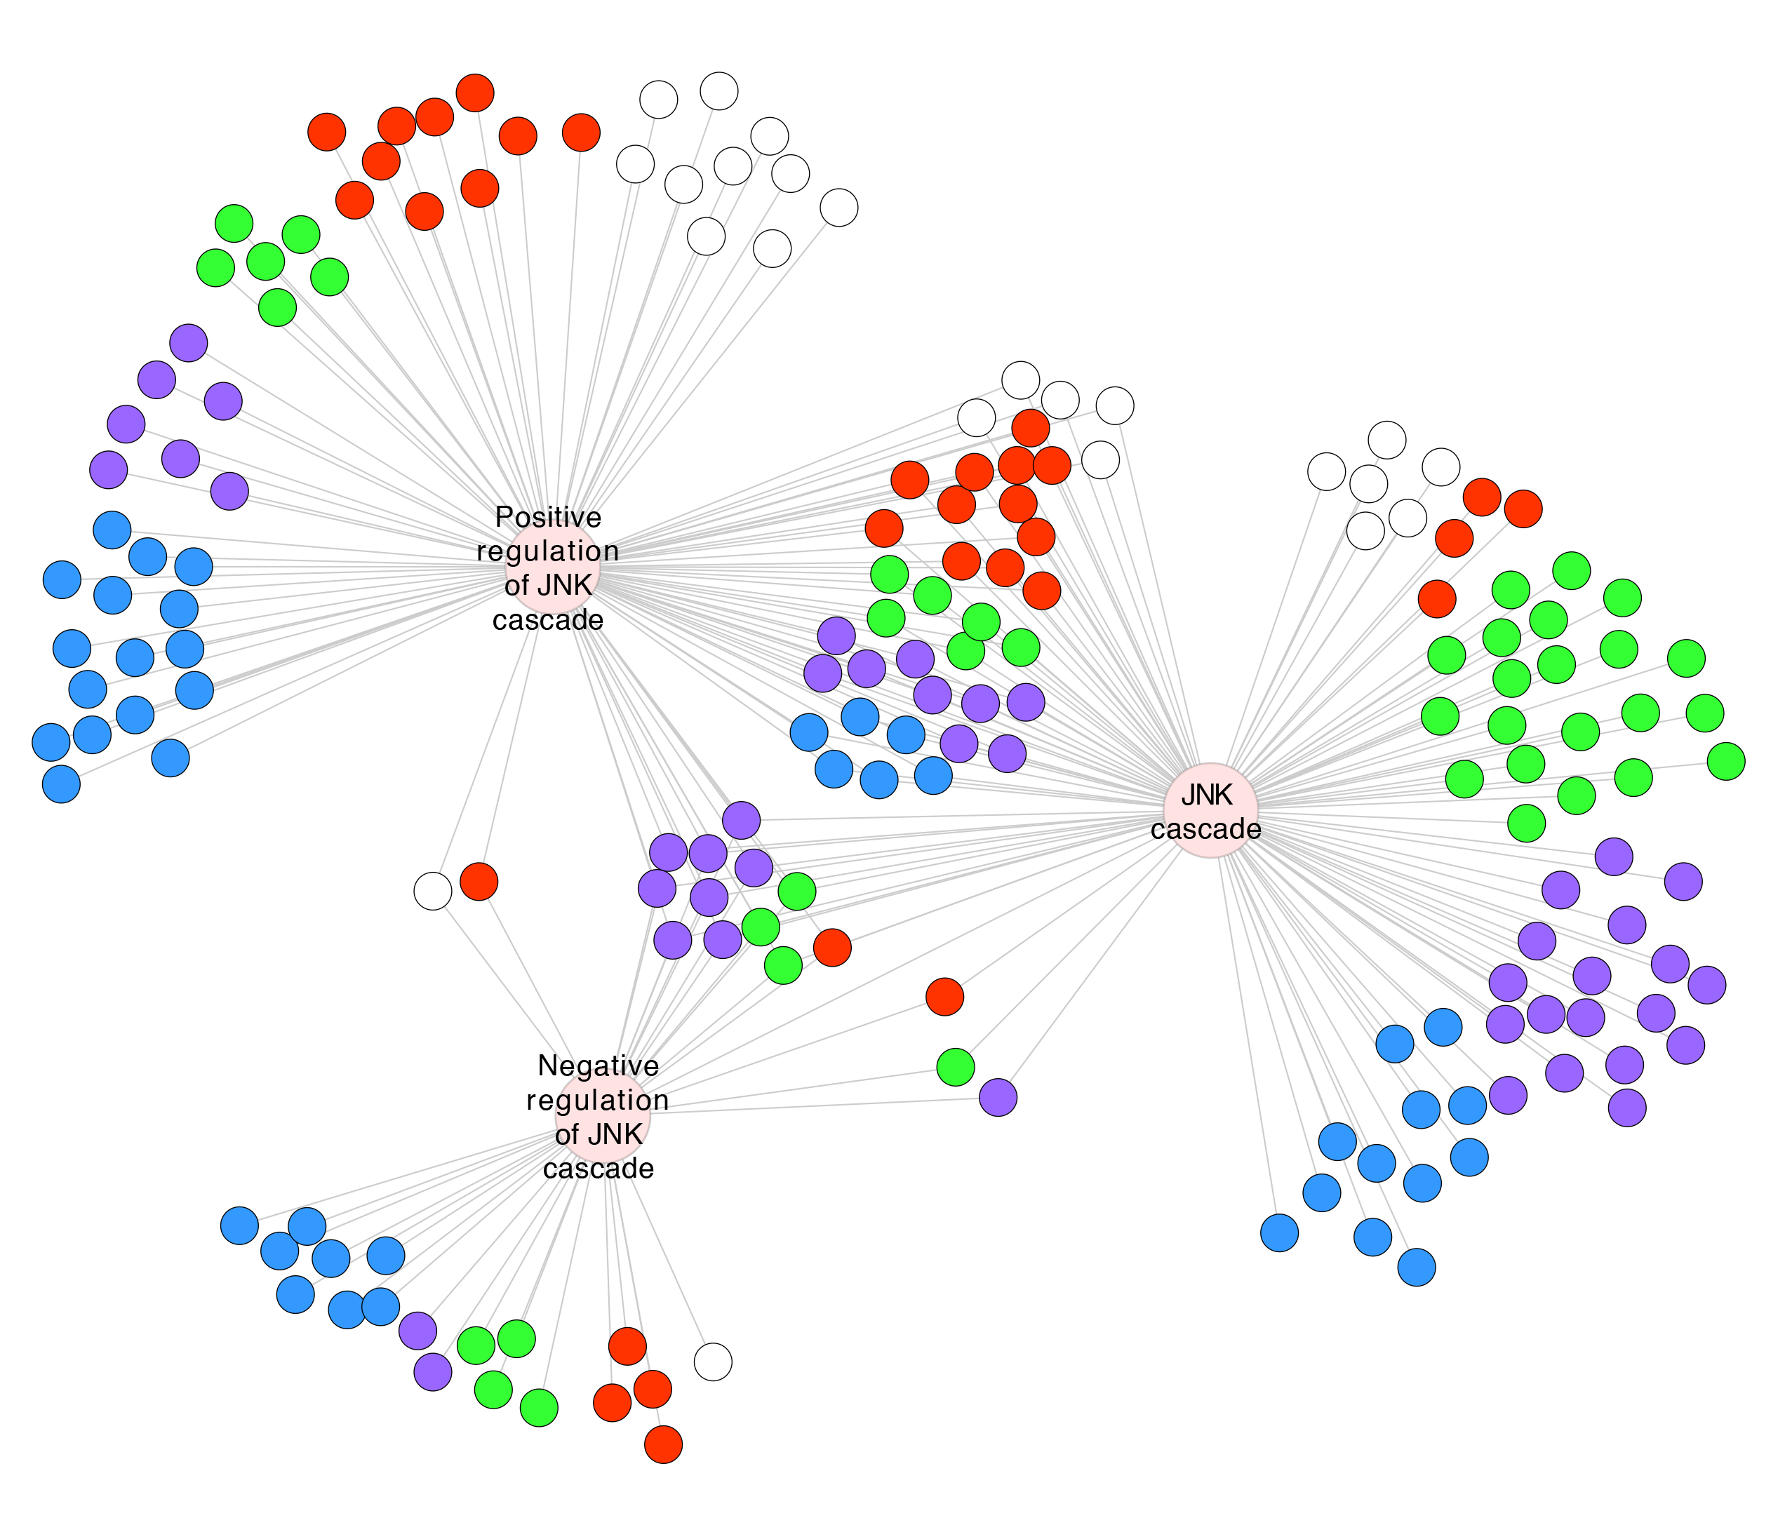Supplemental text figure 4. The predicted functional linkages between the JNK cascade and other biological processes. Purple nodes: upstream pathways; red nodes: downstream pathways; green nodes: overlapping pathways; blue nodes: induced physiological responses; white nodes: predicted biological processes without literature evidence.

Supplemental text for a case study to illustrate the improved capability of GSLA to make biological interpretation of an experimentally observed gene set
As described in main text, for the two statin-sensitive cell lines, GSLA and FNEA suggested cell line-specific routes to apoptosis activation (Supplemental table S4, S5). The expression phenotype of H929 cell line was connected to the Rho/GTPase signaling pathways. Statins were previously shown to inhibit Rho prenylation and prevent its localization within the inner plasma membrane (Cafforio, et al., 2005). Small GTPases, such as Rho, were well-known modulators of apoptosis. On the other hand, the expression phenotype of the KMS11 cell line was connected to many Toll-like receptor (TLR) signaling pathways. TLR2 and TLR4 signaling pathways can be triggered by bacterial pathogens such as lipopolysaccharide or lipoproteins (Aliprantis, et al., 1999; Chow, et al., 1999). They induce innate immune responses and produce cytokines to activate apoptosis (Aliprantis, et al., 1999). Previous studies indicated that statins are potent modulators of TLR activity. They can enhance TLR2 and TLR4 signaling in dendritic cells (Yilmaz, et al., 2006) and macrophages (Matsumoto, et al., 2004), or suppress TLR4 signaling in monocytes (Methe, et al., 2005) and endothelial cells (Rice, et al., 2003). Therefore, it was possible that in the KMS11 cell line, the TLR signaling pathways played an important role in statin-induced apoptosis.
Supplemental text references
Antoniades, H.N. and Williams, L.T. (1983) Human platelet-derived growth factor: structure and function, Federation proceedings, 42, 2630-2634.
Ashburner, M., et al. (2000) Gene ontology: tool for the unification of biology. The Gene Ontology Consortium, Nature genetics, 25, 25-29.
Behrends, C., et al. (2010) Network organization of the human autophagy system, Nature, 466, 68-76.
Ben-Hur, A. and Noble, W.S. (2006) Choosing negative examples for the prediction of protein-protein interactions, BMC bioinformatics, 7 Suppl 1, S2.
Bonanomi, D., et al. (2012) Ret is a multifunctional coreceptor that integrates diffusible- and contact-axon guidance signals, Cell, 148, 568-582.
Brown, M.P., et al. (2000) Knowledge-based analysis of microarray gene expression data by using support vector machines, Proceedings of the National Academy of Sciences of the United States of America, 97, 262-267.
Burbidge, R., et al. (2001) Drug design by machine learning: support vector machines for pharmaceutical data analysis, Computers & chemistry, 26, 5-14.
Ceol, A., et al. (2010) MINT, the molecular interaction database: 2009 update, Nucleic acids research, 38, D532-539.
Cusick, M.E., et al. (2009) Literature-curated protein interaction datasets, Nature methods, 6, 39-46.
DeLuca, T.F., et al. (2012) Roundup 2.0: enabling comparative genomics for over 1800 genomes, Bioinformatics, 28, 715-716.
Fajas, L., et al. (2002) The retinoblastoma-histone deacetylase 3 complex inhibits PPARgamma and adipocyte differentiation, Developmental cell, 3, 903-910.
Feng, B., et al. (2003) The endoplasmic reticulum is the site of cholesterol-induced cytotoxicity in macrophages, Nature cell biology, 5, 781-792.
Finn, R.D., et al. (2010) The Pfam protein families database, Nucleic acids research, 38, D211-222.
Fu, L., et al. (2008) Stimulation of osteogenic differentiation and inhibition of adipogenic differentiation in bone marrow stromal cells by alendronate via ERK and JNK activation, Bone, 43, 40-47.
Geisler-Lee, J., et al. (2007) A predicted interactome for Arabidopsis, Plant physiology, 145, 317-329.
Goh, C.S., et al. (2000) Co-evolution of proteins with their interaction partners, Journal of molecular biology, 299, 283-293.
Graff, J., et al. (2002) Close relationship between the platelet activation marker CD62 and the granular release of platelet-derived growth factor, The Journal of pharmacology and experimental therapeutics, 300, 952-957.
Hwang, W.C., Zhang, A. and Ramanathan, M. (2008) Identification of information flow-modulating drug targets: a novel bridging paradigm for drug discovery, Clinical pharmacology and therapeutics, 84, 563-572.
Ip, Y.T. and Davis, R.J. (1998) Signal transduction by the c-Jun N-terminal kinase (JNK)--from inflammation to development, Current opinion in cell biology, 10, 205-219.
Jeon, Y.J., et al. (2009) ISG15 modification of filamin B negatively regulates the type I interferon-induced JNK signalling pathway, EMBO reports, 10, 374-380.
Johnson, G.L. and Lapadat, R. (2002) Mitogen-activated protein kinase pathways mediated by ERK, JNK, and p38 protein kinases, Science, 298, 1911-1912.
Kerrien, S., et al. (2012) The IntAct molecular interaction database in 2012, Nucleic acids research, 40, D841-846.
Keshava Prasad, T.S., et al. (2009) Human Protein Reference Database--2009 update, Nucleic acids research, 37, D767-772.
Laine, A. and Ronai, Z. (2005) Ubiquitin chains in the ladder of MAPK signaling, Science's STKE : signal transduction knowledge environment, 2005, re5.
Lee, S.A., et al. (2008) Ortholog-based protein-protein interaction prediction and its application to inter-species interactions, BMC bioinformatics, 9 Suppl 12, S11.
Li, Y., et al. (2005) Free cholesterol-loaded macrophages are an abundant source of tumor necrosis factor-alpha and interleukin-6: model of NF-kappaB- and map kinase-dependent inflammation in advanced atherosclerosis, The Journal of biological chemistry, 280, 21763-21772.
Lin, H.P., et al. (2004) Growth inhibitory effects of celecoxib in human umbilical vein endothelial cells are mediated through G1 arrest via multiple signaling mechanisms, Molecular cancer therapeutics, 3, 1671-1680.
Lin, M., et al. (2009) Computational identification of potential molecular interactions in Arabidopsis, Plant physiology, 151, 34-46.
Lin, M., et al. (2011) The predicted Arabidopsis interactome resource and network topology-based systems biology analyses, The Plant cell, 23, 911-922.
Mantovani, A., et al. (2008) Cancer-related inflammation, Nature, 454, 436-444.
Matthews, L.R., et al. (2001) Identification of potential interaction networks using sequence-based searches for conserved protein-protein interactions or "interologs", Genome research, 11, 2120-2126.
McDowall, M.D., Scott, M.S. and Barton, G.J. (2009) PIPs: human protein-protein interaction prediction database, Nucleic acids research, 37, D651-656.
Melillo, R.M., et al. (1999) Ret-mediated mitogenesis requires Src kinase activity, Cancer research, 59, 1120-1126.
Michnick, S.W. (2006) The connectivity map, Nature chemical biology, 2, 663-664.
Mitsutake, N., et al. (2006) BRAF mediates RET/PTC-induced mitogen-activated protein kinase activation in thyroid cells: functional support for requirement of the RET/PTC-RAS-BRAF pathway in papillary thyroid carcinogenesis, Endocrinology, 147, 1014-1019.
Obayashi, T., et al. (2009) ATTED-II provides coexpressed gene networks for Arabidopsis, Nucleic acids research, 37, D987-991.
Oh, J., et al. (2009) 1,25(OH)2 vitamin d inhibits foam cell formation and suppresses macrophage cholesterol uptake in patients with type 2 diabetes mellitus, Circulation, 120, 687-698.
Ostlund, G., et al. (2010) InParanoid 7: new algorithms and tools for eukaryotic orthology analysis, Nucleic acids research, 38, D196-203.
Pellegrini, M., et al. (1999) Assigning protein functions by comparative genome analysis: protein phylogenetic profiles, Proceedings of the National Academy of Sciences of the United States of America, 96, 4285-4288.
Pitre, S., et al. (2006) PIPE: a protein-protein interaction prediction engine based on the re-occurring short polypeptide sequences between known interacting protein pairs, BMC bioinformatics, 7, 365.
Rahman, I., Marwick, J. and Kirkham, P. (2004) Redox modulation of chromatin remodeling: impact on histone acetylation and deacetylation, NF-kappaB and pro-inflammatory gene expression, Biochemical pharmacology, 68, 1255-1267.
Ramana, K.V., Tammali, R. and Srivastava, S.K. (2010) Inhibition of aldose reductase prevents growth factor-induced G1-S phase transition through the AKT/phosphoinositide 3-kinase/E2F-1 pathway in human colon cancer cells, Molecular cancer therapeutics, 9, 813-824.
Rhodes, D.R., et al. (2005) Probabilistic model of the human protein-protein interaction network, Nature biotechnology, 23, 951-959.
Scott, M.S. and Barton, G.J. (2007) Probabilistic prediction and ranking of human protein-protein interactions, BMC bioinformatics, 8, 239.
Seal, R.L., et al. (2011) genenames.org: the HGNC resources in 2011, Nucleic acids research, 39, D514-519.
Sharan, R., Ulitsky, I. and Shamir, R. (2007) Network-based prediction of protein function, Molecular systems biology, 3, 88.
Song, H.Y., et al. (1997) Tumor necrosis factor (TNF)-mediated kinase cascades: bifurcation of nuclear factor-kappaB and c-jun N-terminal kinase (JNK/SAPK) pathways at TNF receptor-associated factor 2, Proceedings of the National Academy of Sciences of the United States of America, 94, 9792-9796.
Stark, C., et al. (2006) BioGRID: a general repository for interaction datasets, Nucleic acids research, 34, D535-539.
Swantek, J.L., Cobb, M.H. and Geppert, T.D. (1997) Jun N-terminal kinase/stress-activated protein kinase (JNK/SAPK) is required for lipopolysaccharide stimulation of tumor necrosis factor alpha (TNF-alpha) translation: glucocorticoids inhibit TNF-alpha translation by blocking JNK/SAPK, Molecular and cellular biology, 17, 6274-6282.
Wagner, E.F. and Nebreda, A.R. (2009) Signal integration by JNK and p38 MAPK pathways in cancer development, Nature reviews. Cancer, 9, 537-549.
Wang, J.Z., et al. (2007) A new method to measure the semantic similarity of GO terms, Bioinformatics, 23, 1274-1281.
Weber, A., Wasiliew, P. and Kracht, M. (2010) Interleukin-1 (IL-1) pathway, Science signaling, 3, cm1.
Winters-Hilt, S., et al. (2006) Support vector machine implementations for classification & clustering, BMC bioinformatics, 7 Suppl 2, S4.
Wu, X., Liu, Q. and Jiang, R. (2009) Align human interactome with phenome to identify causative genes and networks underlying disease families, Bioinformatics, 25, 98-104.
Xiang, Z., et al. (2002) Cyclooxygenase (COX)-2 and cell cycle activity in a transgenic mouse model of Alzheimer's disease neuropathology, Neurobiology of aging, 23, 327-334.
Yellaboina, S., et al. (2011) DOMINE: a comprehensive collection of known and predicted domain-domain interactions, Nucleic acids research, 39, D730-735.
Yu, H., et al. (2008) High-quality binary protein interaction map of the yeast interactome network, Science, 322, 104-110.
Yu, H., Kortylewski, M. and Pardoll, D. (2007) Crosstalk between cancer and immune cells: role of STAT3 in the tumour microenvironment, Nature reviews. Immunology, 7, 41-51.
Yu, H., Pardoll, D. and Jove, R. (2009) STATs in cancer inflammation and immunity: a leading role for STAT3, Nature reviews. Cancer, 9, 798-809.
Zhang, K. and Kaufman, R.J. (2008) From endoplasmic-reticulum stress to the inflammatory response, Nature, 454, 455-462.
Zhang, L.V., et al. (2004) Predicting co-complexed protein pairs using genomic and proteomic data integration, BMC bioinformatics, 5, 38.

