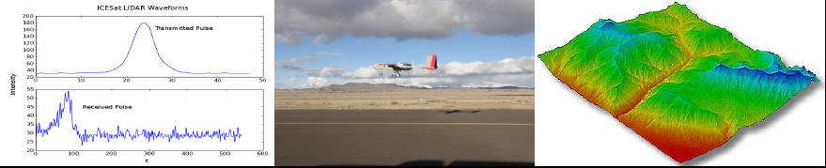
NEW COURSE FOR SPRING 2011 !!!
Undergraduate Research Seminar:

Remote Sensing, Signal Processing and Spatial Data Analysis
(ECEN 4004, M/W 3:30-4:45 in ECCR 137, 3 credit hours)
Faculty: Dr. Ute Herzfeld, Associate Research Professor, ECEE

Explore new topics like a research team:
– remote sensing of the environment
– Earth observation technology
– passive and active microwave
– spatial data analysis
– signal processing
– image analysis, interpolation and extrapolation
– new technology for observations from satellites, manned and unmanned aircraft
– instrument and survey design
– fascinating applications: Greenland and Antarctica, ice sheets, oceans, climate change, forests, ecology, ˜ exploration and mining,......

Things to know:
– course style will be centered on research, problem-solving and skill development
– you need not have background in remote sensing or spatial statistics.
– course counts as technical or general elective
– learn skills that prepare for a job at CU and in the professional world

WHO? UNDERGRADUATES
– in: ECEE, AES,...all engineering majors, (applied) mathematics, computer sciences, physics, physical sciences including PAOS, geology, geography, environmental sciences, glaciology, geophysics, ecology and hydrology
– enthusiasm and interest are more important than speciﬁc course background
– you need: about 15 credit hours towards your degree (such as basic engineering, maths, computer ﬁtness, and/or science)

Assessments: homeworks and a special project on a topic of your choice (1 or 2 students per project)

more info? http://cires.colorado.edu/ herzfeld/utecourses.html
– contact Ute.Herzfeld@colorado.edu (questions? Prerequisites?)

Instructor: Ute Herzfeld is an Associate Research Professor at ECEE, a Senior Research Scientist at the Cooperative Institute for Research in Environmental Sciences (CIRES) and an Aﬃliated Professor in Applied Mathematics. Current research interests include mathematical concepts in geophysics, cryospheric sciences, ecology, oceanography and remote sensing, spatial complexity, and development of instrumentation for spatial Earth observation (ICESat-2, CryoSat, and UASs).

