Interference rejection and precision limits in intensity coded FMCW LiDAR
Andre and Colin
Duke University | PHYSICS 621 Advanced Optics

Abstract
We investigate the sensitivity and interference tradeoff of adding a separately driven Mach–Zehnder intensity modulator to a coherent frequency-modulated continuous-wave LiDAR. A field-level model connects laser chirp, nonlinear modulation, delayed propagation, independent foreign illumination, balanced detection and calibrated range estimation. For a 1550 nm, 500 MHz sweep over 100 μs, an assumed 50 m Lambertian target gives a 1.668 MHz beat and 3.75 pW coherently coupled return at 10 mW launched power. The optical-sweep resolution scale is 0.300 m, whereas the isolated-target white-noise precision bound is 2.76 mm. In 60-trial receiver-noise verification, uncoded and full-field coded processing achieve 2.95 and 2.84 mm RMSE; selected-sideband processing gives 10.70 mm. A separate 20-trial, +10 dB interference case produces approximately 449 mm full-band RMSE and 24.4 mm sideband RMSE. These preliminary, zero-linewidth results illustrate a mechanism rather than establish a general coding advantage. The selected band retains only 5.29% of processed quadrature energy, and an illustrative complete source allocation rises from 11.2 to 42.6 mW with coding. A coupled source calculation and an independent 50 kHz linewidth study qualify that advantage: at +10 dB interference, matched-sideband median error is 28 mm but RMSE is 267 mm.
Keywords: coherent LiDAR; FMCW ranging; electro-optic modulation; mutual interference; statistical optics.

1 Introduction
Frequency-modulated continuous-wave (FMCW) LiDAR estimates distance from the beat between a frequency-swept optical field and a delayed reflection. A strong local oscillator enables coherent detection of weak returns, but a foreign transmitter can also mix with that oscillator. If the resulting beat falls within the processed band, the estimator may identify the foreign signal as a target. The design problem is therefore to discriminate the desired field without discarding so much useful energy that noise-limited ranging becomes impractical.
Snigirev et al. demonstrated a rapidly tunable laser using a hybrid Si₃N₄–LiNbO₃ photonic platform and coherent ranging [1]. That work motivates our source architecture; we do not reproduce its cavity or self-injection-locking dynamics. Hai et al. investigated interference mitigation in coded phase-shift LiDAR [2]. We test a related identifying-code concept in a different measurement architecture: optically coherent FMCW. Low electrical-code correlation alone does not establish low correlation between the complete detected optical waveforms.
Our contribution is a reproducible system-level comparison of uncoded, small-signal coded, calibrated full-field coded and selected-sideband estimation. The primary comparison fixes average launched power, observation time and receiver bandwidth; a source-power comparison exposes the cost concealed by launch normalization. The central hypothesis is that coding can reduce interference-induced range errors only in regimes where reduced waveform overlap compensates for modulation and filtering penalties.
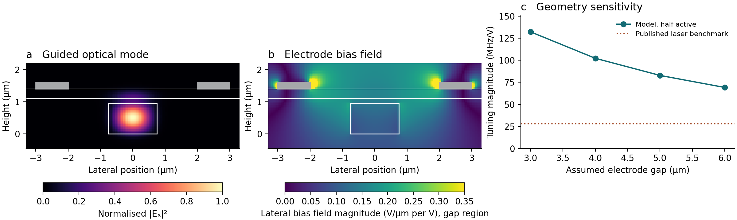
Figure A. Optical mode, unit-voltage electrode field and gap sensitivity. At 50/25 nm mesh spacing, LN electric-energy fractions are 9.46/9.68%, group indices 2.059/2.059 and tuning magnitudes 102/114 MHz/V. The latter changes 11% and exceeds the published locked-laser benchmark of 28 MHz/V [1]. It is a geometry scenario, not a validated laser tuning coefficient.

2 Optical architecture and physical model
Figure 1 separates the laser, coding device and calibration subsystem. Laser A is split before the modulator, leaving the local oscillator uncoded. A second tap enters an unequal-arm Mach–Zehnder interferometer (MZI) for chirp calibration. The Mach–Zehnder modulator (MZM) acts only on the transmit branch. Desired and foreign light enter an ideal balanced coherent receiver; electrical filtering precedes digitization. The model represents one stationary target and one foreign transmitter, with no scan or velocity reconstruction.
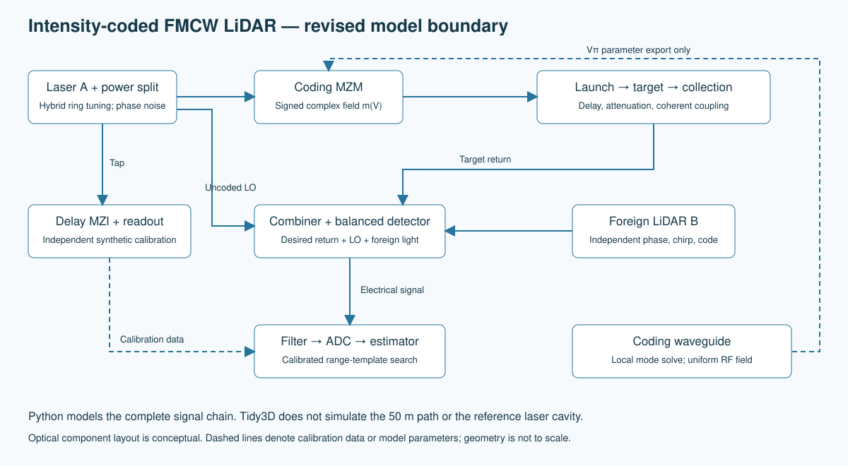
Figure 1. The ring tunes the source frequency while a separate modulator codes only the transmitted field. The local oscillator bypasses the coder. The dashed connection supplies an estimator calibration.

2.1 Source and delayed optical fields
Let an optical field have units of √W. For transmitter j, the instantaneous frequency is νⱼ(t) = ν₀,ⱼ + Sⱼt + δνⱼ(t), where S = B/T is the nominal sweep slope and δν represents deterministic sweep error. The emitted field is
$E_{j,0}(t) = \sqrt{P_{j,0}} exp\{i[2π{∫_{0}}^{t}ν_{j}(u)du + φ_{n,j}(t)]\}$ (1)
The desired return and local oscillator share one laser phase history evaluated at different times. The foreign laser has an independent history. Propagation gives Eᵣ(t) = hEₜ(t − τ), with τ = 2nR/c + τᵢₙₜ; h includes attenuation and target phase. Fractional delays are retained rather than rounded to the ADC clock. Optical carrier oscillations near 193 THz are eliminated analytically in the phase difference, so the numerical sampling resolves electrical beats and modulation rather than the optical carrier itself.

2.2 Course concepts and system boundaries
The system connects anisotropic waves in materials through the LN dielectric response, nonlinear optics through the Pockels interaction, interference through the MZM and coherent receiver, Gaussian propagation through the transmitted beam, and statistical optics through phase fluctuations and photodetection. These connections enter the equations rather than serving only as background. The source phase dynamics remain behavioural; Section 3 estimates its static tuning from geometry; pointing, polarization and optical transmission are lumped assumptions. The calibration readout is represented by independent synthetic phase data, and the background filter is not modeled as a wavelength-resolved optical component.

3 Electro optic coding and component coupling

3.1 Signed field transfer of the modulator
A binary sequence c(t) modulates an electrical subcarrier. The default code contains 100 chips at 1 Mchip/s, with raised-cosine transitions over 0.1 μs and a 5 MHz subcarrier. The two transmitter codes are generated reproducibly from seeds 621 and 622. The drive and ideal balanced transfer are
$V(t) = V_{b} + V_{m}c(t) cos(2πf_{c}t)$ (2)
$m[V(t)] = \sqrt{η_{M}} cos[\frac{πV(t)}{2V_{π}}], E_{t}(t) = m[V(t)]E_{\text{branch}}(t)$ (3)
Here V is the differential arm voltage, ηₘ is the insertion power transmission and V_{π} is the differential half-wave voltage. At the nominal V_{π} = 4 V, the bias is 2 V and the drive amplitude is 1.2 V. A negative m corresponds to a π field-phase reversal. Replacing the field by the positive square root of intensity would lose information used in coherent detection. The implementation also permits arm imbalance and residual phase modulation, although the reported baseline uses an ideal balanced device.
For the equal-launch comparison, the transmit-branch power is adjusted so that P̄ₜ = P_{branch}⟨|m|²⟩ = 10 mW. This normalization must be reported because it changes the source requirement. At quadrature and 3 dB insertion loss, the numerical mean transmission is 0.250594; consequently the required branch power is 39.905 mW. The peak launched power is 18.09 mW at the nominal drive, although the mean remains 10 mW.

3.2 Electro-optic response of the two devices
The electro-optic effect is described by Δ(ε⁻¹)ᵢⱼ = ΣₖrᵢⱼₖEᴿᶠₖ. In a scalar approximation, Δn ≈ −n³rEᴿᶠ/2. This is linear in the applied electrical field but originates from a second-order polarization interaction, χ⁽²⁾(ω;ω,0). In contrast, the cosine in Eq. (3) arises from interference between the two modulator arms. Keeping these mechanisms distinct prevents attributing all MZM distortion to material nonlinearity.
The coding-device calculation solves a rectangular LN ridge/slab optical mode in silica and perturbs the anisotropic permittivity under an assumed uniform field Eᴿᶠ = Varm/g. Crystal Z is aligned with laboratory x, propagation with laboratory y, and the film normal with laboratory z. The derivative κ = dnₑff/dVarm determines the differential voltage response for arm voltages +V/2 and −V/2:
$\frac{d(φ_{1} − φ_{2})}{dV} = \frac{2πL}{λ}κ, V_{π} = \frac{λ}{2L|κ|}$ (4)
Local Tidy3D MZM solves gave Vπ = 2.72 and 3.77 V for width/gap pairs of 1.2/5 and 1.5/7 µm. Both met the 3% numerical checks under a uniform bias field. At the same 2 V bias and 1.2 V drive they require 65.4 and 43.1 mW of branch power for 10 mW launch. A lower Vπ moves the fixed bias away from quadrature; re-biasing is an alternative. The reference receiver experiments retain Vπ = 4 V.
The hybrid source uses a 950 nm SiN core, 150 nm oxide spacer and 300 nm LN film [1]. A straight-section eigenmode and a finite-volume electrode solve share a cross-section. The first-order cavity shift uses the signed lateral bias field, extraordinary optical field energy and an assumed r₃₃ of 31 pm/V. Core width (1.5 µm), electrode gap (4 µm) and effective active fraction (0.5) are design inputs. The model omits metal optical loss, tensor rotation around bends and lock dynamics.

4 Propagation and quantitative performance budget
For a normally illuminated Lambertian target larger than the beam, the collected power is P̄ᵣ = P̄ₜρAᵣη/(πR²), with Aᵣ = πD²/4. We assume reflectance ρ = 0.20, aperture diameter D = 25 mm, aggregate path/receiver transmission η = 0.30 and coherent mode/polarization coupling ξ = 0.10. These are design inputs, not measured properties of the source paper. The coherent power is P̄c = ξP̄ᵣ.
${P̄}_{r}(50 m) = 37.5 pW, {P̄}_{c} = 3.75 pW, N_{γ} = \frac{{P̄}_{c}T}{hc/λ}$ (5)
Equation (5) corresponds to 2,926 coherent-mode-equivalent photons during a 100 μs ramp, before photodetector quantum efficiency. It is not the total collected photon count. For an ideal Gaussian beam with a 5 mm launch waist, z_{R} = πw₀²/λ = 50.67 m and w(50 m) = 7.02 mm. This supports the extended-target assumption only when the illuminated surface exceeds that footprint; target tilt, clipping and turbulence are excluded.
Table 1. Baseline assumptions and original analytical estimates. The linewidth is a sensitivity-model input; the reported Monte Carlo checks set it to zero.
Quantity | Value | Meaning
Wavelength / optical sweep | 1550 nm / 500 MHz | Assumed source output
Ramp / ADC rate | 100 μs / 50 MS/s | 5,000 samples per ramp
Chirp slope | 5 × 10¹² Hz/s | B/T
Round-trip delay at 50 m | 333.564 ns | n = 1; internal delay = 0
Beat / sweep resolution | 1.667820 MHz / 0.299792 m | fᵦ = Sτ; ΔR = c/(2B)
Receiver cutoff / LO | 20 MHz / 0.50 mW | 8th-order filter; fixed LO
Responsivity / electronics | 0.9 A/W / 5 pA/√Hz | Assumed receiver
Effective linewidth | 50 kHz nominal | Lorentzian sensitivity model
Coherence at 50 m | 0.94895 | exp(−πΔντ) at 50 kHz
Shot noise / white-noise bound | 12.008 pA/√Hz / 2.758 mm | No interference or laser noise

At 100 m the desired beat reaches 3.336 MHz. The principal upper coding lobe extends to approximately f_{b} + f_{c} + f_{chip} = 9.336 MHz, within the nominal electrical allocation. Finite transitions and nonlinear harmonics retain spectral tails, however; this estimate does not establish freedom from aliasing. The 20 MHz filter cutoff is below the 25 MHz ADC Nyquist frequency, and the internal simulation rate is increased to assess the residual numerical error.
The 0.300 m sweep-resolution scale describes separation of two returns in a conventional bandwidth-limited measurement. It does not prohibit estimating the frequency of one isolated beat much more precisely. Conversely, a millimetre isolated-target estimate does not establish millimetre resolution for multiple surfaces. The full coded ambiguity function and nuisance parameters determine the relevant coded-system distinction.

5 Coherent detection calibration and estimation
With ideal balanced mixing and detector responsivity ℜ, the current is given by Eq. (6). The one-sided noise spectrum includes shot noise from incident optical power and an electronic current-noise density iₑ. The coherent coupling factor controls mixing efficiency, while collected light can still contribute shot noise.
$i(t) = 2ℜ Re\{{E_{\text{LO}}}^{*}(t)[E_{r}(t) + E_{B}(t)]\} + n(t)$ (6)
$S_{i} = 2qℜ(P_{\text{LO}} + P_{r} + P_{B} + P_{\text{bg}}) + {i_{e}}^{2}$ (7)
For an isolated real sinusoid of amplitude A = 2ℜ√(P_{LO}P̄c), define integrated CNR = A²T/Sᵢ. With Bₙ = 1/(2T), this equals the ratio of sinusoidal mean-square current to noise power SᵢBₙ. The nominal budget gives 35.55 dB including electronics. The unknown-phase white-noise frequency-estimation bound [5], transformed to range, is
$σ_{R} ≥ \frac{c}{2B}\frac{\sqrt{3}}{π\sqrt{\text{CNR}}} ≈ 2.76 mm$ (8)
This high-SNR, isolated-sinusoid reference excludes interference, sweep error, speckle and laser phase noise. It cannot be assigned unchanged to a filtered coded waveform. The code also evaluates local template information for numerical checks. Under the Lorentzian model, Var[φ(t) − φ(t − τ)] = 2πΔντ and |g⁽¹⁾(τ)| = exp(−πΔντ); sampling a common phase history for the return and LO preserves this correlation.

5.1 Independent calibration and range search
Synthetic MZM measurements are fitted independently of the measurement waveform. A delay-MZI phase record estimates the chirp parameters, with calibration noise specified separately from receiver noise. A 10 m fiber imbalance at assumed group index 1.468 gives a 48.97 ns delay and approximately 244.84 kHz beat. This is a calibration model, not an implementation of the iterative learning predistortion demonstrated by Zhang et al. [3]. One fitted calibration realization is reused within each reported Monte Carlo run; uncertainty from repeated recalibration is not marginalized by those trials.
For each candidate range r, two filtered quadrature templates form a matrix Xᵣ. After approximate stationary-PSD whitening, the range search maximizes the projection score J(r) = yᵀXᵣ(XᵣᵀXᵣ)⁻¹Xᵣᵀy. This eliminates unknown amplitude and phase by least squares. The search spans 10–100 m on a 0.075 m grid followed by continuous refinement. The uncoded method uses the same fitting framework; an FFT estimate is an auxiliary baseline rather than the sole estimator.

5.2 Four comparisons and detection protocol
The uncoded method bypasses the MZM. The small-signal method uses a linear expansion of its field transfer; the full-field method uses the independently calibrated nonlinear transfer. The sideband method uses the same physical coded transmitter but restricts processing to 4.5–10 MHz. Reported multi-trial results cover uncoded, full-field and sideband processing; the small-signal method is implemented but lacks an equivalent completed campaign here.
Target-absent trials calibrate the 99th-percentile maximum-search score, followed by independent target-absent validation and target-present testing. When interference is present it is retained in the null hypothesis. Thresholds are fitted separately for each assumed interference condition. This tests detection under a known interference distribution, not a universal fixed-threshold deployment. Gross error is defined as |R̂ − R| > ΔR/2 = 0.1499 m, and RMSE includes all target-present estimates regardless of detection.

6 Verification and preliminary ranging results
Fourteen physical and numerical tests passed, including fractional-delay coherence, link power, MZM field sign, ISR amplitude scaling, filtered-noise variance, independent calibration and noiseless off-grid ranging. For deterministic receiver waveforms, internal rates of 200 and 400 MS/s differed from the 800 MS/s reference by 1.80% and 0.358%, respectively. The reported examples use 200 MS/s; they should be treated as preliminary until selected conclusions are repeated at higher internal rates. Passing the code tests verifies specified behavior rather than validates the target or hardware assumptions.
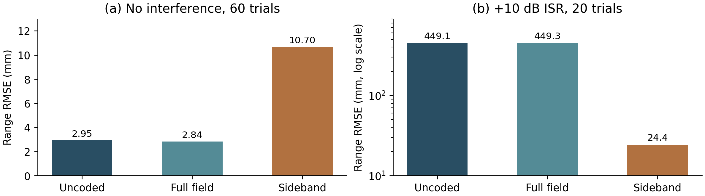
Figure 2. Results regenerated from saved trials. (a) Receiver-noise validation without interference, 60 target-present trials per method. (b) Separate mechanism check with a foreign beat 0.45 m beyond the desired target, +10 dB ISR and 20 target-present trials. Both studies set laser linewidth and deterministic chirp error to zero; panel (b) uses a logarithmic vertical scale.

6.1 Receiver noise verification
Without interference, the RMSEs are 2.945 mm for uncoded, 2.839 mm for full-field and 10.695 mm for sideband processing. The small difference between the first two methods is not evidence of a statistically established advantage. The full-band values are close to the analytical white-noise reference; the sideband estimate loses precision because much of the signal is excluded. No gross error occurred in any 60-trial set, but the two-sided exact 95% binomial interval still permits a failure probability as high as 5.96%.
Each method used 1,000 target-absent trials to calibrate its threshold and 1,000 independent trials to validate it. Held-out false-alarm rates were 0.7%, 1.3% and 1.0%, with respective 95% intervals of 0.282–1.437%, 0.694–2.213% and 0.481–1.831%. All include the 1% target, although none establishes an exact rate. Detection was 60/60 for each method, with a 95% interval of 94.04–100%. These observations apply to the receiver-noise setup rather than the nominal 50 kHz source model.

6.2 A bounded interference mechanism check
At +10 dB received ISR, the uncoded and full-field estimators followed the foreign beat: their RMSEs were 449.129 and 449.338 mm, with 20/20 gross errors. Selected-sideband processing gave 24.351 mm RMSE and 0/20 gross errors. The corresponding 95% gross-error intervals are 83.16–100% and 0–16.84%; the latter does not prove a failure rate below 1%. The sideband result also misses a 1 cm RMSE objective in this case.
Only 100 null trials per calibration and validation split were used for this small study. Its no-interference thresholds produced false-alarm estimates of 9%, 4% and 1%, illustrating the instability of a small tail calibration. Consequently, the interference experiment supports the qualitative range-selection mechanism, but cannot establish a controlled detection advantage or the largest tolerable ISR. No result from a planned larger campaign is included in Figure 2.

7 Coding energy and engineering tradeoffs
For normalized processed templates, let μ denote their overlap after maximizing over unknown phase. The projected foreign-to-desired energy scales approximately as ISR|μ|². This diagnostic explains why an intensity code does not guarantee rejection: a large uncoded optical carrier can remain common to both waveforms. At +20 dB ISR, |μ| must be below 0.1 to make this projected interference smaller than the desired signal; 10 dB projected signal-to-interference would require |μ| below 0.0316.
The executed 41-by-41 timing/frequency ambiguity grid gives full-field overlap of approximately 0.882–0.921 at zero foreign beat offset over sampled timing shifts, versus 0.017–0.278 in the selected band. At +20 dB ISR, these values correspond to projection ratios of roughly 78–85 and 0.029–7.73. Even the sideband case is not uniformly protected. The finite grid can miss narrow maxima, and overlap is a deterministic surrogate, not a measured error probability.
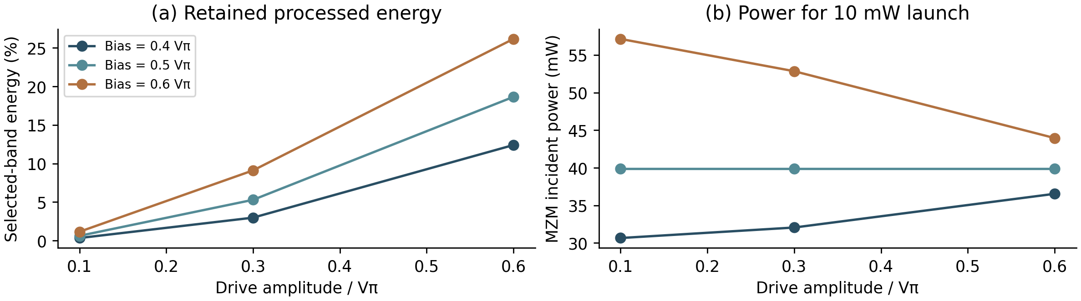
Figure 3. Deterministic bias/drive sweep at fixed 10 mW mean launched power. (a) Fraction of processed quadrature energy retained in the 4.5–10 MHz band. (b) Required incident transmit-branch power. Curves are drawn through the nine calculated points and do not represent a continuous optimization or interference-rejection measurement.
At the nominal bias and drive, the selected band retains 5.29% of the processed quadrature energy, equivalent to a 12.77 dB energy reduction. This is not all code-bearing energy, nor is it an optical-power fraction or a directly transferable RMSE penalty. The observed no-interference RMSE increases by approximately 3.77 times relative to full-field processing. Changing bias and drive increases the retained fraction as high as 26.17% among the tested points, but also changes mean transmission, peak power and template shape. Figure 3 alone therefore cannot select the best interference-resistant setting.

7.1 Complete source allocation and the uncoded alternative
The 39.905 mW required at the nominal MZM input excludes the LO and calibration tap. Assuming a 0.50 mW LO, a 0.10 mW calibration tap and 95% aggregate allocation efficiency gives P_{source} = (P_{branch} + P_{LO} + P_{cal})/0.95 = 42.637 mW. An uncoded bypass with the same 10 mW launch requires 11.158 mW under those assumptions. The coded architecture therefore requires about 3.82 times total optical source power. These are allocation estimates, not established output capabilities of the reference laser or wall-plug electrical power.
The practical alternative is an uncoded, calibrated FMCW transmitter that bypasses the MZM. A fair comparison must include both equal launched power and equal available source power. In the latter experiment, absolute foreign illumination should also be held fixed; otherwise changing the desired return while holding ISR fixed implicitly changes the interferer. The implementation supports this distinction, but a completed equal-source-power interference campaign is not yet available.

8 Accuracy limits and interpretation
High statistical precision does not imply comparable absolute accuracy. With f_{b} = S(2nR/c + τᵢₙₜ), differentiation gives the first-order error relation below. It retains the internal-delay contribution to the sweep-scale term; if τᵢₙₜ is negligible, that term reduces to −RδS/S.
$δR ≈ \frac{cδf_{b}}{2nS} − [R + \frac{cτ_{\text{int}}}{2n}]\frac{δS}{S} − R\frac{δn}{n} − \frac{cδτ_{\text{int}}}{2n}$ (9)
At 50 m, a 0.1% slope-scale error alone produces approximately 5 cm range error. A 1 cm single-error allowance corresponds to 200 ppm relative sweep slope or air-index error, or 66.7 ps internal-delay uncertainty. These are separate allowances, not independent allocations that can all be exhausted simultaneously. Correlated calibration errors require a joint budget, and the current vacuum-index baseline does not demonstrate air-path absolute accuracy.
In weak interference and a stable isolated target, receiver noise sets a useful reference floor. A real system may instead be limited by calibration error, technical laser noise or changing coherent coupling. Under overlapping foreign illumination, common-carrier correlation can dominate range selection. Diffuse targets add a separate limitation: Baumann et al. showed that speckle phase noise can generate non-Gaussian errors and outliers in coherent ranging [4]. The available multi-scatterer extension is a sensitivity model, not a validated reproduction of their theory; no rough-surface performance claim is made here.

8.1 Source-driven ranging with finite linewidth
A 5 V excursion at the 50 nm model coefficient gives a 511 MHz sweep, 0.293 m nominal resolution and a 1.71 MHz beat at 50 m. At the measured 28 MHz/V benchmark the same excursion gives only 140 MHz and 1.07 m. Thus the design cannot promise 30 cm resolution at 5 V. The following experiment is conditional on the modelled sweep, linear response and maintained lock.
Both lasers have 50 kHz linewidth. We search 47 to 53 m and use the same 40 seeds per condition, including identical coded observations for the matched and wrong-code receivers. At +10 dB, 36/40 matched estimates fall within half a resolution cell versus 21/40 uncoded and 3/40 wrong-code. These are localisation counts, not thresholded detections. With no foreign light, uncoded RMSE is 3.42 mm versus 13.56 mm matched. Neither a rare-failure rate nor wide-area acquisition follows from this experiment.
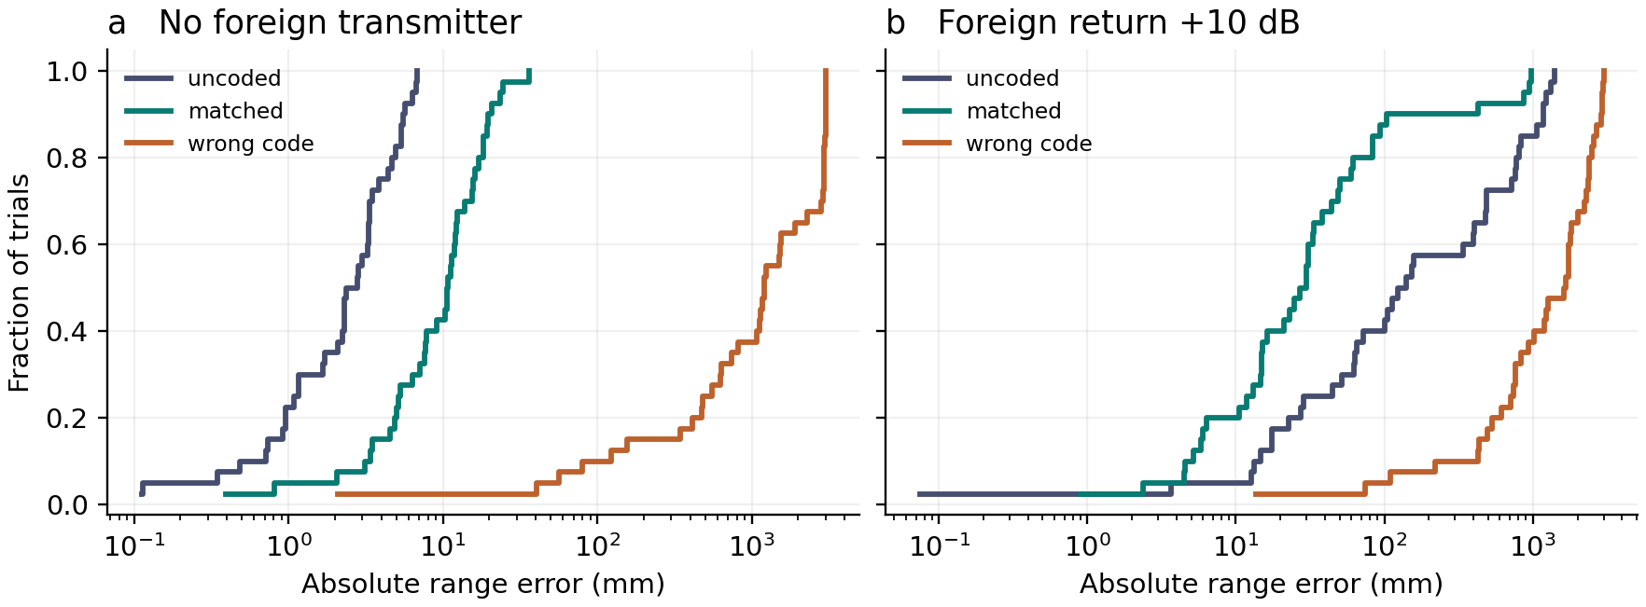
Figure 4. Empirical cumulative range error. Long tails explain why median and RMS error lead to different design judgements. The same-band wrong-code control tests whether filtering alone explains discrimination.

9 Conclusion
Coding trades quiet-target precision and optical power for conditional discrimination. At +10 dB and 50 kHz linewidth the matched sideband lowers RMSE from 581 to 267 mm, but still misses a 1 cm objective. Source tuning is a separate uncertainty: electrode overlap predicts a larger sweep than the reference measurement. Priorities are an independently calibrated sweep, thresholded wider searches, and fixed-source-power tests across foreign slopes.

Author contributions
Andre and Colin: individual contributions to modelling, analysis, writing and presentation are to be confirmed by the authors before submission.

References
[1] V. Snigirev et al., “Ultrafast tunable lasers using lithium niobate integrated photonics,” Nature 615, 411–417 (2023). https://doi.org/10.1038/s41586-023-05724-2
[2] Y. Hai, Z. Yan, A. Pang, C. Liu, and A. Dang, “Immunity to Mutual Interference in Coded Phase-Shift LiDAR,” Journal of Lightwave Technology 41(2), 570–577 (2023). https://doi.org/10.1109/JLT.2022.3219920
[3] X. Zhang, J. Pouls, and M. C. Wu, “Laser frequency sweep linearization by iterative learning pre-distortion for FMCW LiDAR,” Optics Express 27(7), 9965–9974 (2019). https://doi.org/10.1364/OE.27.009965
[4] E. Baumann, J.-D. Deschênes, F. R. Giorgetta, W. C. Swann, I. Coddington, and N. R. Newbury, “Speckle phase noise in coherent laser ranging: fundamental precision limitations,” Optics Letters 39(16), 4776–4779 (2014). https://doi.org/10.1364/OL.39.004776
[5] S. M. Kay, Fundamentals of Statistical Signal Processing, Volume I: Estimation Theory (Prentice Hall, 1993). ISBN 978-0-13-345711-7.
[6] Flexcompute, “Thin film lithium niobate electro-optic modulator,” Tidy3D Example Library, accessed 5 November 2026. https://www.flexcompute.com/tidy3d/examples/notebooks/TFLNTidy3d/ . Tutorial based on Y. Li et al., “High-Performance Mach–Zehnder Modulator Based on Thin-Film Lithium Niobate with Low Voltage-Length Product,” ACS Omega 8, 9644–9651 (2023), https://doi.org/10.1021/acsomega.3c00310.

Computational data provenance
Figures 1 and A: docs/system_architecture.svg and hybrid/source.py. Figure 2: saved baseline and interference trials. Figure 3: results/tradeoff/bias_drive.csv. Figure 4: hybrid/ranging.py and hybrid/output/paired.csv. Reproduction instructions, field arrays, assumptions and numerical checks accompany this manuscript.

