**Project Management Report**

“Simple Merge Program” Progress Report is about

how to create this program Together

Written by Hyeontae Kim

Team 19

Github Repository : <https://github.com/caucse19/SE_TermProj>

Team :

Kim Hyeontae

Son Chang Woo

Kang Min Soo

Lee Jun ho

Park Jin Hyuk

Yang Insu

Semester : Spring 2018

**Introduction**

Simple Merge Program is comparing two file and merge each *block. Has function that can load , save file and edit, compare, merge is also handled. Especially compare function, *blocks are highlighted

*block : a line that differ each file

We also use branch and separate folders in each section development , document

In document folder there are documents for Simple Merge Program like SRS , Usecases and imgs for documents with using ‘document’ branch.

In javasource folder there are java codes for our Simple Merge Program , with using ‘development‘ branch.

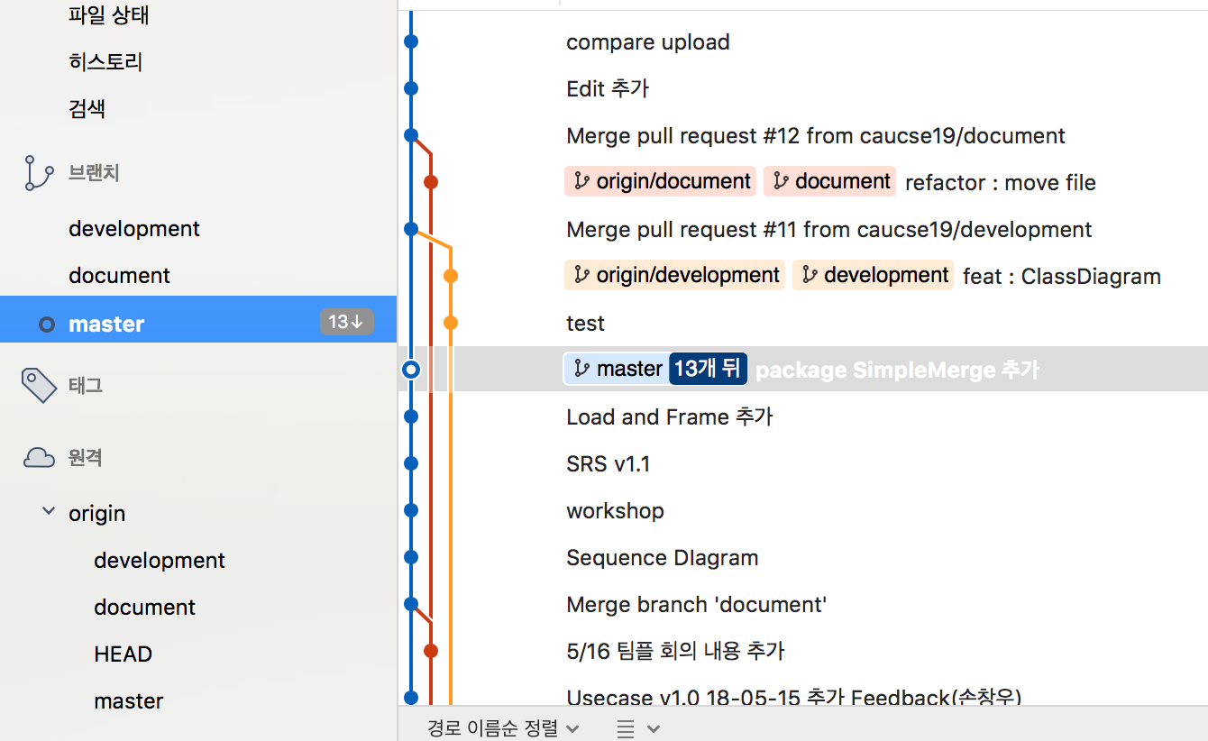

* three branch in source tree program

*Issues also help our team work , when we curious about something that other people has responsibility we just go to github and report new issue then people are commented about that issue so we can understand about curious things

**Progress for a month**

Week1

* Create Github repository
* Learn Source Tree Program for using git efficiently
* planning our project

Week2

* Specify Simple Merge programs goal
* Write Use Case and Misuse Case
* And other non-functional requirements
* Write SRS Document

Week3

* Edit SRS Document
* Create Base Program for Simple Merge Program
* Divide the work up between us

Week4

* Write Java Code for each part based on SRS Document
* Communicate each parts with Sequential diagram

Week5

* Test our program based on check list in Ecllipse Junit
* Merge “Simple Merge Program” in code
* Record our Project

**Pic Logs**

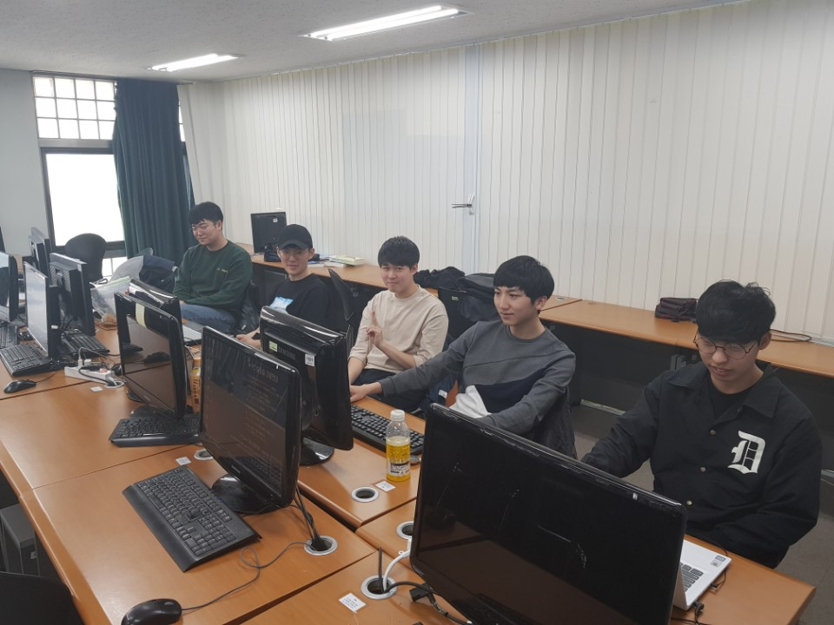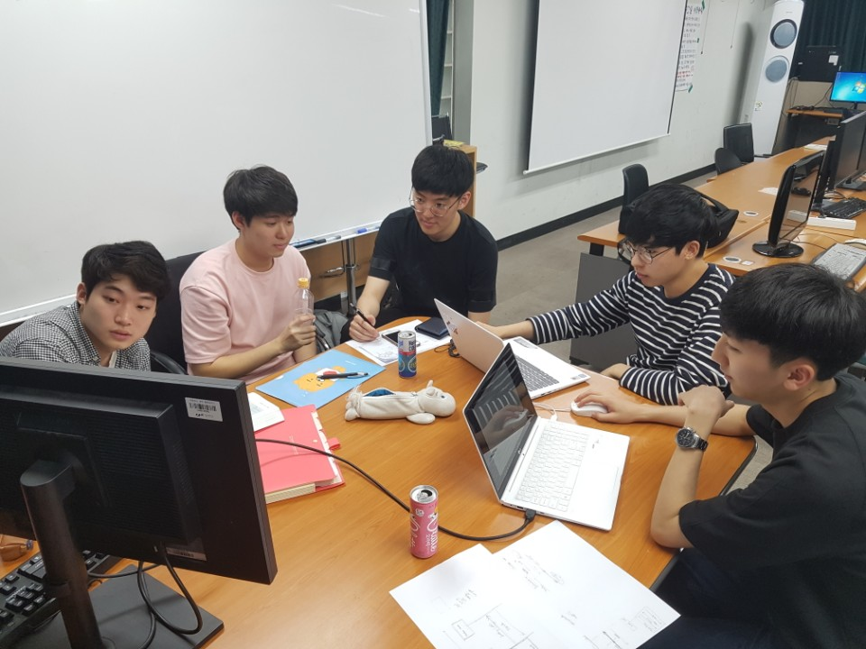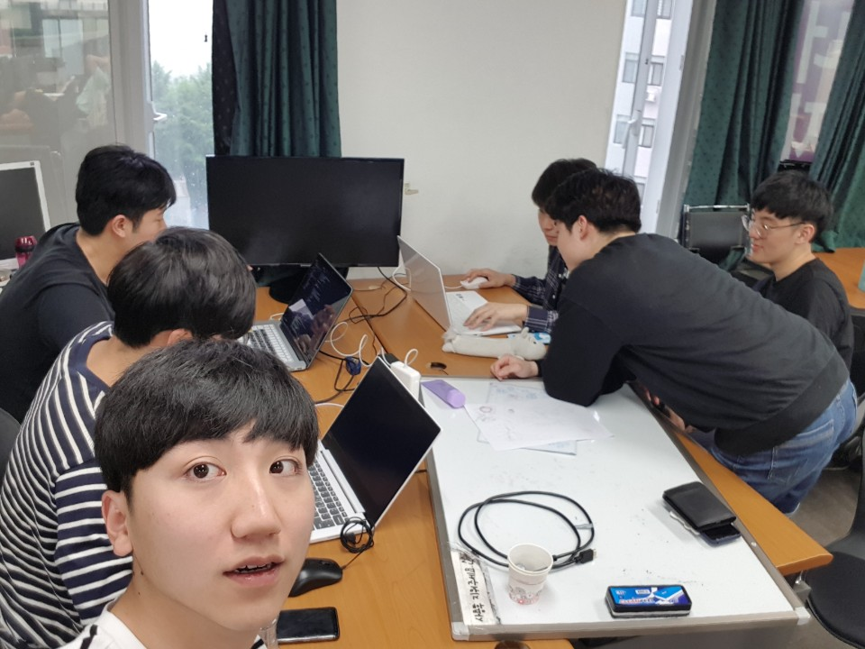

**\*Issues**

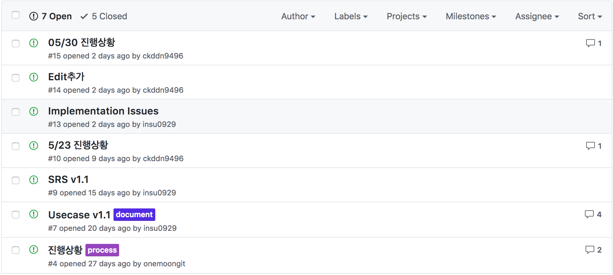

**Summary**

Simple Merge Program that we maded is very simple and powerful tool also easy to use in our GUI ( Graphical User Interface ).

The Program main goal is compare two files and merge to one direction user wants at each blocks

With using github , we can work together easily about code , documents , change logs , etc…

**Experience**