**1. Execute**

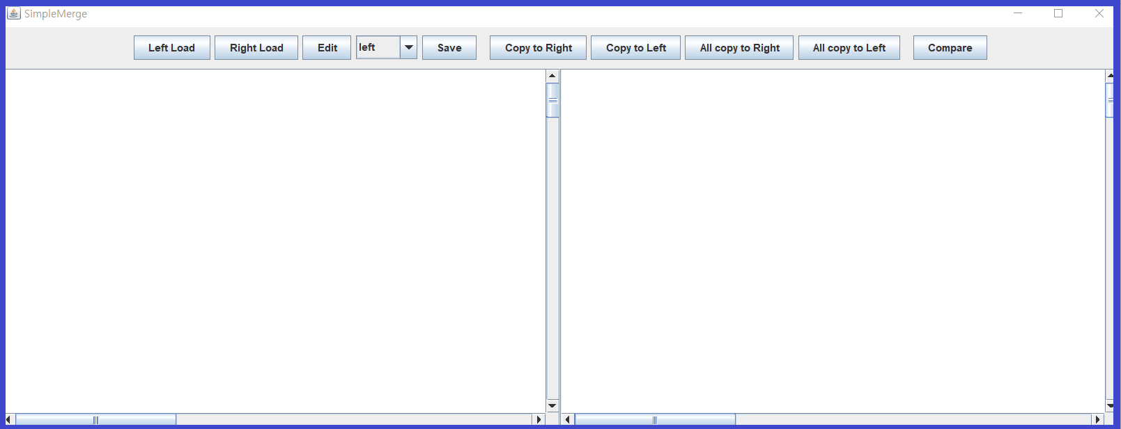

1) Run SimpleMergeMain

- Program displays View (SimpleMergeFrame).

**2. Load**

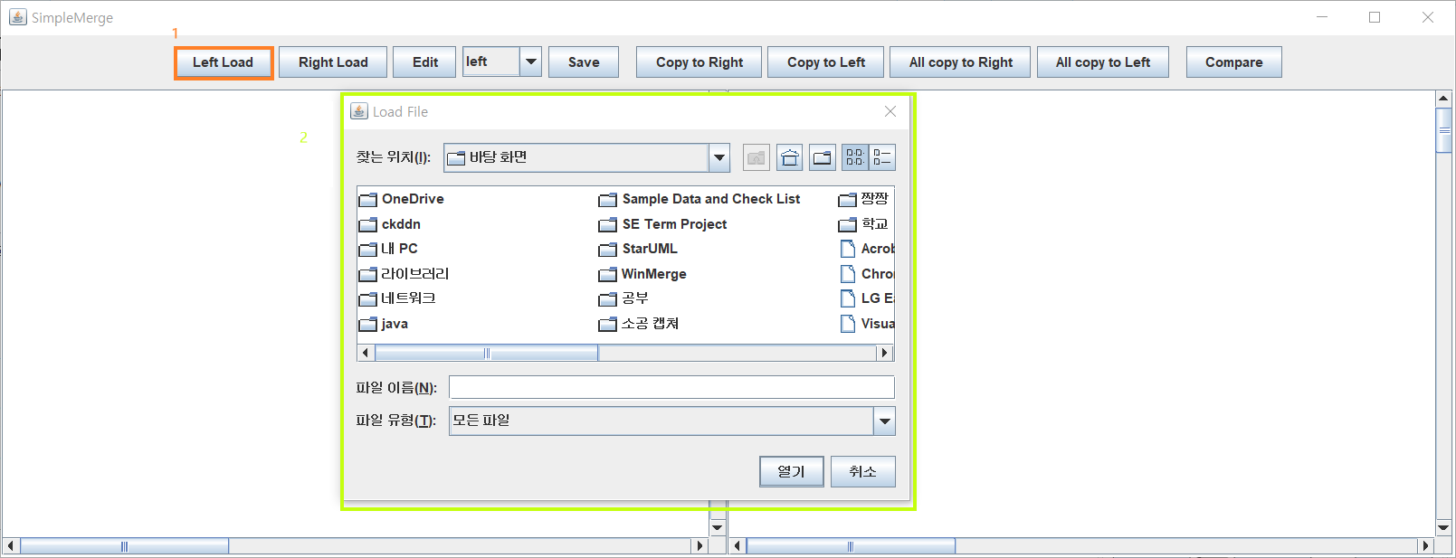

1) Press Left Load Btn

- Press “Left Load” button.

- FileChooser frame for load file to left panel evoke.

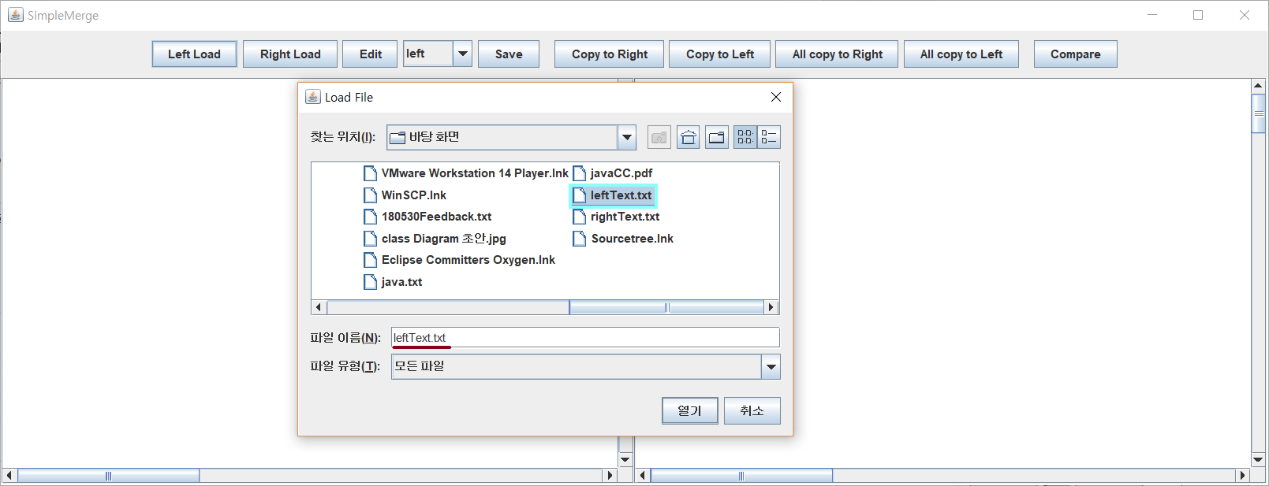

2) Select File and Press Open Btn (Left)

- select file from filechooser frame.

- selected file name recorded in filename label.

- press “열기” button.

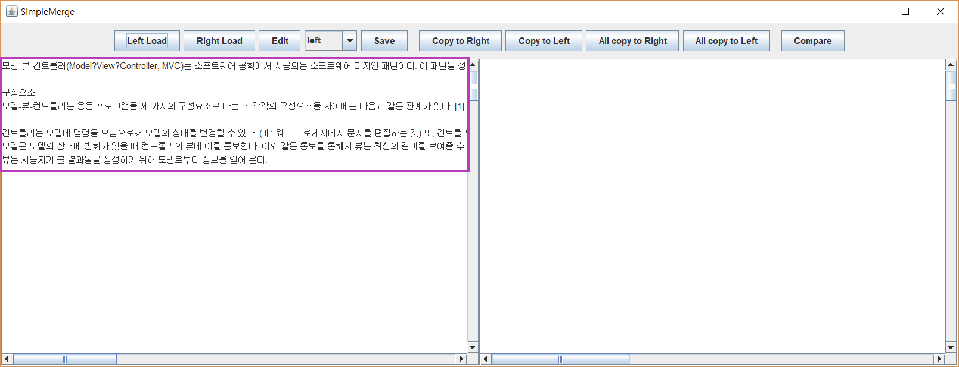

3) Left Load Complete

- selected file’s contents recorded in left panel.

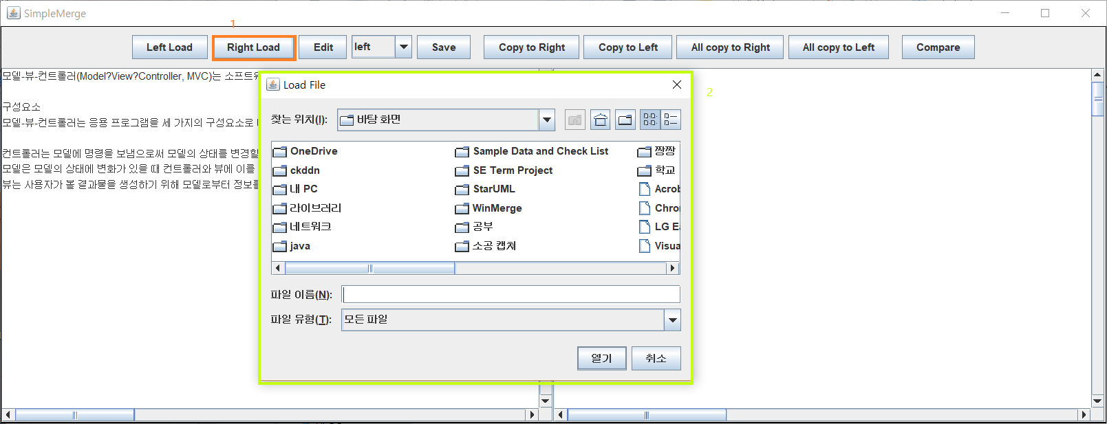

4) Press Right Load Btn

- Press “Right Load” button.

- FileChooser frame for load file to right panel evoke.

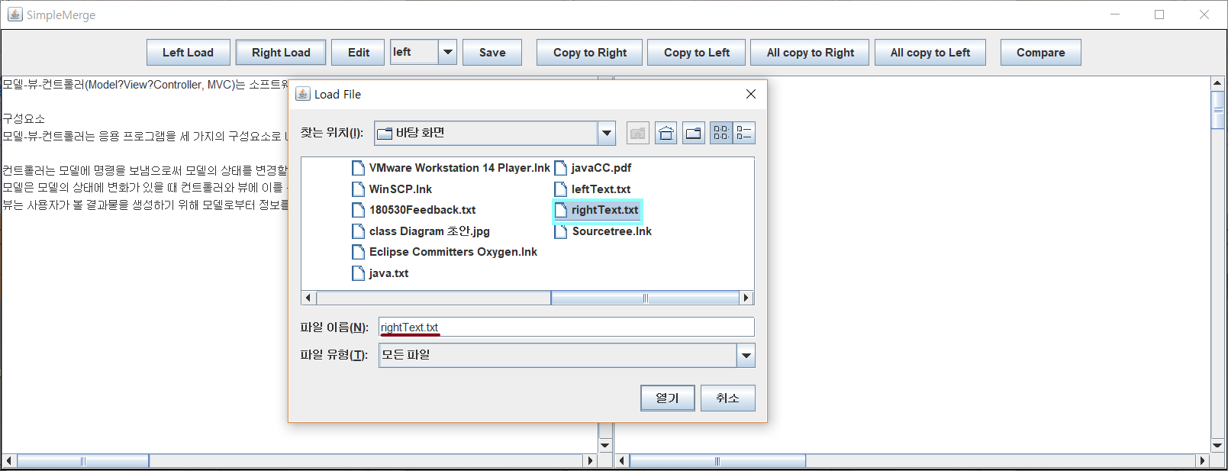

5) Select File and Press Open Btn (Right)

- select file from filechooser frame.

- selected file name recorded in filename label.

- press “열기” button. (same with sequence 2)

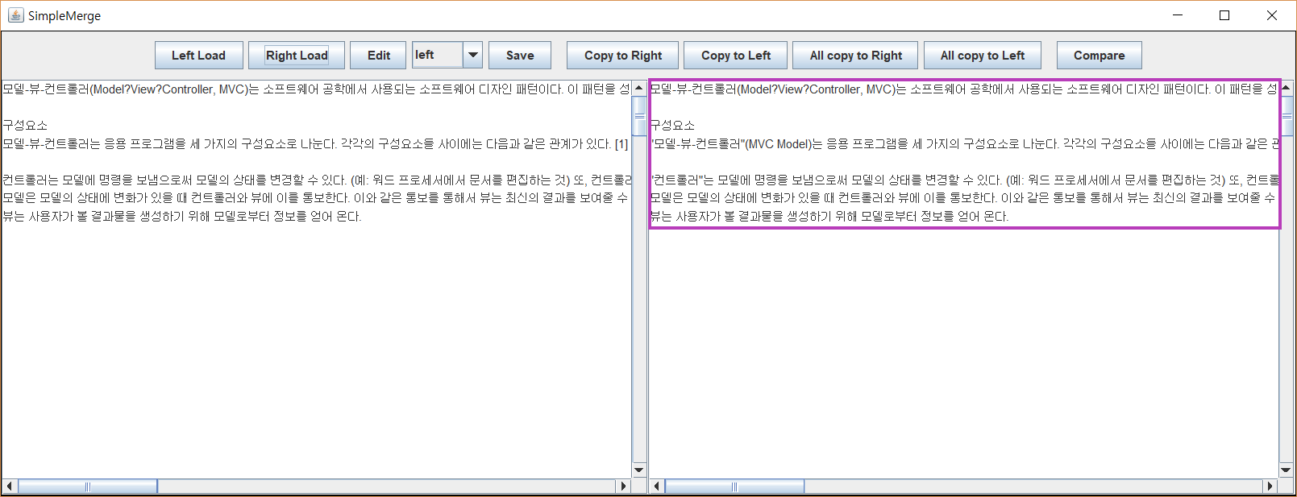

6) Right Load Complete

- selected file’s contents recorded in right panel.

**3. Edit**

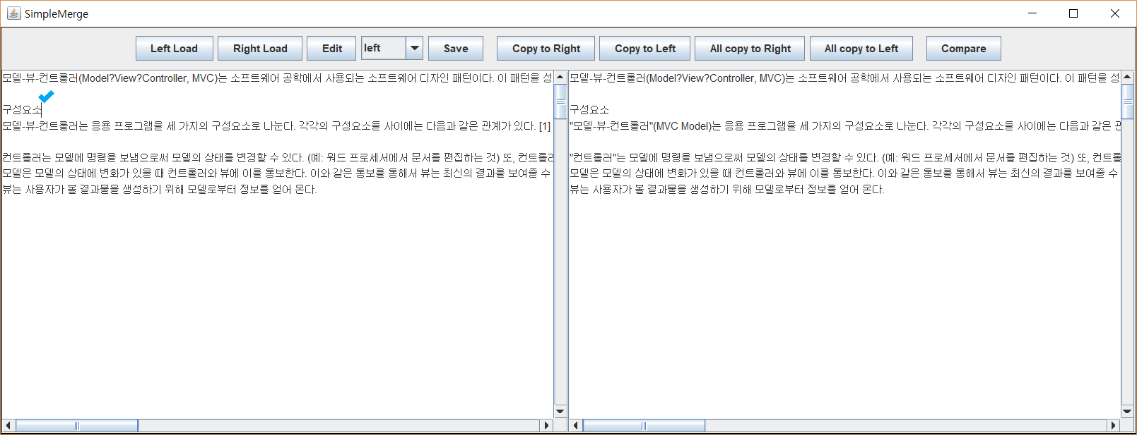

1) Default (Editable)

- Default mode of panel, sight of editable, is editable.

- if you click panel, the cursor will blink.

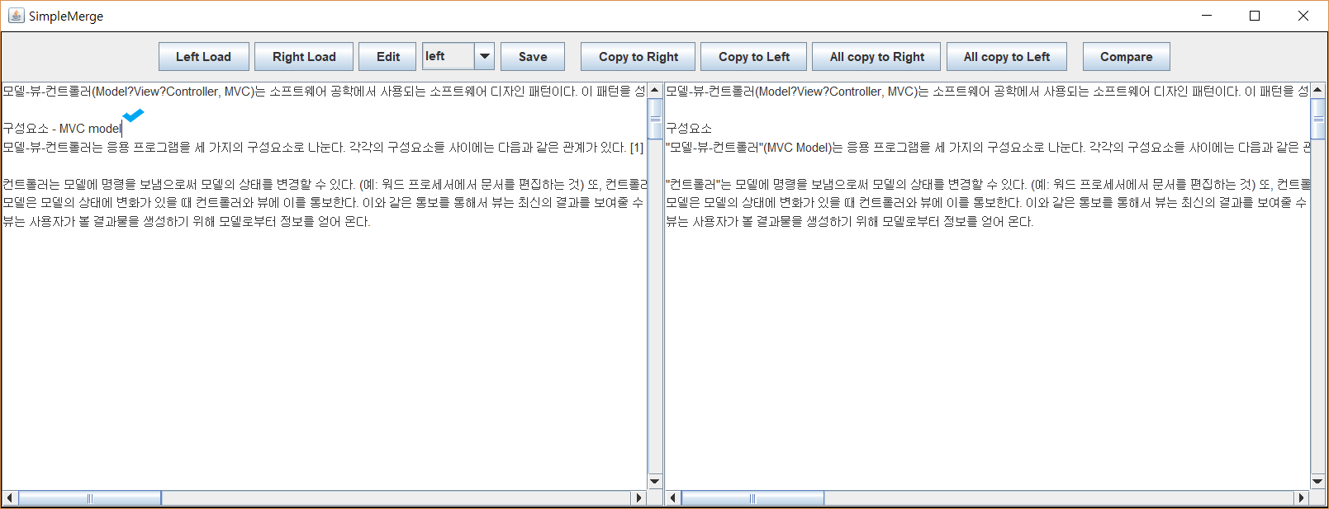

2) Edit contents

- input strings are recorded in the selected panel.

- cursor still blink cause panel is editable.

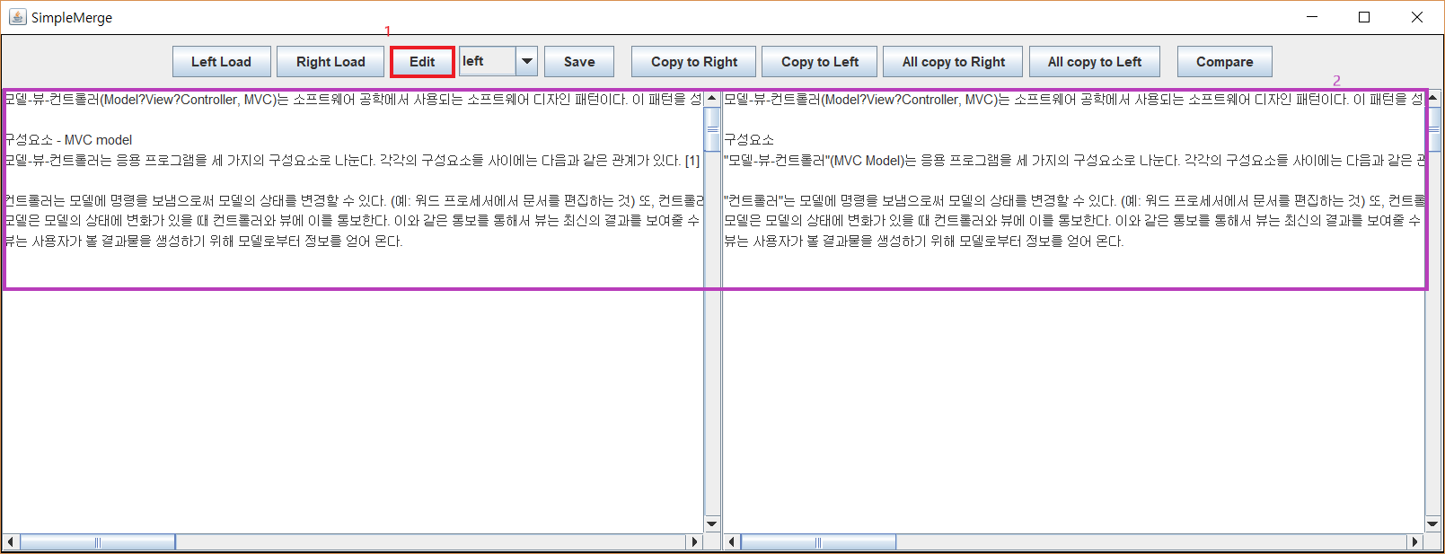

3) Press Edit Btn when the panel is Editable (set Uneditable)

- press the “Edit” button.

- panel will not be selected.

- cursor disappear and panel is not editable.

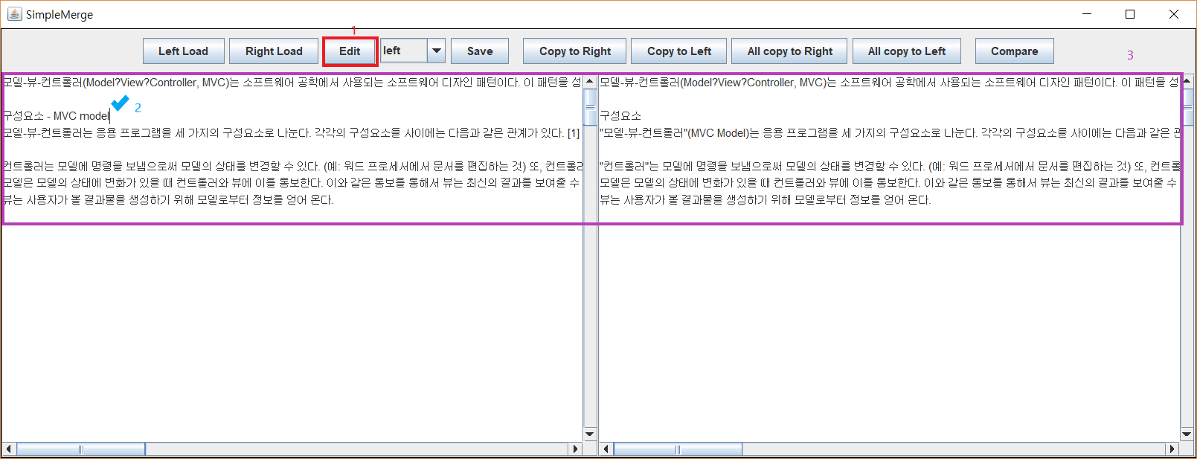

4) Press Edit Btn when the panel is Uneditable (set Editable)

- press the “Edit” button.

- can access to contents.

- cursor appear and panel is editable.