**Robotics Nanodegree**

**Term2 – Project1: Robotic Inference**

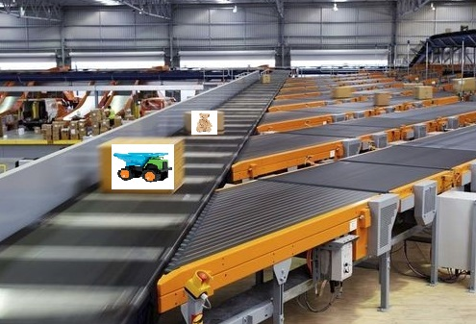

**INTRO**

The objective of the project is to create a classification network that achieves at least 75% accuracy and inference time is less than 10ms. This project involves:

* Data acquisition
* Choosing a network and classification
* Deployment(simulating using a Jetson TX2

For this project I chose the example of a toy factory that has to sort thru different types of toys on a conveyor belt. I chose 2 categories to sort: stuffed animals and cars/trucks.

**DATASET**

The following steps were taken to create the dataset:

* I gathered the data set by saving around 400 images from the internet for each category
* Images were JPEGs RGB
* The images were resized to 256x256
* The images were augmented by flipping them left to right
* After augmentation the dataset had around 1600images
* Split was 75/25 for training/validation

A random sample of 16 images for each class is shown below for class0:

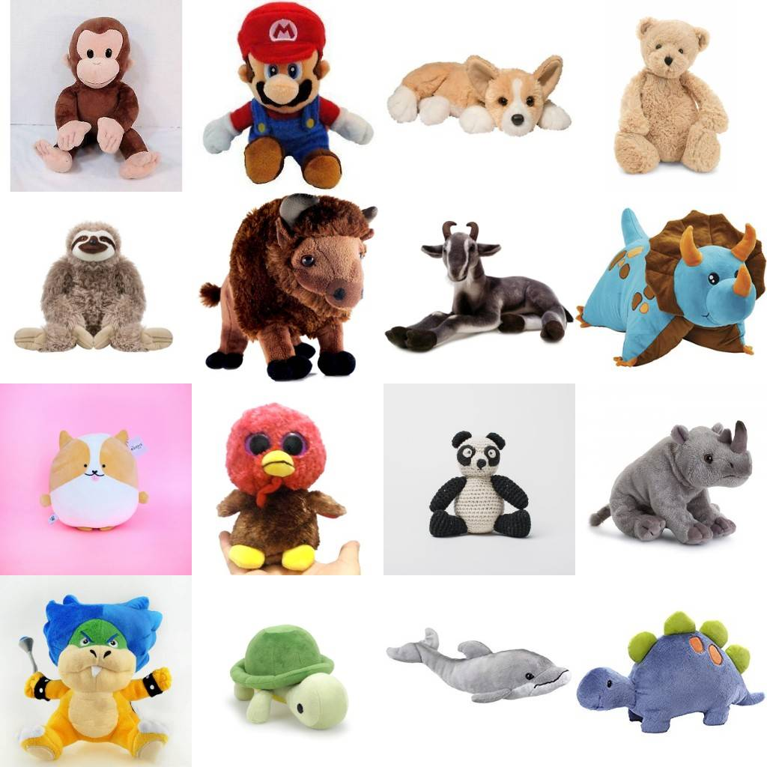

A random sample of 16 images for each class is shown below for class1:

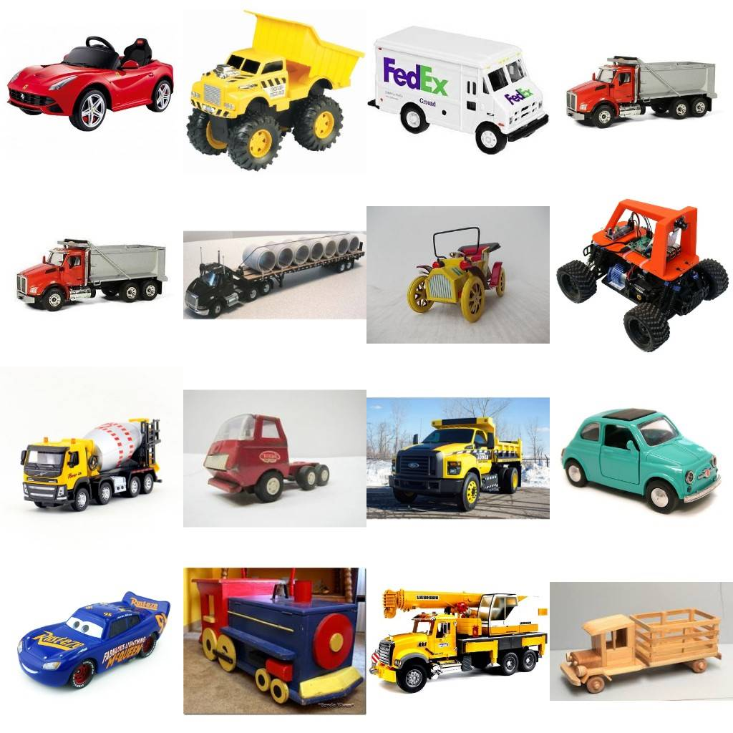

The summary of the dataset from DIGITS is shown below:

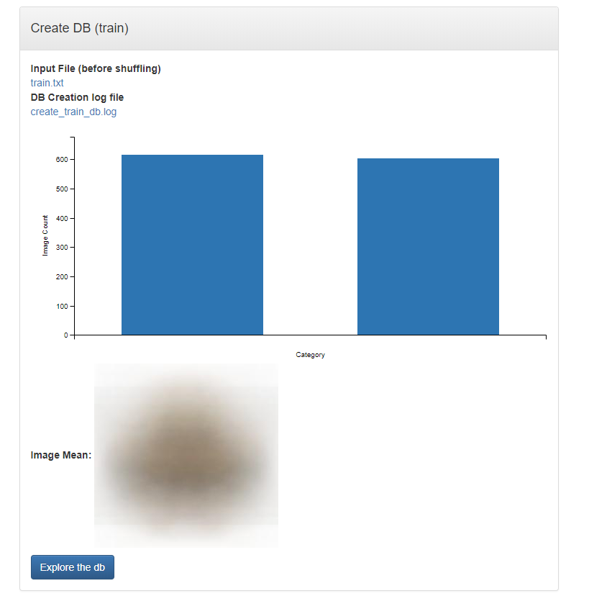

**TRAINING**

The project stated that the accuracy had to be higher than 75%. GoogleNet is a good compromise between Accuracy and Inference speed. I chose to re-train GoogleNet with just 2 classes, which would make it more accurate and faster.

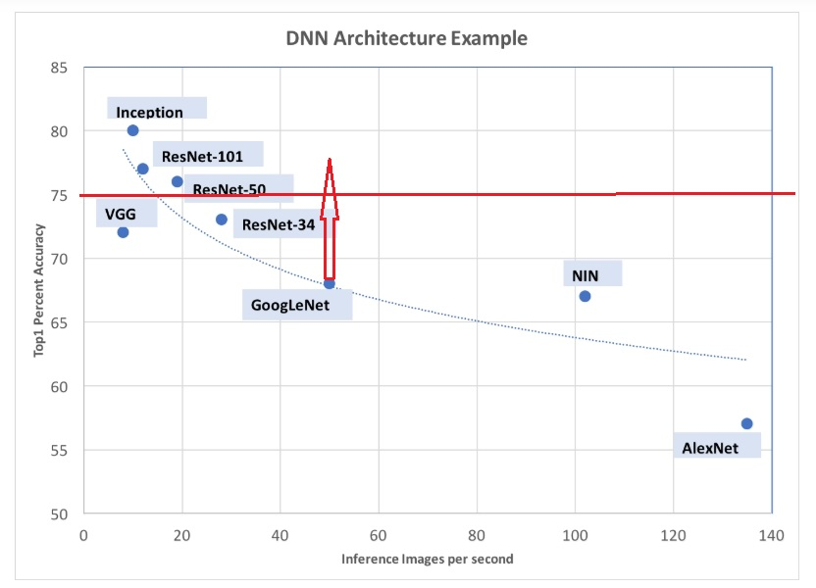

Training was done on DIGITS (NVIDIA Deep Learning GPU Training System):

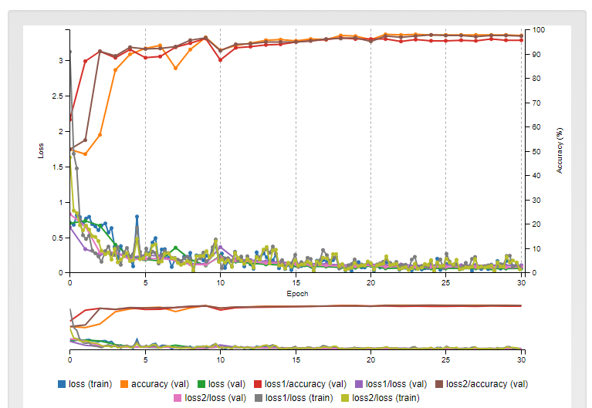

The model was trained using 30 epochs and using a variable training rate of 0.01/0.001/0.0001 . The accuracy of the train/valid was around 98%

**TEST**

To test the model to be deployed, I used images that were not part of the train/valid data. Here are 6 samples with (0 is class stuffed animal and 1 is class car/truck):

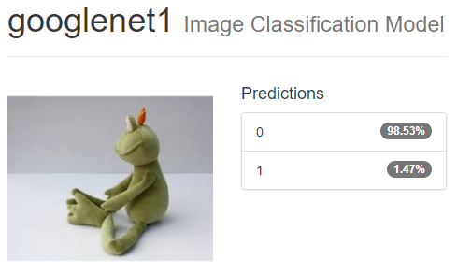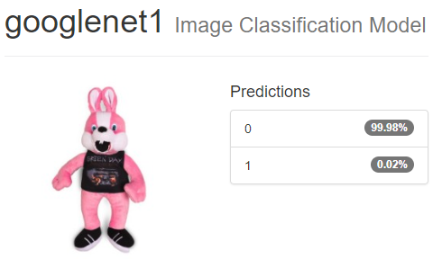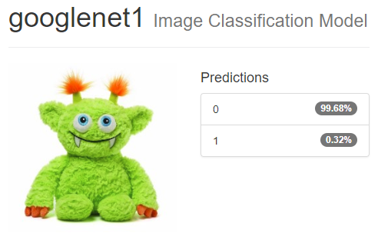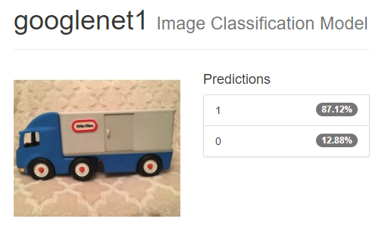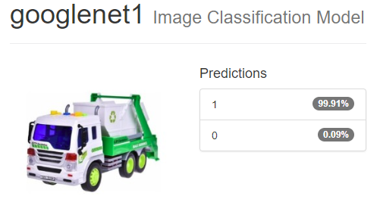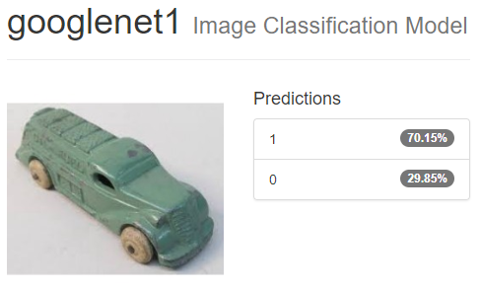

The model was able to correctly classify all 6 images. The accuracy was much higher for the stuffed animal class, possibly because of the easier to identify features such as eyes, mouth, and round shapes.

**DEPLOYMENT**

I was not able to redeploy since I do not have a Jetson TX2, so only the computer simulated was done.

**CONCLUSION/FUTURE WORK**

The DNN was able to correctly identify the items at a very fast rate. This would certainly work on a conveyor system for a factory to sort out the objects.