Mobile Apps 2024   
Movie Screen

Assignment 2

Due: 11:59PM

11 April 2024

Caue Fabiano

n° 25655

# Work

To do this assignment, I to start with drew the plans for the screens that you simply fair can see underneath, and after that coded.

At that point I handled the route. I schemed the courses between the assorted screens inside the file you will be able see underneath, at that point coded. In organize to investigate from screen to screen, I utilized the course Controller from Jetpack Compose.

At final, all the movies' data is put away locally. When I upgrade, for event, the number of seats chosen, the app changes the fitting address on the computer. To encourage my information, I went on the area myvue.com and recuperated the fitting areas. To appear the pictures, I went on pixabay to utilize free-licensed pictures.

You'll see the History fragment to see the wander step by step.

# Designs

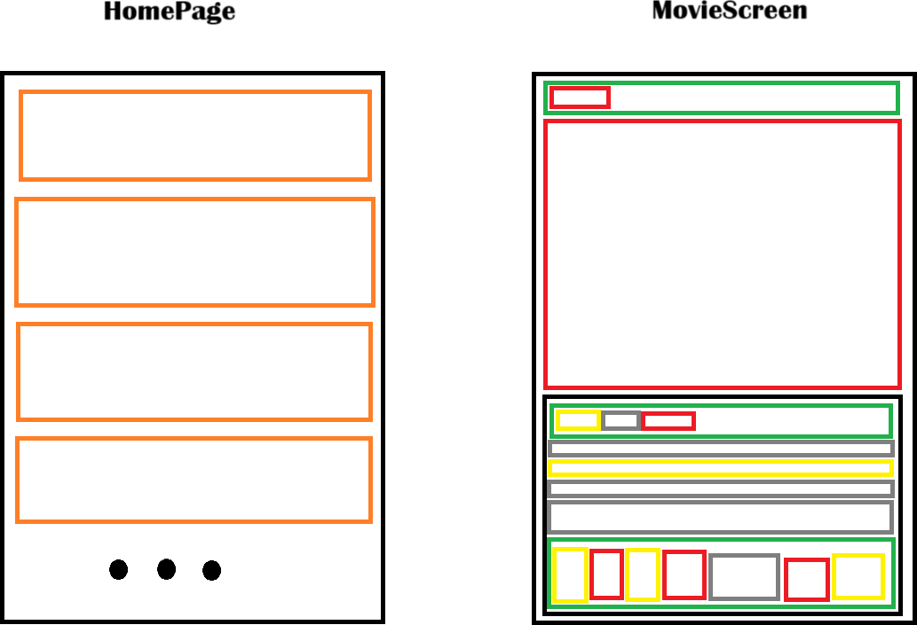

**Legend Column/Row/Image/Text/Card/Spacer**

# Screens

The essential screen named HomePage merely fair can see inside the Plans region, businesses a LazyColumn to list the motion pictures. Interior this LazyColumn, each thing businesses the modifier property clickable to course the client on MovieScreen.

The MovieScreen takes in parameters a Thing from the information course Thing, ie.Requirements. At the most, excellent the picture takes the total screen width and half of the screen tallness, utilizing the modifier's fitting properties. Utilizing Works from jetpack Compose, the screen appears vital information nearly the film. Too, utilizing a variable variable as the counter, the screen shows up the number of seats cleared out. As the counter is put absent particularly inside the movie's data lesson, this information can be showed up when going back on the HomePage.

# Navigation

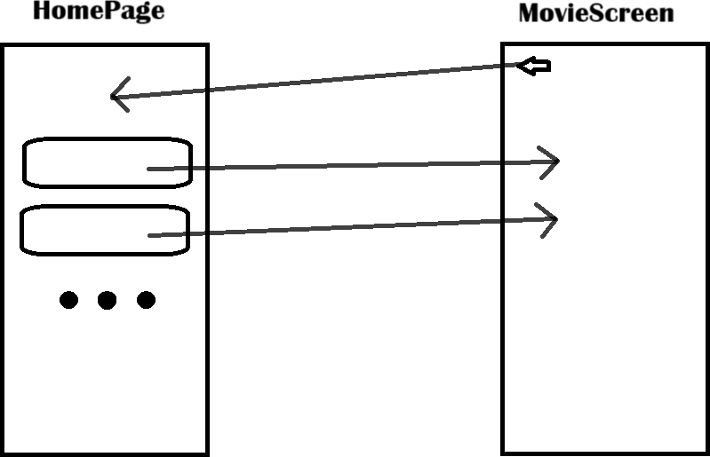

The route is beautiful direct. The client can tap on the cards to go to the MovieScree. Additionally it can press on a Back Bolt to urge back to the HomePage.