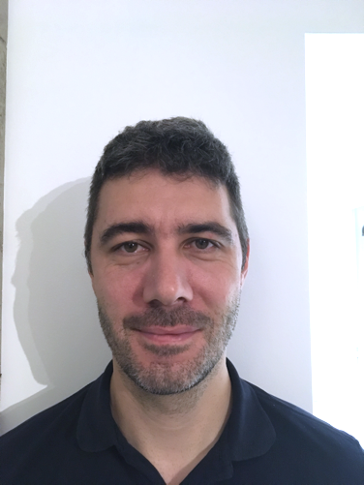

**Supply chain / I.T. / Optimisation**

RESUME

20 years of experience

ANTHONY CAUMOND

**PROFILE**

EXPERIENCE



Supply chain

Industrialization process

C-level communication

**E-commerce website**

**Personal Activities**

[**Demo making**](https://en.wikipedia.org/wiki/Demoscene) **and games**

Univ. BLAISE PASCAL

MICHELIN

**IT Supply Chain Consultant / IT Architect**

**Perimeter** Distribution and production planning, forecasting,

**Main activities:** Deployment, change management, setup and support

**Main achievements:** DRP deployment

UNILOG

Pré - 2001

**Operation Research PhD**

**Main activities:** Researcher and teaching in University

**Articles in** [Computer & Operations Research](https://www.sciencedirect.com/science/article/pii/S0305054806002930) and  
 [European Journals of Operational Research](https://www.sciencedirect.com/science/article/abs/pii/S0377221708004608)

Industrial Proof Of Concept in PSA / Eramet / Michelin

2001-2006

**Consultant IT Supply Chain**

**Perimeter:** Distribution planning, stock policies, …

**Main activities:** Deployment, change management, setup and support

**Main achievements:** Renewed distribution process for 3 product lines

2006-2008

**Product owner of an inhouse PLM**

* Creates, sell and materialize the vision
* Team leader and design

2020-2021

2016-2020

2013-2016

2008-2013

**Leadership**

**Operations Research**

**Information Technology**

**Supply Chain**

**English**

**ASSETS**

**TRAINING**



Order to cash

Logistics

Purchasing product

Purchasing software

S&OP

 Event Driven Architecture

|  |  |
| --- | --- |
| Combiné | +33 6 65 25 02 79 |
| @ | caumond@gmail.com |
| Maison | Live in France - Clermont-Fd | |
| Banque | French Nationality |

**CONTACT**

I started IT really early. My jobs were all close to IT, but now I realized it was not close enough.

After many years in industry in “expertise” and “management”, I now seek for really technical jobs.

My three pillars:   
Supply Chain/Industry, I.T skills and Operations Research.

I demonstrated a will and ability to be disruptive and pragmatic.

**[Université d’Auvergne,](https://www.uca.fr/recherche/etudes-doctorales/ecoles-doctorales-1) 2005**

[**Operations Research Ph.D.**](https://scholar.google.com/scholar?hl=fr&as_sdt=0%2C5&q=CAUMOND&btnG=)

[**ISIMA**](https://www.isima.fr/)**, 2001**

**Computer Science degree**

**TOGAF certified**

**BASICS APICS certified**

 Borland C++



Event simulation & modelling

Metaheuristics & Graph

Clojure(script)



**« Upstream Supply Chain » business architect**

**Perimeter:** Planning process for upstream industry,

**Main activities:**

* Animate business ambitions with C level
* Build architecture rules and business process

**Main achievements:**

* Reshape program objectives with C-level,
* PLM / product B.O.M. and routing data model for planning, quality, manufacturing costing and purchasing,
* New decentralized planning process design

**Enterprise Architect – Supply Chain Planning**

**Perimeter:** Whole group Supply Chain IT

**Other activities:**

* C-Level enterprise study,
* Software purchasing (S&OP, ERP OEM, Integrated Planning…)

**Main achievements:**

* Framework for [OPE transformation program](https://www.usinenouvelle.com/article/michelin-veut-reduire-ses-frais-generaux-de-500-millions-d-euros-d-ici-2020.N396442) on industry
* [Framework & sourcing for group S&OP tooling](https://www.strategieslogistique.com/Michelin-ameliore-son-S-OP-avec) with JDA
* Stock reference architecture for event driven architecture
* [First purchasing in the group of an A.I. focus software.](https://www.supplychaindigital.com/technology/exclusive-interview-girish-rishi-ceo-jda-software)

 PHP5+MYSQL



Assembly language

(Z80 68000)

GFA Basics

 Software architecture

 Supply chain

PLSQL



Graph optimization

