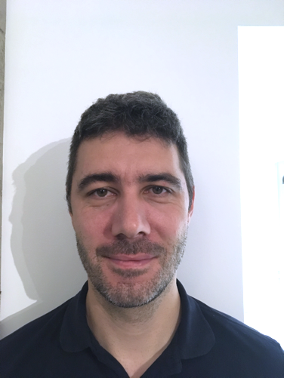

RESUME

**ENTREPRISE ARCHITECT**

20 years of experience

ANTHONY CAUMOND

**Enterprise Architect – Supply Chain Planning**

**Perimeter:**

* From the purchasing of Raw Materials to finished product delivery
* Operational to strategical planning
* All business lines and world-wide

**Main activities:**

* C-Level enterprise study,
* Provides framework to SC projects and programs
* 5 years roadmaps
* Software purchasing (S&OP, ERP OEM, Integrated Planning…)

**Main achievements:**

* Framework for [OPE transformation program](https://www.usinenouvelle.com/article/michelin-veut-reduire-ses-frais-generaux-de-500-millions-d-euros-d-ici-2020.N396442) on industry
* [Framework & sourcing for group S&OP tooling](https://www.strategieslogistique.com/Michelin-ameliore-son-S-OP-avec) with JDA
* Stock reference architecture for event driven architecture
* Target and Roadmaps for Post manufacturing, Offtake, OEM
* [First purchasing in the group of an A.I. focus software.](https://www.supplychaindigital.com/technology/exclusive-interview-girish-rishi-ceo-jda-software)

**Leadership**

**Operationnal Research**

I started IT really early. My jobs were all close to IT, but now I realized it was not close enough.

After many years in industry in “expertise” and “management”, I now seek for really technical jobs. The three pillars of my skills: Supply Chain/Industry, Operations Research and I.T skills.

I demonstrated a will and ability to be disruptive and pragmatic.

|  |  |
| --- | --- |
| Combiné | +33 6 65 25 02 79 |
| @ | caumond@gmail.com |
| Maison | Live in France (Clermont-Fd) | |
| Banque | French Nationality |

**« Upstream Supply Chain » business architect**

**Perimeter:**

* Planning process for upstream industry,

**Main activities:**

* Animate business ambitions with C level
* Build architecture rules and business process

**Main achievements:**

* Reshape program objectives with C-level,
* PLM / product B.O.M. and routing data model for planning, quality, manufacturing costing and purchasing,
* New decentralized planning process for the 5 upstream industries

2013-2016

**Consultant IT Supply Chain**

**Perimeter:**

* Distribution planning, stock policies, …

**Main activities:**

* Deployment, change management, setup and support

**Main achievements:**

* Renewed distribution process for 3 product lines

**Information Technology**

**Supply Chain**

**English**

**FORMATION**

**PROFILE**

**ASSETS**

**CONTACT**

[**Operations Research Ph.D.**](https://scholar.google.com/scholar?hl=fr&as_sdt=0%2C5&q=CAUMOND&btnG=) **,   
 Université d’Auvergne, 2005**

[**ISIMA**](https://www.isima.fr/)**,**

**Computer Science engineering degree**

**TOGAF certified**

**BASICS APICS certified**

**Operation Research PhD**

**Main activities:**

* Teaching in University
* Researcher

**Main achievements:**

* Articles in [Computer & Operations Research](https://www.sciencedirect.com/science/article/pii/S0305054806002930) and  
   [European Journals of Operational Research](https://www.sciencedirect.com/science/article/abs/pii/S0377221708004608)
* Industrial Proof Of Concept in PSA / Eramet / Michelin

**IT Supply Chain Consultant / IT Architect**

**Perimeter**

* Planning de distribution et de production, forecasting, stocks policies

**Main activities:**

* Deployment, change management, setup and support

**Main achievements:**

* DRP deployment
* Déploiement DRP sur les entités principales du groupe
* Algorithme complexe d’optimisation

2008-2013

MICHELIN

UNILOG

UNIVERSITE BLAISE PASCAL

EXPERIENCE

2006-2008

2001-2006

2016-2019