
FPT ACADEMY INTERNATIONAL
FPT – APTECH COMPUTER EDUCATION

King Shop

Center Name |  | FAI – Ho Chi Minh  Address: 21 bis Hau Giang, Tan Binh District , Ho Chi Minh City, VietNam.
Instructor |  | Mr. Tran Phuoc Sinh
Class |  | T1.2311.M0
Group |  | 5
Group members |  | Name | Student ID
 |  | Nguyen Duy Anh | Student1468183
 |  | Nguyen Hai Hoang | Student1339262
 |  | Tran Van Hung | Student1339266
Duration | Start date | Nov 17th 2025
 | End date | Dec 24th 2025

Table of Contents

REVIEW 1............................................................................................................................
ACKNOWLEDGE...............................................................................................................
INTRODUCTION................................................................................................................
PROBLEM DEFINITION ....................................................................................................
CUSTOMER'S REQUIREMENTS SPECIFICATIONS (CRS) ...........................................
CLIENT:..............................................................................................................................
TASK SHEET REVIEW 1 ..................................................................................................
REVIEW 2 ...........................................................................................................................
1. USECASE.......................................................................................................................
2. DATA FLOW DIAGRAM (DFD)......................................................................................
3. ENTITY PROPERTIES ..................................................................................................
4. TABLE DESIGN..............................................................................................................
5. TASK SHEET REVIEW 2 ..............................................................................................
REVIEW 3 ...........................................................................................................................
1. SITE MAP.......................................................................................................................
2. MOBILE SHOP WIREFRAME .......................................................................................
3. MOBILE SHOP SCREENSHOT.....................................................................................
4. Task sheet review 3........................................................................................................

REVIEW 1

Acknowledgement

It is often said that “Gratitude is the sign of noble souls”. That’s why we devote this chapter to express our deep gratitude towards those who have supported and guided us to accomplish this eProject successfully.
First and foremost, we appreciate the invaluable assistance that our beloved instructor - Mr. Tran Phuoc Sinh, has offered us. Whenever problems come up, she’ll always the one that we can count on for solutions. Moreover, there were moments when our team decided to give up our project, and Mr. Sinh gave us a pep talk to keep us back on the track.
Next, it would have been impossible to carry out and complete this project without the collaboration among our team members. Although we have gone through many obstacles during the project implementation, eventually we gained what we aimed at by our hard work, our strong commitment and of course, our brotherhood.
Finally, thanks to Aptech’s eProject assignment, we had a golden opportunity to apply what we have learnt into reality and gain hands-on experience which is essential for our future career.

Introduction
We are in an era where information technology makes buying and selling easier than ever. People can order anything they want, everything is done electronically and interacts in real time. Phone stores are no exception to this cycle. So we are developing a website named King-Shop to help you easily buy mobile phones with best deals online. Mobile phone stores are for organizations that want to develop online stores where visitors can be people who don't have much time to go to phone stores or people who have the habit of shopping online or simply they are in too far from independent stores. It will provide the following features to users.
For King Shop customer base:
- Unregistered visitors can register for a member account.
- Registered visitors can log in and manage their accounts.
- Visitors can search for any product such as Iphone, Oppo, Redmi, etc.
- Visitors can search for products by price.
- Visitors can view product descriptions before purchasing.
- Visitors can purchase products after adding products to the cart.
- Visitors can view cart history.
- Visitors can review order history and make changes.
- Visitors can rate purchased products.
- Visitors can interact with the website by asking questions and giving feedback on the contact us function.

PROBLEM DEFINITION
After analyzing the project specifications of King Shop, to fulfil customer’s requirements properly, we came to conclusion that in order to achieve the best result, we should deal with following queries:
FROM THE VIEW POINT OF VISITORS:
- A homepage will show the main products, suitable logo, display the logo on all the pages in the site.
- A navigation header and footer that will include all the functions implemented in the website.
- Visitor can buy products, add product to cart, view cart and check out.
- Registered visitors can login to their profile, view order history.
FROM THE VIEW POINT OF THE ADMINISTRATOR:
- A login page will grant access to King Shop admin.
- Admin can view, add, update and manage products.
- Admin can add, update, delete and manage orders.
- Admin can update and manage registered user account.
- Admin can manage and send newsletter.

CUSTOMER'S REQUIREMENTS SPECIFICATIONS (CRS)
CLIENT: King Shop
BUSINESS/PROJECT OBJECTIVES:
The project is to design an online website to advertise and sell mobile phones, such as: Iphone, Oppo, Redmi, etc.
INPUT TO THE SYSTEM:
- King Shop administrators need to provide:
- Necessary information to create an account to access the administration system.
- Products will be displayed on the website.
- Payment methods and shipping fees when ordering certain products.
- Necessary information to create employee accounts in the administration system.
- Customers King Shop need to provide:
- Personal information about product purchases.

OUTPUT FROM THE SYSTEM:
- King Shop administrators will be able to:
- Login/Logout to the admin system.
- Manage (view, add, update, hidden) products, price.

- Manage (view, add, update) news.
- Manage (view, add, update) products, order.
- King Shop guests will be able to:
- Register customer account.
- Buy products after add information.
- View products that they have chosen.
- View order history.
- King Shop customer will be able to:
- Register account.
- Login/Logout to the account.
- Search products they want to buy by name, price.
- Add product to cart and checkout.
- View purchase history.
DATABASE:
- The information about products, customers, news, orders cart will be stored in the database.
- The information from the contact us page.

HARDWARE/ SOFTWARE REQUIREMENTS:

HARDWARE

Web Server

Processor | Intel Core I5 or higher.
Memory | 32 GB RAM or greater.
Modem/ADSL | Internet access is required.

Client

Processor | Intel Core I3 or higher.
Memory | 8 GB RAM or greater.
Monitor | Super VGA (1024x768) or higher resolution.
Modem/ADSL | Internet access is required.

SOFTWARE

Web Server

Operation System | Window 10 or later.
Browser | Google Chrome version 35.
Database | MySQL.
Software | Spring Boot (Java) – Restful API
 | Apache Tomcat (embedded trong Spring Boot)
 | Internet Information Services (IIS)

Client

Operation System | Window 10 or higher.
Browser | Google Chrome version 35.

DEVELOPMENT SOFTWARE
- Microsoft Windows 10.
- MySQL.
- IntelliJ IDEA
- Visual Studio Code.
- Google Chrome.
- Postman / Insomnia (kiểm thử API).
- Git / GitHub

TECHNOLOGY
- PHP - Laravel framework.
- Java – Spring Boot (RESTful API).
- Spring Data JPA / Hibernate.
- MySQL Database.
- JavaScript (Frontend).
- HTML / CSS / Bootstrap.
- jQuery.

TASK SHEET REVIEW 1

Project Ref. No.: |  | Project Title: | Activity Plan Prepared By: | Date of Preparation of Activity Plan:
Sr.  No. | Task |  |  | Actual Start Date |  | Actual Days | Team Mate Names | Status
1 | Acknowledgement | King Shop | All member | 17/11/2025 |  | 1 | Hung | Completed
2 | Problem Definition |  |  | 17/11/2025 |  | 1 | Hung | Completed
3 | Requirement Specification |  |  | 17/11/2025 |  | 1 | Hung | Completed
4 | Task sheet review |  |  | 17/11/2025 |  | 1 | Hung | Completed
Date: 18/11/2025
Signature of Instructor:  Mr. Tran Phuoc Sinh |  |  |  |  | Signature of Team Leader:  Nguyen Duy Anh

REVIEW 2

I: USE CASE

1. USER

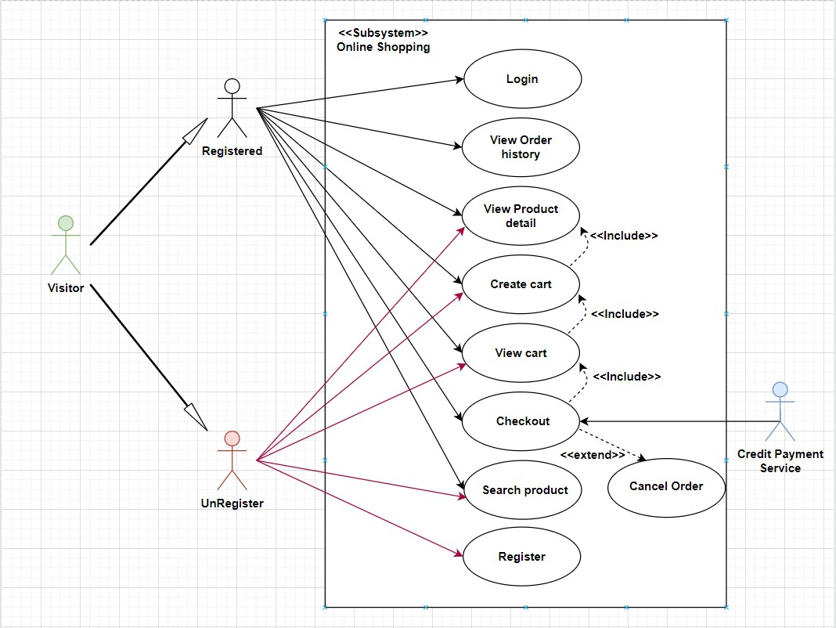

Login

Use Case Name | Login
Actors | User
Description | Users with accounts can log in
Requirements | User provides username and password
Pre-conditions | The user already has an account.
Post-conditions | Success: User logs into the website
 | Failure: Login failed message
Basic flow | Actor’s actions: | System’s responses:
 | 1. User opened the link to the Login Page | 2. The system redirects to the Login Page with the following content control:  "Username" text field  "Password" text field  "Login" button
 | 3. User enters Username and Password, then clicks 'Login' button. | 4. The system checks the information.
 |  | 5. The system redirects to the Home page.
Exceptions | Actor’s actions: | System’s responses:
 | 1. User entered invalid username or password | 2. The system displays the message: "Invalid username and password"

Register

Use Case Name | Register
Actors | User
Description | User requests account
Requirements | User provides personal information
Pre-conditions | User has not been granted an account
Post-conditions | Success: User has an account to purchase products from the Shop
 | Failure: Account creation failed messag
Basic flow | Actor’s actions: | System’s responses:
 | 1. User opens the personal information form on the registration page
 | 2. User fills in personal information on the registration form, then clicks the Submit button | 3. The system saves the user information to the database as 'not activated' and sends a verification email to the user
 | 4. User presses the verification button on the email to verify that he is not a robot | 5. The system changes the account status to 'activated' and redirects the user to the Home page
Exceptions | Actor’s actions: | System’s responses:
 | 1. User entered invalid username or password | 2. The system displays the message: "Invalid username and password"

See product details

Use Case Name | See product details
Actors | User
Description | Users want to see product details
Requirements | User selects product wants to see detailed information
Pre-conditions | Users can access the web
Post-conditions | Success: User can view product details
 | Failure: Report error and return to Home page
Basic flow | Actor’s actions: | System’s responses:
 | 1. User selects the product they want to view detailed information | 2. System redirects to the product detail page that User selected
 | 3. User views and can add product to cart if they want to buy | 4. System adds product to cart if User adds to cart

View cart

Use Case Name | View cart
Actors | User
Description | Users want to see cart details
Requirements | User views his cart
Pre-conditions | Users can access the web
Post-conditions | Success: User can view his cart
 | Failure: Report error and return to Home page
Basic flow | Actor’s actions: | System’s responses:
 | 1. User accesses the cart | 2. System redirects to the user's cart page
 | 3. User views the cart, removes the product if they no longer need to buy it, adjusts the product quantity
 | 4. User confirms the cart and selects payment | 5. System creates an order for the User

Checkout cart

Use Case Name | Checkout cart
Actors | User
Description | User wants to pay
Requirements | The user already has products in the cart
Pre-conditions | Users can access the web
Post-conditions | Success: User successfully pays for the order and waits for confirmation from the Shop
 | Failure: Report error and return to Home page
Basic flow | Actor’s actions: | System’s responses:
 | 1. User enters delivery address information, reviews order and selects payment method and clicks 'Confirm Purchase' | 2. System saves order information and updates order list for Administrator.
 | 3. User waits and views order status in order history
Exceptions | Actor’s actions: | System’s responses:

View purchase history

Use Case Name | View purchase history
Actors | User
Description | Users want to see purchase history
Requirements | Users have placed orders
Pre-conditions | Users can access the web
Post-conditions | Success: Users can view purchase history and order status
 | Failure: Report error and return to Home page
Basic flow | Actor’s actions: | System’s responses:
 | 1. User accesses the purchase history page | 2. System redirects to User's order history page
 | 3. User can view the latest order status and old orders
Exceptions | Actor’s actions: | System’s responses:

See news details

Use Case Name | See news details
Actors | User
Description | Users view news details
Requirements | Users click to see news details
Pre-conditions | User opens news page
Post-conditions | Success: User can see article details
 | Failure: Error message
Basic flow | Actor’s actions: | System’s responses:
 | 1. User opens the news page
 | 2. User selects the news he wants to see in detail | 3. System redirects to that article page
 | 4. User can Like and Comment on that article | 5. System saves user's comments
Exceptions | Actor’s actions: | System’s responses:
 | 1. User opens the news page | 2. System reports error and returns to Home page

2. ADMIN

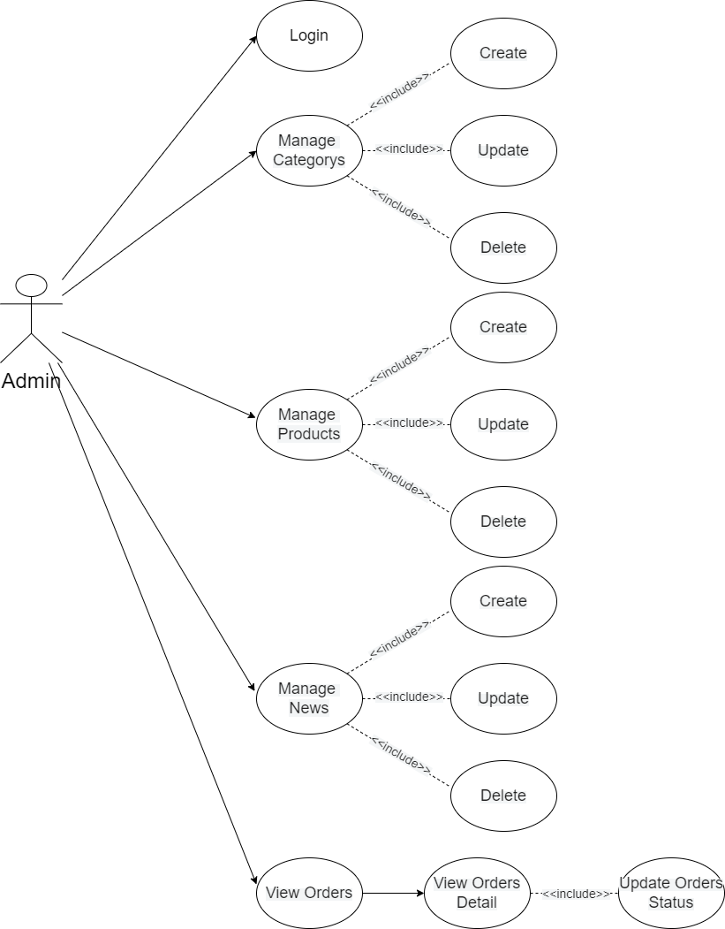

Login

Use Case Name | Login
Actors | Admin
Description | When the Administrator wants to manage Orders, Categories, Products and News
Requirements | Admin provides username and password
Pre-conditions | Admin must be exist on database
Post-conditions | Success: Admin is logged in to website admin
 | Failure: Login failed message
Basic flow | Actor’s actions: | System’s responses:
 | 1. Admin opened the link to the Login Page | 2. The system redirects to the Login Page with the following content control:  "Username" text field  "Password" text field  "Login" button
 | 3. Admin enters Username and Password, then clicks 'Login' button. | 4. The system checks the information.
 |  | 5. The system redirects to the Admin's dashboard.
Exceptions | Actor’s actions: | System’s responses:
 | 1. Admin entered invalid username or password | 2. The system displays the message: "Invalid username and password"

Manage Orders

Use Case Name | Manage Order
Actors | Admin
Description | When the Administrator wants to manage the order
Requirements | Admin go to order management(dashboard) section
Pre-conditions | The administrator must exist on the database.
Post-conditions | Success: Admin redirected to dashboard page
 | Failure: Error message
Basic flow | Actor’s actions: | System’s responses:
 | 1.Admin opens link to dashboard | 2. The system displays the list of orders
 | 3. Admin click to view order details | 4. The system redirects to the order details page
 | 5. Admin confirms 'approve' the order or 'cancels' the order | 6. The system records the Admin's action
 |  | 7. Order status changes to 'approved' and being delivered or cancelled by Admin

Manage Categorys

Use Case Name | Manage Categorys
Actors | Admin
Description | When the Administrator wants to manage the category
Requirements | Admin go to category management section
Pre-conditions | The administrator must exist on the database.
Post-conditions | Success: Admin redirected to category management page
 | Failure: Error message
Basic flow | Actor’s actions: | System’s responses:
 | 1.Admin opens link to category management | 2. The system redirects to the category management page
 | 3. Administrator selects to ‘add’ or ‘update’ categories | 4. The system will redirect to the category 'add' or 'update' page
 | 5. The administrator enters information into the form | 6. Input validation system
 |  | 7. System to 'add' or 'update' data to the database

Manage Products

Use Case Name | Manage Products
Actors | Admin
Description | When the Administrator wants to manage the product
Requirements | Admin go to product management section
Pre-conditions | The administrator must exist on the database.
Post-conditions | Success: Admin redirected to product management page
 | Failure: Error message
Basic flow | Actor’s actions: | System’s responses:
 | 1.Admin opens link to product management | 2. The system redirects to the product management page
 | 3. Administrator selects to ‘add’ or ‘update’ product | 4. The system will redirect to the product 'add' or 'update' page
 | 5. The administrator enters information into the form | 6. Input validation system
 |  | 7. System to 'add' or 'update' data to the database

Manage News

Use Case Name | Manage News
Actors | Admin
Description | When the Administrator wants to manage the new
Requirements | Admin go to new management section
Pre-conditions | The administrator must exist on the database.
Post-conditions | Success: Admin redirected to new management page
 | Failure: Error message
Basic flow | Actor’s actions: | System’s responses:
 | 1.Admin opens link to new management | 2. The system redirects to the new management page
 | 3. Administrator selects to ‘add’ or ‘update’ new | 4. The system will redirect to the new 'add' or 'update' page
 | 5. The administrator enters information into the form | 6. Input validation system
 |  | 7. System to 'add' or 'update' data to the database

II: DATA FLOW DIAGRAM

LEVEL 0

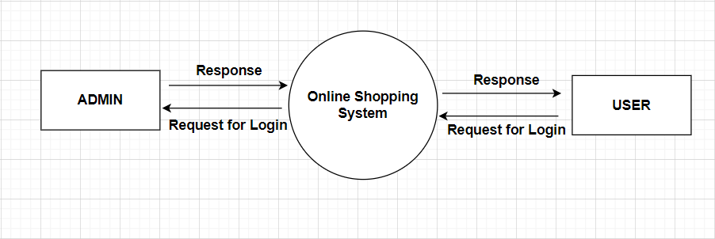

ADMINSIDE LEVEL 1

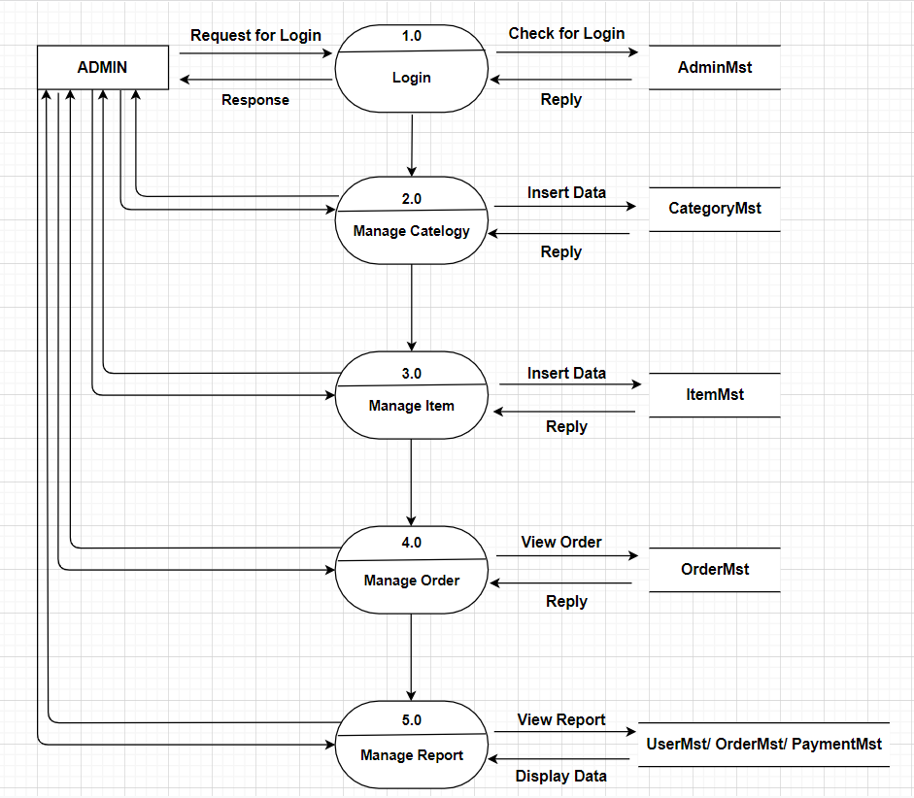

ADMINSIDE LEVEL 2

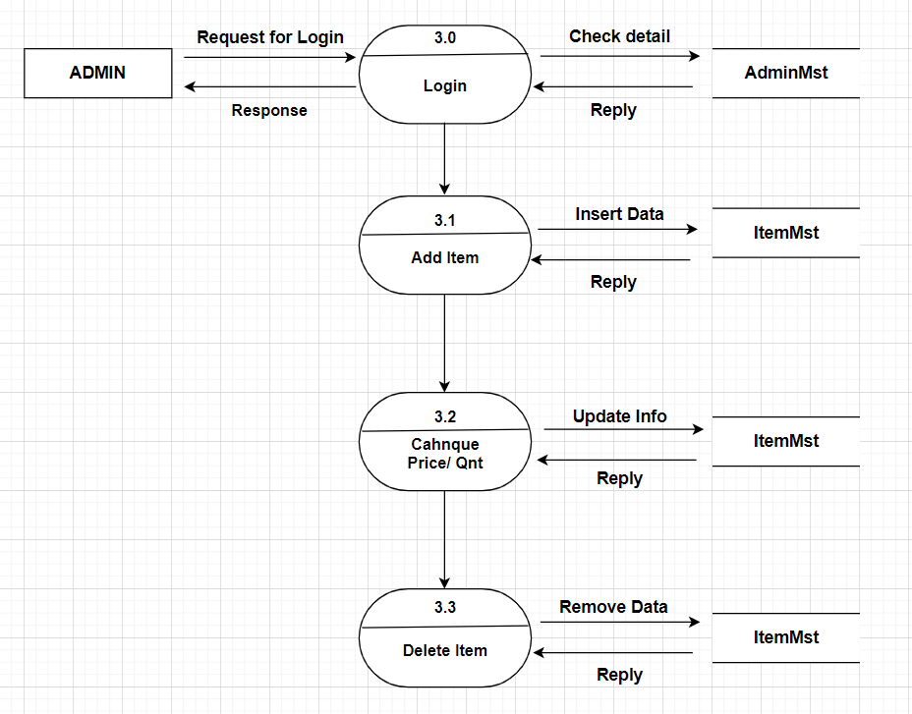

ADMINSIDE LEVEL 3

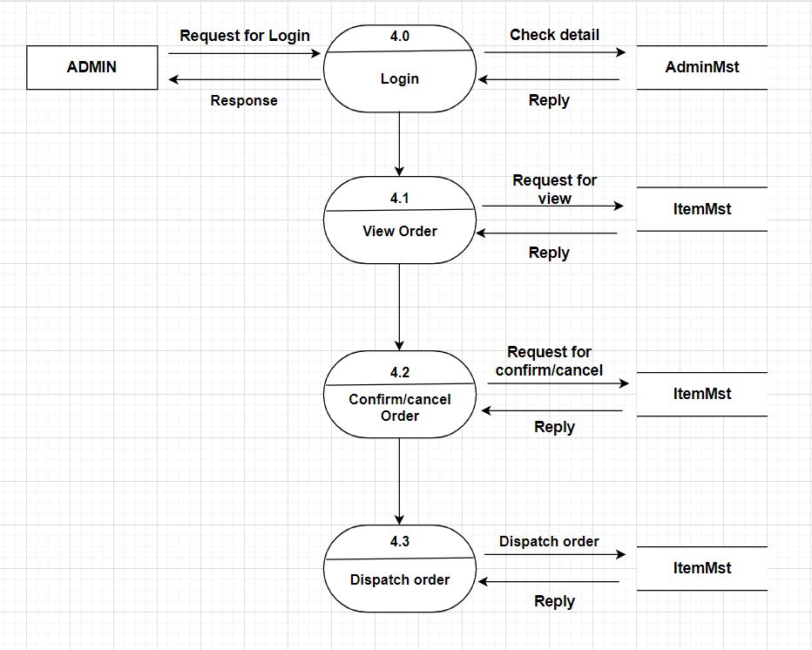

USERSIDE LEVEL 1
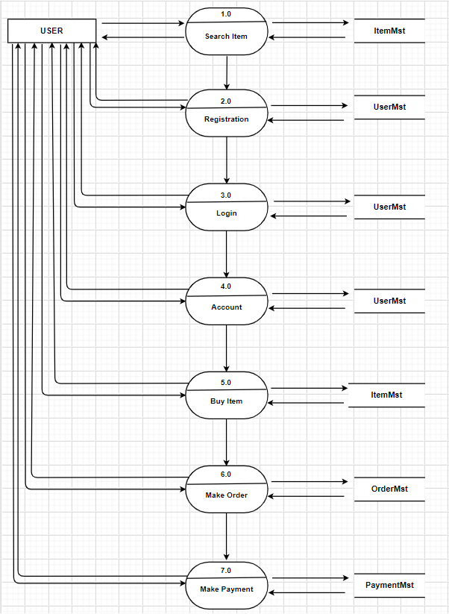

USERSIDE LEVEL 2

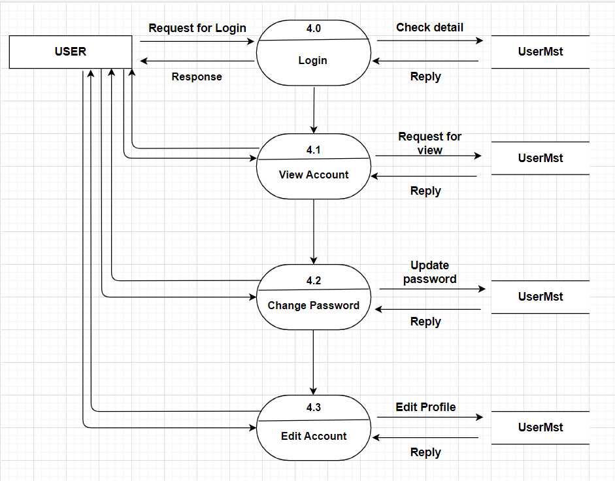

USERSIDE LEVEL 3

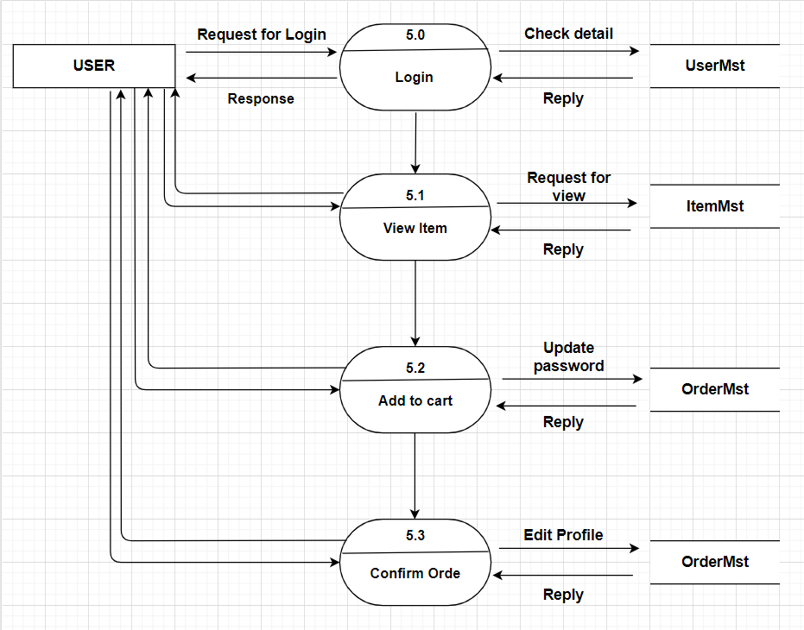

III: ENTITY PROPERTIES

USER
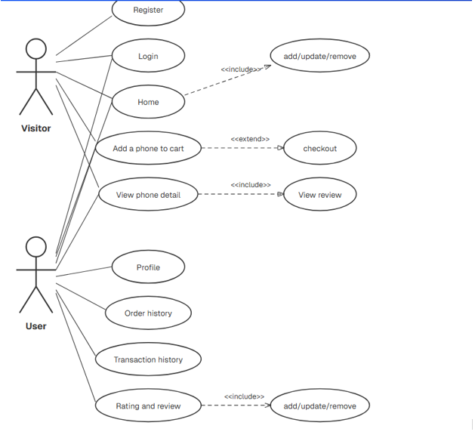

CATEGORY

PRODUCT

NEWS

ORDER

TASK SHEET REVIEW 2

Project Ref. No.: |  | Project Title: | Activity Plan Prepared By: | Date of Preparation of Activity Plan:
Sr.  No. | Task |  |  | Actual Start Date |  | Actual Days | Team Mate Names | Status
1 | Use Case | King Shop | All member | 29/11/2025 |  | 2 | Hung | Completed
2 | Data Flow Diagram |  |  | 29/11/2025 |  | 2 | Hung | Completed
3 | Entity Properties |  |  | 1/12/2025 |  | 2 | Anh | Completed
4 | Task sheet review |  |  | 1/12/2025 |  | 1 | Anh | Completed
Date: 18/11/2025
Signature of Instructor:  Mr. Tran Phuoc Sinh |  |  |  |  | Signature of Team Leader:  Nguyen Duy Anh

