Lim Yao Jie

1001997

Lab3

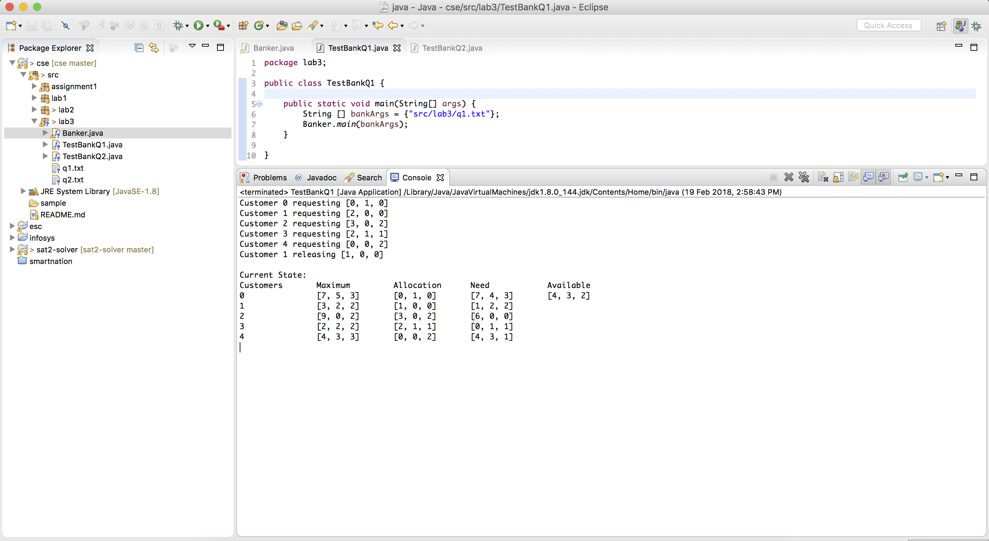

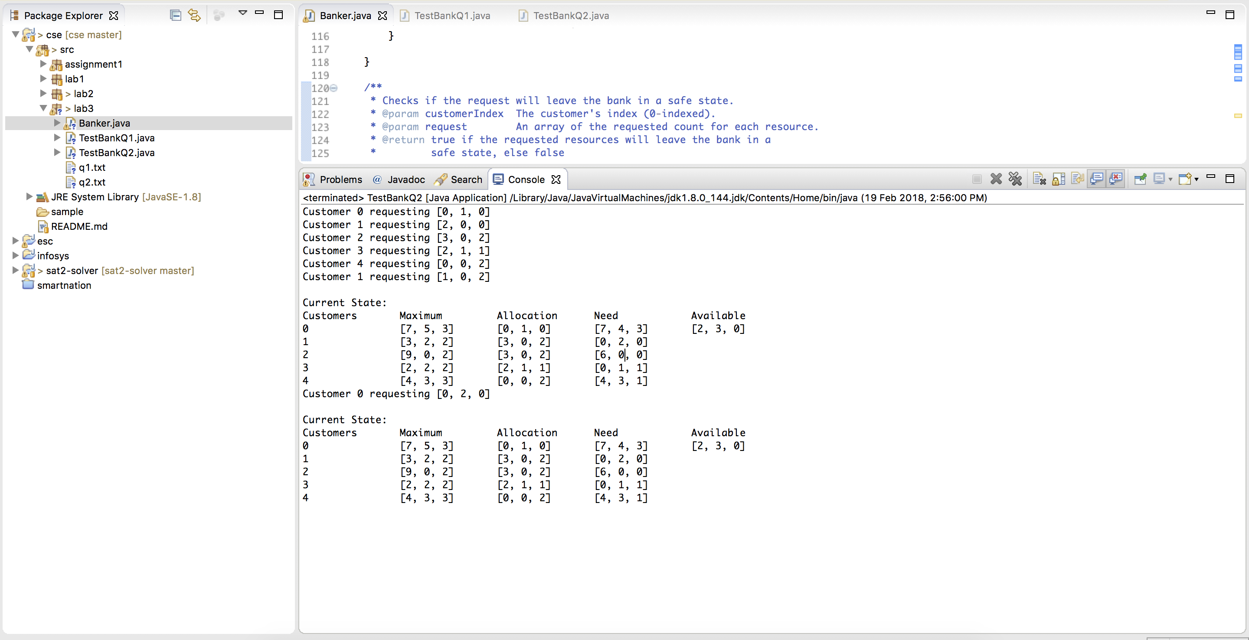

Banker algorithm complexity

The majority of the complexity lies in the safety check algorithm. The complexity of the inner for loops are O(m\*n), given n customers and m resources. The outer while loop runs at a worst case time of O(n) meaning the code runs ultimately at O(n\*n\*m).