**(S2-20_DSECLZG519) (Data structures and Algorithms Design)**

**Academic Year 2020-2021**

Software Design Documentation

**Assignment 2 PS5 – Assignment - Group 21**

**Overview:**

## This problem is about a maximizing the profit by correctly scheduling the problem using greedy method

**Given Problem Statement:**

A teacher has given a set of questions to the class. Each question takes a day to finish the task. Each problem has a deadline, if finished before the deadline the class gets extra bonus marks. No Bonus,If the problem is not finished before the deadline

For example, the class has been given 3 problems: [A,B,C]. The corresponding deadlines are [1,2,1] and the bonus for finishing the problem before time is [10,20,30]. For maximizing the bonus marks you can get problem C and B. While missing the deadline of problem A, which gives you a maximum 50 bonus marks earned. The order of the tasksis C-B-A



**Goal:**

The goal is to create a python program to read the list of use cases (problems) with various tasks and each task consist deadline and bonus, apply the greedy algorithm to get the maximum profit and then write the profit earned and order in which the tasks are taken to an output file

**Flow Diagram:**

The following diagram shows the overall flow

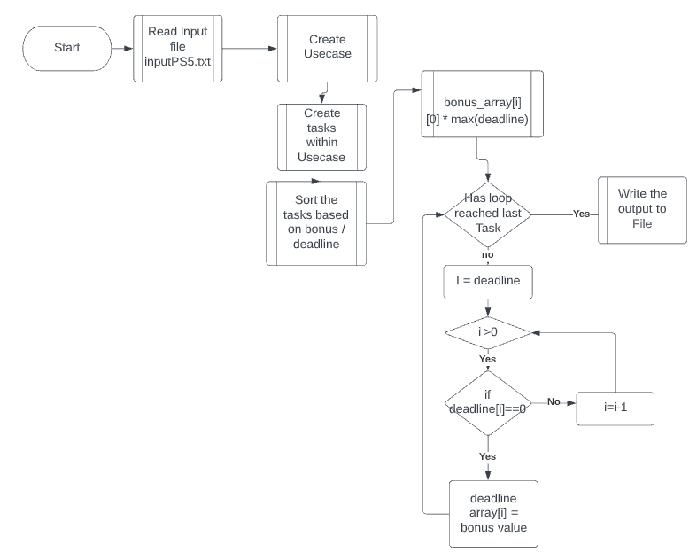

**Design + Data Structures:**

This algorithm uses list and couple of custom class one to hold attributes of task and one to hold usecases and encapsulate its functions

* Task: The custom class consists of three attributes
  + Name of the task, generated at runtime and value can be task:1, task:2, task:3 etc
  + Task deadline: positive integer
  + Task bonus : positive integer
* Usecase: Custom class consists of the following attributes and members
  + Attribute: Use case name : Generated at runtime based on the number of use case passed in the file
  + Attribute: Tasks : List of tasks under a usecase
  + Attribute:Daily bonus : holds the daily bonus values.
  + Method: findMaxDeadlinedTask : Identifies the max deadlined task among the tasks
  + Method: maximizeBonus: greed algorithm implemented as part of this method to maximize the bonus
* List: This list holds list of use cases

This is the simplest data structure meeting all our requirements.

**Run Time Analysis:**

The max complexity to solve one usecase is n*log(n) +n = O(nlogn)

* Step-1 is sort the tasks into descending order w.r.t weightage = (bonus / deadline). This takes O(n*(log n)) complexity
* Step-2: is to loop through (max number of deadline +1) times and allocate the tasks. This is O(n) complexity
* In Big O terms, O(n*logn + n) = O(n (1+logn)) ~= O(n*logn)

**Alternate Modelling:**

**Find Node:**  There are various to implement this problem.

**Algorithm:**

|  |
| --- |
| **Input:** File inputPS5.txt contains list of commands / operations.  E.g.  No of use-cases: 2 Deadlines: 1 2 3 1 4 Bonus: 20 40 10 10 20 Deadlines: 4 1 2 2 Bonus: 20 30 10 40  **Output:** File OutputPS5.txt lists the maximum bonus earned and the sequence of Jobs for every test case.  E.g.  90  90  Total number of test cases are 2   For the use case Usecase:1, the maximum bonus earned is 90 For the use case Usecase:2, the maximum bonus earned is 90 For the use case Usecase:1, the tasks were scheduled in Task:1-->Task:2-->Task:5-->Task:3 For the use case Usecase:2, the tasks were scheduled in Task:2-->Task:4-->Task:1  **Function:** The following algorithm gives a high-level overview of the overall program   * **Main**   + Reads the file contents and caches them into uses cases custom datatype   + For each usecase, it performs maximimzation and maintains the bonus and also processed items   + Finally prints the output to output file |
|  |