Converting from one HTML specification to Another

The Problem
Before Christmas we meet with members of the Protective Services Unit to discuss technology issues they have. The lowest hanging fruit we saw was
Hand convert report to Irish format. NCMEC sends daily reports. This is an American organisation that Social Media companies report to. And they send a pdf and HTML report about Irish resident who have had illegal things posted from their accounts.
The Garda triage this based on amount of illegal stuff, if the person has been seen before and amount of evidence about the person (name, address, phone number etc). And then by hand convert the standard format documentation NCMEC sent them into a form the Irish courts and authorities will accept.
A simple laptop ready program that would convert a file from NCMEC format to the one the Irish legal system uses would save this unit time.

A Demonstration Application
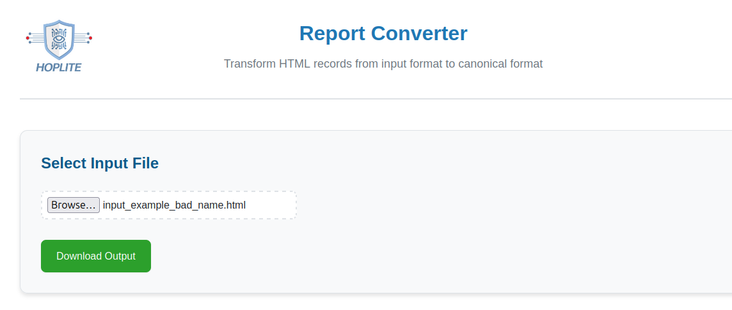
To show that CCI have the skills needed to aid with this issue we have made a demonstration of one possible type of tool as an example. The program works without a server using only local files and sends and receives no information outside the laptop. All the code is public and readable and can be examined. Cryptographic hashes of input and output files are created for auditing purposes.
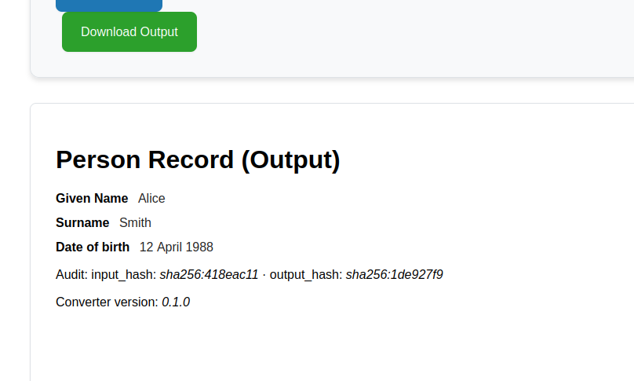

And with a file missing required data
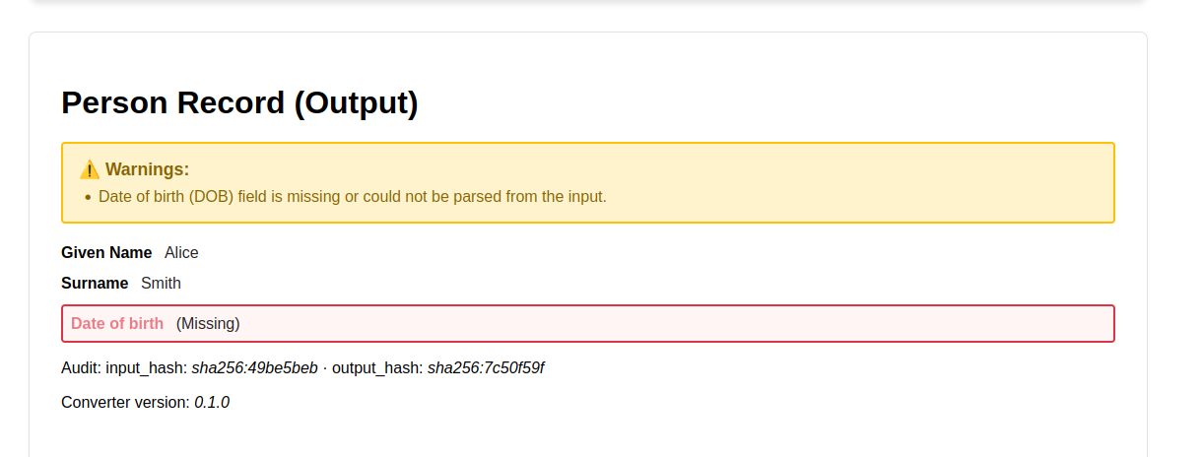

To run the Demonstration

- Unzip the attached zip.
- We have three input files that can be loaded.

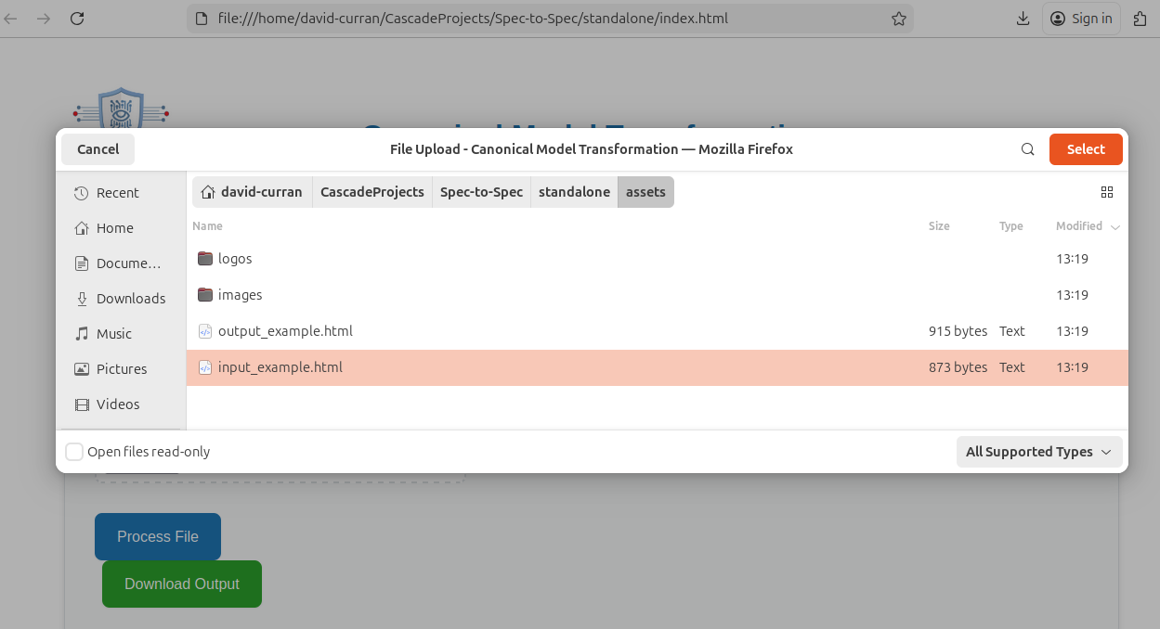

- The first will be input_example.html
- The second, input_example_bad.html and bad name are missing an expected field and the system will warn this is not present

