**功能簡介**

[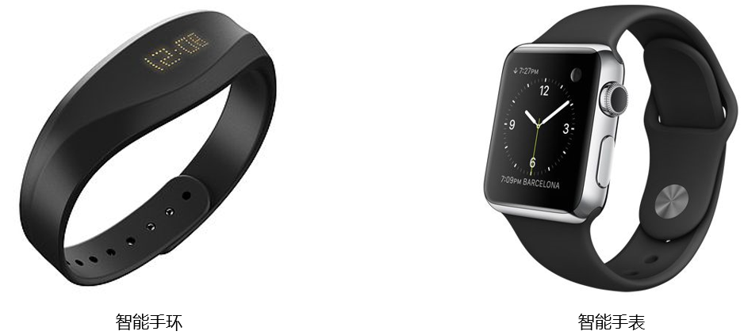](https://github.com/cavedunissin/boson/blob/master/.gitbook/assets/boson-xin-shuai-chuan-gan-qi-mo-kuai-jian-jie.png)

智慧手環 智慧手錶