**功能簡介**

[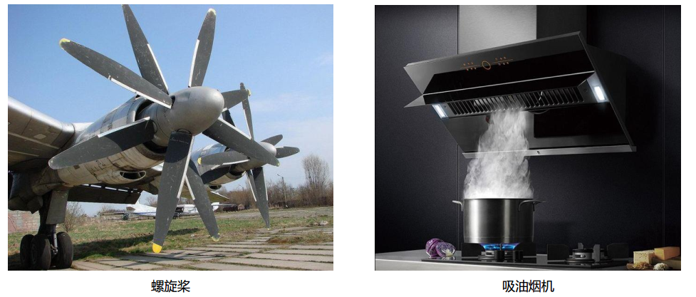](https://github.com/cavedunissin/boson/blob/master/.gitbook/assets/boson-feng-shan-mo-kuai-shi-li.png)

螺旋槳 抽油煙機