**功能簡介**

[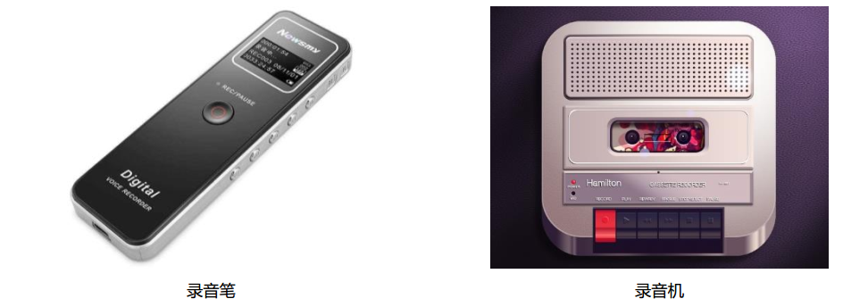](https://github.com/cavedunissin/boson/blob/master/.gitbook/assets/boson-lu-yin-mo-kuai-shi-li.png)

錄音筆 錄音機