Project3 report by F74046420 陳佑瑜

Screen shot:

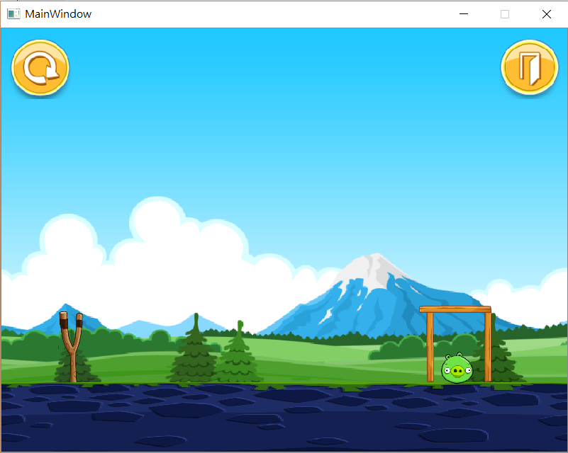

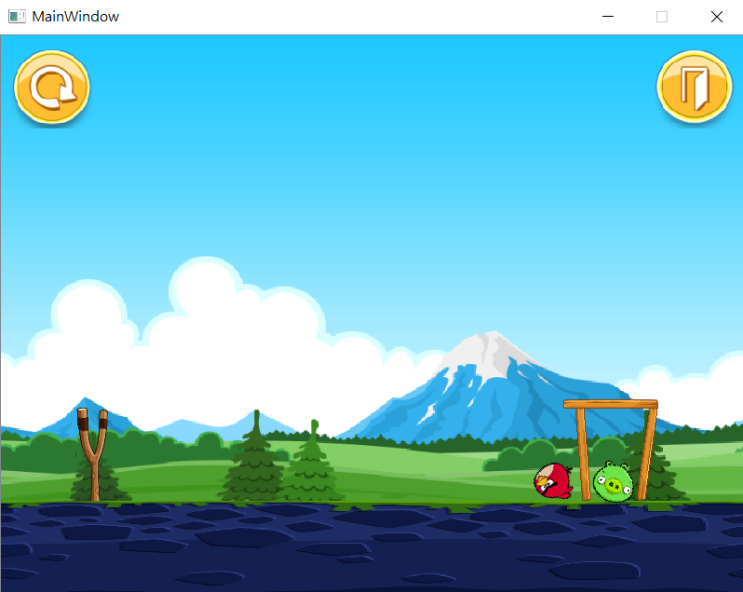

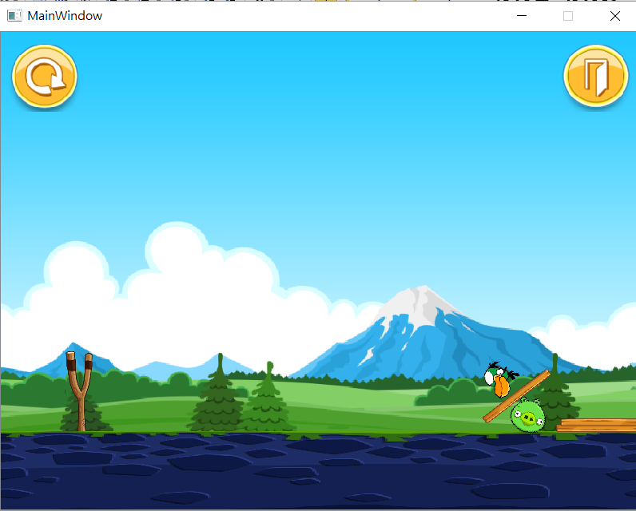

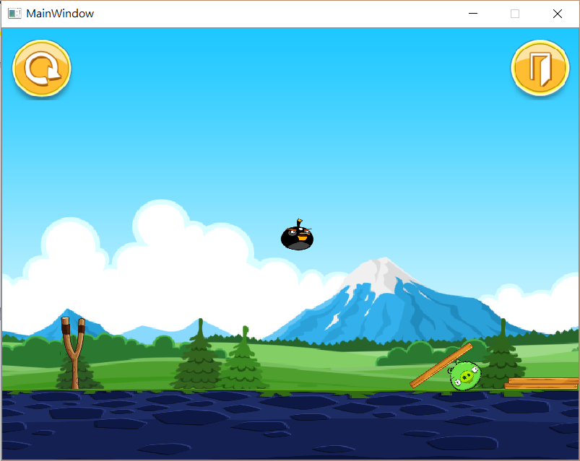

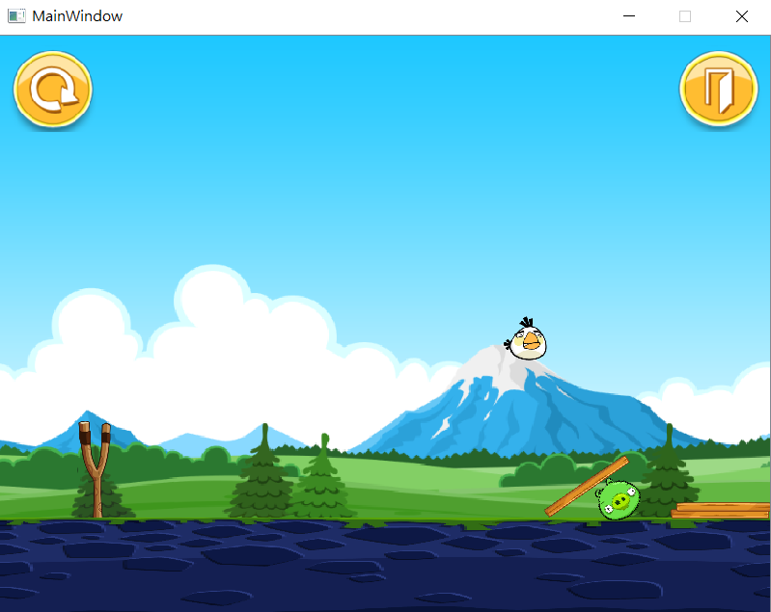

How to play:

Press your mouse and drag to a position, you can shoot out a bird when you release and its speed will depend on the distance that drag. When you shoot out the green bird, press the mouse again, you can enlarge its size. When you shoot out the black bird, press the mouse again, you can have a heavy gravity. When you shoot out the green bird, press the mouse again, you can accelerate its speed. The goal is to hit the pig that protected by the logs. To restart the game, simply press the icon in the upper left. To quit the game, simply press the icon in the upper right.

Program Architecture:

To shoot out the bird, I record the bird’s position where the mouse press and also record the position where it releases. According to the above mention values, I can have my distance and use the distance to decide how the speed is. I initial the status of a bird counter, so every time I press the mouse I can have different bird to shoot. To quit the game, I simply emit a signal to close the windows when your mouse pressed at the quit icon. To restart the game, I delete all the objects that I made and initial all the counters to zero when your mouse pressed at the restart icon.