Zandelee’ Pelser
Contact: +264 812341794
E Mail: zandeleepelser@gmail.com

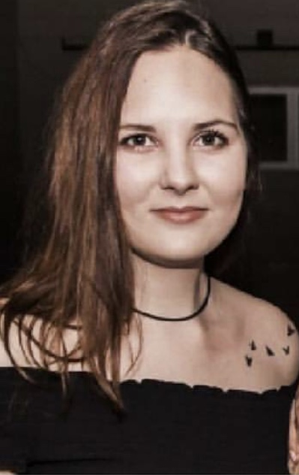

NAME | Zandelee’ Pelser
ADDRESS | PO Box 30271  Windhoek - Pionierspark  Namibia
TEL. NO | 081 – 2341794
E Mail | Zandeleepelser@gmail.com
MARITAL STATUS | Single
CHILDREN | None
DATE OF BIRTH  IDENTITY NUMBER | 23 June 2000  000623005555
NATIONALITY  TAX NUMBER | Namibian  Not Yet
HEALTH | Excellent
LANGUAGES | Afrikaans and English
RELIGION | NG
Physical Address Quiver Road No. 5335
Ocean View
Swakopmund

Computer Programmes:
Windows, Internet, Excel, Word, Social Media

Additional Competencies:
Trustworthy, Professional, Hard Working, Positive and Motivated

Qualifications

Matrix Certificate – Namib High School 2018:
English, Afrikaans, Art, Physical Science, Science, Maths.

Work Experience:

Doortec – Part Time (2018 to Date)
Title: Receptionist
Duties: Reception of Customers, Quotations and Invoicing, General Admin

References

Doortec Swakopmund
Lindie Nel
Tel. No.: +264 (64-404066)

About myself.

I am well groomed, punctual, innovative and an inquisitive person. I am willing to learn new things, is hard working, determined, reliable and a fast learner. I am also loyal, respectful and independent. I am a team player and can work on my own, as well as within a team and well under pressure.

