**UNIVERSITY OF NAMIBIA**

Private Bag 13301, 340 Mandume Ndemufayo Avenue, Pioneerspark, Windhoek, Namibia

Faculty of Science

Department of Biological Sciences

Fax: 206 3791; Tel: +264 61 206 3918

E-mail: [cdeelie@unam.na](mailto:cdeelie@unam.na)

**TO WHOM IT MAY CONCERN**

**Dear Sir/Madam,**

**Re: Recommendation Letter: Aushona Immanuel Kemanya**

I am pleased to write a letter of recommendation for Aushona Immanuel Kemanya (student number 201306561) a 3th year student at the University of Namibia registered under the department of Biological sciences studying towards an Honours degree in Environmental Biology. I taught him Ecosystem Ecology as well as Aquatic Ecology this year.

I recommend him for any internship or attachment that is in line with his qualification. If you need additional information, please do not hesitate to contact me.

Yours sincerely,

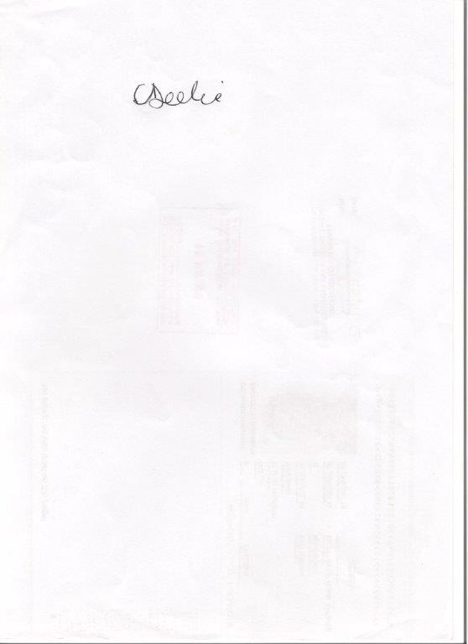

Ms. Cathleen Deelie

Lecturer: Aquatic Sciences