SUMMARY

**Abby Henry**

UK Mobile: (+44) 7941093252

US Mobile: (+1) 3524499587

WhatsApp: (+44) 7941093252

Personal Email: abbyc11h@gmail.com

Student Email: 2343532H@student.gla.ac.uk

References are available upon request.

I am a third-year veterinary student at the University of Glasgow School of Veterinary Medicine. I have a zoo and wildlife-based background with experience particularly related to African species. Opportunities to work with these species has come through past jobs at zoological facilities, externships at an exotic animal clinic and zoo, and internships in South Africa. I plan to complete my education and become a zoo veterinarian with the aspirations of working on wildlife whenever possible.

Experience

**Johannesburg Zoo** (*Clinical EMS 08/19 – 09/19*)

* Performed various clinical skills such as blood draws, vaccinations, health checks, dentals, amputations, anesthesia, and darting.
* 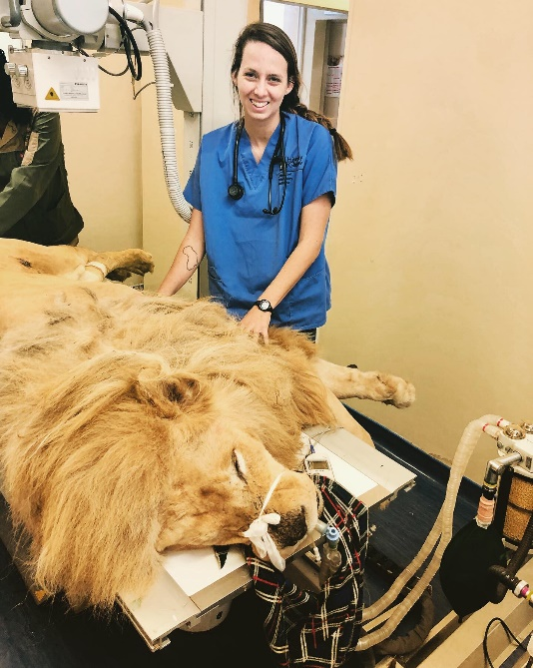Worked on a variety of species including large carnivores, ungulates, avians, reptiles, and primates.

**Zanzibar Animals Affection Society** (*Clinical EMS 03/19 – 04/19*)

* Performed various clinical skills such as IV catheter placement, fluid therapy, wound management, and vaccinations on a variety of domestic species.
* Performed feline castrations and spays under the direction of the head veterinarian.

**Safari4U Veterinary Program**

(*Pre-clinical EMS 06/18 – 07/18 & 08/16 – 11/16*)

* Performed multiple wild game techniques including net capturing, darting, relocating, and various field medical treatments.
* Performed artificial insemination on swine, pregnancy tested cattle, and provided wound treatment to various domestic species.

SeaWorld Orlando (*Seasonal Educator* *02/16 – 08/16*)

* Educated guests about the various marine species and conservation practices throughout the park.
* Conducted self-written narrations about various species while delivering eco-friendly messages at multiple exhibits.
* Received additional training to work in the penguin exhibit educating guests about the birds while monitoring animal heal and safety.

Disney’s Animal Kingdom (*Zookeeper 06/15 – 01/16*)

* Was responsible for the overnight care and husbandry of various animal species throughout the park with a particular focus on hippo, kudu, bongo, okapi, and saddle-billed stork.
* Conducted guest education programs at Disney’s Animal Kingdom Lodge.

Education

**University of Glasgow School of Veterinary Medicine**

Currently enrolled as a 3rd year BVSc student

Past exam results: Written Exam – B3 OSCEs – A0

University of Florida (*Undergraduate Degree 06/11 – 05/15*)

BSc in Zoology

Minor in Wildlife Ecology and Conservation

Honors: *Cum Laude* (GPA: 3.55/4.0)