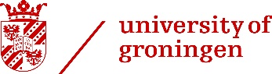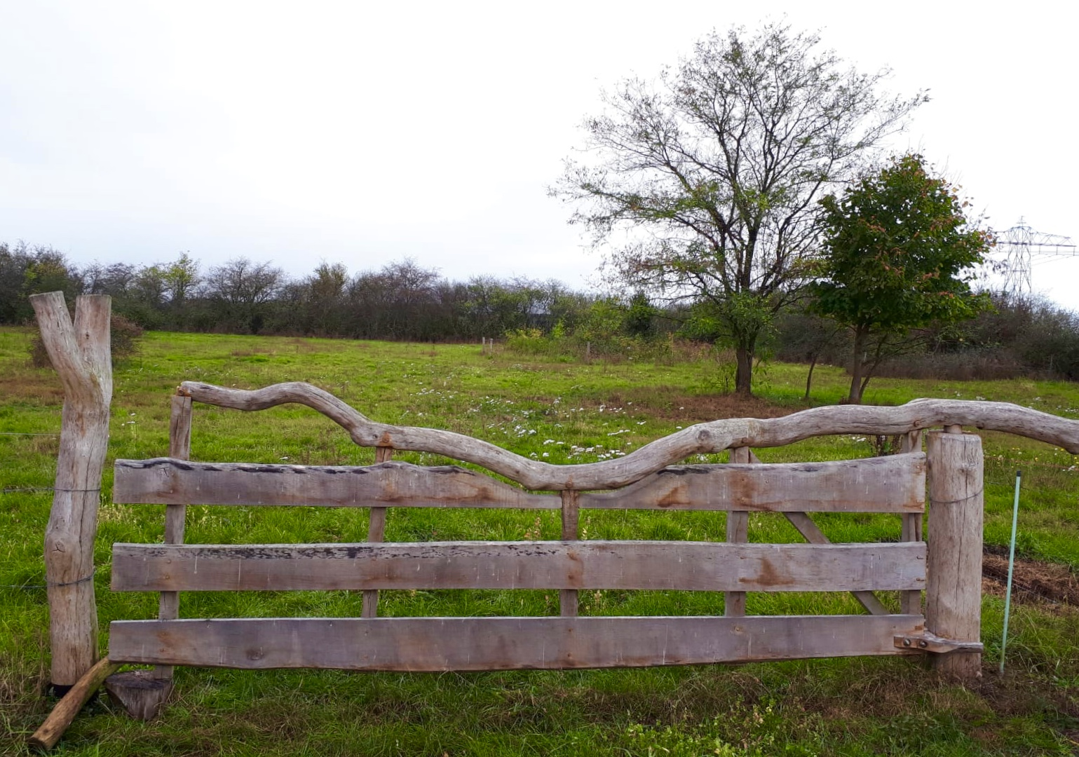

**Conservation Ecology Practices**

**T. Saccà, N. Wemer, Z. Yuan, L. van Gijssel**

**2018**

**Project Muntendam**

**Agriculturally sustainable biodiversity**

# Summary

Agriculture is the most important sector in the country of the Netherlands, which takes up to around 70% of the landmass of the country. This report was made with the aim to improve the biodiversity in agricultural lands, without compromising the revenue of the farm, on which the farmers depend. It is proposed in the report that the area of Muntendam will be managed by a cooperative of all the farmers in this area, alongside experts with agriculture and ecology conservation background. With the management of this team, over the 20 years’ time span of the project, new farming methods will be tested and optimized with new advancement of scientific knowledge. Under the management proposed by this report it is expected that the biodiversity of the farms in Muntendam will increase, represented by improvements in vegetation community habitat availability, diversity in invertebrate community and an increase in value of the Farmland Birds Index. To accomplish this, we explore new agricultural techniques, such as agroforestry and strip farming.

The management plan aims to further diversify the crops, maintaining and further improve farmland biodiversity at all the different trophic levels and dedicate 5% of the arable land for biodiversity. Consistent monitoring of the vegetation, invertebrate and bird communities, and soil quality will be in place for the following decades. The management plan will change according to the performance of these indicators and advancement in scientific knowledge. Meanwhile, a 10 year long experiment program is in place to study on the performance of agroforestry, land sharing and strip farming, both financially and in terms of biodiversity. The techniques with the best performances will be utilized and applied throughout the farm in the following decade.

Content

Summary 1

Content 2

Introduction 2

Description of the area 2

*Location and size:* 2

*Use:* 3

*Current projects:* 3

*Abiotic and biotic characteristics:* 4

*Important actors in the area:* 5

*Applicable conservation policies and laws (Natura 2000, Habitat or Bird Directive):* 5

Vision 6

Practices 7

*EU and National subsidies:* 7

*New agricultural techniques in the area:* 7

*Additional interventions:* 8

*Business model:* 8

Monitoring and research agenda 10

*Birds* 10

*Flower strips (invertebrates & vegetation)* 10

*Soil* 10

*Experiment* 10

References 12

# Introduction

Biodiversity in agricultural areas has declined strongly over the last 50 years, because of the negative effects of agricultural intensification (Geiger *et al.*, 2010). Nowadays small and conservative measurements are taken in order to get the biodiversity back, often encouraged by subsidies of individual countries or the European Union. New and revolutionary techniques are available to support biodiversity. In this report, the current evidence for different techniques has been collected with the aim to formulate a management plan for a farmland near Muntendam, the Netherlands, which improves biodiversity in these agricultural areas,. The ambition of this plan is to combine interventions at a different scales to create an agricultural area with opportunities for a larger biodiversity of plants, invertebrates and birds to establish, while maintaining economically profitable agriculture.

Currently, the Muntendam area is owned by several different farmers, who already aim to improve biodiversity in their area together. Consequently, it’s necessary to incorporate many different opinions and needs into the management plan.

During a field visit to the area, the landscape was analysed and the current management of the area was discussed with one of the farmers. Afterwards, the vision was established based on a literature search to determine which management techniques are most valuable for biodiversity, and how it would affect the profit of the farms. Monitoring schemes were designed, so the effect of the new management can be tested and adjusted if necessary. The result is a new management plan for the area for the next 20 years.

# Description of the area

## Location and size:

The area, consisting of 900ha, is located between the two towns of Zuidbroek and Muntendam, in the region of Groningen (fig. 1). Historically, the area has been characterized by a peat colonial construction plan and agricultural use of soil (Ottens, 2014).

## Use:

The area is primarily used for agriculture. In 2012, 40% of the area was used for the cultivation of starch potatoes. In the same period more than a quarter of the area was used for the cultivation of cereals, of which 54% was summer wheat and 46% winter wheat. Another portion was used for sugar beets (12.2%). Lower parts of the area were used for grassland and maize (4.5%), and for conservation areas as fauna strips and winter-feeding grounds (2.3%, 21ha). The remaining surface featured roads, forests, train tracks and gas locations (around 11.4%) (Boerenbuitengebied, n.d.; Ottens, 2014).

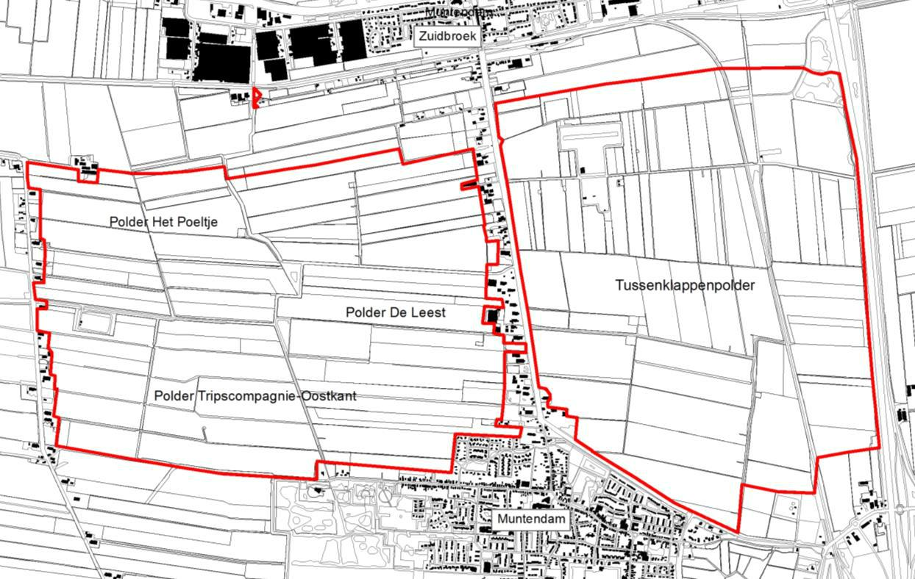

Figure 1: project area (Ottens, 2014)

## Current projects:

*Project red-backed shrike*: the red-backed shrike is a small passerine bird which lives in half-open grasslands rich with invertebrates. The population of this bird is increasing in areas close to Muntendam, and through this project the farmers hope to make the area more favourable for this bird, so it can breed there as well (Klaassen, 2018).

*Butterflies and partridges along the Legeweg*: The project focus on the partial conversion of road sides, previously under a mowing regime, to areas with brambles and bushes. Those areas are attractive for pollinators and partridges, which are the aim of the project (Klaassen, 2018).

*Grazing*: some parts of the area are extensively grazed with Lakenvelder cows to create a mosaic landscape, and increase invertebrate biodiversity, which are attracted by the cow dung (Boerenbuitengebied, n.d.; Klaassen, 2018).

Table 1: list of 2012 breeding red list species in the area (Ottens, 2014)

## Abiotic and biotic characteristics:

|  |  |  |
| --- | --- | --- |
| Red list species | Total abundance (900ha) | Breeding pairs/100ha |
| Yellow wagtail (*Motacilla flava*) | 170 | 19,0 |
| Meadow pipit  (*Anthus pratensis*) | 17 | 1,9 |
| Common linnet  (*Linaria cannabina*) | 16 | 1,8 |
| Grey partridge  (*Perdix perdix*) | 5 | 0,6 |
| Eurasian skylark  (*Alauda arvensis*) | 62 | 6,9 |

A survey of the area in 2012 of the breeding bird community showed a great biodiversity in the area, with 31 species breeding in the area, of which 5 of them are categorized as red list species (see tab.1). Other 13 bird species were present but were not found breeding in the area. In the area is also observed the presence of hares, foxes and row deer (Boerenbuitengebied, n.d.; Ottens, 2014).

Muntendam is characterized by various soil types (see fig. 2). “Peat” and “nutty on sand” consist mainly of organic matter, while “light savel” and “sand” are mainly sandy soils of different grain sizes (Boer&Bunder, n.d.). Sand appears to be predominant in the area, which is a product of Pleistocene deposits that consist mostly of river sand. Ideal soils for agriculture are balanced in contributions from mineral components (sand: 0.05–2 mm, silt: 0.002–0.05 mm, clay: <0.002 mm), organic matter, air, and water. By having a combination of mostly sand, peat and light savel, this place makes a perfect agricultural area (Boer&Bunder, n.d.). However, this agricultural opportunity has been used too intensively. Creating damage to the environment and the biodiversity on both in the soil and outside the soil (Thrupp, 2000; Oosterbaan & Kuiters, 2009).

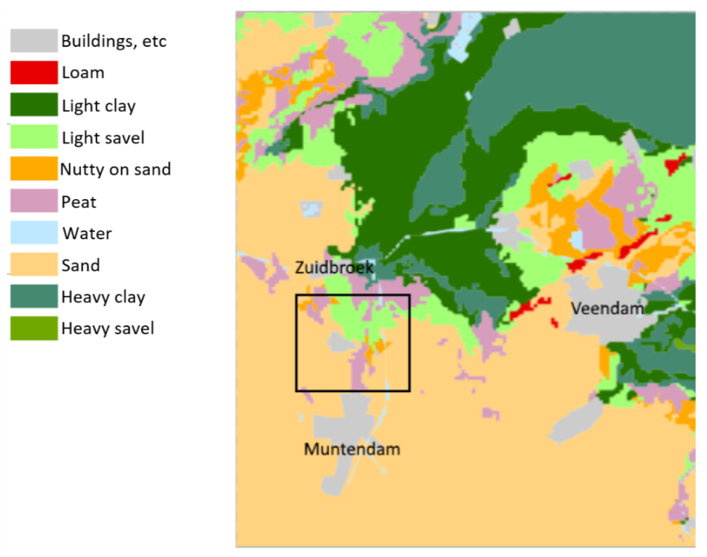

Figure 2: Soil types in the project area (Brouwer, F. 2006).

## Important actors in the area:

The main actors in the area are the farmers, that as land owners have the most to say about the management and use of the area. Other actors are the food customers and the visitors of the area, that particularly in the summer comes to the area to enjoy and observe the nature. Finally, the state representatives have a say in the area for the management of the public utilities, such as road and train tracks, particularly with the Water Board, that manage the water management of the area (Boerenbuitengebied, n.d.; Ottens, 2014).

## Applicable conservation policies and laws (Natura 2000, Habitat or Bird Directive):

The area is managed by different farmers, and is therefore not registered as a protected area of any kind. The aim of this area is to provide an example for managing of biodiversity in a regular farming area.

# 

# Vision

Our vision sees the Muntendam area as an example and a case of study for how a standard, non-organic agriculture can be applicable and profitable while other conservation targets are pursued. The area will feature a series of different techniques ranging from more conservative ones to cutting-edge approaches. The reason behind the choice of every management plan has to be found in the scientific consensus and the advancement in the scientific knowledge of farmland conservation. For that reason, one or more scientific advisors will closely follow-up the area, in order to be ready to monitor the effectiveness of the approaches and, if needed, modify or update them. In addition, much emphasis is put on the economic side, so that the area will be up to date on the EU and national legislation to receive all the possible subsidies for applying conservation approaches.

Our main goal is to halt or reverse the negative trend of bird populations that can currently be observed in farms all over Europe and to increase the biodiversity and numbers of invertebrate and plant community (Erisman *et al.*, 2015). Therefore, our focus lays on different trophic levels, which is expected to have a positive, integrative effect in the general health of the ecosystem. This will result in an increase in natural pest control, due to predation, that will allow a less intensive use of pesticides (Thrupp, 2000; Nicholls & Altieri, 2012; The Royal Society for the Protection of Birds, 2012). Many approaches are expected to have a positive outcome on the quality and resilience of the soil, resulting in a decreased need of fertilizers. Hope Farm is a good example to work towards. It’s a fairly new area consisting of 181ha where various agricultural methods have been assessed. This will lead to economic returns, supposedly more in the medium-long term than in the short term. In 20 years, this site would not only have a sizeable revenue, but also have a better soil quality, better habitat in terms of vegetation, local invertebrate, bird and under-ground communities (The Royal Society for the Protection of Birds, 2012). Also, the effects of the different methods used in this farm should be studied thoroughly, therefore better management could be achieved by applying the knowledge gained in the field.

# 

# Practices

## EU and National subsidies:

In order to increase biodiversity while limiting the income reduction that conservation approaches can have, we aim to meet all the EU and national requirement stated in the Common Agricultural Policy greening (CPA) criteria, namely:

* diversifying crops
* maintaining permanent grassland
* dedicating 5% of arable land to 'ecologically beneficial elements' ('ecological focus areas', EFA).

To comply with the first point, accordingly to EU policy at least three crops have to be cultivated in the area (European Commission, n.d.). As Muntendam is a large area, many more crops should be cultivated, to maintain and promote a more heterogeneous landscape. To further improve heterogeneity, and thus disease resistance, different cultivar of the same crop should be used when possible (European Commission, n.d.; Erisman *et al.*, 2015).

The Ecological Focus Areas will be used for different approaches; skylark plots, uncultivated, uncropped plots (lapwing plots), flower strips and landscape elements. All these approaches are meant to improve biodiversity, with the positive effect of increase presence of natural predators of pests (The Royal Society for the Protection of Birds, 2012). This will allow a less intensive use of pesticides. Field and road edges will be treated to provide natural environments such as landscape elements and flower strips, as 96% of the biodiversity in a farming area comes from edges of croplands (Sanders *et al.*, 2015). Also, different interventions as top soil removal or mowing might be taken in consideration whether field or road edges are excessively nutrient rich, due to the spatially close application of fertilizers, or to naturally sustain flower communities in the long time.

We don’t aim to use a much bigger proportion of land for exclusive conservation purposes than the one stated in the requirements of CPA. This is because one of the main aims of the area is to provide an example for a new way of using agricultural lands with a net positive revenue alongside the effective integration of conservation practises. Sacrificing too much profit to conservation efforts would lower the attractiveness of this project to other farmers. Even though additional approaches like planting shrubs and trees in strategic locations to prevent wind to deplete soil in dry periods, might both benefit biodiversity and productivity and will be considered also outside the 5% EFA threshold.

## New agricultural techniques in the area:

As aforementioned, outside of the more conservative agricultural use of the soil – namely land sparing with diversified crops – approximately 200ha will be intended for more advanced, cutting-edge techniques. The aim of that area is to find new, equally profitable solutions that mix profit with a more healthy, biodiverse environment.

Agroforestry is a possible solution for our experimental agriculture systems (Agroforestry Nederland, 2014). Incorporating trees and shrubs in farmlands can have many positive effects; they provide more efficient water and nutrient dynamics in the soil due to deeper roots and they show positive interactions between the crops and trees (e.g. increase in nitrogen production, shade, natural suppression of plagues), they require less pesticides and provide higher biodiversity (Sukkel, 2018). For this approach, trees that produce fruits and valuable timber can be chosen, such as walnut (*Juglans regia L.*), cherry (*Prunus sp.*) and sweet chestnut (*Castanea sativa Mill.*) (Oosterbaan *et al.*, 2006). Linked to this, much focus will be invested on pollinators’ populations, and their number will be monitored in coordination with dynamical approaches to keep them high enough to properly pollinate trees, as later explained (Oosterbaan & Kuiters, 2009; Nicholls & Altieri, 2012).

Another possibility is strip farming. This is a method of farming which consists of cultivating a field with long, narrow strips of crops, often leaving parts of the field bare. This is a method of farming which consists of cultivating a field with long, narrow strips of crops, often leaving parts of the field bare. This strip farming can prevent soil erosion because the soil washed away from these bare areas is held by closer-growing vegetation (Francis *et al.*, 2018). Furthermore, a strip cropping result in higher biodiversity among the crops, which provide in an increased resistance to diseases, pests or extreme weather conditions. Not only does this present the farmer with higher biodiversity of plants, but also of invertebrates and therefore birds (Sukkel, n.d.; Nicholls & Altieri, 2012). In the past, strip farming was seen as a very costly and time-consuming way of farming. However, in the present day, strip cropping is compatible with farm machinery and thus can be adapted in large-scale systems (Sukkel, n.d.; Francis *et al.*, 2018).

## Additional interventions:

We will also implement additional interventions that are or not economically burdening, or that will show a profit in the long term. This includes the use of solid manure over mineral fertilizers, as this has been seen to have many positive returns, from plant and biodiversity to earthworm abundance (European Commission, n.d.; Hance & Gregoirewibo, 1987). This will help increasing the quality of the soil also resulting in an increased percentage of organic matter in the soil, compared to artificial fertilizers.

Another approach is the use of specific mowing techniques to reduce animal mortality. Certain techniques are to avoid, since they cause heavy damage (e.g. flail and suction flail mowing), while the choice of other techniques can be dependent on the specific animal community that want to be preserved in that field (J.Y. *et al.*, 2009). Mowers that uses mechanical processors are also not to be applied in areas intensively used by pollinators such as bees, as they cause much more damage to bee populations than mowers without processors (14,000 vs 2,000 honey bees/ha dead or unable to fly) (Fluri & Frick, 2002).

Raising cutting heights has been seen in one study to have a positive effect on productivity of Skylarks, allowing them to nest sooner after cutting. A reduce in number of cuttings each year will allow more chicks to reach the development stage necessary to escape the area during the mowing. Furthermore, overwintering field of grains will also be present in specific location to allow specific bird species to have a source of food in the winter (Sanders *et al.*, 2015).

Providing nest boxes for solitary bees and bumblebees is a practically inexpensive method that will likely help the population of these invertebrates, that will synergize with the measures already taken to limit their mortality (Fluri & Frick, 2002). The bee population size is closely monitored, if the boxes attract enough wild bees for the pollination of the productions trees, then no additional bee population will be introduced. Otherwise, domestic bees will be brought in to make up for that. However, our aim is to keep domestic bee numbers as low as possible, to prevent competition with local wild bees and bumblebees. Domestic bees, if present, could also provide a potential source of income by selling by-products like honey and beeswax.

We will also start out with the execution of no-till farming; a way of growing crops without disturbing in depth the soil through tillage (Thrupp, 2000). This reduction of tillage, that will be confined to few centimetres, will bring various positive effects. It promotes both below- and above-ground biodiversity, it increases the amount of water in the soil and promotes nutrient cycling and less nutrient washout (Klaassen, 2018). Furthermore, the most important effect of no-till farming is that it improves soil fertility, making the soil more resilient. As an economic upside, less fuel is needed to execute the zero-tillage farming (Klaassen, 2018).

## Business model:

The different farmers will be grouped in a cooperative. This will allow, thanks to an economical internal organization, a sharing of risks, losses and gains, that will hamper negative effects of less productive years for certain crops, crop diseases and less successful approaches (European Commission, n.d.). The internal organization, joined with a central management of the area, will permit a set and spatial distribution of approaches that would not be possible if land owners operated on their own. Certain fields located in focus areas might end up having a higher percentage of EFAs, but they will be compensated for that.  
The choice of reserving 700ha of the area to more conservative approaches provides a better economic stability to the whole system, allowing to have more flexibility on the other 200ha. If proven profitable, those new techniques will be expanded over the additional parts of the area.   
Permanent, seasonal or annual grassland might be rented to dairy farmers to let cows and sheep graze, and the decreased presence of pesticides might be appealing to some farmers that aim to sell organic products,

or simply more qualitative meat and dairy products.  
Even nowadays, a smaller part of the area that features measures to preserve biodiversity is a often used destination for different groups of people that want to explore and visit it. We aim to enlarge this trend to the whole 900ha, and we plan to design a path, with no particular economic investments, to show the features of the area.

# Monitoring and research agenda

## 

## Birds

Farmland birds will be monitored by the “Stichting Werkgroep Grauwe Kiekendief”, who also monitored the bird population in 2012. During that year the number of birds breeding in the area and number of territories were determined, using the method of SOVON (bird research bureau in the Netherlands) (van Dijk & Boele, 2011). The same monitoring method will be repeated annually to determine whether the bird populations are positively affected by the new management, and whether new species establish. The data collected will be analysed, and used in combination with to up-to-date scientific literature, to determine whether to implement or change the conservation approaches taken in the area.

## Flower strips (invertebrates & vegetation)

Invertebrates monitoring is important to determine whether flowering strips on the side of roads and agricultural fields actually increase the amount of invertebrates, of which certain species (ladybugs, spiders, hoverfly larvae) may act as natural pest control for the crops (Kuiper *et al.*, 2015). Moreover, the invertebrates in these flower strips can be food sources for different bird species (Sanders *et al.*, 2015). Invertebrate experts from ecological consultancies will be hired to monitor invertebrates in flower strips annually. The vegetation composition of these flower strips will be monitored as well, to determine if there is enough diversity of flowers growing without additional management, or if additional interventions are required (e.g. additional seeding) to increase pollinator diversity.

## Soil

Since some of our measurements (i.e. agroforestry, use of organic fertilizer, no-tilting) are implemented with the aim to increase soil quality and resilience, we want to monitor the changes in soil properties and ecosystem services. Consequently, the nutrient content and organic matter content of the fields will be assessed annually. Furthermore, the below-ground community will be annually monitored as well. This is to keep track of the changes in composition and abundances, which will allow us to further determine the quality of the soil and to assess the abundances of under-ground organisms that might be both promoting or damaging to the productivity of crops. To observe whether the population of damaging organisms will surpass certain risk thresholds, subsequent actions will be considered accordingly.

## Experiment

A 10 year experiment will be set to study the effectiveness of different types of land management. The idea of strip farming, land sharing and agroforestry will be set in the field and compared with the land sparing. Land sparing is a well-accepted concept in Europe nowadays, the whole EU legislation and subsidies organization around agricultures revolves around that concept. Therefore the majority of farms in our study area have already established spared strips at the edges of farm parcels, because – in general – these portions of land are less productive.

A control group (C) consisting of land sparing is already well-established in our area.

The experimental groups consist of three parts: Land Sharing (LS), Strip Farming (SF), and Agroforestry(AF).

The effectiveness of land sharing in increasing the local biodiversity is often debatable (Phalan *et al.*, 2011), and the effect on yield also varies from land to land. In some cases the yield would increase (Phalan *et al.*, 2011; Garnett *et al.*, 2018). The size of this experimental field would be around 10 hectares, which is not much when compared with the share size of this farm, but it still provides an area large enough to assess productivity and biodiversity. This is to reduce the uncertainty in the yield due to the technique applied to keep it to a manageable level.

Strip farming would also be installed as one of the experimental fields, because the edges of strips are ecology hotspots. Over 90% of the biodiversity happens in and around the edges (Sanders *et al.*, 2015). In this field, the strips would be twice as intensive as it is right now, which means that the width of the strips will be reduced to half of its original size. In theory this would not affect the yield dramatically. The size of this field will be around 100 hectares.

Lastly, the Agroforestry. According to the recent research, introducing intercropping or grazing can increase the revenue. Also, the shelter provided by trees can positively reflect in yield productivity in some arable systems (Phalan *et al.*, 2011). According to the research done by Oosterbaan *et al*. (2006), walnut is the go-to tree in the Netherlands, which is also the choice of this experiment group. Because of the relative rich experience with the agroforestry, the area will be around 100 hectares.

The crop rotation for all these experimental areas should be the same over the years to allow a proper comparison between different treatments. Also, the choice of the experimental areas will be influenced by the soil type, that should be the same or relatively similar between the areas, to further improve the relevance of the comparison.

These areas will be monitored as all the other parts of the project area for both the biodiversity of different trophic levels and economic return. Additional and/or specific surveys might be taken in consideration if necessary. In the end, the biodiversity and the revenue of these experimental field will be compared together with the regular farming, and a conclusion will be drawn in order to find an optimal solution for both reasonable revenue and increased biodiversity.

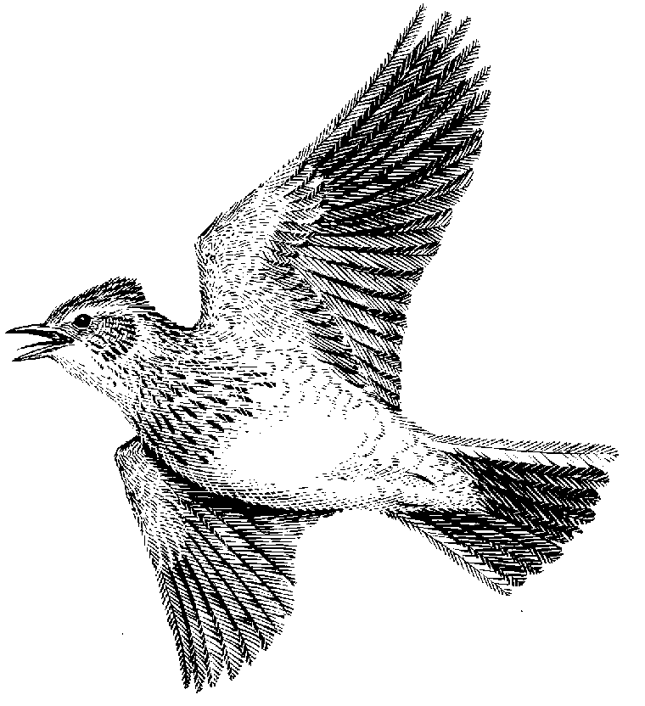

# References

Agroforestry Nederland. 2014. Agroforestry Nederland | Netwerk ter stimulering van agroforestry in Nederland.

Boer&Bunder. n.d. Perceelsrapport.

Boerenbuitengebied. n.d. Boerenbuitengebied Muntendam.

Erisman, J.W., Van Eekeren, N., De Wit, J., Koopmans, C., Cuijpers, W., Oerlemans, N., *et al.* 2015. Agriculture and biodiversity: a better balance benefits both. *AIMS Agric. Food* **1**: 157–174.

European Commission. n.d. Greening | Agriculture and rural development.

Fluri, P. & Frick, R. 2002. Honey bee losses during mowing of flowering fields. *Bee world* **83**.

Francis, C., Jones, A., Crookston, K., Wittier, K. & Goodman, S. 2018. Strip cropping corn and grain legumes: A review. , doi: 10.1017/S0889189300001235.

Garnett, T., Appleby, M.C., Balmford, A., Bateman, I.J., Benton, T.G., Bloomer, P., *et al.* 2018. Sustainable Intensification in Agriculture: Premises and Policies. *Agriculture*, doi: 10.1126/science.1234485.

Geiger, F., Bengtsson, J., Berendse, F., Weisser, W.W., Emmerson, M., Morales, M.B., *et al.* 2010. Persistent negative effects of pesticides on biodiversity and biological control potential on European farmland ARTICLE IN PRESS. *Basic Appl. Ecol.* **11**: 97–105.

Hance, T. & Gregoirewibo, C. 1987. Effect of agricultural practices on carabid populations. *Acta Phytopathol. Entomol. Hungarica* **22**.

J.Y., H., J., G. & T., W. 2009. Meadow harvesting techniques and their impacts on field fauna. *Agric. Ecosyst. Environ.* **130**.

Klaassen, R. 2018. *Nature conservation in agriculture*.

Kuiper, M.W., Ottens, H.J., van Ruijven, J., Koks, B.J., de Snoo, G.R. & Berendse, F. 2015. Effects of breeding habitat and field margins on the reproductive performance of Skylarks (Alauda arvensis) on intensive farmland. *J. Ornithol.* **156**: 557–568. Springer Berlin Heidelberg.

Nicholls, C.I. & Altieri, M.A. 2012. Plant biodiversity enhances bees and other insect pollinators in agroecosystems. A review. , doi: 10.1007/s13593-012-0092-y.

Oosterbaan, A. & Kuiters, A.T. 2009. Agroforestry in Europe. **6**.

Oosterbaan, A., Schepers, H. & Kwanten, E. 2006. Walnut as a farm crop in the Netherlands: An agroforestry project in the East and selection of cultivars for organic cultivation in the North. *Acta Hortic.* **705**: 27–34.

Ottens, H.J. 2014. *Broedvogelkartering omgeving Muntendam 2013*.

Phalan, B., Onial, M., Balmford, A. & Green, R.E. 2011. *Reconciling Food Production and Biodiversity Conservation: Land Sharing and Land Sparing*.

Sanders, M.E., Westerink, J., Migchels, G., Korevaar, H., Geerts, R.H.E.M., Bloem, J., *et al.* 2015. Op weg naar een natuurinclusieve duurzame landbouw - WUR.

Sukkel, W. 2018. Agroforestry wordt nieuwe standaard voor duurzame landbouw - WUR.

Sukkel, W. n.d. Strip cultivation of six different crops for more biodiversity - WUR.

The Royal Society for the Protection of Birds. 2012. *Farming for food, profit and wildlife HOPE FARM 2*.

Thrupp, L.A. 2000. Linking agricultural biodiversity and food security: the valuable role of agrobiodiversity for sustainable agriculture. *Int. Aff.* 265–281.

van Dijk, A.J. & Boele, A. 2011. *Handleiding SOVON Broedvogelonderzoek*.