THE INFLUENCE OF AGGRESSIVENESS ON INDIVIDUAL’S FITNESS IN THE PIED FLYCATCHER

Clazina Kwakernaak & Nynke Wemer

Supervisor: Marion Nicolaus

**Abstract**

The movement of individuals from their birth site or breeding site to another breeding site is called dispersal. Dispersal consists of three steps and within the steps several factors promote dispersal behaviour (Cote *et al.*, 2010). By moving from one site to another the fitness of a dispersing animal can be affected. Behavioural types like aggressiveness, boldness and sociability are suggested to make dispersal behaviour favourable and together characterise an individual who tends to disperse. (Sih *et al.*, 2004; Cote *et al.*, 2010). Depending on the situation, being a more aggressive individual could be advantageous or disadvantageous and can therefore affect an individual’s fitness (Sih *et al.*, 2012). To understand if the aggressive phenotype has a positive influence on an individual’s fitness during the third step of dispersal, we conducted research on a wild Pied Flycatcher (*Ficedula hypoleuca*) population in Drenthe. Our results show that there was a significant effect of nest building and egg laying stage on the aggressiveness of the Pied Flycatchers and show that aggressiveness has a significant effect on clutch size.

**Introduction**

Since the last decades humans have had an enormous influence on ecological interactions that lead to the dispersal of species and changes in individual’s fitness. Dispersal is the movement of individuals from either their birth site (natal dispersal) or breeding site (breeding dispersal) to another breeding site (Cote *et al.*, 2010). Dispersal consists of three successive stages: 1. departure from the current patch, 2. transfer to a new patch and 3. settlement in the new patch. Within these three steps of dispersal several factors can promote dispersal behaviour such as kin interaction, interspecific competition, habitat quality and predation risk (Cote *et al.*, 2010). The behaviour to disperse is an element of the behavioural syndrome consisting of behavioural traits which are correlated with an individual’s dispersal tendency at a population or species level (Sih *et al.*, 2004). Behavioural syndromes are thought to be the outcome of natural selection and allow organisms to respond to changing environmental conditions mostly accelerated by human influences (Duckworth & Badyaev, 2007). The possibility to respond to the changing environment makes it necessary to understand the proximate and ultimate causes of dispersal in order to manage the population and predict these environmental changes (Cote *et al.*, 2010). By moving from one patch to another, individual fitness – but also whole populations – can be affected. From gene flow, population dynamics and population genetics to species distribution can be influenced by dispersal (Cote *et al.*, 2010).

Individuals exhibiting behavioural traits that might be more advantageous for dispersal than residency should show a ‘dispersal syndrome’. These integrated traits can be seen as a behavioural type. For example, boldness, aggression and sociability are suggested to be behavioural types that make dispersal behaviour favourable and together characterise a ‘disperser’ type (Sih *et al.*, 2004; Cote *et al.*, 2010). However, all three aforementioned stages of dispersal have different favourable behavioural types. Some individuals might show more aggressive behaviour in situations where high aggressiveness is favoured, whereas the same individuals might show disadvantageous aggressive behaviour in situations where low aggression is favoured (Sih *et al.*, 2012). Therefore, an individual’s behavioural phenotype – like aggressiveness and boldness – could affect its fitness. For example, bold and aggressive individuals tend to take more risks and therefore suffer from higher mortality than the more careful individuals. However, the cautious individuals often miss out on opportunities because they do not expose themselves to more risky situations (Sih *et al.*, 2012). Those different situations and risk taking behaviour could be influenced by species distribution, intra- and interspecific competition and habitat quality. These factors might all have different influences on how advantageous the aggressive behaviour is. Individual’s fitness can be measured during the third the third stage of dispersal where settlement, nest-building and egg-laying occurs.

Furthermore, habitat quality and phenotypes may influence the occurrence of dispersal. Few studies on non-social songbirds have found a positive relationship between the phenotype of the dispersing individual and the habitat quality of their new settlement. (Camacho *et al.*, 2013). In addition, some behavioural traits may be influenced by phenotype (individual traits). When looking at the aggressive behavioural type, darker individuals tend to show more aggressive behaviour. A study of Ducrest *et al*. (2008), has shown that on average darker pigmented individuals experience higher levels of aggression and sexual activity than lighter pigmented individuals. This correlation has been presented in several animal species including three species of mammal – among which the African lion and white-tailed deer – four species of fish, four species of reptile and 36 species of bird (Rushton & Templer, 2012).

The growing importance of understanding which behavioural traits are needed in order to respond to (human induced) changes to the environment has led to an increased attention towards studies involving the effect of behavioural syndromes on an individual’s fitness (Sih *et al.*, 2012).

To understand if the aggressive phenotype has a positive influence on an individual’s fitness during the third stage of dispersal, we conducted research on a wild Pied Flycatcher (*Ficedula hypoleuca*) population. Observing Pied Flycatchers during both the nest building and egg laying phase will give insight in to which extent the fitness of an individual and pair is influenced by aggressiveness in the settlement stage of dispersal. In our study settlement success is defined as the probability of laying eggs. To be successful in a new area, Pied Flycatcher individuals are expected to be more aggressive than the individuals who breed in their natal or in already established settlements because high level of aggressiveness is expected to enhance the chance of getting a territory in new established areas (Duckworth & Badyaev, 2007). Furthermore, we expected the aggressiveness of both sexes during the nest building and the egg laying phase to be positively correlated. Because nest defence is part of the parental investment, we predicted aggressiveness to increase with increased investment, i.e. during the nest building phase and the egg laying phase in the breeding season. Because the investment in being more aggressive is expected to increase the survival of future offspring (Sergio *et al.*, 2001)

In addition, we investigated whether variation in aggressiveness can be explained by individual traits (plumage colouration) and by habitat quality and Great Tit density. To that purpose, we measured the male plumage colouration to investigate whether darkness and aggressiveness were positively correlated. Melanocortin levels are higher in darker individuals, which is expected to be positively correlated with testosterone. This makes darker individuals more aggressive in their behaviour (Ducrest *et al.*, 2008; Rushton & Templer, 2012). Level of aggressiveness might also be influenced by environmental factors such as Great Tit density and the proportion of oaks. Great Tits and Pied Flycatchers prefer similar habitats where they can breed at high densities. Furthermore, migratory Pied Flycatchers arrive at the breeding sites later than resident Great Tits. These factors can result in competition for nesting places with resident tits, which often leads to fatalities among Pied Flycatchers (Slagsvold, 1975; Samplonius *et al.*, 2017). However, Pied Flycatchers tend to prefer settling near Great Tits. This might be because judging the environment for food and safety is time consuming, thus copying the Great Tit nesting place choice saves a lot of time (Samplonius *et al.*, 2017). Finally, we estimated habitat quality by looking at the proportion of oaks on both territorial and plot level. Pied Flycatchers preferably breed in oak habitat as oaks are preferred by caterpillars and caterpillars represent an important proportion of nestling diet (Feeny, 1970; Forkner *et al.*, 2004)

**Methods**

*Study areas*

Research on the Pied Flycatchers has been conducted since 2007 in two national parks in the Netherlands; Drents-Friese Wold and Dwingelderveld. Research has been conducted in plots which are defined as the area were the pied flycatcher is able to breed in nest boxes which were placed in these areas. In this study, we focus on ‘new plots’ which were established in 2017 and 2018 and on a subset of the ‘old plots’ which were established in 2007 (Fig.1). The old study plots (fig. 1, plot 1-12) vary in surface area between 50 hectare with 100 nest boxes and 20 hectare with 50 nest boxes (Both *et al.*, 2017). The new study plots consist either of 15 nest boxes (Fig.1, red dots) or of 20 nest boxes (Fig.1, green dots) and the distance between the nest boxes is approximately 50 meters. The habitat of the old plots ranges from mostly deciduous or coniferous trees to a mixture of both tree species. When the plot consisted of mostly deciduous trees, the most abundant tree species was the common oak. When the plot consisted mostly of coniferous trees, the most abundant tree species was the scots pine (Both *et al.*, 2016).

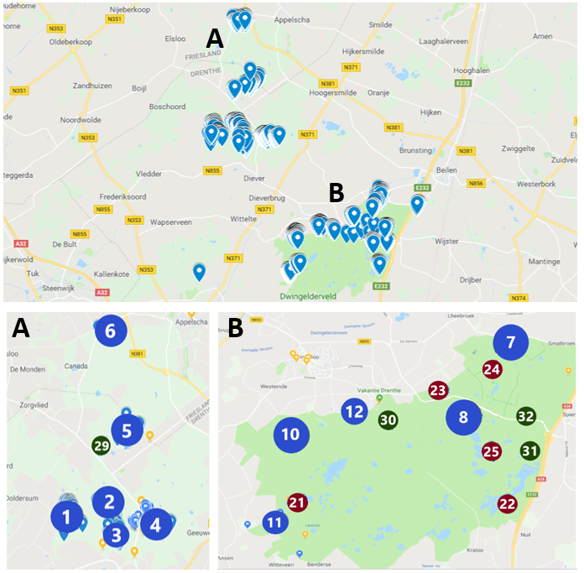

Figure 1: The study area of Pied Flycatcher divided in 2 national parks, Drents-Friese Wold (A) and Dwingelderveld (B). The blue dots represent the old plots, the red dots represent the plots established in 2017 and the green dots represent the plots established in 2018. The size of the dots reflects the number of the nest boxes in the plot.

*Data collection*

Aggression tests were conducted twice, both during the nest building and the egg laying phase. Both phases are important for successful settlement. For the aggression test, a caged Great Tit model and a MP3 player with Great Tit songs were placed on the top of a Pied Flycatcher nest box for a maximum of 15 minutes (Fig.2).

When one of the sexes arrived, the actual test started and for 3 minutes three aggressiveness measures were taken: 1. the number of vocalisation, 2. the number of attacks and 3. the distance between the Pied Flycatcher and the Great Tit model. The test was conducted for both birds separately and after these 3 minutes the Great Tit model and the MP3 player were removed. While removing the set-up, we checked the content of the nest box. The identity of the Great Tit model and the Great Tit song used were randomized across the tests.

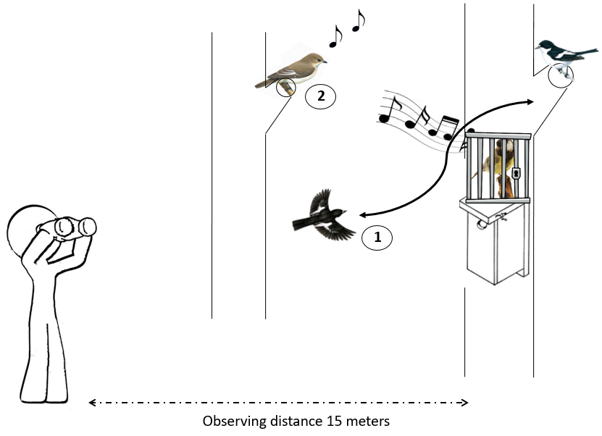

Figure 2: The experimental design of the aggression test with the caged Great Tit model. An observer situated at a distance of 15 meters measures the arrival of the Pied Flycatcher, the number of attacks (1), the number of alarm calls (2) and the minimum distance from the Pied Flycatcher to the Great Tit model.

We assumed that three aggressiveness proxies were interdependent and a correlation analysis confirmed that it was indeed the case (Fig. 3). In both sexes the number of alarms and the number of attacks were positively correlated (female = 0.11, P<0.05 and male = 0.37, P<0.001). However, for both male and female, the number of alarms (female = -0.28, P<0.001 and male = -0.34 P<0.001) and the number of attacks (female = -0.12, P<0.05 and male = -0.29, P<0.001) were negatively correlated with the minimum distance to the dummy bird. Subsequently, the aggressiveness trait that explained most of the variance at individual level and had the highest repeatability was chosen based on generalized linear mixed models (GLMMs) (appendix A). As a result, the number of alarms of the female (r[95%CI] = 0.210 [0.056; 0,365]) and the number of attacks of the male (r[95%CI] = 0.692 [0,486; 0.849]) had the best repeatability and predicted variation in the other traits, were chosen as proxy for individual aggressiveness.

To test whether being more aggressive is positively correlated with the plumage colour, the percentage of black on the head and the back of the male Pied Flycatchers was estimated during the aggression tests. This was done by using DROST scores ranging from 1 to 7 (Camacho *et al.*, 2018). The DROST scores 1 to 3 represent black males whereas males with a score of 4 are anthracite coloured. The scores 5 and 6 represent light grey males and brown males with black on their head. Finally, a DROST score of 7 represents brown males and males with a buff collared belly (Laaksonen *et al.*, 2015).

The environmental factors that might explain the variation in aggressiveness in Pied Flycatchers were also measured and were divided in two categories; density of Great Tits and habitat quality. The density of Great Tits was calculated as the number of breeding pairs per plot per surface area. Since Great Tits and Pied Flycatchers both breed in nest boxes, they were checked regularly during nest building phase and egg laying phase every 3 days in the new plots and every 5 days in the old plots. The habitat quality was measured by counting the tree species in a circle with a radius of 15 meters around each nest box in each plot. This enables to calculate the proportion of oaks per nest box (territorial level) and on plot level.

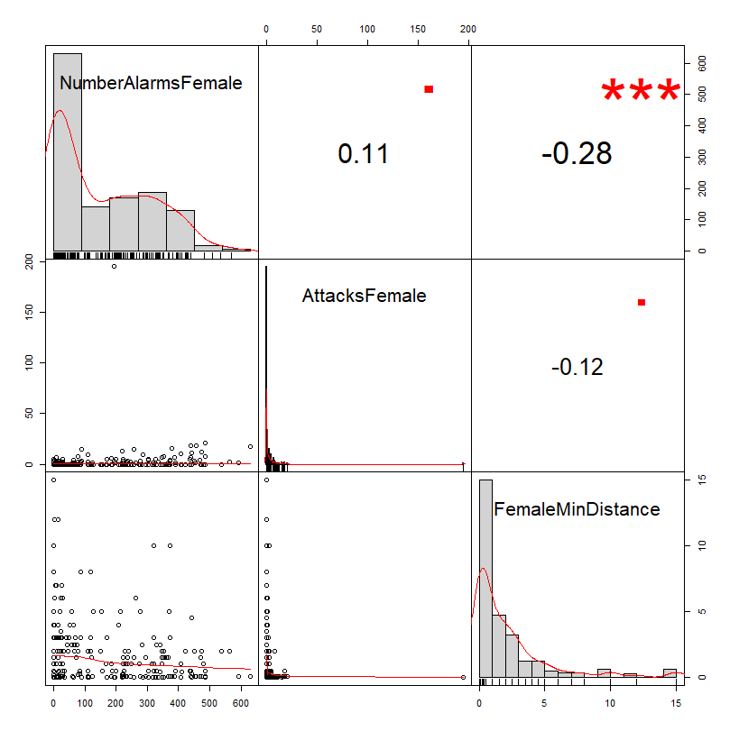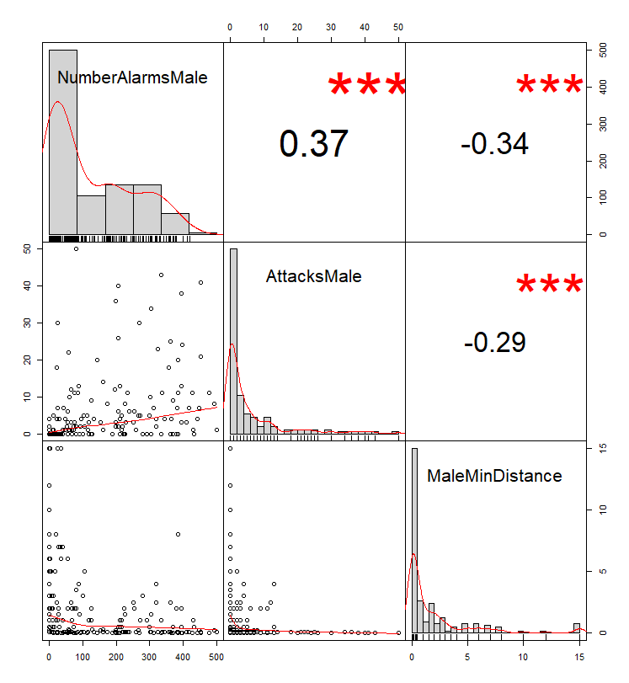

Figure 3: The significant correlations between the aggressiveness measurements of both the female (left) and male (right) Pied Flycatcher. The number of alarms and attacks of the female are positively correlated with each other (P<0.05). The number of alarms and distance of the female are negatively correlated with each other (P<0.05). The alarms and attacks of the male are positively correlated (P<0.001). The alarms and attacks are both negatively correlated with the distance of the male (P<0.001).

To measure the settlement success, we scored if the Pied Flycatcher pairs were able to lay eggs. We also noted down the date of the first egg laid and the final clutch size, which were used as a measure of fitness. For the fitness measurements only the aggressiveness of the female because in the end, the female energetically invests in laying eggs.

**Results**

*Effect of individual traits on the variation in aggressiveness*

Linear regression analysis between the aggressiveness of the male and his plumage colour showed that male individuals with a darker plumage colour is not positively correlated to the aggressiveness of the males (Fig. 4). The corresponding GLMM shows that the variation in aggressiveness of the male is not significant explained by the plumage colour (Table 1).

However, the nest stages, nest building and egg laying, do explain the variation in aggressiveness in relation to the individual traits in both male and female (Table 2). The GLMM with a gaussian distribution for the variation in aggressiveness shows that from the nest building stage to the egg laying stage the aggressiveness in both male (90.210 ± 15.13) and female (89.630 ± 18.160) significantly increases.

Table 1: The GLMM presents how much of the variance in aggressiveness is explained by the plumage colour (DROST score) of the male. The number of attacks male is the measurement of aggressiveness.

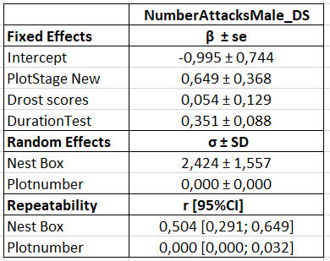

Figure 4: The linear regression analysis between the aggressiveness of the male and his plumage colour. There is no relationship found.

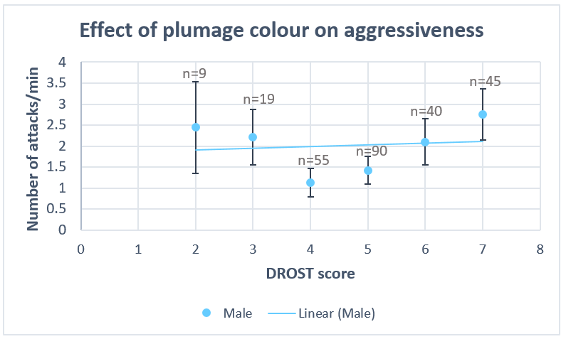

*Effect of environmental factors on the variation in aggressiveness*

The age of the different plots might influence the dispersal and therefore the plot age might explain the variation in aggressiveness. The age of the plots was divided in the two categories old and new. The GLMM which tested for a linear effect between plot age and the variation in aggressiveness for both sexes showed that plot age did not significantly explain the variation in aggressiveness (male = 0,414 ± 0,346, female = 8,772 ± 27,134, table 3). Pearson correlation analysis showed that other environmental factors, Great Tit density and the proportion of oaks on plot level, are significantly correlated (P<0.05, appendix B). However, only the GLMM of aggressiveness in relation to the Great Tit density significantly explains the variance in aggressiveness in only the female Pied Flycatcher (-88.288 ± 35.430, Table 4). In other words, a significant negative correlation (R=-0.22) exists between the Great Tit density and the aggressiveness of the females (appendix B).

Table 2:The GLMM which explains the variation in aggressiveness for both male and female in relation to the nest stages. The number of alarm calls is the measurement of aggressiveness. Nest Stage 3 is the egg- laying stage and Nest Stage 4 is the incubation stage.

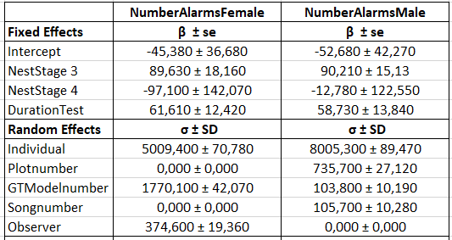

*Effect of aggressiveness on fitness components*

When measuring the effect of aggressiveness on the settlement success, the aggressiveness of sexes was taken into account (Table 5). Because the behaviour of both male and female makes the settlement successful or not. However, GLMM showed that the settlement success could not be explained by the aggressiveness of both sexes (female = 0.001 ± 0.002 and male = 0.020 ± 0.038, table 5). Next, the first day of egg laying and the clutch size were taken as fitness measurements.

Table 3:The GLMM does not explain the variation in aggressiveness for both sexes in relation to the plot age. The number of alarm calls is the measurement of aggressiveness for the female and for the male is it the number of attacks. The plot age is divided into two categories: Plot Stage Old and Plot Stage New.

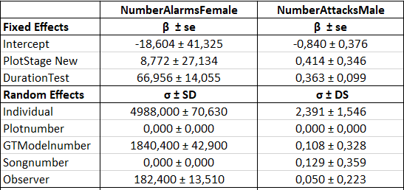

For the fitness measurements the aggressiveness of only the female was taken into account because in the end, the female has to energetically invest in laying eggs. The GLMM of the first egg day in relation of aggressiveness shows that the variance in date of the first egg is not significantly explained by the aggressiveness of the female (0.002 ± 0.002, table 5).

Table 4: The GLMMs of Great Tit density (GTDensity) and proportion of oaks (PropOaks) in relation to the aggressiveness of both male and female. The number of alarm calls is the measurement of aggressiveness for the female and for the male is it the number of attacks.

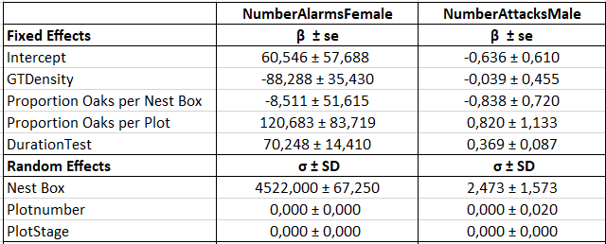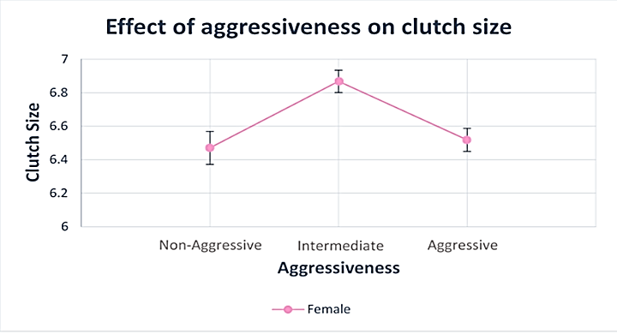

Figure 5: The directional relationship between the clutch size and the aggressiveness of the female. The aggressiveness of the female is divided into three categories: non-aggressive (female; -216.54 – -109.39), intermediate (female; -107.23 – 98.77) and aggressive (female; 101.46 – 414.46).

Figure 5 shows the directional relationship between the clutch size and the aggressiveness of the female. For graphical purposes the aggressiveness is categorized into non-aggressive, intermediate and aggressive, but the GLMM is based on the raw continuous data. Also, GLMM of the clutch size in relation to aggressiveness shows that the clutch size can be significantly explained by the square of the aggressiveness (-8.088e-06 ± 2.563e-06, table 5). This means that being non-aggressive or being aggressive results in a smaller clutch size.

**Discussion**

The results showed that significant effects were only found between aggressiveness on nest stage and clutch size. All results will be discussed in this next chapter.

We hypothesized that darker coloured individuals should be more aggressive. However, our results did not support this hypothesis. An important assumption in this research was that only adult males (>2 calendar year) were present which was not true and thus may explain our result: the plumage of Pied Flycatchers tends to be browner in their first years and then gets darker with age. The ‘cryptic hypothesis’ presents an explanation in which it states that darker males tend to be more exposed to aggressive behaviour from other males

Table 5 The GLMMs of aggressiveness in relation to the settlement success and the fitness components. The mean centered number of alarm calls is the measurement of aggressiveness for the female and for the male is it the mean number of attacks.

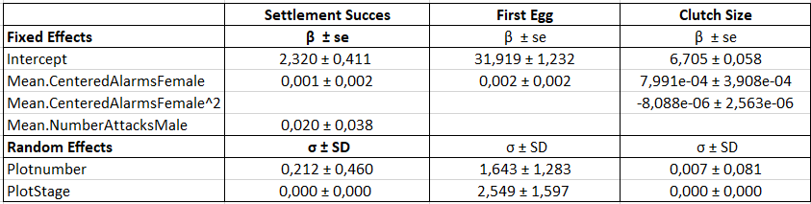

(Huhta & Alatalo, 1993). Young Pied Flycatcher males have lower reproductive success. Hence, being more cryptic of colour, young males can minimize aggressive interactions (Huhta & Alatalo, 1993). Thus, as a consequence of having young males included in the analysis, the relationship between aggressiveness and plumage colour has been masked as age and colouration are confounded.

Furthermore, colouration in Pied Flycatcher males is known to change along a geographical cline. Here two hypotheses can be brought to light. Firstly, as a consequence of geographical variation and dispersal, colour variation at each location is likely to reflect genetic variation that may not be related to male aggressiveness (Huhta & Alatalo, 1993). Next to this, birds may use variation in plumage characteristics as a cue for individual and species recognition (Järvi *et al.*, 1987). In order to prevent mating with the closely related species, the collared flycatchers (*Ficedula albicollis*), male Pied Flycatchers have evolved a browner colour in contact zones between the two species (Alatalo *et al.*, 1990; Qvarnstrom *et al.*, 2010). Hence as a result of doing research in an environment with risks of mating with closely related species, a lot of males will be browner of colour in order to prevent hybrid species.

We expected the aggressiveness of both sexes during the nest building and the egg laying phase to be positively correlated. Because nest defence is part of the parental investment, we predicted aggressiveness to increase with increased investmentand. Our outcome matches this hypothesis of increased aggressive behaviour in the second nest stage (egg laying) in both sexes. Our results support the idea that the costs of losing a breeding opportunity increases with breeding stage (Alatalo *et al.*, 1990; Qvarnstrom *et al.*, 2010).

We expected that – due to similar habitat preferences – there would be competition between Flycatchers and Great Tits for nest boxes and food. Yet, the outcome of the analyses with the environmental component – including Great Tits, the proportion of oaks and plot age – showed some surprising results. First of all, we found a negative, instead of a positive, correlation between female aggressiveness and Great Tit density. This can be explained with various hypotheses. First, migratory birds are often time constraint when choosing for the best nesting location when they arrive at the breeding areas (Camacho *et al.*, 2013). That is why some species rely on the (local) species to select the best environment (Samplonius & Both, 2017). Usually, males arrive 2 weeks before the female and choose a place to settle partly based on the distribution of their main competitor, the Great Tits (Slagsvold, 1975). However, this year Great Tits bred relatively late and thus when males arrived information on Tit settlement and performance may have not been available yet. This might result in male Flycatchers choosing the first box they encounter. This way there is no selection on habitat, competition or food. In contrast, when the females arrived, Tits started breeding and thus females may have picked a male present in high Great Tit density areas because the Tits provide them with information about the environment. However, then there is a high density of Tits in one area, it immediately means that there is less space for male Flycatchers to settle. Thus, when females choose a male at a low density Tit area, it will probably be more aggressive due to competition for a male.

Furthermore, recent unpublished data on the amount of caterpillar droppings under oaks indicates that there are four times more caterpillars this year in Dwingelderveld (Both, 2018 unpublished data). This could cause the male to not see plot differences but just pick any nest box because every box is in an environment with good food availability. This might immediately explain why there is no significant difference in aggressiveness between the old and new plots. The female then chooses a male probably by looking at Great Tit densities.

To study the link between level of aggressiveness and fitness, we examined variation in three fitness proxies: settlement success, lay day and clutch size. These analyses again gave surprising outcomes. First, we did not find that settlement success was related to the level of aggressiveness. There was no variation present among individuals in settlement success, thus this trait is not a good fitness proxy. Hence, settlement success might be explained by a personality trait other than aggressiveness. Second, we expected that more aggressive individuals would have a later first lay day than non-aggressive or intermediate individuals. However, we found no significant effect between the first egg day and aggressiveness. Third, we expected that the more aggressive individuals would have a smaller clutch size because of a high energy cost in being aggressive. Our results indeed show this, including a decreased clutch size when individuals are non-aggressive.

So, when an individual is too aggressive, it will use a lot of energy that cannot be invested into reproduction. However, when an individual is not aggressive enough, it might lose the competition with other birds over food and habitat, thereby reducing its reproductive success. To conclude, the clutch size analysis revealed that there might be an optimal level of aggression that confers the highest fitness since intermediate females laid the largest clutches. However, to conclude that there exists an optimal aggressive phenotype in our female population, long term fitness proxies should be used.

So, in conclusion, there were significant effects found of aggressiveness on nest stage and clutch size. Furthermore, a surprising negative correlation (instead of positive) had been observed between the Great Tit density and the aggressiveness in female Flycatchers.

However, there is still some uncertainty for the effect of aggressiveness on the complete fitness of Pied Flycatchers. For our research we were limited in time, meaning that we could not analyse the hatching and fledging of Flycatcher young. Therefore, we could not complete the observation of fitness.

**References**

Alatalo, R. V., Eriksson, D., Gustafsson, L. & Lundberg, A. 1990. Hybridization between Pied and Collared Flycatchers—sexual selection and speciation theory. *J. Evol. Biol.* **3**: 375–389.

Both, C., Bijlsma, R.G. & Ouwehand, J. 2016. Repeatability in Spring Arrival Dates in Pied Flycatchers Varies Among Years and Sexes. *Ardea* **104**: 3–21.

Both, C., Burger, C., Ouwehand, J., Samplonius, J.M., Ubels, R. & Bijlsma, R.G. 2017. Delayed Age at First Breeding and Experimental Removals Show Large Non-Breeding Surplus in Pied Flycatchers. *Ardea* **105**: 43–60.

Camacho, C., Canal, D. & Potti, J. 2013. Nonrandom dispersal drives phenotypic divergence within a bird population. *Ecol. Evol.* **3**: 4841–4848.

Camacho, C., Pérez-Rodríguez, L., Abril-Colón, I., Canal, D. & Potti, J. 2018. Plumage colour predicts dispersal propensity in male pied flycatchers. *Behav. Ecol. Sociobiol.* **72**. Behavioral Ecology and Sociobiology.

Cote, J., Clobert, J., Brodin, T., Fogarty, S. & Sih, A. 2010. Personality-dependent dispersal: characterization, ontogeny and consequences for spatially structured populations. *Philos. Trans. R. Soc. B Biol. Sci.* **365**: 4065–4076.

Duckworth, R.A. & Badyaev, A. V. 2007. Coupling of dispersal and aggression facilitates the rapid range expansion of a passerine bird. *Proc. Natl. Acad. Sci.* **104**: 15017–15022.

Ducrest, A.L., Keller, L. & Roulin, A. 2008. Pleiotropy in the melanocortin system, coloration and behavioural syndromes. *Trends Ecol. Evol.* **23**: 502–510.

Feeny, P. 1970. Seasonal Changes in Oak Leaf Tannins and Nutrients as a Cause of Spring Feeding by Winter Moth Caterpillars. *Ecology* **51**: 565–581.

Forkner, R.E., Marquis, R.J. & Lill, J.T. 2004. Feeny revisited: condensed tannins as anti-herbivore defences in leaf chewing herbivore communitites of Quercus. *Ecol. Entomol.* **29**: 174–187.

Huhta, E. & Alatalo, R. V. 1993. Plumage colour and male-male interactions in the pied flycatcher. *Anim. Behav.* **45**: 511–518.

Järvi, T., Røskaft, E., Bakken, M. & Zumsteg, B. 1987. Evolution of Variation in Male Secondary Sexual Characteristics: A Test of Eight Hypotheses Applied to Pied Flycatchers. *Behav. Ecol. Sociobiol.* **20**: 161–169.

Laaksonen, T., Sirkiä, P.M., Calhim, S., Brommer, J.E., Leskinen, P.K., Primmer, C.R., *et al.* 2015. Sympatric divergence and clinal variation in multiple coloration traits of Ficedula flycatchers. *J. Evol. Biol.* **28**: 779–790.

Qvarnstrom, A., Rice, A.M. & Ellegren, H. 2010. Speciation in Ficedula flycatchers. *Philos. Trans. R. Soc. B Biol. Sci.* **365**: 1841–1852.

Rushton, J.P. & Templer, D.I. 2012. Do pigmentation and the melanocortin system modulate aggression and sexuality in humans as they do in other animals? *Pers. Individ. Dif.* **53**: 4–8. Elsevier Ltd.

Samplonius, J.M. & Both, C. 2017. Competitor phenology as a social cue in breeding site selection. *J. Anim. Ecol.* **86**: 615–623.

Samplonius, J.M., Kromhout Van Der Meer, I.M. & Both, C. 2017. Nest site preference depends on the relative density of conspecifics and heterospecifics in wild birds. *Front. Zool.* **14**: 1–8. Frontiers in Zoology.

Sergio, F., Bogliani, G. & Bildstein, K. 2001. Nest defense as parental care in the northern hobby (Falco subbuteo). *Auk* **118**: 1047–1052.

Sih, A., Bell, A.M. & Ziemba, R.E. 2004. Behavioural Syndromes: An Intergrative Overview. *Q. Rev. Biol.* **79**: 241–277.

Sih, A., Cote, J., Evans, M., Fogarty, S. & Pruitt, J. 2012. Ecological implications of behavioural syndromes. *Ecol. Lett.* **15**: 278–289.

Slagsvold, T. 1975. Competition between the Great Tit Parus major and the Pied Flycatcher Ficedula hypoleuca in the Breeding Season. *Scand. J. Ornithol.* **6**: 179–190.