**ANIMAL PERSONALITY AS A DRIVER OF SEXUAL SELECTION**

Nynke Wemer (S2714442)

n.wemer@student.rug.nl

Supervisor: Marion Nicolaus

## Abstract

Consistent individual behaviour – or animal personality – can have an enormous impact on an individual’s fitness. Influences of animal personality on an individual’s ability to show the best behaviour in various environments, can result in an increase of survival and reproductive success. With animal behaviour so closely correlated to fitness, there is a growing interest in how this can cause advances for the so needed animal conservation resulting in more research on animal behaviour. However, there is still very little known about a possible correlation between sexual selection and the maintenance of various personality traits and its stability within individuals. In this thesis I provide an overview of existing literature on different female preferences for male personalities and how sexual selection plays an important role in maintaining personality traits. In addition this thesis presents some new insights for future research based on existing knowledge gaps in the available literature.

## Introduction

Sexual selection theory was first proposed by Charles Darwin in his book The Origin of Species (1859) and developed further in The descent of man (1871). He defined it as “the advantage which certain individuals have over other individuals of the same sex and species, in exclusive relation to reproduction.” (Darwin, 1859, 1871). So sexual selection can be seen as intra-specific reproductive competition (Hosken & House, 2011). Two mechanisms of sexual selection were provided by Darwin: competition for mates (intrasexual selection) and mate choice (intersexual selection) (Darwin, 1871; Hosken & House, 2011; Hughes, 2015). Intrasexual selection has mostly been defined as the competition among males for access to females and intersexual selection is often defined as the mate choice of females (Hughes, 2015). Female mate preference has mostly been observed because – even though males can be choosy and females competitive – females tend to be the choosy sex while males have higher competitive behaviour (Hosken & House, 2011). It has been proposed that females may choose males either because of direct (e.g. parental care) or indirect (e.g. better offspring) fitness benefits (Schuett *et al.*, 2010). For example, the ‘good-genes’ hypothesis explains how costly traits can signal male reproductive quality and be attractive to females (Dugatkin & Godin, 1996). This hypothesis states that “if the expression of costly preferred traits in males is proportional to the male’s quality or reveals his quality, a well-developed trait should indicate social dominance, good condition, good nutritional status, high behavioural vigour and/or high viability” (Dugatkin & Godin, 1996). This hypothesis will be discussed further in my thesis. Darwin has never really explained why females might favour some males over others and why males with exaggerated traits are often preferred by females. However, it can be stated that sexual selection should be stronger on males because their fitness is limited by the access to females (Brennan, 2010; Hosken & House, 2011; Davies *et al.*, 2015).

In species with monogamy and biparental care, it is speculated that females prefer to choose a male with a matching phenotype to theirs. By mating assortatively, cooperation between them can be more efficient, resulting in mutual reproductive benefits (Garamszegi *et al.*, 2008). There are different ways of finding a partner that might have a ‘matching’ phenotype:

1. **Indirect choice**: some individuals choose the same environment to live in, probably because of phenotype-dependent preferences and therefore often similar personalities (Brennan, 2010).
2. **Direct choice**: an individual actively chooses a partner out of a pool of individuals (Schuett *et al.*, 2010).
3. **Misinformed choice**: some individuals might seem to have similar phenotypes (and thus often similar personalities), but these similarities are caused by common environmental effects. This mechanism is referred to as adaptive plasticity: personality changes in function of the environment (Garamszegi *et al.*, 2008; Schuett *et al.*, 2010).

Because most present studies highlight sexual selection in correlation with phenotypic traits (e.g. ornamentation and size), animal personality has been overlooked for quite some time (Cummings & Mollaghan, 2006). Probably because behavioural traits have been considered uncertain and highly changeable. However, the growing recognition that animal personality can be of assistance with conservation, increased the amount of research on personality (Kelleher *et al.*, 2018), making it a more interesting subject in science. Therefore, my thesis will focus on animal personality as a driver of sexual selection rather than the well-known phenotypic traits.

Individuals of the same population very often differ consistently in suites of behaviours. These differences are referred to as coping styles, behavioural syndromes or **animal personalities** (Dall *et al.*, 2004; Dingemanse *et al.*, 2005). Animal personalities have been identified in a wide range of taxa (Garamszegi *et al.*, 2008; Schuett *et al.*, 2010). Personality traits can be available in individuals due to either nature or nurture. First, with genetic inheritance of personality (nature), personality traits can be carried on to offspring (Mazué *et al.*, 2015). Second, non-genetic inheritance of personality (nurture) means that personality traits are acquired or learned characteristics (Mazué *et al.*, 2015). In my thesis only the genetic heritability of personality will be discussed further because these are the type of preferred traits by females that can be passed on to the offspring and are therefore subjected to selection.

Personality traits such as aggression, boldness or social behaviour are suggested to be consistent through an individual’s lifetime (Dall *et al.*, 2004; Bell *et al.*, 2009) and are often heritable and related to fitness (Bell *et al.*, 2009). For example high levels of aggression can be beneficial in competing for limited resources (Dall *et al.*, 2004), while high levels of exploration may increase predation risk (Garamszegi *et al.*, 2008; Chen *et al.*, 2018). Therefore personality traits like aggression might affect mating decisions because they can indicate an individual’s reproductive potential (Garamszegi *et al.*, 2008; Brennan, 2010) or reflect an individual’s quality and provide an advantage over a rival in securing a mate (Hosken & House, 2011). Empirical studies indeed support the idea that male personality traits signal reproductive quality to females (Schuett *et al.*, 2008). For example, bolder individuals may be faster in locating new resources, because bolder individuals take more risks in finding novel areas. (Dall *et al.*, 2004). However, behavioural consistency is not always favourable. If an individual is consistent in its behaviour over different contexts, it may behave maladaptively in many situations and suffer from a reduction of its fitness (Schuett *et al.*, 2010; Davies *et al.*, 2015). For example, more aggressive individuals might be better at competing for resources or against predators, but such a trait may be really costly when it is not needed (e.g. in an antipredator context) (Smith & Blumstein, 2008), resulting in a lower chance of survival (Smith & Blumstein, 2008). Because of these trade-offs, populations vary enormously in levels of various personality traits. (Smith & Blumstein, 2008).

In this thesis I will try to answer the question of whether females differ in their preferences for male personality and how this choice is affected by both male and female personality. To reach that aim, I will review the literature on several aspects of animal personality in relation to sexual selection, including the evolution of mate choice and the maintenance of personality variation (e.g. can it help maintaining variation within populations?). This review of literature is presented in table 1, where several studies investigating various personality traits are present. The literature present in the table has been selected by looking at completed studies of animal species where research is fairly common. This way the outcome of these studies is quite trustworthy. Table 1 has been divided into several aspects: 1) the studied species, 2) the investigated personality traits, 3) whether there is assortative or disassortative mating present, 4) the direct- and indirect benefits of that personality trait, 5) important notifications to clarify the study, 6) experimental or descriptive studies and 7) if the study was done in the lab (in captivity) or in the field. By examining these factors, the correlation of animal personality and sexual selection can be well investigated in several animal species.

## Direct and indirect benefits from female choice

Behavioural syndromes can have an enormous impact on mating patterns. For example, assortative mating is a mating pattern in which individuals choose a mate with a similar phenotype or dissimilar phenotype (disassortative) from themselves more frequently than would be expected under a random mating pattern (Schuett *et al.*, 2010; Keats & Sherman, 2013). Females are almost always the choosy sex, even when all they get from the male is sperm and not even parental care (Davies *et al.*, 2015). By being choosy, females can search for males that give them either direct or indirect benefits in their reproductive success (Schuett *et al.*, 2010; Hosken & House, 2011; Hughes, 2015). **Direct benefits** include material benefits; females then prefer males which can provide them with parental care, food or a good territory. These benefits can be used by the female in producing offspring with high fitness. Furthermore, when the female choice is adaptive, other direct advantages can occur (e.g. less searching time for mates when a female prefers easily noticeable males) (Schuett *et al.*, 2010; Hughes, 2015). Next there are **indirect benefits** which include the genetic quality of the mate and therefore future offspring (Hughes, 2015). Females than prefer males that have genes that increase the fitness of the offspring. High offspring fitness might occur when a male has genes that can produce offspring with an advantageous phenotype, or because some male genomes are more in harmony with particular female genomes (genetic compatibility) (Schuett *et al.*, 2010). Table 1 shows several studies with direct and indirect benefits for every examined personality trait.

Within the indirect benefits, there are two main hypotheses that explain why some males are preferred over others by females (Hosken & House, 2011; Davies *et al.*, 2015; Hughes, 2015). First, the **sexy son theory** (or Fisher’s effect), which states that male displays may be subject to sexual selection, because it makes them more attractive to females (Fisher, 1930; Hosken & House, 2011). A well-known example is the female preference for elongated tails in some bird species. When females have a high preference for elongated tails, it will result in selection on this trait in males. Therefore only males with this preferred trait are able to mate (Fisher, 1930; Davies *et al.*, 2015). When these individual differences in tail length in males and the female preference for them have a genetic basis, they will be passed on to their offspring (Andersson & Simmons, 2006; Hosken & House, 2011; Davies *et al.*, 2015), resulting in highly wanted offspring (Andersson & Simmons, 2006). The theory of Fisher can be extended with the “runaway process” (Fisher, 1930). The runaway process implies that there is an optimum to a sexually selected trait (e.g. the elongated tail). This is because sexual selection can impose directional selection on some male characteristics that ultimately become so extreme that they turn into a disadvantage for survival (Andersson & Simmons, 2006; Hughes, 2015). This develops into a condition of relative stability in both male appearance and female preference (Davies *et al.*, 2015; Hughes, 2015).

The second hypothesis of female preference is the general viability or good genes hypothesis, (Zahavi, 1977) which states that flashy ornaments – such as a peacock tail – constitute a handicap (or honest signal) that compromises an individual’s survival on a daily basis and therefore signal male genetic and phenotypic quality (Zahavi, 1977; Andersson & Simmons, 2006; Hosken & House, 2011; Møller, 2017). Another well-known ornamentation that causes a decrease in survival are bright colours in for example guppies (*Poecilia reticulata*). This trait makes males incredibly vulnerable for predators (Dugatkin & Godin, 1996). However, this bright colouration of males in *P. reticulata* is positively correlated with bold behaviour. Thus by demonstrating their colours, males show off their high viability to females, which is heritable. (Iwasa *et al.*, 1991; Dugatkin & Godin, 1996). The handicap principle is seen as a honest signalling principle because weaker individuals are not able to carry the costly traits just as well as a stronger individual (Iwasa *et al.*, 1991; Møller, 2017; Számadó & Penn, 2018).

## Evidence for (dis)assortative mating by personality

We are familiar with humans having differences in their personalities, but now it is known that animals often differ consistently in their behaviour as well. These individual differences, strategies or tactics form an evolutionary outcome to compete with others for resources (Davies *et al.*, 2015). Behaviour is a phenotypic aspect that is often considered to have the highest plasticity (Briffa *et al.*, 2008). However, it is now established that individuals are not illimitably behaviourally plastic and that personality has the genetic basis. The heritability of personality gives them the potential to evolve under sexual- and natural selection, resulting in consistent differences in behaviour between individuals from the same population (Briffa *et al.*, 2008).

The most common behavioural axes of animal personality or behavioural syndromes are shyness-boldness, activity, sociability, exploration-avoidance and aggressiveness (Bierbach *et al.*, 2015; Mazué *et al.*, 2015; Kelleher *et al.*, 2018), which could have an enormous influence on mating patterns (e.g. assortative and disassortative mating). There are some individuals that prefer to mate with an individual with opposite personality traits. This happens when disassortative mating increases genetic diversity, which is favourable at that time (Schuett *et al.*, 2010; Ingley & Johnson, 2014). However, my review of the literature reveals that most studies found **assortative mating** by personality (Table 1 and Fig. 1). It is argued that assortative mating may be adaptive because matching personalities could promote efficient cooperation between the individuals and lead to higher reproductive success (Garamszegi *et al.*, 2008; Ingley & Johnson, 2014). Because assortative mating can result in higher reproductive success, the personality trait that is often being studied is based on parental care (Kokko *et al.*, 2003; Garamszegi *et al.*, 2008; Hall *et al.*, 2017).

Being choosy over finding a mate allows females to discover males which are genetically compatible with them, either by assortative (more genetic similarity) or disassortative (heterozygote advantages) mating (Schuett *et al.*, 2010). Because of the close relatedness between animal personality and fitness, choosing a mate has to be done with care (Myers & Young, 2018). This gave interest in investigating whether females have preference for similar male behavioural traits. The five aforementioned behavioural syndromes have been shown to be often correlated to each other and they influence an individual’s fitness (Kelleher *et al.*, 2018). Therefore, these traits can signal male reproductive and parental quality to females. For example the female fighting fish (*Betta splendens*) prefers males that are both aggressive and bold, because this is positively correlated with a better territory and offspring defence (Kelleher *et al.*, 2018). Furthermore, in the western mosquitofish (*Gambusia affinis*) females showed preference for bolder males because these males often have additional high levels of activity and aggressiveness (Table 1). In *G. affinis*, female preference results in males with increased body size, improved exploration of novel environments and better territories (Bierbach *et al.*, 2015; Chen *et al.*, 2018). Additionally, social individuals are often less bold.

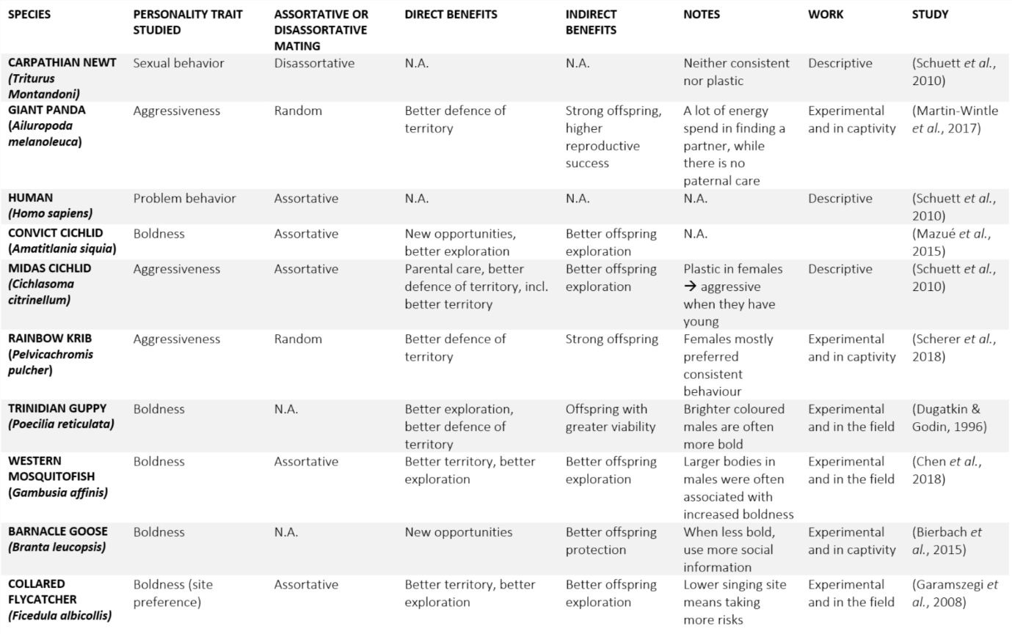

Table 1: Reviewed studies investigating various personality traits in correlation to (a) assortative mate choice, (b) disassortative mate choice and (c) direct- and indirect benefits of partners. In this table the most studied species are presented, with especially the Collared Flycatcher, Zebra Finch and Great Tits as regularly investigated species.

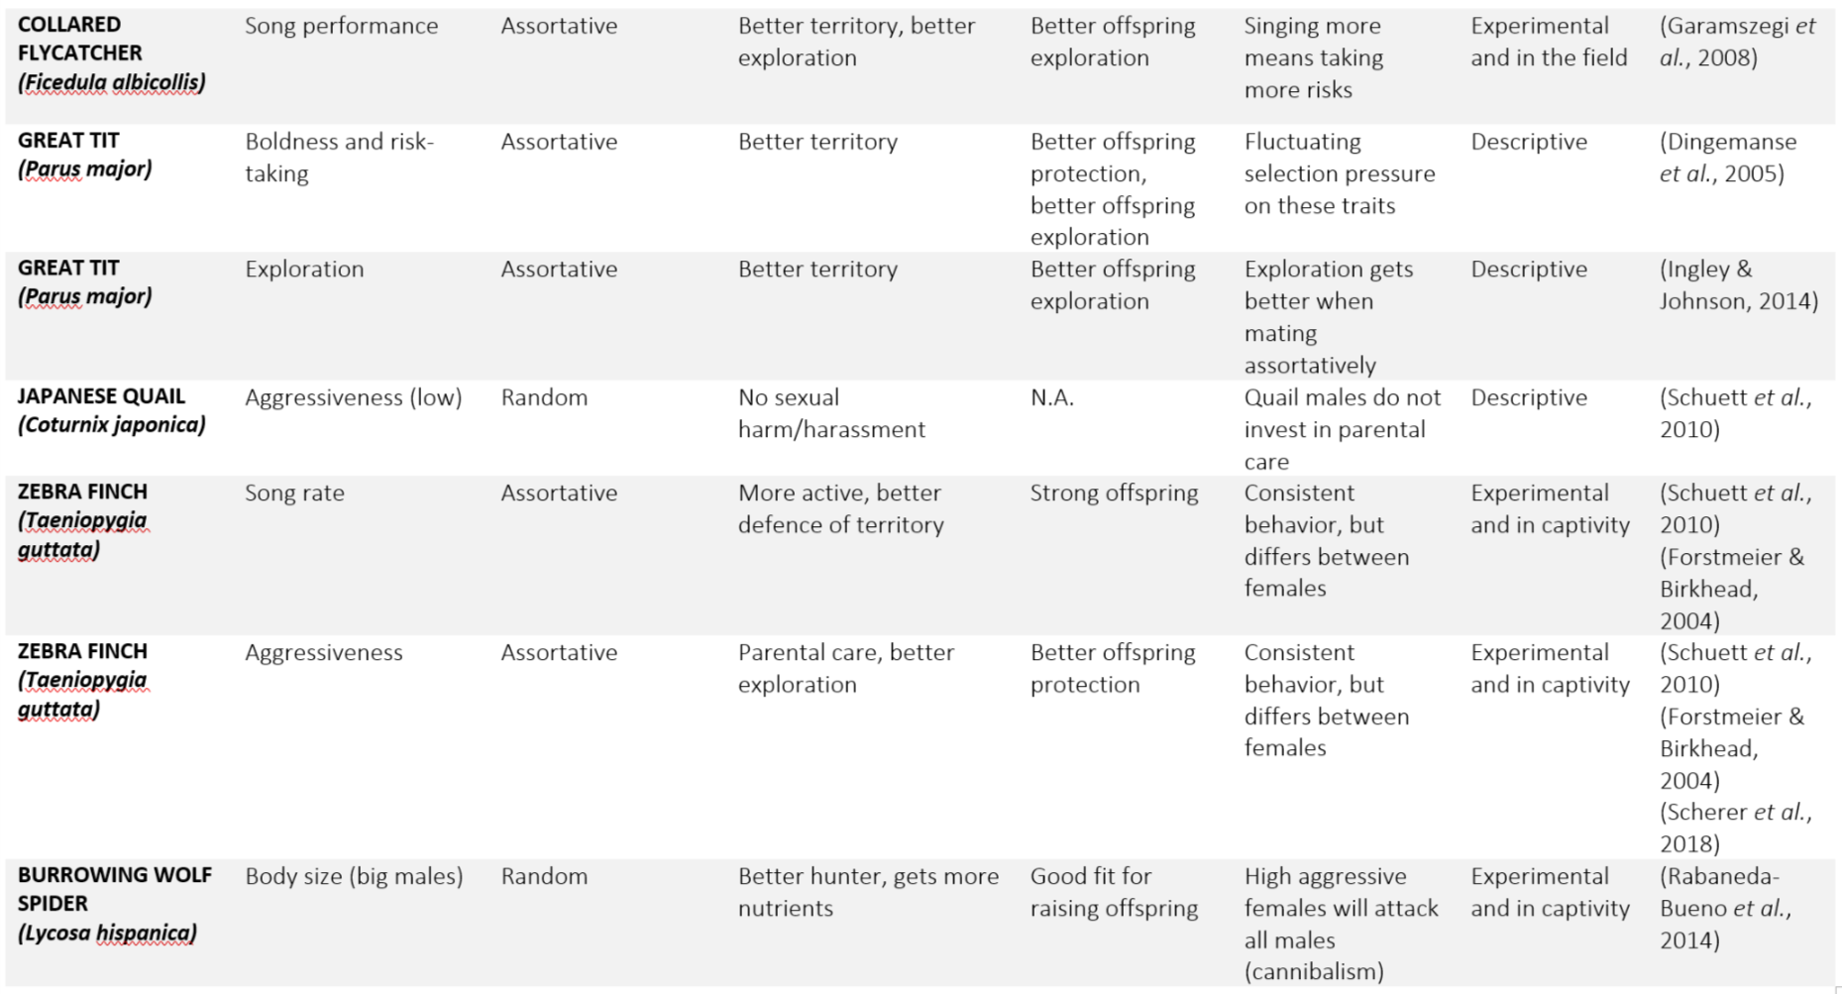

Table 1

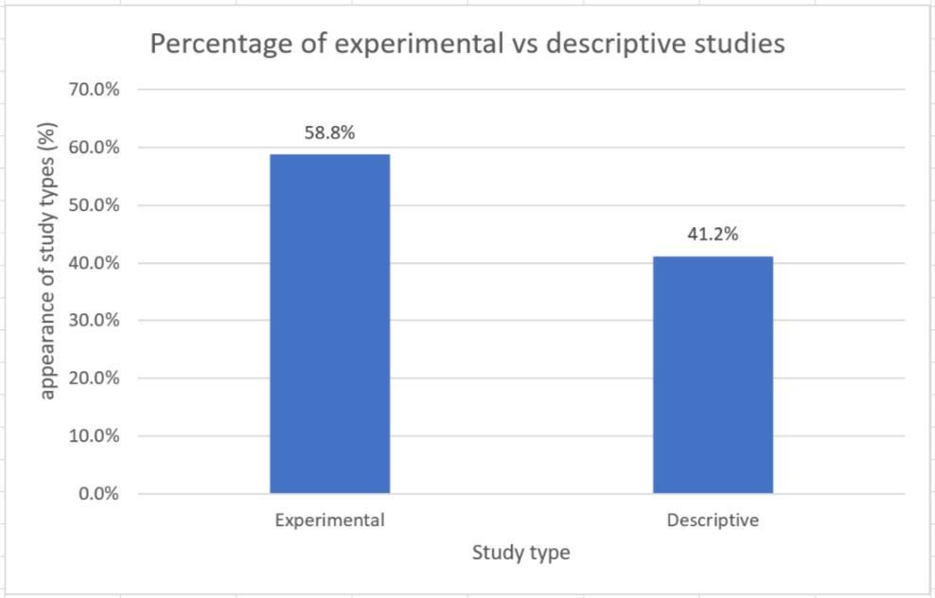

Figure 2: This graph shows the % of the study types present in Table 1: Experimental (58.8%) and descriptive (41.2%).

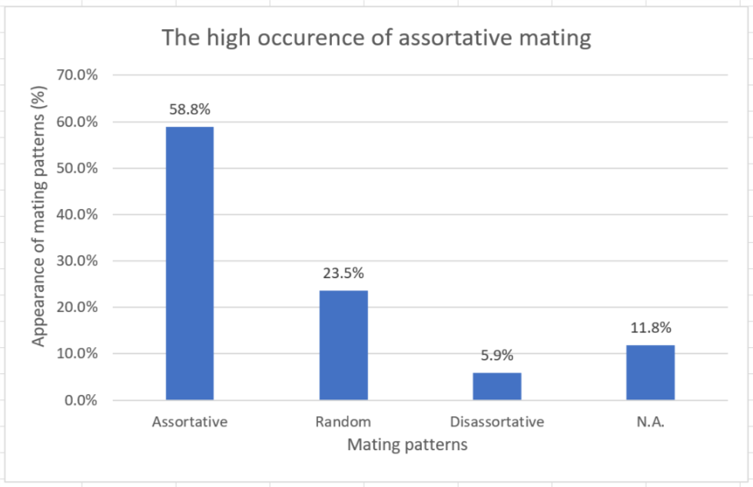

Figure 1: This graphs shows the % of the mating patterns present in Table 1: assortative (58.8%), random (23.5%), disassortative (5.9%) and N.A. (11.8).

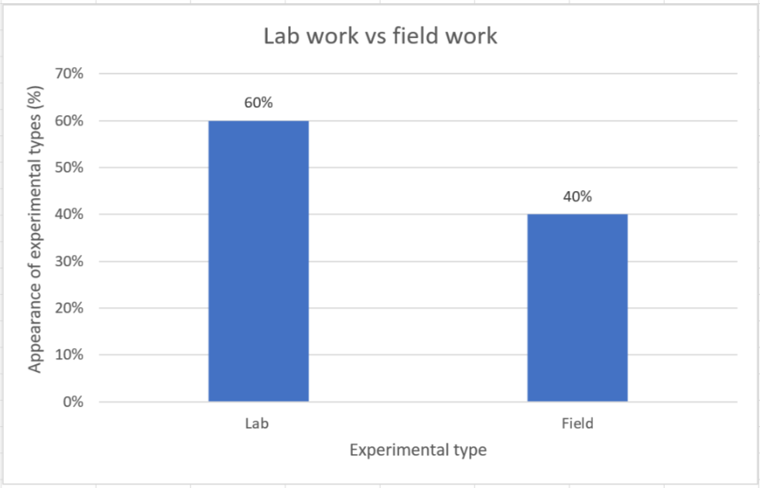

Figure 3: This graph shows the % of the experimental types present in Table 1: Lab (60%) and field (40%).

This phenomenon has been shown in Barnacle geese (*Branta leucopsis*), where the more bold individuals used social information to a much less extent in comparison to shy ones (Table 1) (Bierbach *et al.*, 2015). In *B. leucopsis* boldness is correlated to having better exploration, resulting in better territories. Thus, females of this species can choose a male by observing not only their level of boldness, but also sociability (Smith & Blumstein, 2008; Chen *et al.*, 2018). Boldness is a much preferred trait by females of various animal species. Which can be explained by the general trend that bolder individuals often have higher reproductive success than the more shy ones (Smith & Blumstein, 2008).

In some species, males provides no parental care. A female is then thought to make a choice based on only indirect benefits (Hughes, 2015). The reasons why females care more for their offspring in several species are firstly because a female knows for sure that the offspring is hers, while a male might not be sure. There is little benefit from staying to help raise the offspring of other males (Davies *et al.*, 2015). Furthermore, when 1 male (out of 20) mates with 1 female 20 times than it has a reproductive success which is 20 times higher than the female. This male should be less willing to care for offspring than a female because parental care would decrease his potential future reproductive success more than it would from her success (Davies *et al.*, 2015). However, when a male does provide parental care, it is more important for a female to choose her partner wisely. This pairing take up a greater amount of energy than in species with no biparental care (Martin-Wintle *et al.*, 2017). The reproductive performance is dependent on various combinations of personality traits, where the optimal combination differs between time, place, individual and species (Martin-Wintle *et al.*, 2017; Montiglio *et al.*, 2017). For example in the Giant panda (*Ailuropoda melanoleuca*); if males were more aggressive than their female partners they had a higher likelihood to mate and produce cubs, while males with higher excitement levels, had to pair up with low excited females in order to get better reproductive outcomes (Martin-Wintle *et al.*, 2017). Thus the preference for male personality traits is partially based on whether paternal care is provided.

## Discussion

My review reveals that animal personality plays a very important role in sexual selection. Personality traits seem to be under sexual selection. Traits such as boldness can signal male quality and can provide both direct- and indirect benefits (Table 1) (Schuett *et al.*, 2010; Hosken & House, 2011; Hughes, 2015). When looking at mating patterns, assortative mating by personality rather seems to be a rule than the exception in nature (58.8% of the reviewed literature showed the presence of assortative mating (Fig. 1)). Resulting in these mating decisions being mostly dependent on parental care (Myers & Young, 2018).

Despite an increasing interest in animal personality, there are still a lot of gaps in the present knowledge. First, within the reviewed studies there are some uncertainties in how the experiments were performed. Table 1 shows that most of the experimental studies were carried out in the lab (captivity) (60% as seen in Figure 3). The experimental studies were the only studies that provided information about either lab or field experiments. The advantage here is that this makes it easier to study the animal species and control or standardise the environmental conditions. Furthermore, the experiment can be repeated with more ease. The problem is that the circumstances for animals in that have been examined in the lab are not comparable to the ones in the wild. For example, there are no predators present in captivity. This can possible cause very different behavioural reactions (Briffa *et al.*, 2008). Thus, when capturing wild animals and studying them in the lab, it can change the way they behave from how they would in the wild, which gives faulty data. Unfortunately, some animal species simply cannot be studied in the wild, which makes accurate research on animal personality incredibly hard. Furthermore, note that distinction between lab and field studies were only made in the reviewed experimental literatures. The descriptive studies were either unclear or mentioned both lab and field work.

For future research I would suggest to compare the behaviour of a wildtype individual both in the field and in captivity to see whether or not the behaviour changes a lot in these different circumstances. If the behaviour does not show a significant change, it might be good to investigate individual differences in behavioural consistency more. This effects of individual differences has been shown little to no attention (Scherer *et al.*, 2018). Next I would suggest follow-up breeding experiments to determine if females choose males because of direct or indirect benefits. By using breeding experiments, it can be observed if there is paternal care and if female choices are heritable (Scherer *et al.*, 2018). Finally, more research on the different mate choices made due to good genes or the Fisher’s sexy son theory has to be done. This might help us to decide whether extreme male ornaments are present just for attractiveness or if they really show a male’s genetic quality. If they do show genetic quality, more research is needed to investigate if these ornaments are directly correlated to behavioural traits (Andersson & Simmons, 2006).

## Conclusion

In this thesis I asked whether females differ in their preferences for male personality and how this choice is affected by both male and female personality. Between species there is a lot of difference in female preference for male personality. It all depends on time, space, species, but also an individual itself (Martin-Wintle *et al.*, 2017). Parental care plays an important role in mate choice. When parental care is done by both female and male, assortative mating often occurs.

By mating assortatively, personalities can be matched in a way that benefits the cooperation between the individuals, which can eventually lead to a higher reproductive success (Garamszegi *et al.*, 2008; Ingley & Johnson, 2014). For assortative mating it is still not clear if both personalities – male and female – play a role or just male personality (Chen *et al.*, 2018).

Currently, the field of animal personality starts to gain more interest. This results in an increasing knowledge on the effects of animal personality traits on individual fitness. There is an enormous influence of animal personality on an individual’s ability to show the most optimal behaviour in changing environments, which results in a significant increase in the individual’s survival ability and reproductive success (Kelleher *et al.*, 2018). It is an enduring challenge to understand how variation in personality traits can be maintained, but it is very much likely that sexual selection influences this maintenance of personality trait variety (Schuett *et al.*, 2010; Mazué *et al.*, 2015).

## References

Andersson, M. & Simmons, L.W. 2006. Sexual selection and mate choice. *Trends Ecol. Evol.* **21**: 296–302.

Bell, A.M., Hankison, S.J. & Laskowski, K.L. 2009. The repeatability of behaviour: a meta-analysis. *Anim. Behav.* **77**: 771–783. Elsevier Ltd.

Bierbach, D., Sommer-Trembo, C., Hanisch, J., Wolf, M. & Plath, M. 2015. Personality affects mate choice: Bolder males show stronger audience effects under high competition. *Behav. Ecol.* **26**: 1314–1325.

Brennan, P.L.R. 2010. Sexual Selection.

Briffa, M., Rundle, S.D. & Fryer, A. 2008. Comparing the strength of behavioural plasticity and consistency across situations: animal personalities in the hermit crab Pagurus bernhardus. *Proc. R. Soc. B Biol. Sci.* **275**: 1305–1311.

Chen, B. jian, Liu, K., Zhou, L. jun, Gomes-Silva, G., Sommer-Trembo, C. & Plath, M. 2018. Personality differentially affects individual mate choice decisions in female and male Western mosquitofish (Gambusia affinis). *PLoS One* **13**: 1–24.

Cummings, M. & Mollaghan, D. 2006. Repeatability and consistency of female preference behaviours in a northern swordtail, Xiphophorus nigrensis. *Anim. Behav.* **72**: 217–224.

Dall, S.R.X., Houston, A.I. & McNamara, J.M. 2004. The behavioural ecology of personality: Consistent individual differences from an adaptive perspective. *Ecol. Lett.* **7**: 734–739.

Darwin, C. 1871. *The Descent of Man*. Wordsworth editions.

Darwin, C. 1859. *The origin of Species*. Collins classics.

Davies, N.B., Krebs, J.R. & West, S.A. 2015. *An Introduction to Behavioural Ecology*, 4th ed. Wiley-Blackwell.

Dingemanse, N.J., Réale, D. & Reale, D. 2005. Natural selection and animal personality. *Behaviour* **142**: 1159–1184.

Dugatkin, L.A. & Godin, J.-G.J. 1996. Female mating preference for bold males in the guppy, Poecilia reticulata. *Proc. Natl. Acad. Sci. U. S. A.* **93**: 10262–10267.

Fisher, R. a. 1930. The Genetical Theory of Natural Selection. *Genetics* **154**: 272.

Garamszegi, L.Z., Eens, M. & Török, J. 2008. Birds reveal their personality when singing. *PLoS One* **3**.

Hall, M.L., Parson, T., Riebel, K. & Mulder, R.A. 2017. Personality, plasticity, and resource defense. *Behav. Ecol.* **28**: 138–144.

Hosken, D.J. & House, C.M. 2011. Sexual selection. *Curr. Biol.* **21**: R62–R65. Elsevier.

Hughes, A.L. 2015. Sexual Selection and Mate Choice: Insights from Neutralist Perspectives. *Evol. Biol.* **42**: 366–378. Springer US.

Ingley, S.J. & Johnson, J.B. 2014. Animal personality as a driver of reproductive isolation. *Trends Ecol. Evol.* **29**: 369–371. Elsevier Ltd.

Iwasa, Y., Pomiankowski, A. & Nee, S. 1991. The Evolution of Costly Mate Preferences II. The “Handicap” Principle. *Evolution (N. Y).* **45**: 1431.

Keats, B.J.B. & Sherman, S.L. 2013. *Emery and Rimoin’s Principles and Practice of Medical Genetics*, 6th ed. Elsevier.

Kelleher, S.R., Silla, A.J. & Byrne, P.G. 2018. Animal personality and behavioral syndromes in amphibians: a review of the evidence, experimental approaches, and implications for conservation. *Behav. Ecol. Sociobiol.* **72**. Behavioral Ecology and Sociobiology.

Kokko, H., Brooks, R., Jennions, M.D. & Morley, J. 2003. The evolution of mate choice and mating biases. *Proc. R. Soc. B Biol. Sci.* **270**: 653–664.

Martin-Wintle, M.S., Shepherdson, D., Zhang, G., Huang, Y., Luo, B. & Swaisgood, R.R. 2017. Do opposites attract? Effects of personality matching in breeding pairs of captive giant pandas on reproductive success. *Biol. Conserv.* **207**: 27–37. The Authors.

Mazué, G.P.F., Dechaume-Moncharmont, F.X. & Godin, J.G.J. 2015. Boldness-exploration behavioral syndrome: Interfamily variability and repeatability of personality traits in the young of the convict cichlid (Amatitlania siquia). *Behav. Ecol.* **26**: 900–908.

Møller, A.P. 2017. Amotz Zahavi (1928-2017). *Ethology* **123**: 493–494.

Montiglio, P.O., Wey, T.W., Chang, A.T., Fogarty, S. & Sih, A. 2017. Correlational selection on personality and social plasticity: morphology and social context determine behavioural effects on mating success. *J. Anim. Ecol.* **86**: 213–226.

Myers, P.J. & Young, J.K. 2018. Consistent individual behavior: evidence of personality in black bears. *J. Ethol.* **36**: 117–124. Springer Japan.

Scherer, U., Kuhnhardt, M. & Schuett, W. 2018. Predictability is attractive: Female preference for behaviourally consistent males but no preference for the level of male aggression in a bi-parental cichlid. *PLoS One* **13**: 1–14.

Schuett, W., By, U., The, T.O., Of, N., As, X., For, a T., *et al.* 2008. Sexual selection and personality in zebra finches. **1**: 1–17.

Schuett, W., Tregenza, T. & Dall, S.R.X. 2010. Sexual selection and animal personality. *Biol. Rev.* **85**: 217–246.

Smith, B.R. & Blumstein, D.T. 2008. Fitness consequences of personality: A meta-analysis. *Behav. Ecol.* **19**: 448–455.

Számadó, S. & Penn, D.J. 2018. Does the handicap principle explain the evolution of dimorphic ornaments? *Anim. Behav.* **138**: e7–e10.

Zahavi, A. 1977. The cost of honesty. Further Remarks on the Handicap Principle. *J. Theor. Biol.* **67**: 603–605.