Covid-19: Relief to Rural Communities in Namibia

**Summary**

The situation in Namibia is grim as the country faces a deadly second wave of COVID 19. The pandemic is severely affecting the lives in rural areas where medical facilities are either not available or dysfunctional. In response, After School Program for OVC is providing essential support and supplies to rural vulnerable families in northern Namibia. Your donation to this project will provide relief & support to the vulnerable families in rural villages during this challenging time.

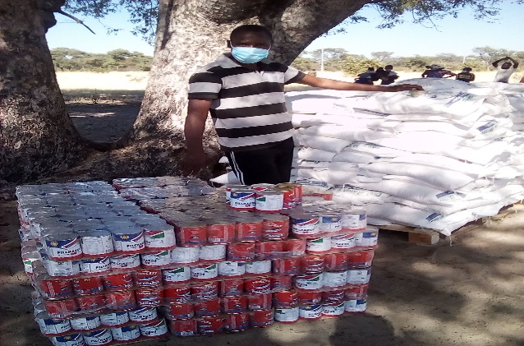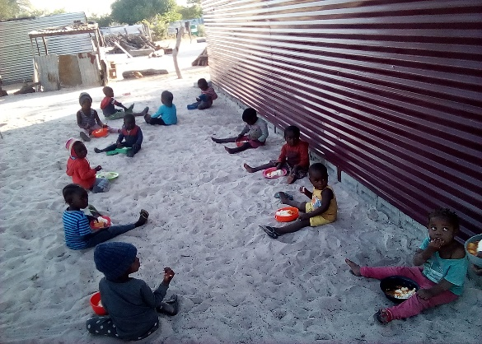

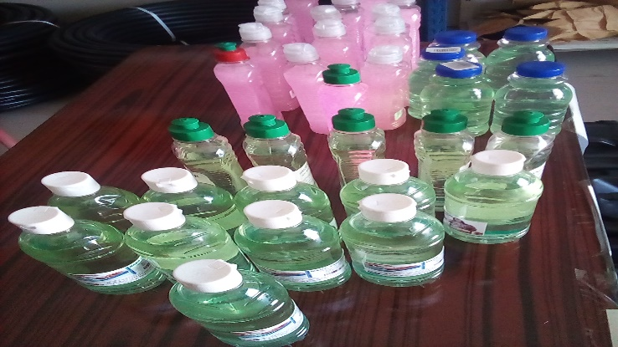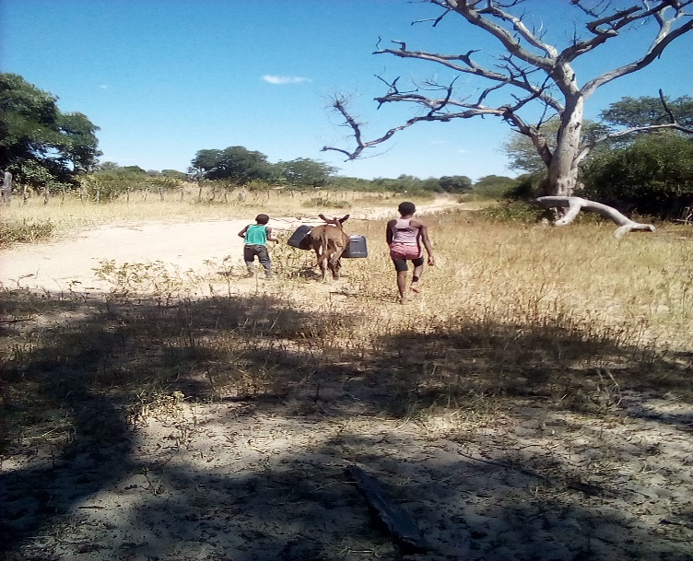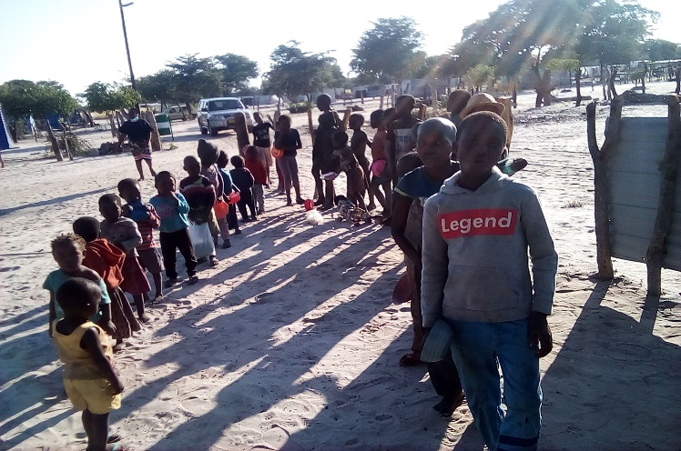

**Challenge**

With a large number of vulnerable families in villages Ohangwena region affected by COVID-19, people are facing a lack of medical facilities and are crippled with the loss of livelihood due to the current second wave and lockdown. This situation is resulting in deep suffering followed by untimely deaths in many rural poor families. NGO frontline volunteers who are working on relief efforts do not have the necessary safety equipment and incentives to carry the relief work with assurance.

**Solution**

The goal at hand is to immediately provide food and hygiene kits to the Covid-19 affected families along with elderly people, at schools, we offer remote and in-person schooling and tutoring to learners who lost their livelihoods because of the pandemic. Also with immediate relief, the project will help provide school kits and clothing to children who lost parents in the villages. The project will also ensure the welfare of the NGO warriors involved in the relief efforts in risk areas along with supplying required safety equipment to them. The project will also organise COVID awareness campaign to educate people about the prevention, detect, treatment and vaccination.

**Long-Term Impact**

Coronavirus will have long-lasting economic consequences, especially for those in poverty. Your support will help the most vulnerable families survive the pandemic and also receive critical assistance during lockdown. Our food packages ensure children avoid hunger and grow up strong and healthy, and psychosocial support help prevent long-lasting emotional trauma. COVID awareness campaign will help children, community avoid future spreading by teaching them and keeping them engaged, and addressing vaccine concerns will help us all achieve herd immunity faster. Our long-term livelihood support will ensure families have the economic means to sustain themselves during and after the pandemic ends.

**Items in Food and Hygiene Kit per household**

|  |  |
| --- | --- |
| **Item** | **Quantity** |
| Flour | 20 kg |
| Tin fish | 5x450 ml |
| Rice | 10 kg |
| Cooking oil | 10 liter |
| Salt | 2 kg |
| Onions | 3 kg |
| Potato | 20 kg |
| |  |  | | --- | --- | | Macaroni | 30 kg | | Soap | 6 | | Detergent | 4 Kg | | Mask | 20 | | Gloves | 20 | | Cap/Net | 20 | |  |