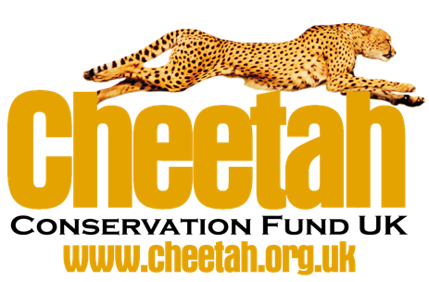

**Calling all graphic designers – lend your design skills**

**to support cheetah conservation!**

The vast majority of wild cheetahs live outside protected areas, coming into conflict with humans that share the same landscape. There are now less than 7,500 cheetahs remaining in the wild and the cheetah is the most endangered big cat in Africa. Saving this magnificent animal from extinction requires innovative conservation programmes that address the welfare of both the cheetah and human populations over large landscapes. Losing this apex predator would have serious repercussions for the local eco-systems.

**About Cheetah Conservation Fund**

Founded in Namibia in 1990 by Dr. Laurie Marker, The Cheetah Conservation Fund (CCF) is the global leader in research and the conservation of cheetahs. The mission of CCF UK is to increase awareness in the UK about the cheetah and the threats it faces in the wild and to raise funds for the work of CCF in Africa. The funds that we raise go directly to support the work of CCF in Namibia and throughout Africa. One of the ways we raise income is creating and selling cheetah themed merchandise to sell to our supporters.

**Overview of the project:**

We want to expand our merchandise offer outside of ‘typical’ charity logo t-shirts and use a more creative approach for that will not only appeal to those who already support our charity, but potentially those who just like beautifully designed animal-themed products to help generate more income for our charity.

We are looking for graphic designers, to lend their skills on a pro-bono basis to create some t-shirt designs to support cheetah conservation. The designs should centre around a cheetah theme or cheetah conservation message, but otherwise full creative licence is given to the designer

**How will we use your cheetah design:**

* The designs will feature in a new collection of t-shirts
* Designers will also be asked to provide their designs in a format that allows the production of further products including bags, hats, hoodies and mugs in the next stage of our merchandise update
* The merchandise will be available to purchase via our CCF UK website, and promoted via our social media accounts
* 25% of the profits will directly towards our cheetah conservation work
* All designs will be ‘printed to order’ by [Teemill](https://teemill.com/the-journey/) an organic/fairtrade printing company
* Whilst we are unable to offer payment, full credit will be given for your design and we are happy to help to promote your services via our website.

You can view the current offering on the CCF UK website:<https://cheetah.org.uk/merchandise>

**If you would like to support this project please email** [**laura@cheetah.org.uk**](mailto:laura@cheetah.org.uk)

***Please note:***

* *that the work designed will be performed pro bono; and*
* *that IP belongs to CCF; and*
* *CCF can use it howsoever it wishes; and*
* *without having to pay any royalties or licence fees for it.*

***Teemill Design Specifications***

