Sequence diagrams, commonly used by developers, model the interactions between objects in a single use case. They illustrate how the different parts of a system interact with each other to carry out a function, and the order in which the interactions occur when a particular use case is executed. In simpler words, a sequence diagram shows how different parts of a system work in a ‘sequence’ to get something done.
Sequence diagrams are widely used in software development to visualize system behavior and help developers design, analyze, and understand complex interactions.

User Registration: A user signs up for a new account.

ate with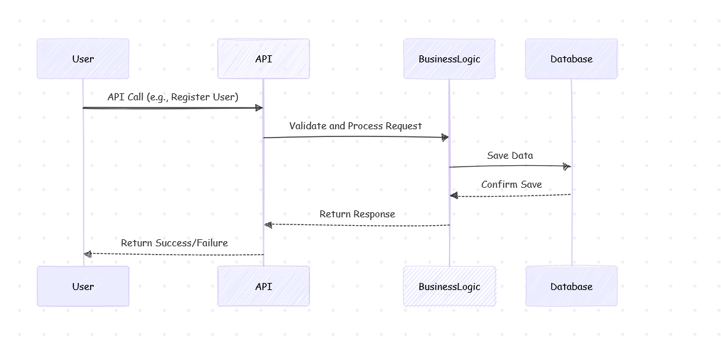

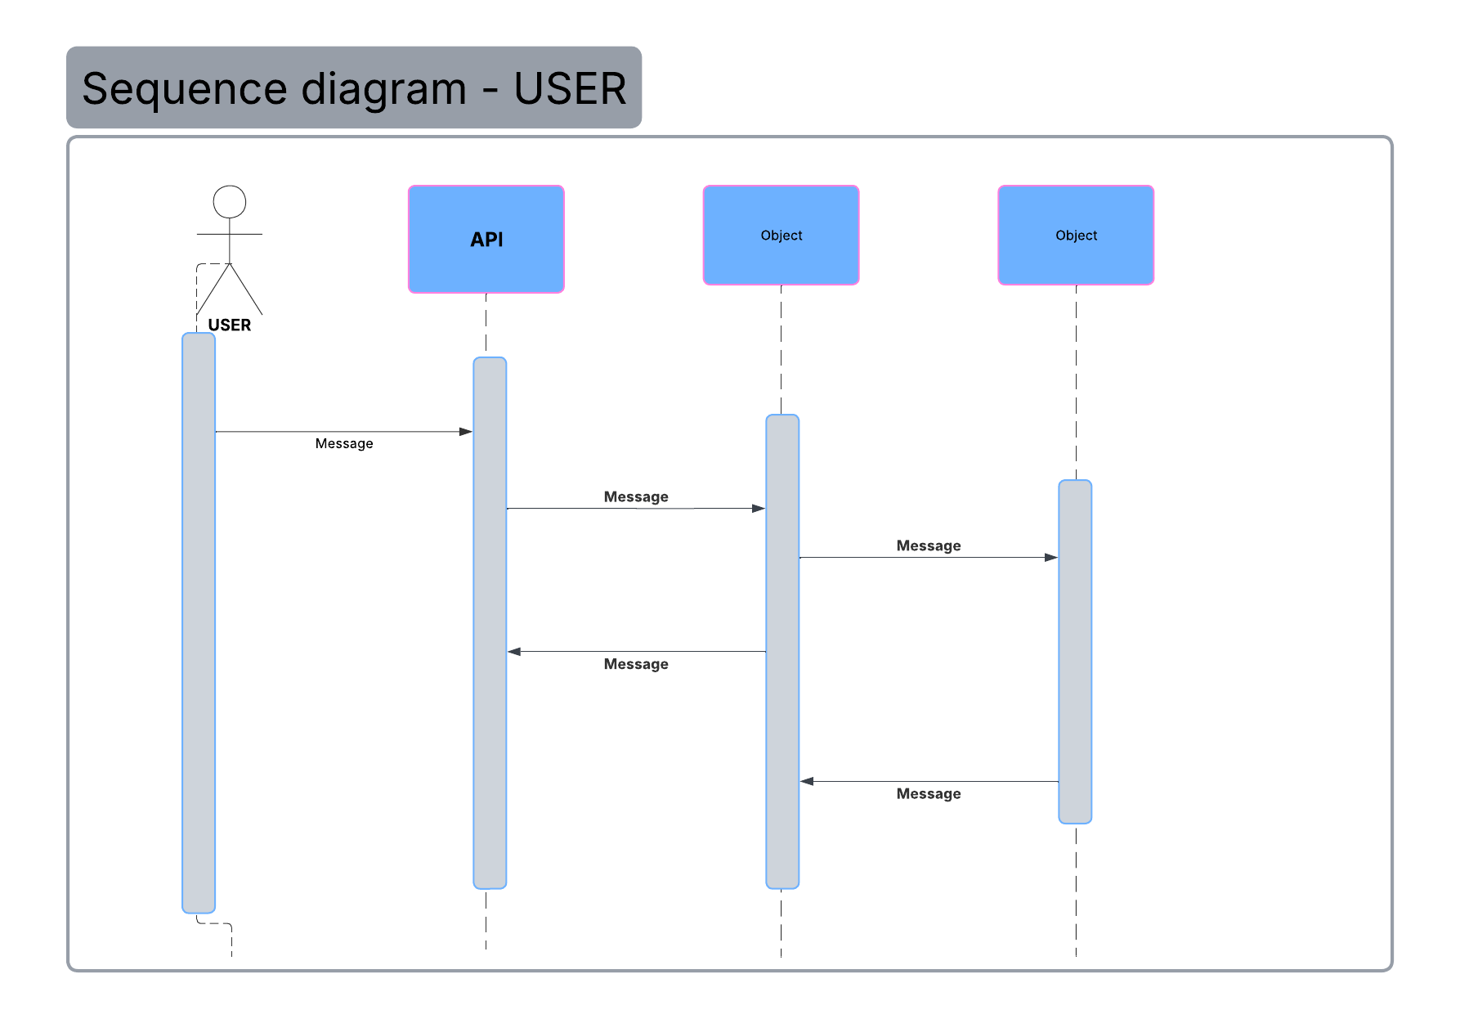
API : Application programming interface. APIs are mechanisms that enable two software components to communicate with each other using a set of definitions and protocols.

Activation Bars : The activation bar is the box placed on the lifeline. It is used to indicate that an object is active (or instantiated) during an interaction between two objects. The length of the rectangle indicates the duration of the objects staying active.

Place Creation: A user creates a new place listing.

Review Submission: A user submits a review for a place.

Fetching a List of Places: A user requests a list of places based on certain criteria.

