Controls and Game Info

Snake Game:

In the game of Snake, the player uses the arrow keys to move a "snake" around the board. As the snake finds food, it eats the food, and thereby grows larger. The game ends when the snake either moves off the screen or moves into itself. The goal is to make the snake as large as possible before that happens.

Use the arrow keys to control the snake.

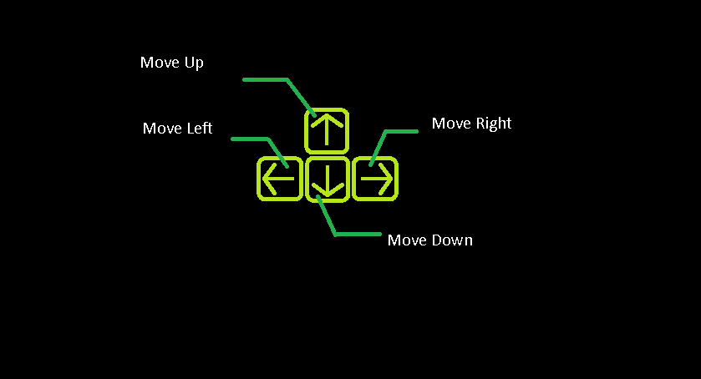

Brick Breaker:

In the Brick breaker game, the player moves a PADDLE from side-to-side to hit a BALL. The game's objective is to eliminate all of the BRICKS at the top of the screen by hitting them with the BALL. But, if the ball hits the bottom ENCLOSURE, the player loses and the game ends! To win the game, all the BRICKS must be eliminated.

Use the left-right arrow keys to move the board/paddle. The ball will bounce on the board.

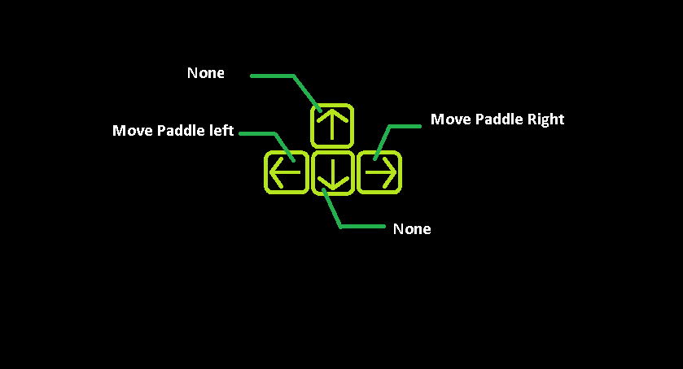

Tetris:

Tetris has very simple rules: you can only move the pieces in specific ways; your game is over if your pieces reach the top of the screen; and you can only remove pieces from the screen by filling all the blank space in a line. Rules give much needed structure to our play

Use the up-down arrow keys to turn the pieces and use the left-right arrow keys to move the pieces. Press the spacebar key to speed up the pieces so they reach the end faster.

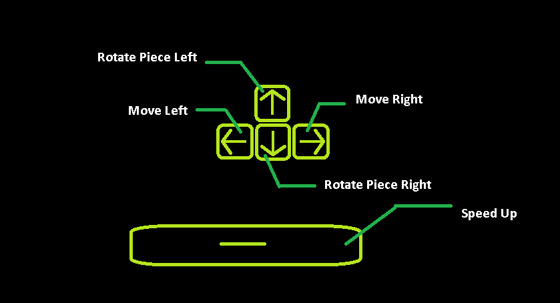

Mine-Sweeper:

Minesweeper is a single-player puzzle video game. The objective of the game is to clear a rectangular board containing hidden "mines" or bombs without detonating any of them, with help from clues about the number of neighbouring mines in each field. If no mine is revealed, a digit is instead displayed in the square, indicating how many adjacent squares contain mines; if no mines are adjacent, the square becomes blank, and all adjacent squares will be recursively revealed. The player uses this information to deduce the contents of other squares and may either safely reveal each square or mark the square as containing a mine.

