NIP Project — Submission Template
Pega Platform project · This document is your complete submission
Read this before you start:
1. Fill in Section 1 completely. The Pega application name must follow the format NIP-[Project]-[YourName].
2. Create a new Operator in Pega with your full name and log in as that operator before taking any screenshot.
3. When you create your test case, enter YOUR FULL NAME in the Issue Description (Vehicle) or Movie Name (Movie) field.
4. Complete only the section for your chosen project. Delete the other project section.
5. Paste one screenshot per user story (10 total). Follow the screenshot rules in your selected project section.
6. Answer every question in Sections 3 and 4 in your own words.
7. Save the file using this format: ProjectName_FirstName_LastName.docx. Use VehicleService or MovieTicket as the ProjectName. Examples: VehicleService_Ravi_Kumar.docx or MovieTicket_Ravi_Kumar.docx.

Section 1 — Your Details
Full Name | CAVIRAJ N
Email ID (registered on NIP) | ncaviraj@gmail.com
Phone Number | 8248804293
College Name | V.S.B ENGINEERING COLLEGE KARUR
Course (e.g. IT, CS) | B.Tech AI &DS (ARTIFICIAL INTELLIGENCE AND DATA SCIENCE)
State | TAMILNADU
Project Chosen (Vehicle Service OR Movie Ticket Booking) | MOVIE TICKET BOOKING
Pega Application Name (e.g. NIP-VehicleService-YourName) | NIP- Movie Ticket Booking Management-Caviraj
Case Type Name (exact) | Movie Ticket Request  Show Management  Ticket Booking
Pega Instance URL | https://derhorem.pegaacademy.net/prweb/app/movie-ticket-booking-management/
Operator Name (created in Pega with your full name) | CAVIRAJ N

Section 2B — Movie Ticket Booking Management Application
Complete this section only if you selected this project. Delete the other project section before submitting.

Screenshot rules — IMPORTANT before you start:
1. Name your Pega application as: NIP-VehicleService-YourName OR NIP-MovieTicket-YourName
2. Create a new Operator in Pega with your full name (Security → Operators) and log in as that operator.
3. When you create your test case, enter YOUR FULL NAME in the Issue Description (Vehicle) or Movie Name (Movie) field.
4. The logged-in operator name must be visible in every screenshot wherever the Pega interface displays it.5. The student's full name must be visible in all running-case screenshots.6. Configuration screenshots must clearly show the relevant application or rule name.
Screenshots that do not show these will not be accepted.

US-001 — Submit Movie Ticket Request
What is expected:
Case created, customer submits Movie Name, Show Date, Show Time, Number of Tickets. Validation applied.
Screenshot — paste your screenshot below this line:
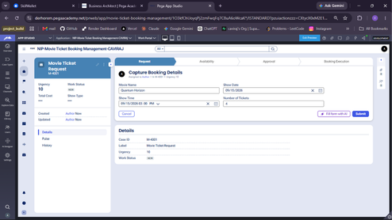

What I built for this (1–2 lines in your own words):
Configured the Request Intake stage with a Collect Booking Details form to capture Movie Name, Show Date, Show Time, and Number of Tickets with mandatory field validations.

US-002 — Check Show Availability
What is expected:
Availability stage. Seat Availability Status and Available Seats Count captured. Booking proceeds only if available.
Screenshot — paste your screenshot below this line:
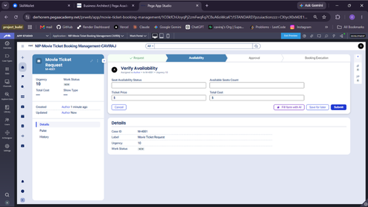

What I built for this (1–2 lines in your own words):
Created the Availability stage to capture seat availability status and available seats count, adding stage routing to handle unavailable requests.

US-003 — Calculate Booking Cost
What is expected:
Total Cost calculated automatically from Ticket Price and Number of Tickets using a business rule.
Screenshot — paste your screenshot below this line:
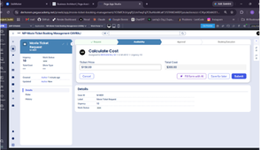

What I built for this (1–2 lines in your own words):
Configured an automated calculation for Total Cost by multiplying Ticket Price with Number of Tickets using a Declare Expression.

US-004 — Confirm Booking Request
What is expected:
Approval stage assigned to Customer. Booking Status captured. Flow branches on confirm/cancel.
Screenshot — paste your screenshot below this line:
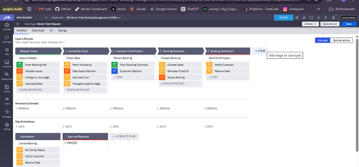

What I built for this (1–2 lines in your own words):
Configured the primary workflow stages along with conditional routing and alternate stages (Approval Rejection and Booking Rejection) to handle edge-case branching and cancellations.

US-005 — Maintain Movie and Show Data
What is expected:
Reusable Movie and Show data objects created with Movie Name, Genre, Show Date, Show Time, Seat Capacity — linked to case.
Screenshot — paste your screenshot below this line:
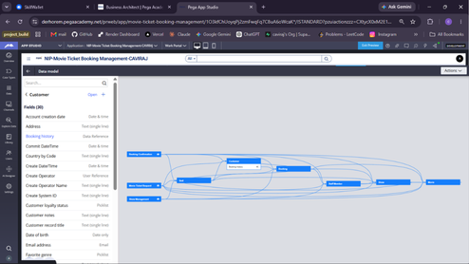

What I built for this (1–2 lines in your own words):
Configured the Data Model and visual entity relationships with core Data Objects including Customer, Movie, Show, Seat, and Booking along with their relevant field properties.

US-006 — Review Booking Details
What is expected:
Confirmation screen shows Movie Name, Show Timing, Number of Tickets and Total Cost clearly.
Screenshot — paste your screenshot below this line:
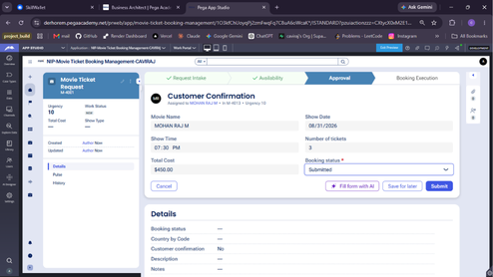

What I built for this (1–2 lines in your own words):
Configured the Customer Confirmation review step displaying consolidated booking details (Movie Name, Show details, and Total Cost) for user validation prior to ticket allocation.

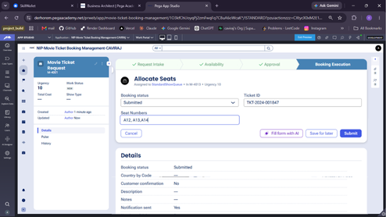

US-007 — Process Ticket Booking
What is expected:
Booking Execution stage. Seat Numbers, Ticket ID and Booking Confirmation Status maintained.
Screenshot — paste your screenshot below this line:

What I built for this (1–2 lines in your own words):
Configured the Booking Execution stage with the Allocate Seats step to assign confirmed seat numbers and finalize the reservation details before issuing confirmation.

US-008 — Notify Booking Confirmation
What is expected:
Correspondence rule triggered on case resolution. Email includes movie, show, seat and cost details.
Screenshot — paste your screenshot below this line:
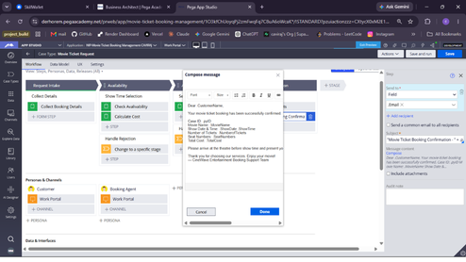

What I built for this (1–2 lines in your own words):
Configured automated correspondence using the Send Booking Confirmation email step to automatically send booking details and confirmation notice upon successful seat allocation.

US-009 — Define Booking SLA
What is expected:
SLA configured on the case type. Goal: 1 day. Deadline: 2 days. Priority increases on breach.
Screenshot — paste your screenshot below this line:
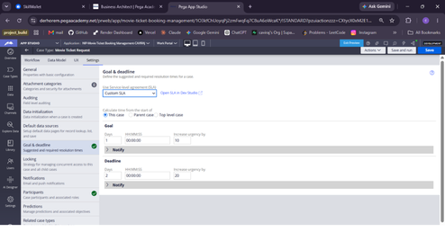

What I built for this (1–2 lines in your own words):
Configured Service Level Agreements (SLAs) with defined Goal and Deadline intervals along with urgency adjustments to ensure timely processing of movie ticket requests.

US-010 — Route by Show Type
What is expected:
Routing rule or Decision Table routes to PremiumShowQueue or StandardShowQueue based on Show Type property.
Screenshot — paste your screenshot below this line:
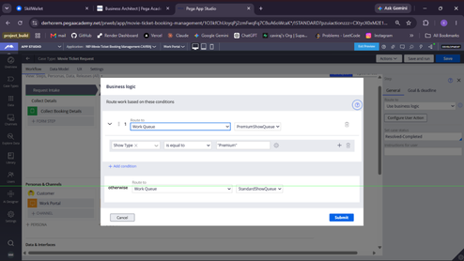

What I built for this (1–2 lines in your own words):
Configured task routing on user steps to direct assignments to specific personas and work queues (Booking Agent / Operator) for streamlined case processing and workload distribution.

Section 3 — About Your Application
These answers are checked against your screenshots. Write exactly what is in your application.

Q1. List your stages in the order they appear in your case lifecycle.
Stage names in order, separated by commas.
Request Intake, Availability, Approval, Booking Execution, Handle Rejection(Alternate), Handle Cancellation(Alternate)

Q2. Name the data object(s) you created and the properties inside them.
Data object name and its properties.
Movie (Movie Title, Genre, Language, Duration, Director, Release Date) and Show (Show Date, Show Time, Seat Capacity, Show Type, Screen Type, Venue)

Q3. What is the exact name and type of the rule you used to calculate Total Cost?
Provide:• Rule Name• Rule Type• Properties used in the calculation• Formula used
Rule Name: CalculateCostRule Type: Declare ExpressionProperties used: NumberOfTickets, TicketPriceFormula used: TotalCost = NumberOfTickets * TicketPrice

Section 4 — Your Understanding
Short, honest and specific answers score well.

Q4. What did Blueprint generate for you, and what did you add or change yourself afterwards?
Be specific about what was already there and what you built or modified on top.
Blueprint generated the base lifecycle structure with standard stages, fields, and persona definitions. On top of it, I configured calculation logic for Total Cost, established reusable data objects, built decision rules for cancellation branching, configured SLA goals and deadlines, and set up dynamic work queue routing with correspondence email templates.

Q5. Was there anything Blueprint created that you had to correct or configure further? Describe one example.
A real example from your own work.
In the Customer Confirmation step, Blueprint configured summary fields as editable text boxes. I modified the view settings to make Movie Name, Show Date, Show Time, Number of Tickets, and Total Cost strictly Read-only, ensuring only the Booking Status field remained editable for customer selection.

Q6. Explain your case flow from creation to resolution, in order.
What happens first, who does what, when the case closes.
First, the customer submits show preferences in Request Intake. Next, the system verifies seat availability and calculates Total Cost in the Availability stage. Then, the customer reviews details in the Approval stage; selecting Cancelled routes the case to an alternate stage, while Confirmed moves it forward. Finally, in Booking Execution, the task routes to the appropriate work queue, seats are assigned, the status updates to Resolved-Completed, and an automated confirmation email is sent to the customer.

Q7. Pick two design choices you made in your application and explain why you made them.
For each design choice, provide:• What you implemented• Why you chose that approach• What benefit it provides to the application
Design Choice 1: Created reusable Data Objects for Movie and Show instead of embedded properties to ensure data consistency across multiple cases.
Design Choice 2: Implemented Business Logic Work Queue Routing based on Show Type to automate assignment between premium and standard operational teams without manual triage.

Q8. What was the hardest part, and how exactly did you fix it?
Specific and honest. A real challenge scores much better than a generic answer.
The most challenging part was configuring the Send Email step with dynamic property references without syntax errors. I resolved this by correctly using double quotes for static strings and dot notation with concatenation operators for property values.

Q9. If the approval step was only needed when Total Cost is above a certain amount, what would you change in your application?
Explain what you would change and where. You do not need to build this.
I would configure a custom start condition on the Approval process using the rule: TotalCost is greater than the specified threshold amount, allowing smaller bookings to skip approval automatically.

Q10. List three exact rule names from your application that you personally created or modified.
Include the rule name and rule type for each one (for example: CalculateTotalCost - Declare Expression).
1. CalculateCost - Declare Expression
2. Send Booking Confirmation - Send Email Automation Step
3. Handle Cancellation - When Rule Process Condition

Q11. List all personas used in your application.
List the persona names exactly as they appear in your application.
Customer, Booking Agent

Q12. List all work queues used in your application and explain when each one is used.
For each work queue, provide its exact name and the condition or type of work routed to it.
1.PremiumShowQueue: Used to route booking execution tasks when Show Type is equal to Premium.
2.StandardShowQueue: Used as the default work queue to route booking execution tasks for all standard movie shows.

Before You Submit — Check These
Read through once before uploading.
1. Section 1 filled in. Application named as NIP-[Project]-[YourName]. Names match the actual application.
2. New Operator created in Pega with my full name. I logged in as that operator for all screenshots.
3. Only my chosen project section remains — the other project section is deleted.
4. All 10 user story screenshots are pasted and follow the operator, running-case, application, and rule-name evidence requirements.
5. Every question in Sections 3 and 4, including Q10, Q11, and Q12, is answered in my own words.
6. This file is named using the required format: ProjectName_FirstName_LastName.docx (for example, VehicleService_Ravi_Kumar.docx or MovieTicket_Ravi_Kumar.docx) and uploaded as required.

