Setting up Logging

Table of Contents

Introduction 1

Log4Net via Nuget 1

More Information 4

# Introduction

The SDK uses the Apache Common Infrastructure Libraries for .NET, which provides a common interface for logging adapters. The SDK currently uses version 3.0 of Common.Logging.

In order to use logging within the SDK, you need to reference the packages for the adapter you want to use.

# Log4Net via Nuget

The following steps describe the process for using the Log4Net Adapter with the SDK:

1. Using the NuGet Package Manager in Visual Studio, include the following package in your project:Common.Logging.Log4Net1213

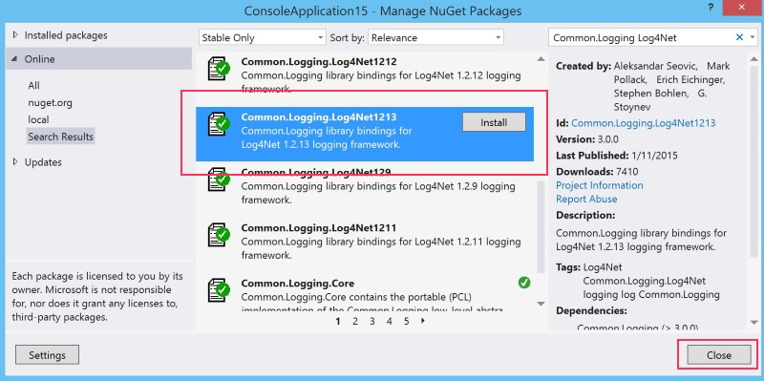

1. In your App.Config or Web.Config, add the following elements between the <configuration> and </configuration> tags so that your configuration looks like this:

|  |
| --- |
| <?xml version="1.0" encoding="utf-8" ?>  <configuration>  <configSections>  <sectionGroup name="common">  <section name="logging" type="Common.Logging.ConfigurationSectionHandler, Common.Logging" />  </sectionGroup>  <section name="log4net" type="log4net.Config.Log4NetConfigurationSectionHandler, log4net" />  </configSections>  <common>  <logging>  <factoryAdapter type="Common.Logging.Log4Net.Log4NetLoggerFactoryAdapter, Common.Logging.Log4Net1213">  <arg key="configType" value="INLINE" />  </factoryAdapter>  </logging>  </common>  <log4net>  <appender name="FileAppender" type="log4net.Appender.FileAppender">  <param name="File" value="C:\temp\log.txt" />  <layout type="log4net.Layout.PatternLayout">  <conversionPattern value="%date [%thread] %level %logger - %message%newline" />  </layout>  </appender>  <root>  <level value="DEBUG" />  <appender-ref ref="FileAppender" />  </root>  </log4net>  <startup>  <supportedRuntime version="v4.0" sku=".NETFramework,Version=v4.5.1" />  </startup>  </configuration> |

**Note:**This example creates a FileAppender. There's a wide variety of possible appenders and configuration options you can customize to your liking. For more information regarding customizing your configuration, check out the [Log4Net documentation](http://logging.apache.org/log4net/release/manual/configuration.html).

# More Information

Setting up Logging

<http://developer.couchbase.com/documentation/server/4.0/sdks/dotnet-2.2/setting-up-logging.html>

Apache Log4Net Documentation

<http://logging.apache.org/log4net/release/manual/configuration.html>