Investing · Options

GOOGL · Gamma Profile (SpotGamma Framework)
← 返回期权栏目
Gamma Profile Dashboard
SpotGamma Framework
GOOGL Alphabet Inc.
$396.015 ▼ -5.055 (-1.26%) 2026/05/15 · OPEX
CALL WALL
$400.00
Largest +γ · Resistance
PUT WALL
$395.00
Largest -γ · Support
GAMMA FLIP (HVL)
$371.24
Regime threshold
ABSOLUTE γ
$400.00
Max dealer hedge
DAILY 1σ RANGE
$392.8 - $399.2
±$3.2 implied
POSITIVE GAMMA
Dealers in mean reversion mode · Volatility suppressed · Price pinned between walls
DIST. TO FLIP +24.76
PIN STRENGTH HIGH
DEALER FLOW SUPPRESSIVE
Net Gamma Profile by Strike
2026/05/15 · Range $350-430 · 38 strikes
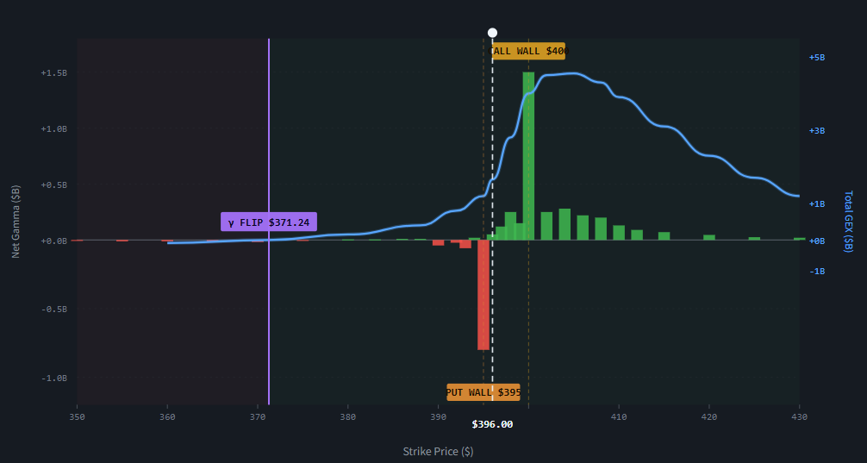
SIMULATE
$396.00
+γ (Call dominant)
-γ (Put dominant)
Total GEX
Call/Put Walls
Gamma Flip (HVL)
Simulated Price
HEDGING ANALYSIS
Simulated Price $396.00
Regime +γ
Distance to Flip +24.76
Total GEX at Price +$1.65B
DEALER HEDGE FLOW
$↑ $1: Sell 4.1K shares
$↓ $1: Buy 4.1K shares
MM is short γ (always). In +γ zone, hedging compresses moves — price gets pinned toward $397.5 between walls.
NEAREST LEVELS
↑ Nearest Resistance Call Wall $400
↓ Nearest Support Put Wall $395
Range Width $5.00
Vanna Exposure ∂²V / ∂S∂σ
Dealer's delta sensitivity to IV changes. When IV drops, vanna flows trigger systematic buying as dealers reduce hedges. Critical near OPEX.
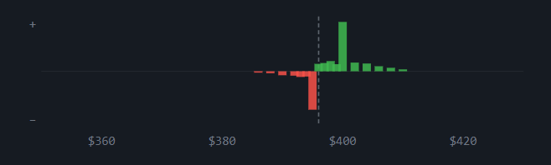
Current Vanna Flow +POS · IV ↓ → Bid
Charm Exposure ∂Δ / ∂t
Delta decay over time. Drives the OPEX week run-up pattern — as expiration nears, OTM call deltas decay, forcing dealers to unwind short hedges by buying.
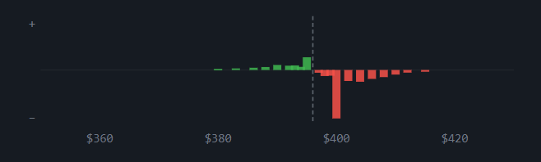
Current Charm Flow +POS · Time Decay Bid
⚠ DISCLAIMER · 重要免责声明
数据基于 2026/05/15 GOOGL Gamma敞口截图的视觉重构估值,采用 SpotGamma 公开框架的术语和方法论(Call Wall / Put Wall / Gamma Flip / Absolute Gamma / Vanna / Charm),但非 SpotGamma 官方产品。所有数值仅供学习参考,不构成投资建议。真实交易决策应使用经过验证的实时数据源。
来源：https://cavno.org/investing/options/gamma-profile/

