MTH337 Report 3
Mayfly Model Exploration

Guyin Yu

1. Introduction
Tracking the dynamics of population change of mayflies, a “mayfly model” can be generalized using the following equation:
x_{t+1}=b(1-x_{t})x_{t}
x_{t} is the proportion of mayfly population in year t to the maximum possible population, while b stands for the maximum growth rate. There is no upper limit to b.
The mayfly model is supposed to be a deterministic dynamic system, which means no randomness is involved in the future development of its states. For a given starting condition, a deterministic model will always deliver the same output.
The parameters in our model are x, b and t. Therefore, if we seek to explore the repertoire of mayfly model behavior, we need to fix some of them while we vary the rest. The tasks for this report are laid out as follows:
1. Plot population dynamics over time with a fixed maximum growth rate. (Fixed b, track x over t)
2. Plot population dynamics over time with a fixed initial population but varying b. If we find interesting behaviors here, we repeat task #1.
Due to the nature of this report, results and observation will be combined to one section so that each plot can be accompanied by relevant comments.

2. Approach
To track population dynamics over time governed by a few parameters, it is best of plot them out. The following functions and objects shall be used for the corresponding reasons. They are listed by the order of appearance.
Task #1
def mayfly(x,b,t) | We create this function to vary x over years with a fixed b. This tracks the changes of x (population in year t as a proportion of the maximum possible population) over time with a fixed growth rate. Then we will plot out x versus i, which is an individual year.  After defining this function, we try a few different b values to see what kind of behavior patterns we might get.
plt.annotate | To annotate the generated plot and point out any existing patterns that correspond with different b values.
Task #2
tmax=10000  tmin=tmax/2 | tmax and tmin give the upper and lower limit for t, the years over which we track population dynamics. In this case we track between year 10000 and year 5000.
b=linspace(m,n,100) | It gives the range in which b varies. Here we test for 100 equally spaced b values in (m,n).
plot(b,x, 'g.', alpha=.12, ms=2) | We plot the stabilized x valueversus b over the course of 500 years (as specified above). For clarity, we also specify 88% transparency.
Def bplot(m,n,x) | We define this function to plot stabilized x value against b values in the range of (m,n), as required by task #2. This function is defined so that we don't have to repeat the same code again in case we need to plot a new set of values.
Xlim, ylim | These allow us to “zero in” on a plot to study it in detail.

3. Results & Observation

Task #1 For a fixed b, vary x against t.
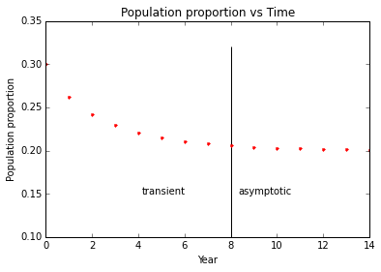 | Attempt #1: mayfly(0.4,1.25,15)  In attempt #1 as illustrated in the right, we track the population changes over 15 years with a fixed maximum growth rate of 1.25 and an initial population proportion of 0.4. As we see from the graph, the mayfly population declines over time (transient) and gradually converges to a stability (asymptotic).  To see if the same pattern holds true, we enter another b value and plot as follows. We keep the same value for x and t.
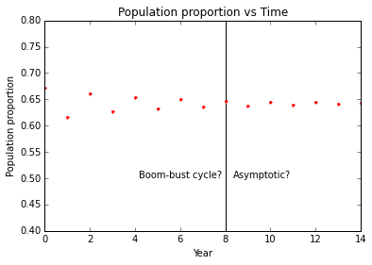 | Attempt #2: mayfly(0.4,2.8,15)  Now it seems that we get a boom-bust cycle in the first half of the 15 years we are tracking. The population dynamics gradually stabilized later.  We again enter a different value for b in attempt #3.
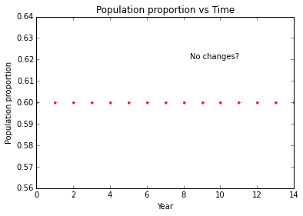  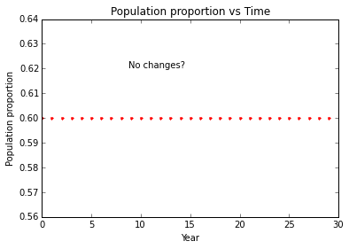 | Attempt #3: mayfly(0.4,2.5,15)  In this case, there seems to no change in population over the 15 years. To make sure, we extend to 30 years in the second plot for this attempt. Still, the population seems to be static.

Task #2 For varying values of b, plot the “stabilized” x.
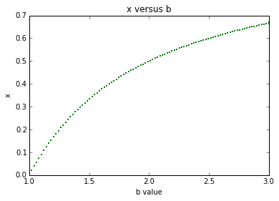 | Here we plot the stabilized x over 100 b values varying from 1 to 3. As we can see, each b value corresponds to a distinct, unique x value. It means that for each b value in (1,3), the population dynamics in the mayfly model will eventually settle down to an asymptotic state, converging to a unique x value. In other words, we won't see a boom-bust cycle going forever.  This observation matches what we have seen in task #1, where all plots eventually show a stabilized, converging x.  Now we proceed to test different b values in a different range to see if we can find something more interesting.
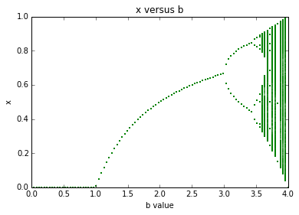 | Now we plot the stabilized x values for 100 b values in (0,4). Something curious happens --- while we see more regularity for b values in (1,3), the stabilized x behaves quite unexpectedly in the following ranges:  (0,1) – x stabilized to 0. Will mayflies die out here?  (3, 3.4) – x stabilized to two points. Do we expect a boom-bust cycle that goes on forever?  (3.4, 3.5) - x stabilized to 4 points.  (3,5, 4) – x stabilized to multiple values.  Note all the range boundaries here are just approximate values, as we haven't zeroed in yet.
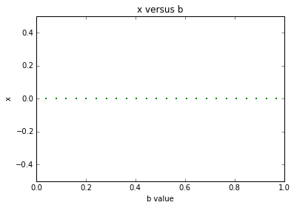 | Scenario #1 b in (0,1)  Here each b still leads to a single stabilized x, but all x values here are the same. Based on this plot, we are under the impression that for b values in (0,1), the mayfly population will stabilize to the same point (x=0, namely they all die out).  Let's repeat what we did in task #1 to see if it is true.
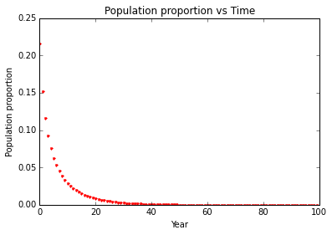 | Pick b=0.9 and we plot as we did in task #1. As we can see, indeed the population will converge to 0 in the end. With a growth rate less than 1, the mayflies will be expected to die out ultimately.
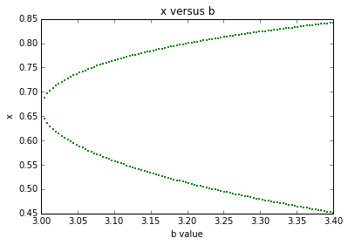 | Scenario #2 b in (3,3.4)  Here each b leads to two stabilized x values, which means we expect a population boom-bust cycle to go on forever if b values falls in this range. We repeat task #1 to see if it's true.
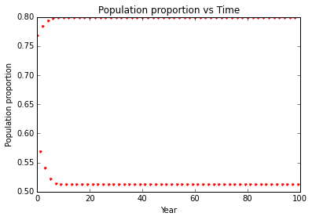 | Here we choose b=3.2. Indeed we see a boom-bust cycle that seems to repeat forever.
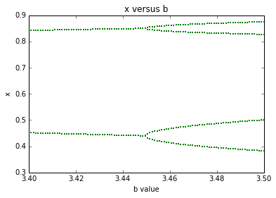 | Scenario #3 b in (3.4,3.5)  Based on the plot, we see the “watershed” between scenario #2 and scenario #3 is actually 3.45. So for a b value in (3,45,5) we expect x stabilize to 4 points. Repeat task #1 to see what we would get.
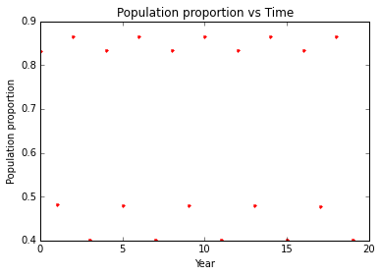 | Here we pick t=20 instead of 100 for a better view, hence the more sparse distribution.  As we can see, here x stabilizes to 4 points. It is a more complicated version of the boom-bust cycle we previously saw.
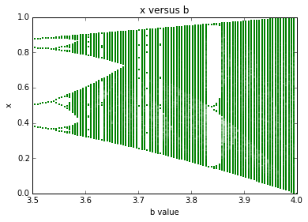 | Scenario #4 b in (3.5,4)  Based on this graph, it seems that the watershed for scenario #3 and #4 is actually 3.55. Here the behavior of stabilized x is more complicated. For b=3.7, for example, x stabilizes to several distinct points. But for b=3.8, it seems that x stabilizes to a continuity of values. We will zero in and find out about x behavior here.
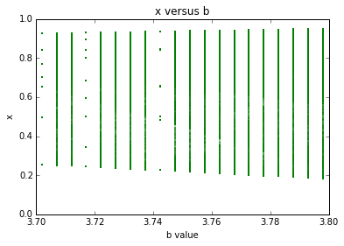 | We zeroed in on b (3.7, 3.8). Let's pick b=3.8 and repeat task #1.
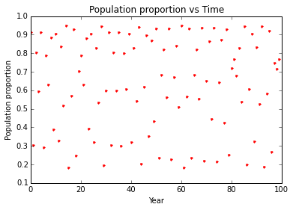 | It looks really random here when we have b=3.8. No generalizable pattern can be detected.
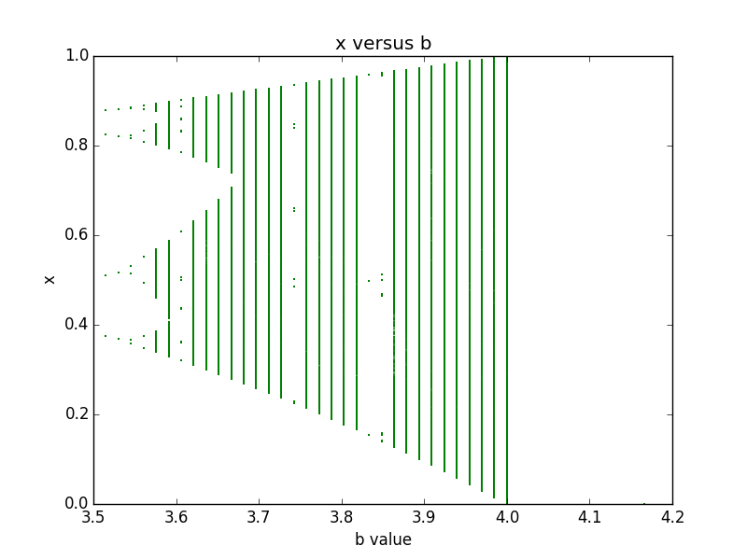 | For b values beyond 4:  Somehow we don't see any graph for b values beyond 4.

Now we sum up our findings in the following table, along with a few questions.
x=0.4
b value range | Asymptotic (stabilized x) behavior | Notes
(0,1) | x stabilizes to zero. Mayflies eventually die out.
(1, 3) | x stabilizes to one value. Population growth eventually stabilizes to a value above x. | To borrow a term from demography, b=2.5 seems to be the “replacement rate” for mayfly populations.
(3, 3,45) | x stabilizes to two values. Population growth eventually stabilizes to a boom-bust cycle that goes on forever.
(3.45, 3.55) | x stabilizes to 4 values. Population growth stabilizes to a more complicated boom-bust cycle that also goes on forever.
(3.55, 4) | The asymptotic behavior of mayfly populations seem to exhibit random patterns at certain points while at other points can still be regular.
(4, ∞) | Nothing?

4. Analysis
To borrow a concept from demographic studies, the replacement fertility is the total fertility rate at which women give birth to enough babies to sustain population levels. As we have observed in the plot x=0.4, b=2.5 as shown in the left, the mayfly population proportions stay constant at 0.6 over years. If we know x, the initial condition, can we find the “replacement rate” b value?
Given such a b value would satisfy the following equations:
x₁=x₀(1-x₀)b
x₁=x₀
It follows that (1-x₀)b=1, from which we can calculate the “replacement rate” b if we know x₀. Given x always belong to [0,1], naturally replacement rate b will be greater than 1, not resulting in the extinction of the mayfly populations.
Let's try with model x₀=0.75, b=4 and track its population dynamics over 100 cycles.
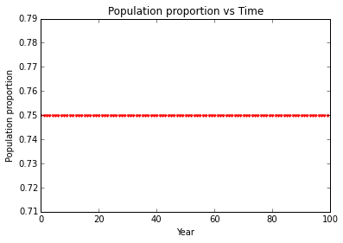
The plot confirms our analysis. In this case where (1-x₀)b=1, indeed we have a mayfly population that stays constant over the years. Once we know x₀, we can easily calculate the replacement rate b.
However, going back to x=0.4, b=2.5 in the beginning of our analysis, clearly (1-0.4)*2.5≠1. It seems that (1-x₀)b=1 is only a part of the story. Given x₀, We can also find out the replacement rate b by computing x_{0*}b=1. In this case, x₀=0.4, b=2.5 and x₀=0.6, b=2.5 would lead to the same result: population equilibrium at x=0.6.

5. Code

%pylab inline

# Task 1
def mayfly(x,b,t):
"x initial value, b growth factor, t # of steps to run"
for i in range(t):
print x
x=b*(1-x)*x
plot(i,x, 'r.')
title("Population proportion vs Time")
xlabel("Year")
ylabel("Population proportion")

mayfly(0.4,1.25,15) #Test 1
vlines(8, 0.1, 0.32) #Divider between two states
plt.annotate('asymptotic',
xy=(8, 0.15),
xycoords='data',
textcoords='offset points')
plt.annotate('transient',
xy=(4, 0.15),
xycoords='data',
textcoords='offset points')

mayfly(0.4,2.8,15) #Test 2 Boob-bust cycle
ylim(0.4,0.8)
plt.annotate('Asymptotic?',
xy=(8, 0.5),
xycoords='data',
textcoords='offset points')
vlines(8, 0.4, 0.8) #Divider
plt.annotate('Boom-bust cycle?',
xy=(4, 0.5),
xycoords='data',
textcoords='offset points')

mayfly(0.4,2.5,15) #Test 3, equilibrium
plt.annotate('No changes?',
xy=(8, 0.62),
xycoords='data',
textcoords='offset points')

mayfly(0.4,2.5,30) #Test 3 extended, still equilibrium
plt.annotate('No changes?',
xy=(8, 0.62),
xycoords='data',
textcoords='offset points')

# **Generate a picture of the asymptotic behavior for a large number of "b" values.**

from math import *
from numpy import *

def bplot(m,n,x):
tmax=10000
tmin=tmax/2
b=linspace(m,n,100)
for i in xrange(tmax):
if i>tmin:
plot(b,x, 'g.', alpha=.12, ms=2)
x=b*(1-x)*x
xlabel("b value")
ylabel("x")
title("x versus b")

bplot(1,3,0.4) #Test

# **More interesting behavior?**
bplot(0,4,0.4) #Overview

# **Zero in on scenario #1 b(0,1)**
bplot(0,1,0.4)
xlim(0, 1)
ylim(-0.5,0.5)

mayfly(0.4,0.9,100) #Test for b=0.9, extinction

# **Zero in on scenario #2 b(3, 3.4)**
bplot(3,3.4,0.4)

mayfly(0.4,3.2,100) #Test for b=3.2, boom-bust

# **Zero in on scenario #3 b(3.4, 3.5)**
bplot(3.4,3.5,0.4)

mayfly(0.4,3.47,20) #Test b=3.47, complicated boom bust

# #### **Zero in on scenario #4, b (3.5, 4)**
bplot(3.5,4,0.4)

# Zero in further
bplot(3.5,4,0.4)
xlim(3.7, 3.8)

mayfly(0.4, 3.8, 100) #Test b=3.8, random distributions

bplot(3.5,5,0.4) #Now test b>4 b=5

# ##Replacement rate for mayflies
mayfly(0.25,4,100) #Example

