NOTICE D’UTILISATION DU PROGRAMME PYTHON

1 imports :
The code imports necessary Python libraries: numpy for array manipulation,os for interacting with the operating system, csv for handling CSV files, and matplotlib.pyplot for creating plots.
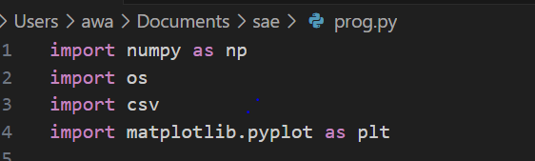
2 Opening « extraire.txt » :
tries to open the file "extraire.txt" and reads it’s content.
If the file is not found, it prints an error message and exits the program.
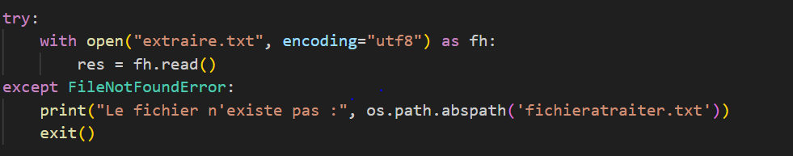
3 treatment the content of « extraire.txt » :
Splits the content of res into lines and stores them in the list ress.
Initializes an empty NumPy array named tab_dest.

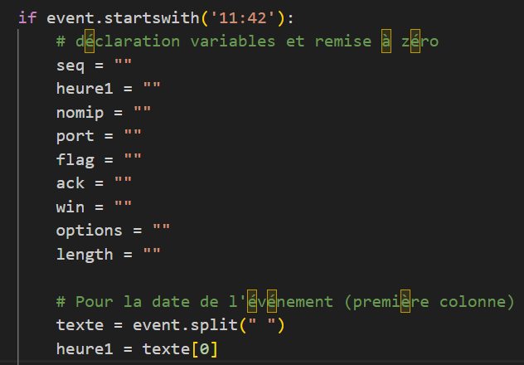
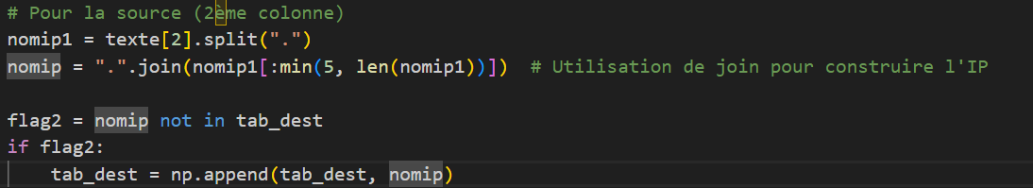
The code splits the IP address from the event and constructs it using the first five segments (if available) by joining them with dots.

It checks if the constructed IP is not already in the tab_dest array. If not, it appends the IP to the array.
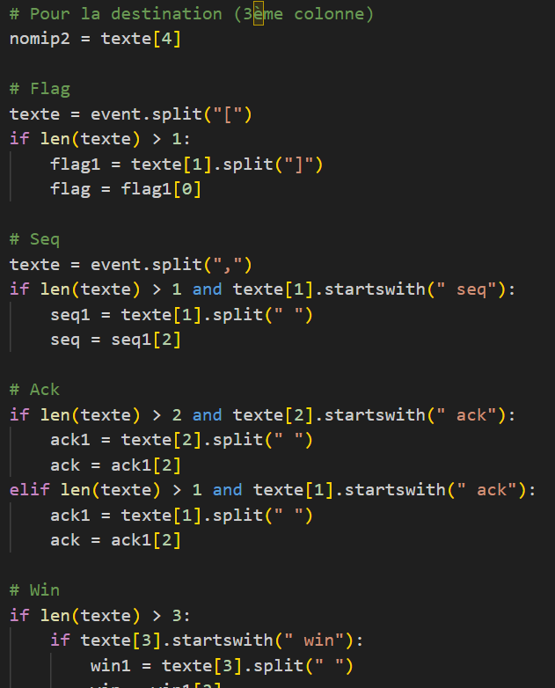

Extracts the destination IP from the event.
Splits the event based on "[" to extract information inside square brackets (flag information).
Splits the event based on "," and checks if the second part starts with " seq". If true, it extracts the sequence information
Extracts acknowledgment information from the event.
Extracts window size information from the event
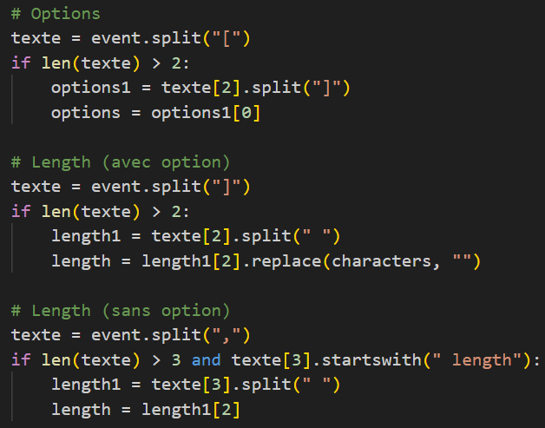

Extracts options information from the event.
Extracts length information from the event, removing characters like ":"
Extracts length information when there is no option
4 Writing to the csv file :
Opens the CSV file "test.csv" for writing.
Writes the column headers to the CSV file
Iterates through each event in ress that starts with '11:42'.
Extracts specific information from each event and writes it to the CSV file.
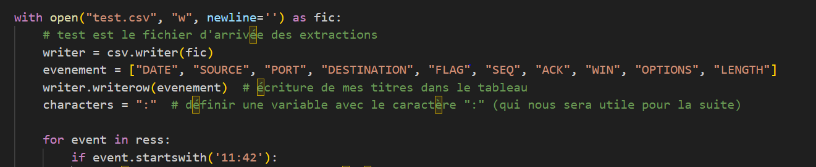
5 Displaying the final destination array :
Prints the final destination array after processing all events.
Matplotlib6 plotting the graph with
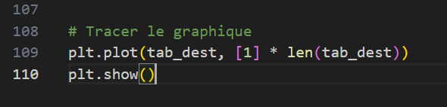

POUR LE FICHIER EXCEL

Open Excel: Launch Microsoft Excel on your computer
Go to the "Data" tab: In the ribbon at the top of Excel, look for the "Data" tab
Import Data: Inside the "Data" tab, you should find an option called "Get External Data" or "Import Data." Select this option
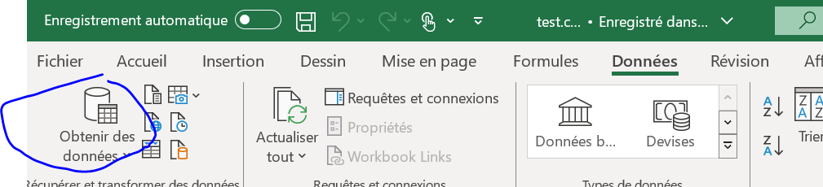
Choose "From Text" or "Get Data" (depending on your version of Excel): In the drop-down menu, choose the option that looks like "From Text" or "Get Data
Select the CSV file: Navigate to the location of the CSV file you want to open in Excel and select it
Configure Import Options: An import window will appear. Follow the steps to configure import options. Typically, you'll need to specify the delimiter used in the CSV file (usually a comma), and you may see a preview of the data to ensure it's interpreted correctly

