Fall Detection & Novu Notification Architecture
Cawil / Medical Avatar — technical architecture documentation for the fall-detection safety subsystem (/fall-detection) and its Novu-powered emergency-email pipeline.
Branch: feature/fall-detection · Last updated: 2026-07-11

1. Overview
The fall-detection subsystem turns the patient’s phone into a passive fall monitor. It streams accelerometer data through a transparent, physics-based state machine (no ML), asks the user to confirm they are okay after a suspected fall, and — if they do not respond within 30 seconds — escalates: it sounds a local SOS siren, shows a browser notification, and emails every configured emergency contact through Novu with the fall’s severity, time, and a Google Maps link to the patient’s GPS position. Every incident (including dismissed false alarms) is persisted to Appwrite and shown in the on-page Fall History Log, which can be exported as a doctor-readable JPG or PDF report (§10).

File map
File | Responsibility
src/services/fallAlgorithm.ts | Pure detection engine: thresholds, state machine, classification, severity, confidence. No React, no I/O.
src/services/fallService.ts | Persistence (Appwrite / localStorage), browser notifications, Novu email alerts, Web Audio SOS siren.
src/app/hooks/useFallDetection.ts | Runtime hook: sensor streams (real DeviceMotion or simulator), detector loop, GPS capture, simulate/SOS triggers.
src/app/pages/FallDetectionPage.tsx | Page orchestrator: loads events/contacts, resolves the countdown outcome, persists + fans out alerts.
src/app/components/fall/FallCountdownModal.tsx | 30-second countdown → alarm state machine with “I’m Okay” cancel.
src/app/components/fall/StatusBanner.tsx | Monitoring on/off, sensor mode, GPS status chips.
src/app/components/fall/LiveSensorFeed.tsx | Real-time accelerometer SVG chart with threshold guides.
src/app/components/fall/SosButton.tsx | Manual SOS trigger.
src/app/components/fall/EmergencyContactsWidget.tsx | CRUD UI for emergency contacts.
src/app/components/fall/FallHistoryLog.tsx | Incident history table + JPG/PDF export buttons.
src/services/fallReportExport.ts | Doctor-report generator: offscreen A4 sheets → JPG / PDF download.
The page is registered at route /fall-detection in src/app/routes.ts and linked from the “Safety” section of src/app/components/Sidebar.tsx.

2. Architecture diagram
Styled after the Copilot-Studio “runtime pipeline” convention: external services across the top, the numbered runtime pipeline in the middle, internal data stores along the bottom.
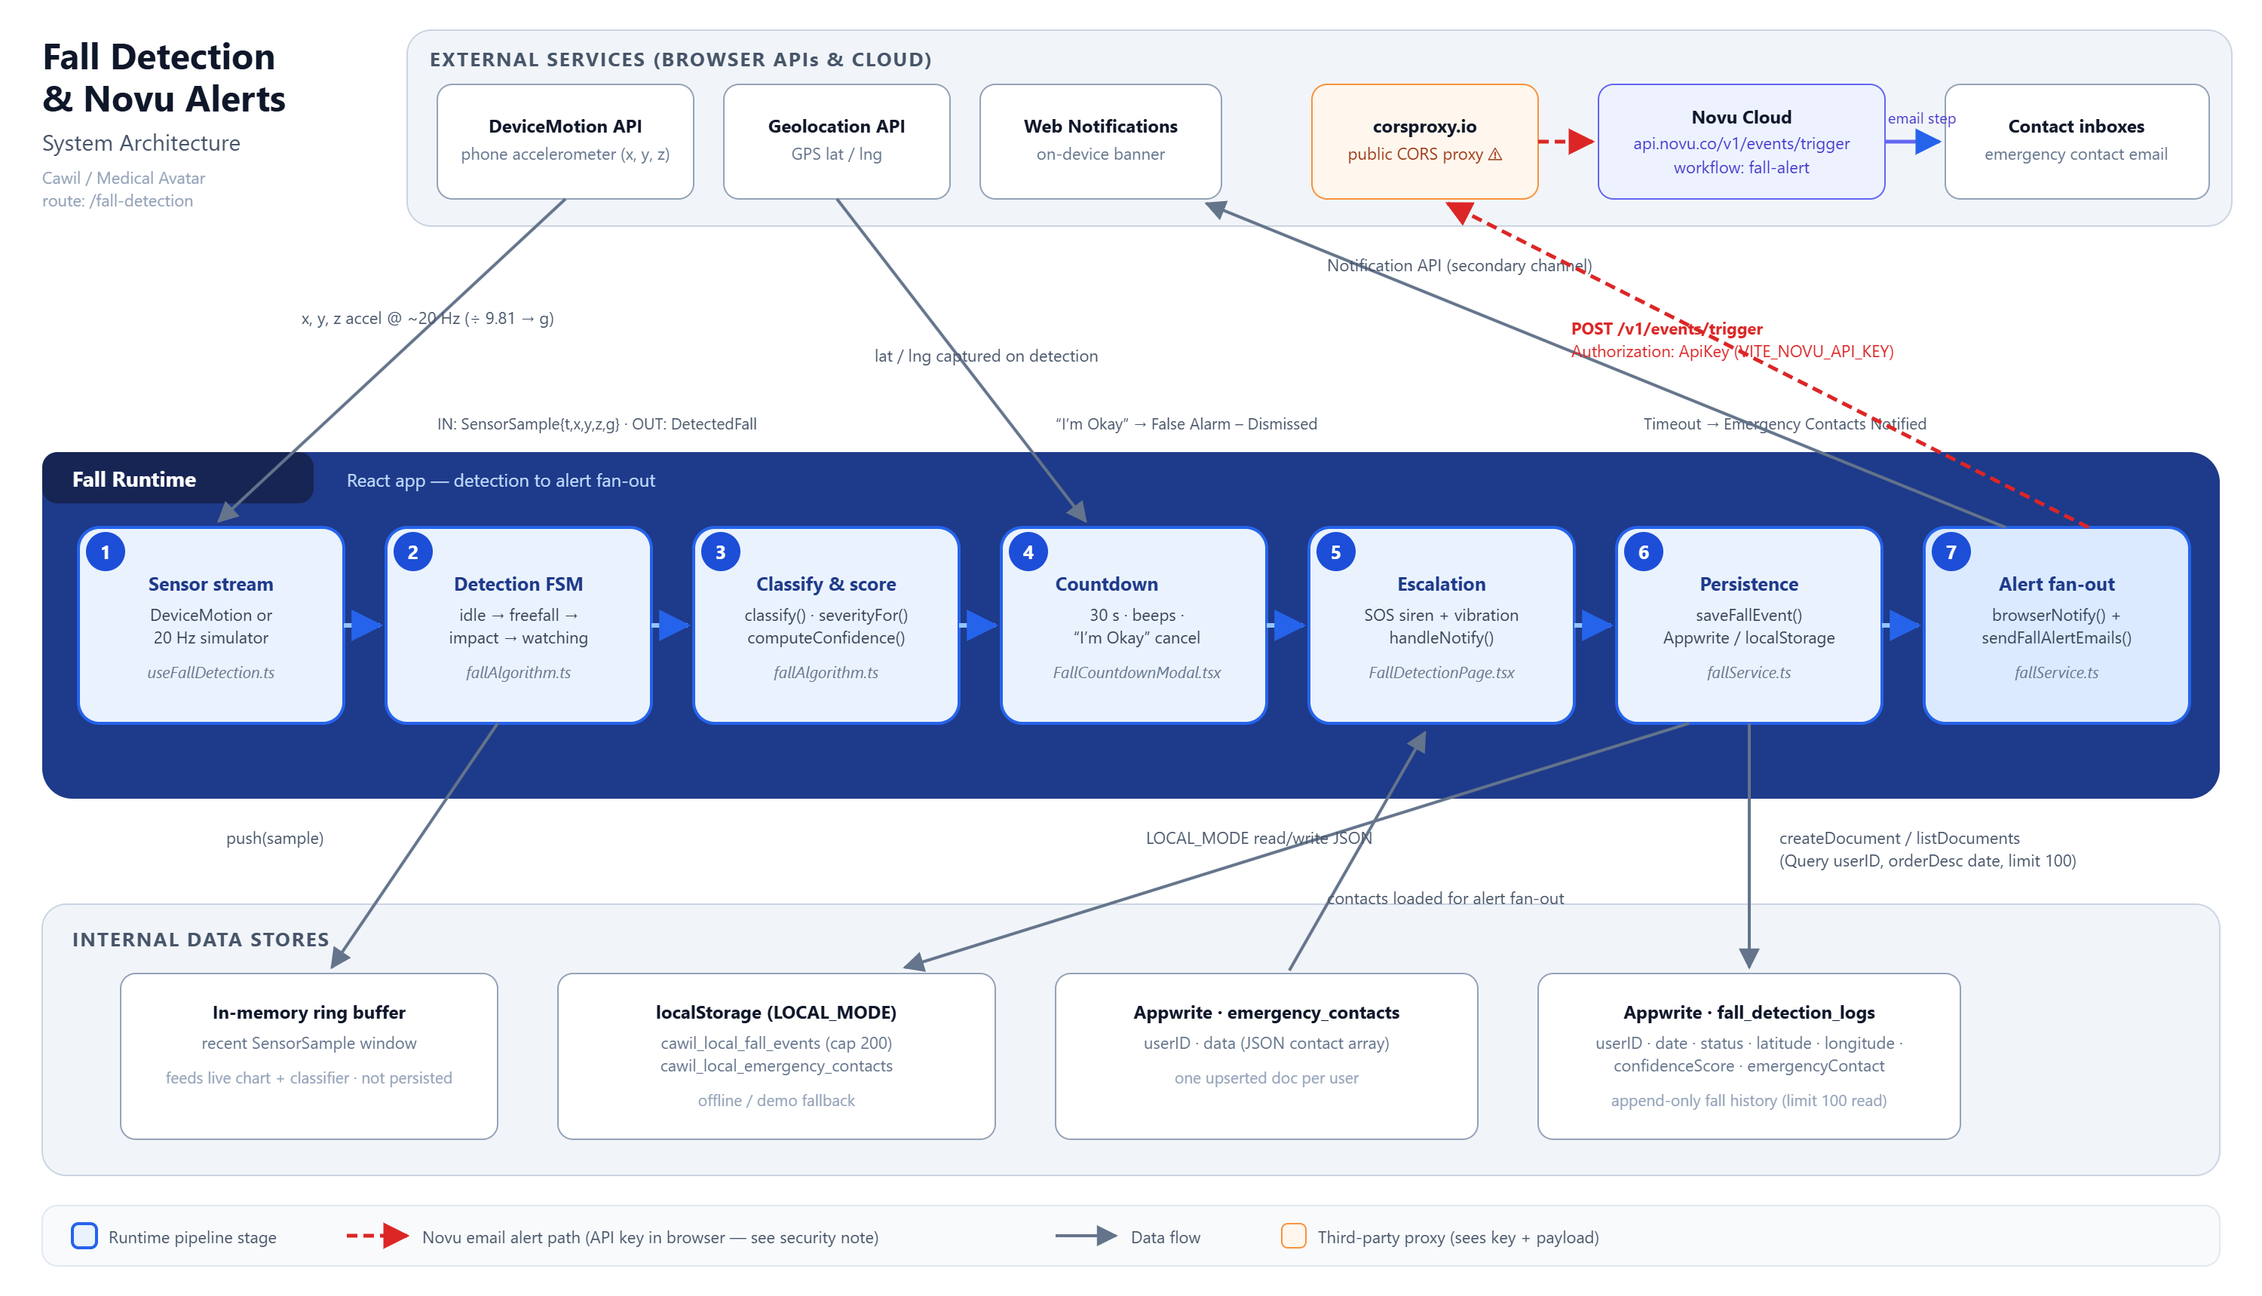
Figure 1 — Fall detection & Novu system architecture (docs/assets/fall-detection-architecture.svg)

3. Runtime pipeline (stages 1–7)
# | Stage | Where | What happens
1 | Sensor stream | useFallDetection.ts | Real DeviceMotion events (m/s² ÷ 9.81 → g; iOS 13+ requires DeviceMotionEvent.requestPermission() from a user gesture) or a 20 Hz simulated stream of ~1 g noise for desktop demos. Each tick produces a SensorSample { t, x, y, z, g }.
2 | Detection state machine | fallAlgorithm.ts → createFallDetector() | Samples are pushed through the 3-phase FSM idle → freefall → impact → watching (§4).
3 | Classification & scoring | classify(), severityFor(), computeConfidence() | Candidate events are filtered against false-positive heuristics; survivors get a severity band and a 0–100 confidence score, emitted as a DetectedFall.
4 | Countdown fail-safe | FallCountdownModal.tsx | raiseFall() sets the pending fall and captures GPS. The modal counts down 30 s with per-second beeps (higher/faster in the last 5 s). “I’m Okay” cancels.
5 | Escalation | escalate() → handleNotify() | At zero the modal switches to its alarm phase, starts the looping Web Audio siren + vibration, and fires onNotify exactly once (notifiedRef guard).
6 | Persistence | fallService.saveFallEvent() | The resolved FallEvent (either outcome) is written to Appwrite fall_detection_logs — or localStorage in LOCAL_MODE (§6).
7 | Alert fan-out | notifyEmergencyContacts() + sendFallAlertEmails() | Run in parallel (Promise.all): a browser Notification plus one Novu email trigger per eligible contact (§7). Sent/failed counts surface as toasts.
Outcomes. A pending fall always resolves to exactly one of two persisted actions:
- "False Alarm – Dismissed" — user tapped I’m Okay during the countdown.
- "Emergency Contacts Notified" — countdown expired (or manual SOS), alerts fanned out.

4. Detection algorithm (fallAlgorithm.ts)
A deliberately transparent physics model — every decision is explainable to a clinician.

Thresholds
Constant | Value | Meaning
FREE_FALL_G | 0.5 g | Total acceleration below this ⇒ body is in free fall.
IMPACT_G | 2.5 g | Spike above this ⇒ impact with the ground.
STILL_TOL | 0.18 | |g − 1| below this ⇒ the person is lying still.
freeFallWindowMs | 1 200 ms | Impact must follow free fall within this window.
stillnessMs | 8 000 ms default | Stillness required to confirm. The hook overrides this to 4 000 ms for demos (STILLNESS_MS in useFallDetection.ts); the product spec calls for 15–60 s.

Phase state machine
idle ── g < 0.5 ──▶ freefall ── g > 2.5 within 1.2 s ──▶ impact ──▶ watching
watching ── |g−1| < 0.18 sustained for stillnessMs ──▶ CONFIRMED → emit DetectedFall
watching ── movement resumes ──▶ idle (candidate rejected / classified) freefall window expires ──▶ idle

False-positive rejection — classify()
Verdict | Trigger | Interpretation
activity | ≥ 3 recent impact spikes without stillness | Running / jumping / exercise.
sit | Impact below 2.5 g | Sat or lay down hard.
drop | Hard impact but movement resumed | Dropped the phone.
fall | Free fall → hard impact → sustained stillness | Confirmed fall — raised to the UI.

Severity — severityFor() (write-time, from impact force)
Impact | Severity
≥ 4 g | high
≥ 3 g | moderate
otherwise | low

Confidence — computeConfidence() (0–100)
confidence = 50% · impact magnitude + 35% · stillness duration + 15% · free-fall seen
clamped to 0–100 and persisted as confidenceScore.

5. Countdown & escalation state machine (FallCountdownModal.tsx)
pendingFall → countdown (30 s, beeps) ─┬─ "I’m Okay" → stopSosAlarm() → log "False Alarm – Dismissed"
└─ reaches 0 → escalate(): alarm phase, startSosAlarm()
(looping siren + vibration), onNotify() fired ONCE → "Stop SOS" button
Guarantees worth knowing:
- onNotify can never double-fire — a notifiedRef guard latches after the first call.
- Unmount cleanup always clears the timer and stops the alarm, so the siren cannot keep ringing after navigation.
- The shared AudioContext is unlocked on a user gesture (ensureAudio()), so the alarm can sound later even though browsers block autonomous audio.
- ⚠ A web app cannot bypass the iOS silent switch / DND, and iOS Safari has no Vibration API — a native wrapper is future work.

6. Data model & persistence (fallService.ts)

Appwrite fall_detection_logs (VITE_COLLECTION_FALL_EVENTS) — append-only history
Attribute | Type | Source (FallEvent)
userID | string | current user id
date | datetime | event.ts (ISO)
status | string | event.action — "False Alarm – Dismissed" | "Emergency Contacts Notified"
latitude / longitude | double | GPS captured at detection (nullable)
confidenceScore | double | event.confidence 0–100 (nullable)
emergencyContact | string | comma-joined names of alerted contacts (nullable)
Read path: Query.equal('userID', …) + Query.orderDesc('date') + Query.limit(100).

Appwrite emergency_contacts (VITE_COLLECTION_EMERGENCY_CONTACTS)
One upserted document per user: { userID, data } where data is a JSON-encoded EmergencyContact[] — each { id, name, phone, email?, pref?: 'phone' | 'email' | 'both' }.

LOCAL_MODE fallback
When LOCAL_MODE is true, reads/writes mirror to localStorage instead of Appwrite: cawil_local_fall_events (capped at 200 events) and cawil_local_emergency_contacts.

7. Novu notification subsystem
Novu is used for exactly one thing: emailing emergency contacts when a fall is confirmed (stage 7). No SDK is installed — sendFallAlertEmails() in fallService.ts calls Novu’s REST API directly from the browser.

Trigger contract — workflow “fall-alert”
POST https://api.novu.co/v1/events/trigger (via corsproxy.io — see caveat)
Authorization: ApiKey <VITE_NOVU_API_KEY>
{ "name": "fall-alert",
"to": { "subscriberId": "<contact email>", "email": "<contact email>" },
"payload": { "to_name": "<contact name>", "severity": "HIGH | MODERATE | LOW",
"timestamp": "<localized date-time>",
"maps_link": "https://maps.google.com/?q=<lat>,<lng>" | "Location unavailable",
"message": "A <severity> severity fall was detected. Impact: <n.n> g." } }
- Subscribers are created/identified lazily by email address — no pre-registration step.
- Recipient filter: contacts with a non-empty email whose pref is email, both, or unset. Contacts with pref: ’phone’ are skipped (no SMS channel exists; phone is display-only).
- Each contact is triggered individually in a loop; results aggregate to { sent, failed, errors[] }, which handleNotify() surfaces as toasts.
- If VITE_NOVU_API_KEY is empty the function logs “[fall] Novu not configured — skipping email alerts.” and returns without error.
- Novu-side setup required: a workflow whose trigger identifier is fall-alert with an email step templated on to_name, severity, timestamp, maps_link, message.

⚠ corsproxy.io caveat
Novu’s trigger endpoint is not browser-CORS-friendly, so the request is routed through the public proxy corsproxy.io. That third party sees the API key and the full alert payload (name, location link), and its availability is outside our control. Acceptable for a demo; not for production.

🔐 Security note — API key in the browser bundle
VITE_NOVU_API_KEY is compiled into the client JavaScript. Anyone can extract it and trigger arbitrary Novu events (spam emails, quota burn). Recommended remediation: move the trigger server-side — e.g. an Appwrite Function that the client calls with its session — which also eliminates the CORS proxy. Documented here as a known limitation / future work.

Channel summary
Channel | Mechanism | Role
Email | Novu workflow fall-alert | Primary remote alert to contacts
Browser notification | Notification API (browserNotify) | Secondary, on the patient’s device
Siren + vibration | Web Audio + navigator.vibrate | Primary on-device fail-safe
SMS | — | Not implemented (contact phone is metadata only)

8. Environment variables
Variable | Purpose
VITE_APPWRITE_ENDPOINT / _PROJECT_ID / _DATABASE_ID | Appwrite client + database.
VITE_COLLECTION_FALL_EVENTS | Collection id for fall history (prod: fall_detection_logs).
VITE_COLLECTION_EMERGENCY_CONTACTS | Collection id for contacts (prod: emergency_contacts).
VITE_NOVU_API_KEY | Novu API key used by sendFallAlertEmails() (see security note, §7).
VITE_LOCAL_MODE | Intended offline/demo switch — but see §9.

9. Known inconsistencies & caveats
- Severity changes on round-trip. At write time severity derives from impact force (≥ 4 g → high); on read-back it is recomputed from confidence via severityFromConfidence (≥ 66 → high, ≥ 33 → moderate). The same event can therefore display a different severity after a reload. Severity itself is never persisted.
- impactG and stillnessMs are not persisted — events read from Appwrite report them as 0. This is why the doctor report (§10) shows the persisted confidenceScore instead of impact force.
- LOCAL_MODE is hard-coded false in src/lib/appwrite.ts (“forced to ensure syncing”), while routes.ts still reads VITE_LOCAL_MODE for the default route — the flag is effectively split-brained.
- Demo stillness override: the hook confirms falls after 4 s of stillness instead of the spec’s 15–60 s, to keep demos fast.
- iOS limits: no Vibration API in Safari; silent switch/DND cannot be bypassed from the web.

10. Fall history export (doctor report)
The Fall History Log card offers two export buttons (JPG, PDF) implemented in src/services/fallReportExport.ts:
- A clean, light-themed A4 report (794 × 1123 px @ 96 dpi per page) is built as self-contained inline-styled HTML — patient name/email, generation date, covered period, summary counts, and a table of Date · Time · Severity · Action Taken · Confidence · Location (newest first, paginated with “Page i of n” footers).
- The sheets are mounted offscreen and rasterized with modern-screenshot (domToCanvas, 2× scale) — the live glassmorphism UI is never captured, avoiding backdrop-filter/oklch rasterization pitfalls.
- JPG: pages are stitched vertically onto one white-filled canvas → image/jpeg at 92%.
- PDF: each canvas becomes one A4 page via jspdf addImage → fall-history-YYYY-MM-DD.pdf.
- Both libraries are dynamically imported so they don’t weigh down the initial bundle.
- Buttons are disabled while exporting or when the history is empty; success/failure is reported via the app’s standard sonner toasts.

