MEASUREMENTS

- All measurements had the value of PSNR = inf
- During the time measurements, the CPU wasn’t busy with other “heavy” calculations, in order to measure the time more precisely
- The minimum time resolution is 1us and is implemented using the function clock_gettime() which is used before the start and after the end. Before measuring the end time, we have already compared the differences between original output and our output, in order to calculate the PSNR(Signal to Noise Ratio)
- The spreadsheet includes both -fast and -O0 measurements. However this report includes only the best of these 2
- All the measurements have an unique number in parenthesis. This number corresponds to the number of measurement in spreadsheet
- In (c) Code of Unroll optimization, I assumed that the defined size is 4096. If “#define SIZE 4096” changes, the loop must be rewritten
- The optimization methods have been applied with the following order:
Loop Interchange →

LOOP INTERCHANGE

- Optimizations began from the source code 0_orig.c

- We can apply that optimization, because we dont read from memory after the value has been modified by a previous loop iteration: e.g for ( i=0; i<N; i++)
a[i] = a[i-1] + b[i];

- In line 109, we change the loop order, so the variable “i” runs in the outer loop and variable “j” in the inner. That leads in much better performance, 0.075837375secs with the -fast flag enabled
( Code (a) )

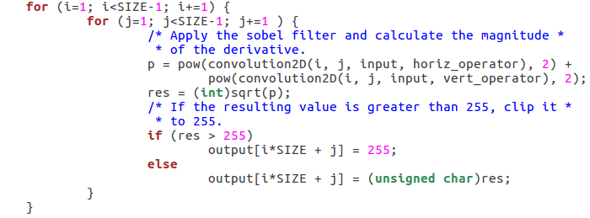

- Including the previous optimization, we repeat the some methodology for the convolution2D function. That leads again to a better impletentation,317 microseconds faster than the (a) ,using the -fast flag( Code (b) )

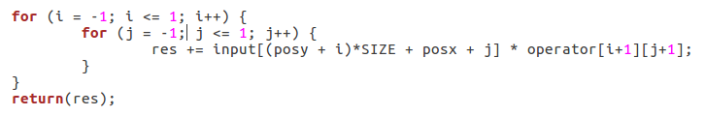

- However, if we try to do the same thing in the nested loop in line 127 the performance is getting worser per 12 microseconds than the previous one.
In the spreadsheet, number 7 uses the -O0 and number 8 the -fast( Code (c) )

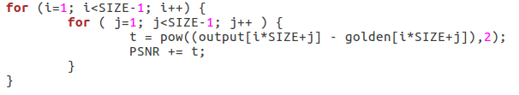
- In the spreadsheet, code(a) corresponds to numbers number 3 and 5, code(b) to 4 and 6 and finally code(c) to 7 and 8

- So we keep the code(b) implementation and continue to the next optimization method.

LOOP UNROLLING

- Optimizations began from the source code 1_loopInter.c

- We start this optimization from the function convolution2D. This function contains the following nested loop:

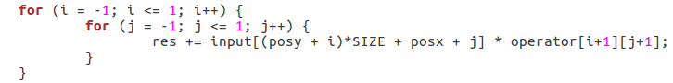
- Firsty we try to unroll the inner loop. So the new code looks like the above( Code (a) )

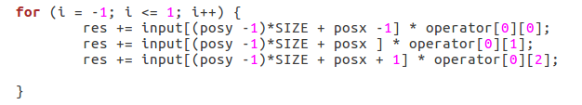

- Now we measure with both -O0 and -fast and we find 2 complete different results. Flag -O0 seems not to decrease the execution time. Οn the contrary it increases it.
- On the other hand, -fast flags seems to create the best running time until now. So lets try to unroll the outer loop and make the nested loop fully unrolled ( Code (b) )
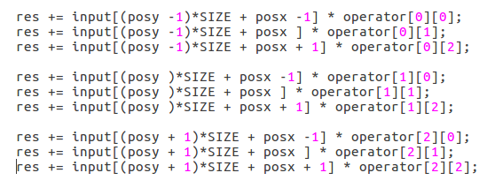

- While the automatic optimizations that compiler produces using the -fast decreases the latency, the -O0 flag seem to increase the execution’s time. Under that circumstances, compiler’s optimization like register allocation seem to do great job

- Now, we continue with further unrolling. Now look the nested loop in sobel function

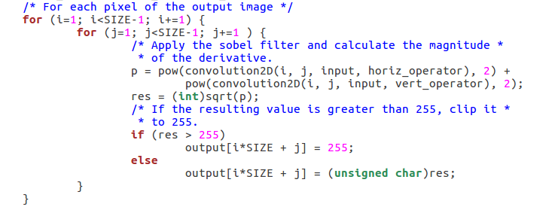
- Try to unroll the inner loop. Assuming that SIZE=4096, the inner loop executes 4094 times. So we can unroll the loop N times, where 4094%N = 0. Possible values for N can be 2, or 8

- For N = 2, the execution time seems to be the same as the previous best time for both -fast and -O0. So no effect.

- If we try N =4, despite the fact that 4094%4 = 2, we get better time with PSNR=inf. The reason why choosing N = 4 isn’t illegal is because we don’t really count the last column and row of the array. So we keep N = 4. The following picture shows how the last executions for unroll factor = 4:

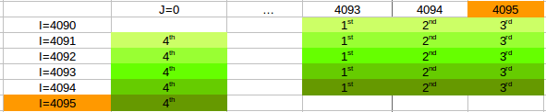

- If we try to unroll our loop 4 times instead of 2, the bellow code shows the unroll( Code (c) )

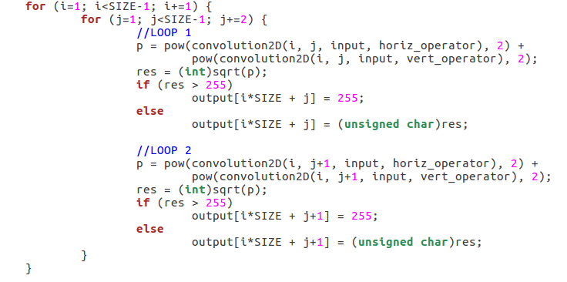
- We get an obvious decrease in total time using -fast, however for -O0 flag we again don’t take worthy results. Using the -fast, the total time has fallen to 0.0641150333 seconds.

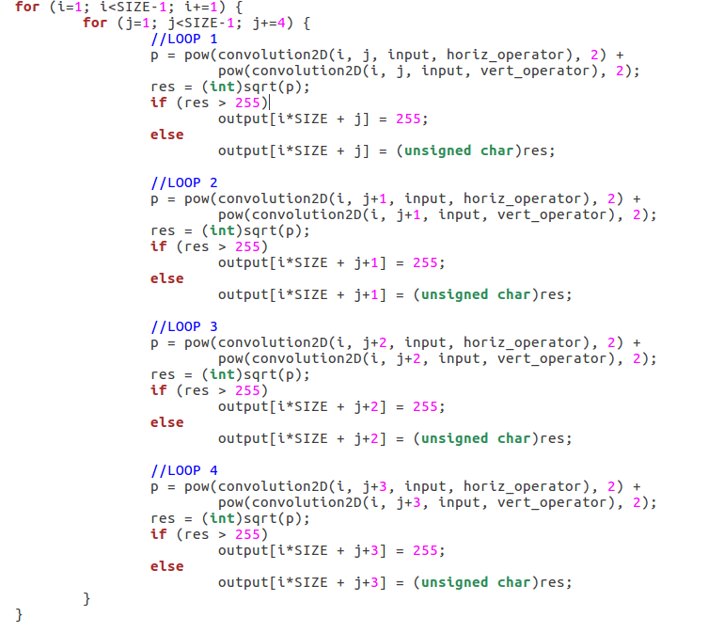
- For N = 8, we get the same results as the previous one. So we stop at N=4

- Now, if we try to unroll the outer loop the code that we will be produced is going to increase a lot the size of the binary file. Also, after measurements for N = 2 or 4, the running time stays stable for -fast and gets even worser for -O0

- Now lets continue with the following loop:
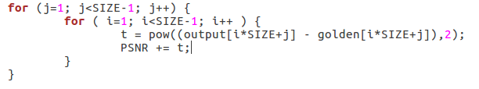

- After measuring times, we don’t have any improvement. I tried unrolling these 2 loops and separately and together for N = 2, 4 and 8 but there was no improvement. Also tried to change loop order in order to increase locality for the inner loop, but it had no effect.

- In the spreadsheet, code(a) corresponds to numbers number 9 and 10, code(b) to 11 and 12 and finally code(c) to 13 and 14

- So we keep the code(c) implementation and continue to the next optimization method.

LOOP FUSION

- Optimizations began from the source code 2_loopUnrol.c

- In function sobel , we have the 2 following for nested for-loops:

(a)
(b)
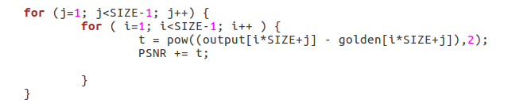
- If we notice these 2 nested loops, we can implement the Loop-Fusion technique with some changes in the 2nd loop. Firstly change loop order and then unroll partialy by j = j + 4. Lets take it step by step:

a) By changing loop order at (b) we have the same time as before, so:

b) Now we merge the two following loops ( code(a) )

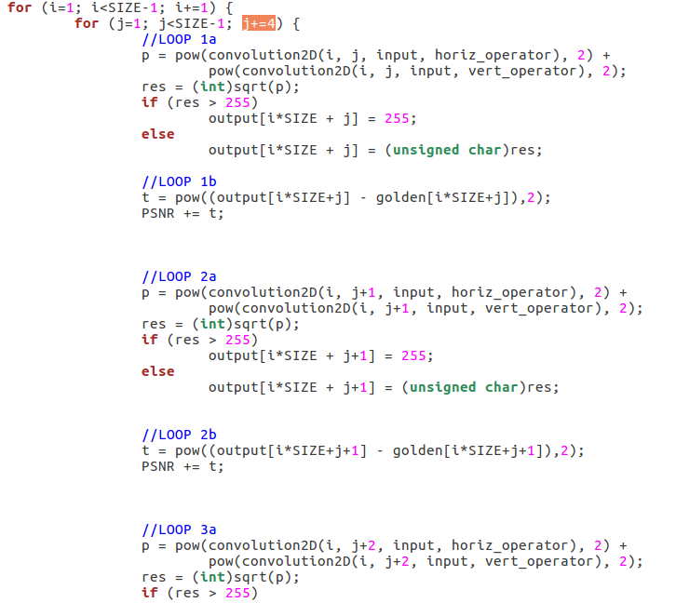
- If we measure again the time is almost the double than before, 0.111 seconds and PSNR is 37.4392. We don’t continue more that optimization because we don’t improve our results

- Now lets go back at out 2_LoopUnrol.c code. If we try to merge the outer for-loops, the code looks like the following( code(b) )

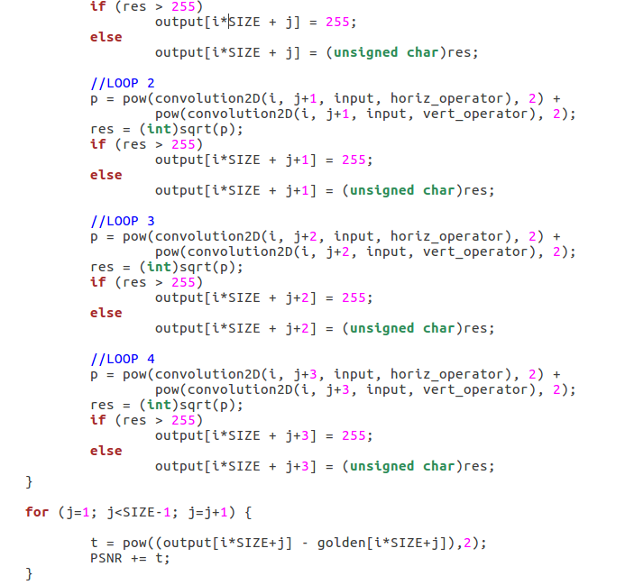

- Now, if we run code(b) t using the -fast flag we have a small impovement in time, a bit less than 0.064 seconds.

- Also, if we run tcode(b) using the -O0 flag we have an important impovement in time. New best time for -O0 flag is 5.8283991 seconds

- In the spreadsheet, code(a) corresponds to numbers number 15 and 16, code(b) to 17 and 18

- So we keep the code(b) implementation and continue to the next optimization method.

