Christos Axelos, AEM 1814, 2nd Assignment in High Performance computing 2017/18

OBSERVATIONS

- We add the -qopenmp flag to include the openMP libraries

- We run each time our programm using the command:
./seq_main -i Image_data/texture17695.bin -o -b -n 10000
so the number of clusters is 10000

- Flag -O0 gave very bad performance, so I used only the -fast flag

SYSTEM SPECS

- All the measurements were done using the below characteristics:
a) OS: Ubuntu LTS 16.04
b) Core Edition: 4.4.0-97-generic
c) CPU: Intel Core i5
d) NumOfProcessors: 4
e) Compiler: icc
f) Compiler’s edition: 18.0.0

RESULTS

- We begin with our initial code, trying to find the loops that increase the execution time. The bellow code is the initial code that we want to parallelize. It is from function main()

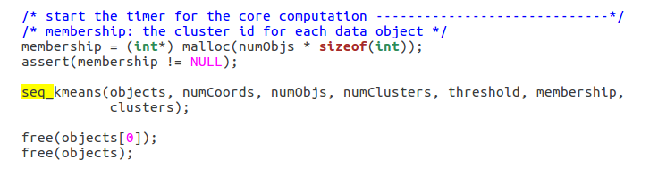
and the main calculations that function seq_kmeans() does:

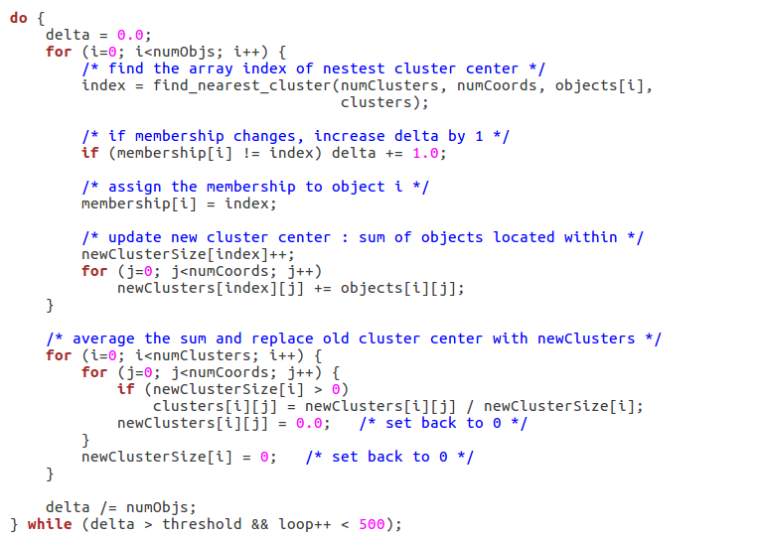
- From the above code, we have function find_nearest_cluster()

