ElectricIMP @ NST Getting started guide (eimp account:nstimp, nstwifiimp)
If using the SparkFun expansion board:
- power from USB port through miniUSB plug
- bridge USB and VIN pins on the board to power the imp
- download the iPhone/Android OS app to configure the imp optically
  - make sure you connect to the WiFi net with your phone first
  - the credentials will be encrypted and sent to the device optically (strobe light – pulses)
    - if you configured the device to another network make sure you clear WiFi settings first (can do with the same application) and then reflash with the current settings
- after flashing the imp, the device connects to the internet through the WiFi connection
  - the progress is marked by LED status
    - if OK imp LED flash green after a second or two
      - the imp won’t appear in the online IDE automatically so refresh the browser window to see it
      - the device has an unique hex identifier which you have to assign to a model
Blink-up troublsehooting
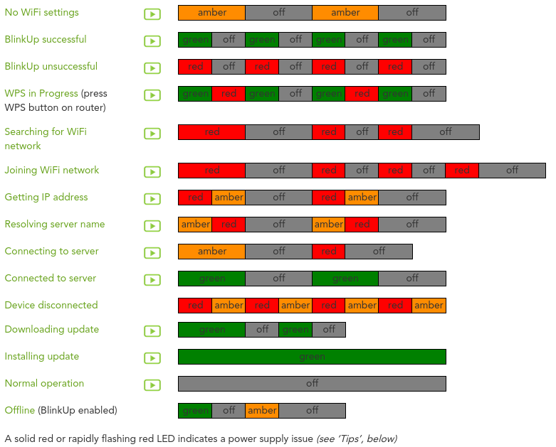

Throughput test

Version 1

Agent code

// Test software for data throughput using Electric imp @ NST - agent side

function handlePing(time)
{
// post messsage from the agent to the device
device.send("pong", time);
}

// create dummy payload to send back
function handleDevicePayload(d)
{
// echo back the data
device.send("datain", d);
}

// register functions to handle messages from the device to the agent
device.on("ping", handlePing);
device.on("dataout", handleDevicePayload);

Device code

// Test software for data throughput using Electric imp @ NST - device side

// get server data
server.log(" nstimp connected to WiFi SSID: " + imp.getssid() + " with BSSID " + imp.getbssid());

// functiomn to ping the agent
function ping()
{
// send the message from the device to agent
agent.send("ping", hardware.millis());
}

// create dummy payload to send
function createDevicePayload()
{
// Add a n Bytes blob of arbitrary binary data to send out
local n = 2500;
agent.send("dataout", blob(n));
}

// roundtrip handler
function handlePong(startMillis)
{
local endMillis = hardware.millis();
local RTT = endMillis - startMillis;
server.log("RTT: " + RTT + " ms ");
// send a ping to check RTT every second
imp.wakeup(1.0, ping);
}

// receive payload from agent
function handleAgentPayload(echoData)
{
// check the received data
local RX=echoData.len();
// server.log("RX:" + format("%u bytes", RX));
// create a new payload and send as fast as possible (100Hz max res)
imp.wakeup(0.0, createDevicePayload);
}

// throughput = RWIN/RTT
// RTT - round trip time: get it from ping pong
// RWIN - receive window: is default 3KB but up to 30KB using this function
// imp.setsendbuffersize(4000); // in bytes and 3KB is default

// register function to process messages from agent to device
agent.on("pong", handlePong);
agent.on("datain", handleAgentPayload);

// send first ping
ping();
// send the first payload
createDevicePayload();

Version 2 (Revision 212)

Agent code

// Test software for data throughput using Electric imp @ NST - agent side

// response payload
function handleDevicePayload(d)
{
// echo back the data
device.send("datain", d);
}

// register functions to handle messages from the device to the agent
device.on("dataout", handleDevicePayload);

Device code

// Test software for data throughput using Electric imp @ NST - device side

// get server data
server.log(" nstimp connected to WiFi SSID: " + imp.getssid() + " with BSSID " + imp.getbssid());

// create dummy payload to send
function createDevicePayload()
{
// Add a n Bytes blob of arbitrary binary data to send out
local n = 3072;
local data = blob(n);
local time = hardware.millis();
// create the data holder
local payload = [];
// append data inside
payload.push(data);
payload.push(time);
agent.send("dataout",payload);
}

// receive payload from agent
function handleAgentPayload(echoData)
{
local endMillis = hardware.millis();
local RTT = (endMillis - echoData.pop())/1000.0;
server.log("RTT: " + RTT + " s ");
// check the received data
local RX=(echoData.pop()).len()/1000.0;
server.log("RX:" + format("%u KB", RX));
// check the throughput
server.log("TP:" + RX/RTT + "KB/s");
// create a new payload and send as fast as possible (100Hz max res)
imp.wakeup(0.0, createDevicePayload);
}

// throughput = RWIN/RTT
// RTT - round trip time: get it from ping pong
// RWIN - receive window: is default 3KB but up to 30KB using this function
imp.setsendbuffersize(3000); // in bytes and 3KB is default

// register function to process messages from agent to device
agent.on("datain", handleAgentPayload);

// send the payload to agent
createDevicePayload();

Generic development flow for electric Imp

The hub of imp communication is the imp’s agent. This server-based code responds to incoming HTTP requests by analyzing what they contain and then, if necessary, triggering appropriate behavior in the imp itself. The client application should interface through http calls to the agent which is responsible to mediate the communicate with the device.

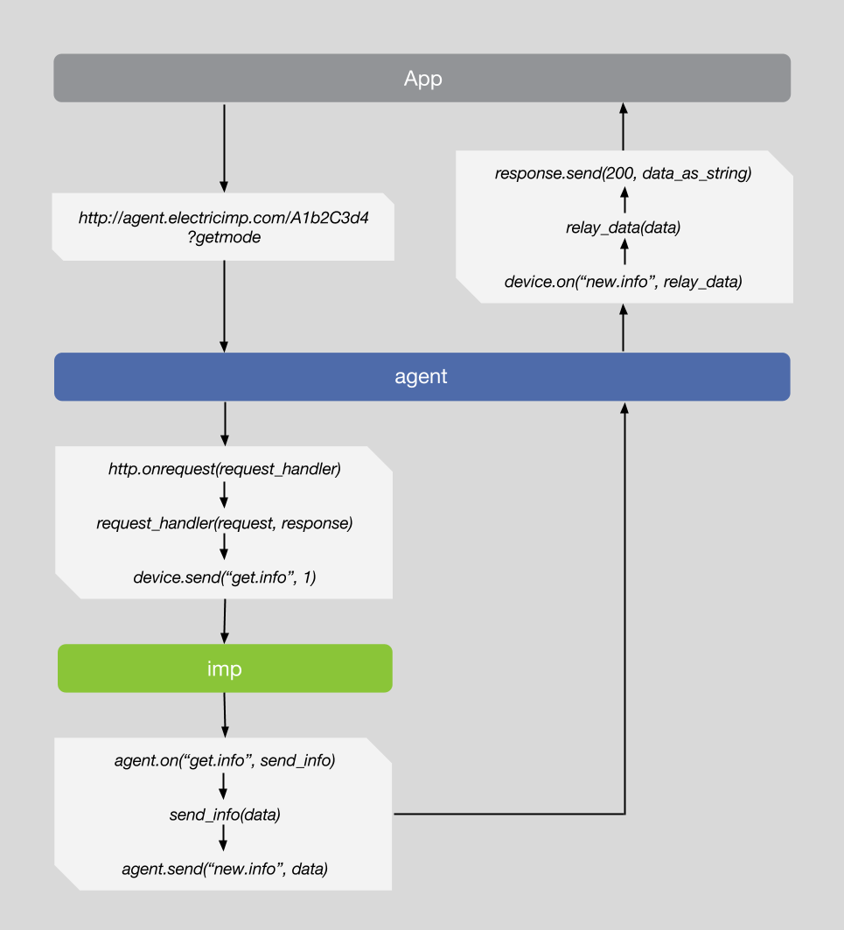

Version 1

Agent code

// Test software for data throughput using Electric imp @ NST - agent side

// agent URL
server.log("nstimp agent is found @ " + http.agenturl());

reply <- "";

// response payload handling and data relay to requesting app
function handleDevicePayload(data)
{
// extract payload sections
local t = data.pop();
local d = data.pop();
local n = data.pop();
// convert in human understandable format
local dev_resp = n.tostring() + " bytes " + "of data @ " + t.tostring() + "ms";
// copy data in global var
reply = dev_resp;
}

// HTTP Request handlers expect two parameters:
// request: the incoming request
// response: the response we send back to whoever made the request
function appRequestHandler(request, response) {
// The parameter request is the incoming HTTP request
// The parameter response is an auto-generated HTTP response
try
{
// Process incoming http request

// Check if the variable d was passed into the query
if ("get_data" in request.query) {
// if it was, send the value of it to the device
device.send("get_data", null);
}

// If everything worked as expected, send the data to the app
response.send(200, reply);
}
catch (exception)
{
response.send(500, "Internal Server Error: " + exception);
}
}

//agent registers to app calls
http.onrequest(appRequestHandler);
// register functions to handle messages from the device to the agent
device.on("data", handleDevicePayload);

Device code

// Test software for data throughput using Electric imp @ NST - device side

// get server data
server.log(" nstimp connected to WiFi SSID: " + imp.getssid() + " with BSSID " + imp.getbssid());

// receive payload from agent
function handleAgentRequest(ignored_val=null)
{
// Add n bytes blob of arbitrary binary data to send out
local ndata = 1024;
local data = blob(ndata);
local dtime = hardware.millis();
// payload holder
local payload = [];
// add things in the payload field
payload.push(ndata);
payload.push(data);
payload.push(dtime);
agent.send("data", payload);
}

// throughput = RWIN/RTT
// RTT - round trip time: get it from ping pong
// RWIN - receive window: is default 3KB but up to 30KB using this function
// imp.setsendbuffersize(8000); // in bytes and 3KB is default

// register function to process messages from agent to device
agent.on("get_data", handleAgentRequest);

