Problem Set 4 - Fuzzy Logik / Fuzzy Systems

Problem 2: Mobile Robot Soccer

In mobile robot soccer, following the real world setup, each team of collaborative robots uses a strategy to move in the field and score in the opponent's post. Each robot in the team moves on a given trajectory in a timely and precise manner to reach a scoring position. In this problem you should implement a fuzzy controller to ensure that the reference trajectory imposed by the strategy is tracked by a single robot with minimal error (Figure 1).
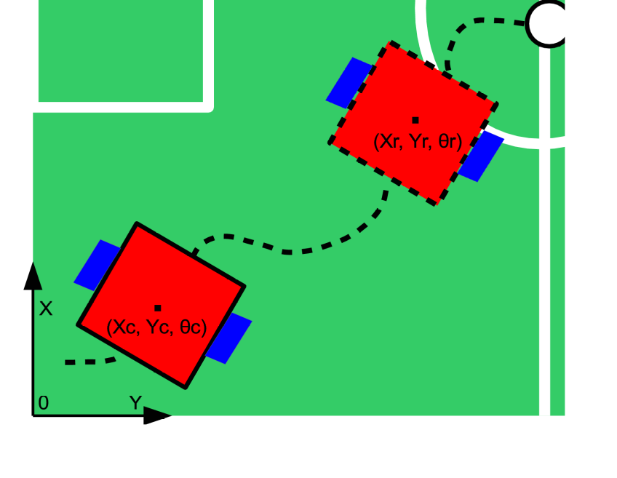

Figure 1 – Problem setup: Fuzzy Controller for Soccer robot
A. (10 points)
In this subproblem you will have to compute the membership values of the two inputs in the fuzzy controller of the robot. The inputs are the errors (pose error, de and heading error, θe) between the reference position of the robot and the current position estimated by the sensors. The membership functions and error expressions are depicted in Figure 2.

The inputs are the reference and current trajectories of the robot are given as a sequence of coordinates in the 2D plane of the field (Xr, Yr, θr, Xc, Yc, θc) with less than 1000 entries.
The output should be a sequence of 4 values (μde1, μde2, μθe1, μθe2), the same size as the input sequence.

Example Input | Visualization | Required output
testInputA.txt | 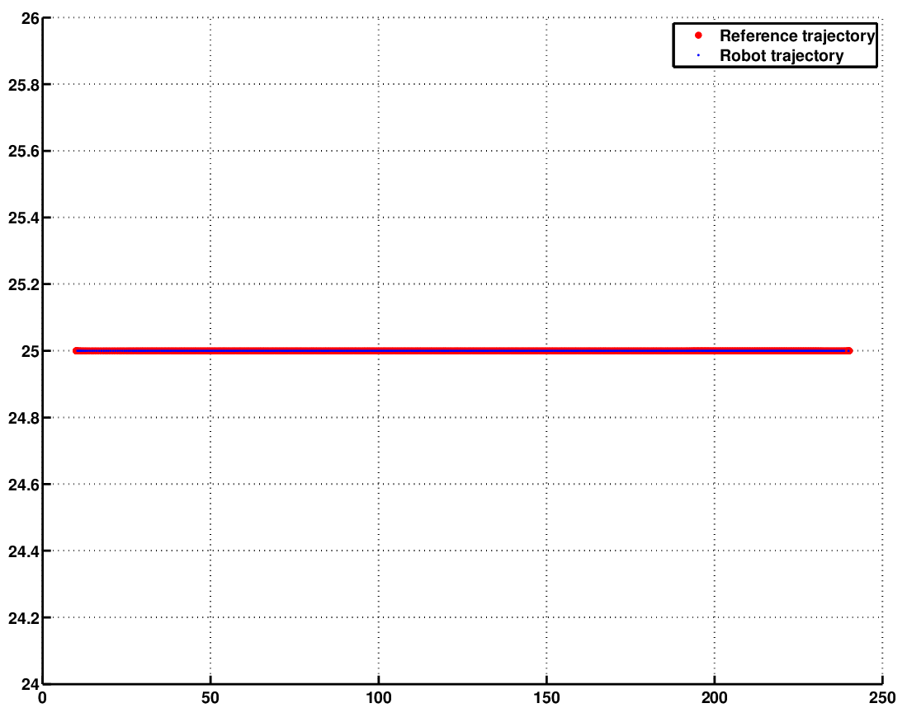 | testOutputA.txt
testInputB.txt | 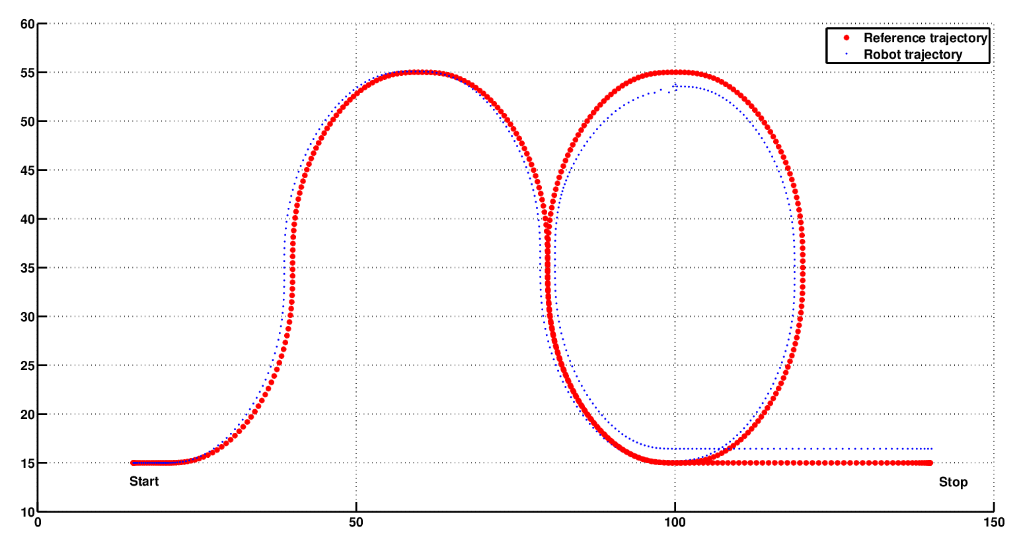 | testOutputB.txt

B. (20 points)
In this subproblem you will have to compute the value of the control signal (e.g. left and right wheel velocities, depicted on the left side in Figure 3) for which the robot tracks the reference trajectory. The fuzzy controller will be implemented given the rules in Figure 3 and MFs in Figure 2.

The inputs are the reference and current trajectories of the robot are given as a sequence of coordinates in the 2D plane of the field (Xr, Yr, θr, Xc, Yc, θc) with less than 1000 entries.
The output should be a sequence of 2 values (vl, vr) the same size as the input sequence.

Example Input | Visualization | Required output
testInputA.txt | 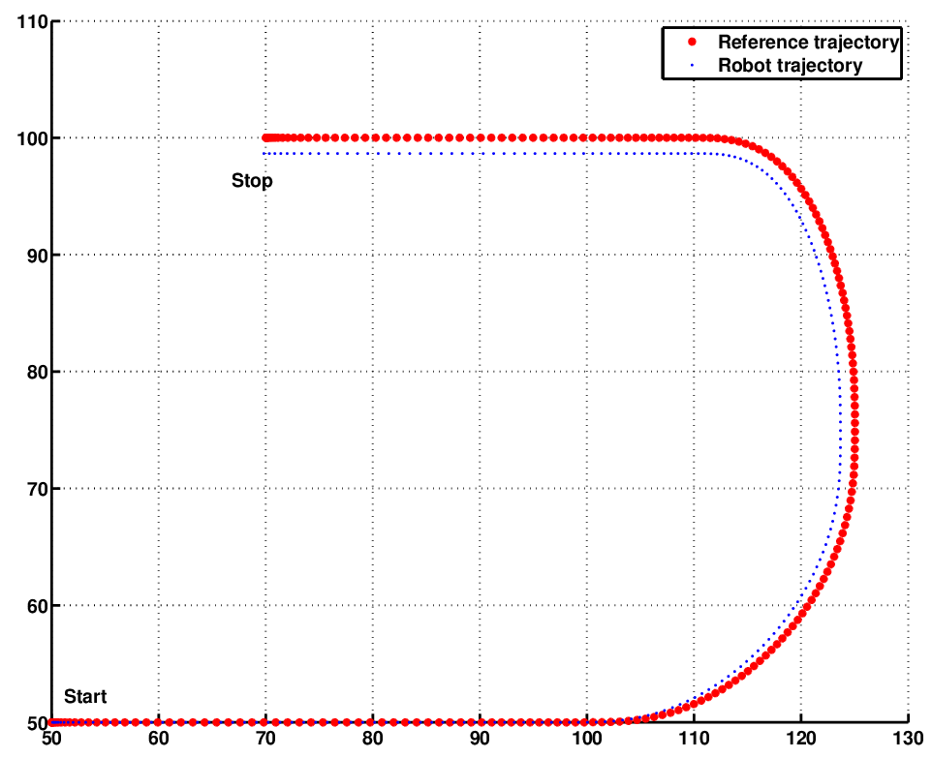 | testOutputA.txt
testInputB.txt | 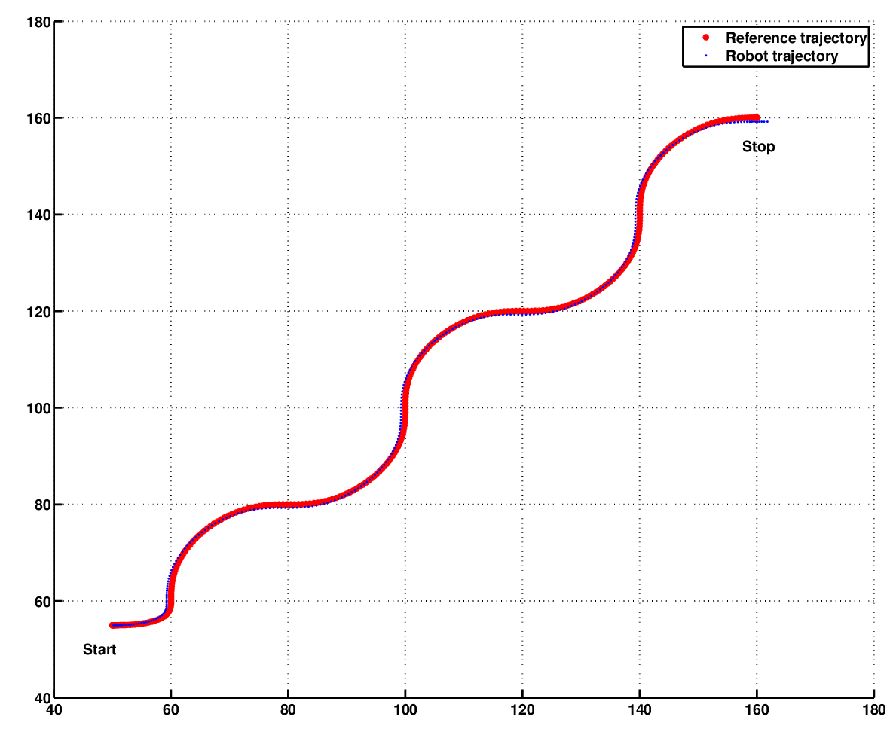 | testOutputB.txt
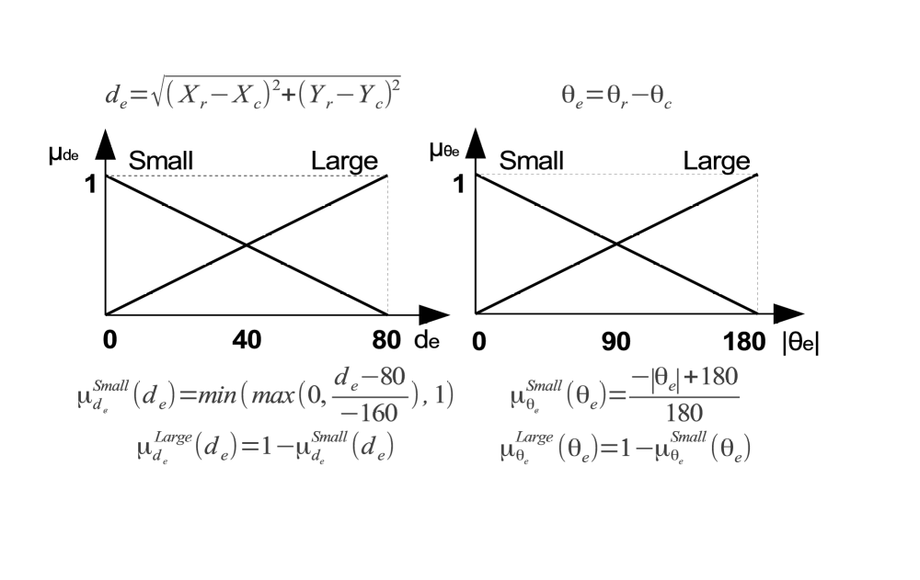
Figure 2 – Inputs and membership functions for fuzzy controller
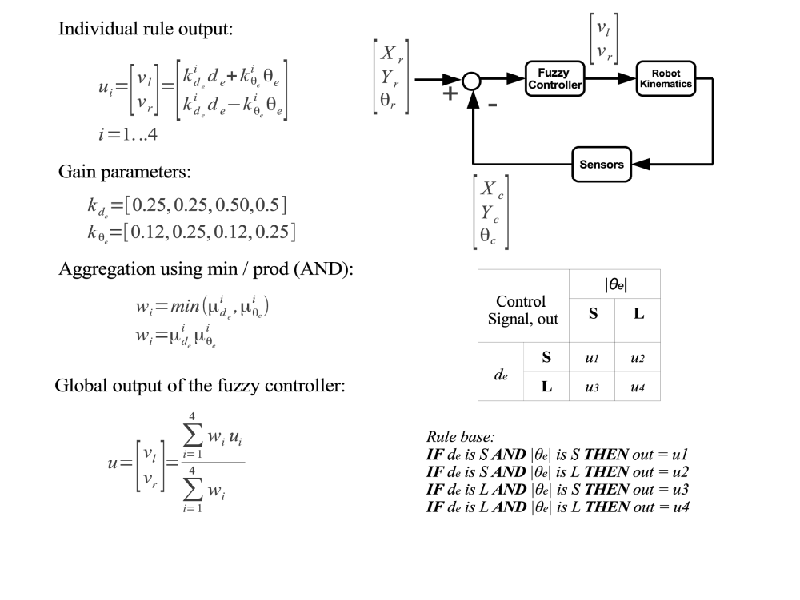
Figure 3 – Rules, control signal and fuzzy controller output

C. (40 points)
In this subproblem you will have to implement the full fuzzy control loop (Figure 4, bottom) for trajectory tracking. Given the fuzzy rules, MFs and robot kinematics (Figure 4, top) compute the control signal to track the reference trajectory.

The input is the reference trajectory of the robot given as a sequence of coordinates in the 2D plane of the field (Xr, Yr, θr) with less than 1000 entries.
The output should be a sequence of coordinates in the 2D plane of the field (Xc, Yc, θc) the same size as the input sequence.

Example Input | Visualization | Required output
testInputA.txt | 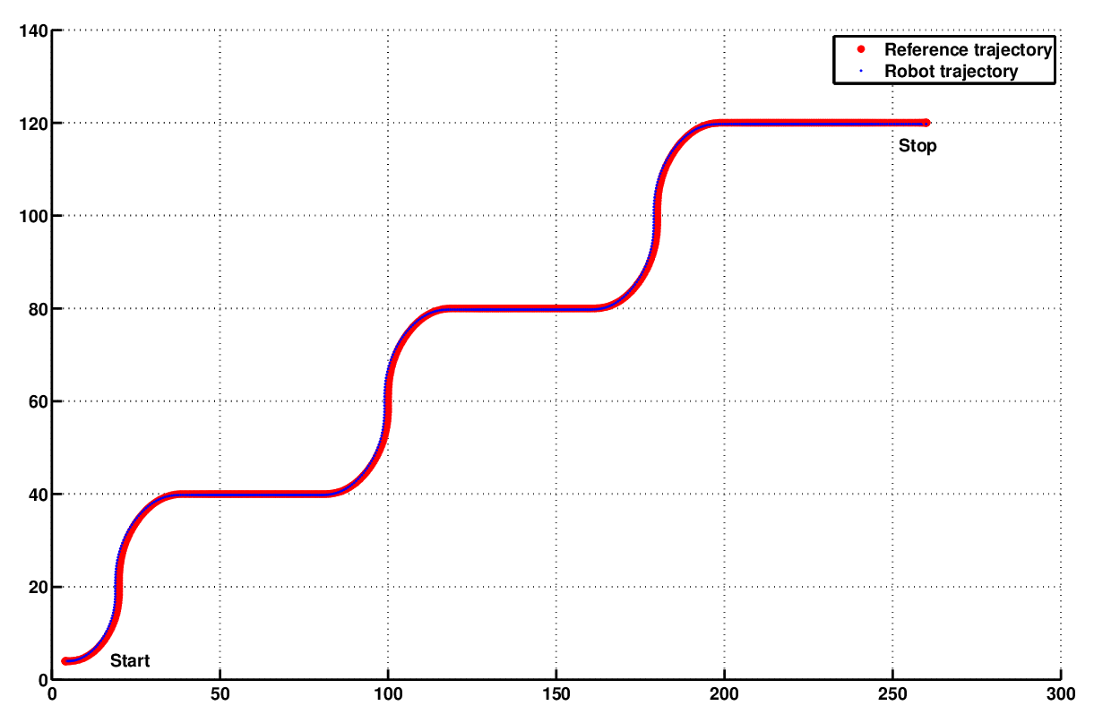 | testOutputA.txt
testInputB.txt | 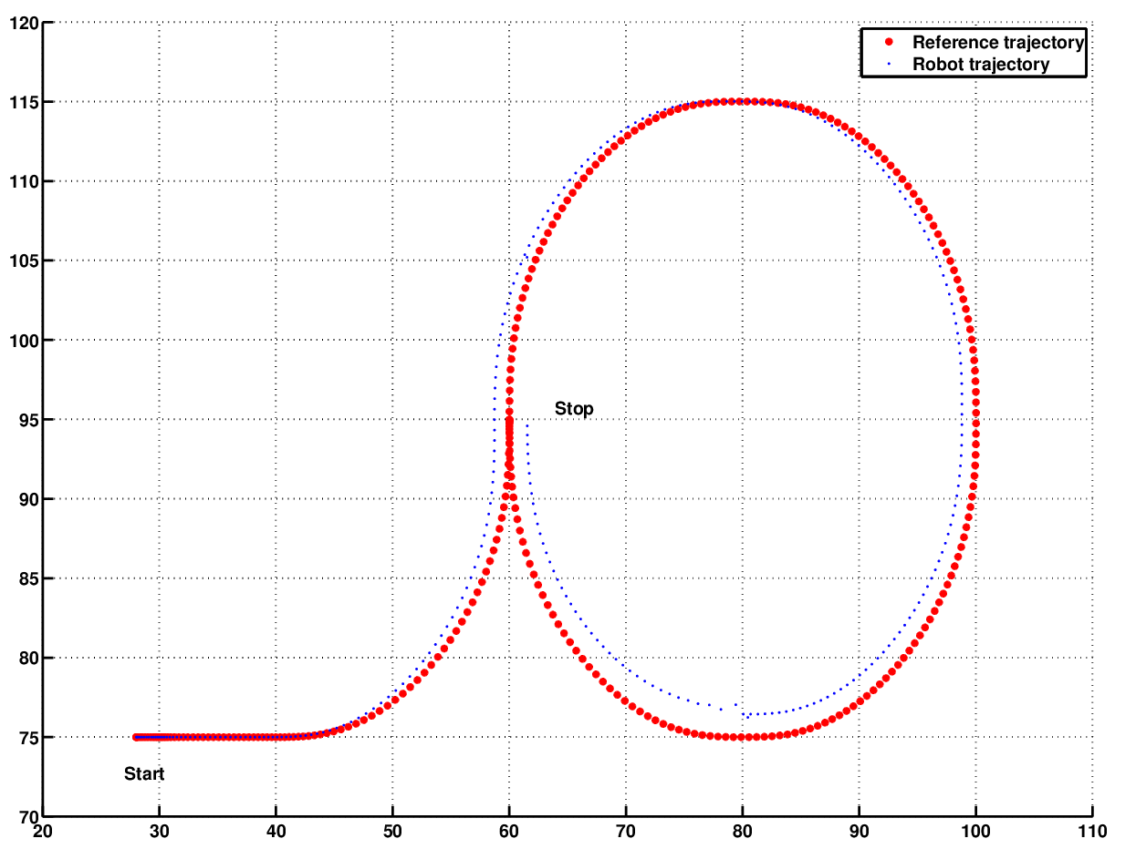 | testOutputB.txt
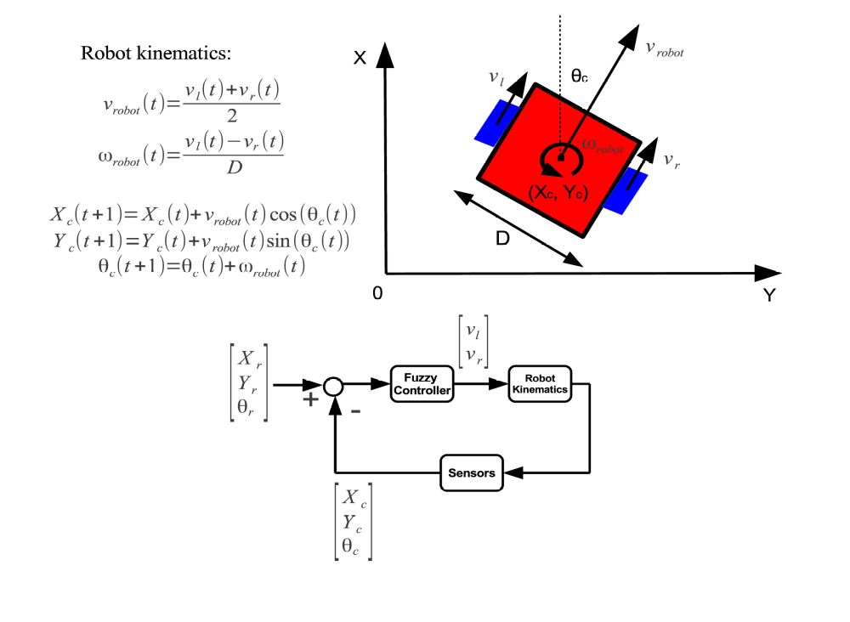
Figure 4 – Robot kinematics and complete fuzzy control loop

