1. Neural Net Classification

Your algorithm reads a number of 3-valued training examples: each such example consists of two inputs ("x" and "y" value) and a desired output value of +1 or -1. The exact number of training examples is unknown, but you can safely assume you will read less than 1000.

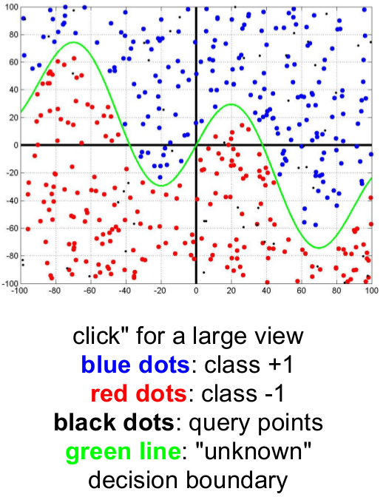
At some point your program will find a training example '0,0,0\n' , (note the desired output of zero, which is invalid!). This indicates that the training data is completely read, and your program should start training the neural network.

After training, your program continues to read 2-valued evaluation data: for each such example your program should report the corresponding class (+1 or -1) followed by return ('\n') as output.

Note (1): Do not include the example (0,0,0) in your training set!
Note (2): Your program needs to output the string '+1\n' (with a plus sign) for the positive class, not just a '1\n'.

Tasks:

For training use the file classification_data.txt, whereas ground truth to test/validate is contained in the file classification_groundtruth.txt.
Please plot your network output against the ground truth and calculate classification metrics (AUROC, F1, Precision, Recall).

2. Neural Net Regression

In this problem you shall implement a neural network that learns to regress (approximate) a function. Your algorithm reads a number of 2-valued training examples: each such example consists of one input ("x") and a desired output value ("y"). The exact number of training examples is unknown, but you can safely assume you will read less than 1000.
At some point your program will find a training example '0,0\n' , (note that this input might be a possible training point, but we define that (0,0) is invalid!). This indicates that the training data is completely read, and your program should start training the neural network.

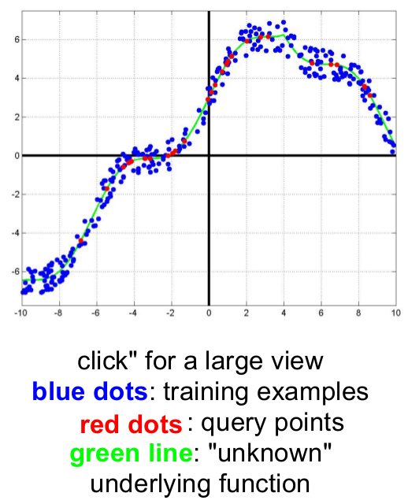
Note: Do not include the data (0,0) in your training set!
Note (2): Your network might not be able to learn the data without a remaining error. This is normal. We will tolerate small deviations around the required output, typically within 5% of the overall output range. Ensure that your network does not need "forever" to learn data.

Tasks:

For training use the file regression_data.txt, whereas ground truth to test/validate is contained in the file regression_groundtruth.txt.

