Beginner

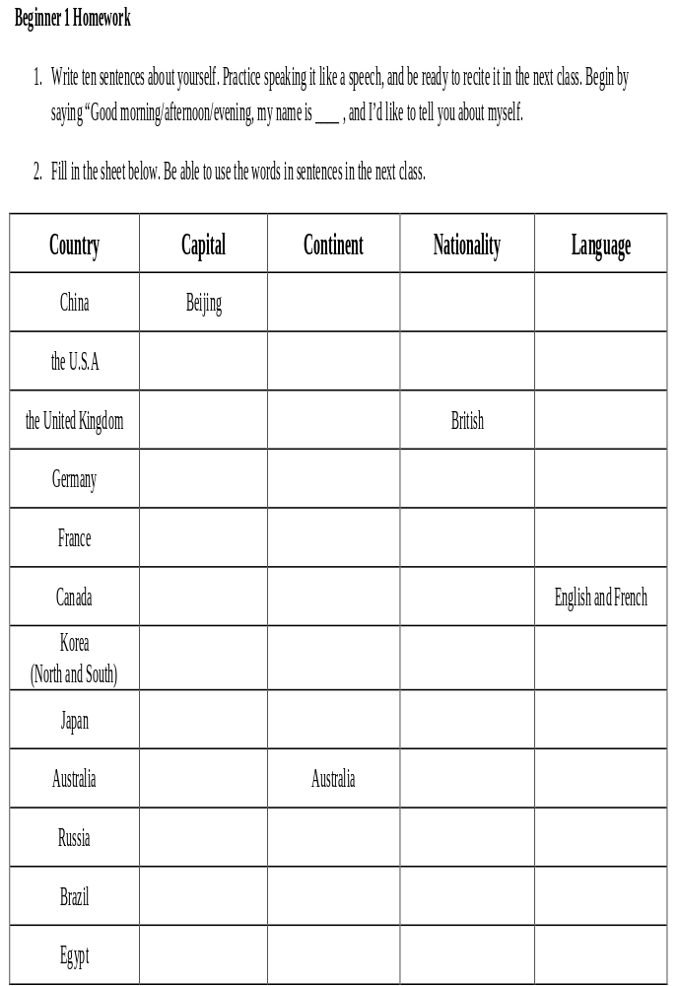

B-3 Homework

Write the answers to the questions shown below by completing the sentences. Include the units (e.g. kg, cm, ml) and adjectives (e.g. tall, wide, thick, etc.) if necessary.
- What is your date of birth? My date of birth is _____________________
- What is your address? I live at _______________________________________________
- How tall are you? I am _____________________
- How high is a badminton net? It is _____________________
- How much do you weigh? I weigh _____________________
- How far is your home from Web? It is _____________________ from Web.
- How big is your apartment? It is _____________________
- How long is the little finger on your right hand? It is _____________________
- How wide is the Yangtze River? It is _____________________
- How thick is your Web Study Guide? It is _____________________
- What is the area of China? It is _____________________
- Approximately how much does your pen weigh? It weighs _____________________
- How much do potatoes cost? They cost _____________________
- How much does gasoline cost? It costs _____________________
- How much water does a small bottle of water contain? It contains ___________________
- What is the population of China? It is _____________________
Fill in the spaces with the correct fraction, decimal, and percentages, e.g. ½ = 0.5 = 50%
 | ____ | = | ____ | = | 75% |  |  | 2/5 | = | ____ | = | ____
 | ____ | = | 1.7 | = | ____ |  |  | ____ | = | ____ | = | 225%
 | ____ | = | 0.03 | = | ____ |  |  | 1 ³/₁₀ | = | ____ | = | ____

B-5 Homework

Fill in the two charts shown below describing two of your relatives. Be prepared to use full sentences to talk about each relative as well as ask questions about your classmates’ relatives.
My uncle or aunt
full name: _______________ | lives where: _____________ | children: _____
age: _____ | occupation: ______________ | housing: ________________
from: __________________ | school/company: _________ | lives with: ______________
languages: ______________ | marital status: __________ | pets: ___________________
My cousin
full name: _______________ | lives where: _____________ | children: _____
age: _____ | occupation: ______________ | housing: ________________
from: __________________ | school/company: _________ | lives with: ______________
languages: ______________ | marital status: __________ | pets: ___________________

B-7 Homework

Describe the weekly schedules of two people you know. Interview them if you’re not sure. You must use all of the following words or phrases in the homework (although not every word or phrase for each person):
- For [time]  - Last (as a verb)  - It takes  - Walks  - Takes or drives  - On [a day]+s, e.g. on Mondays  - [Some number of days] a week, e.g. five days a week  - [Some number of times] a week, e.g. twice a week | - Leaves  - Goes to bed  - Leaves for  - Gets to  - Gets up  - Before  - After  - If

Beginner 9 Homework

- Prepare a weather report for a city outside China. Fill in the template below with the name of the city, the weather right now, and what the weather was like yesterday, what it will be/is like today, and what it will be like tomorrow and the next day. Draw in sun, clouds, and rain in the large boxes and the high and low temperatures below that. An example is shown below the template.
 |  | Right now:
Yesterday | Today |  | Tomorrow |  | 2 days from today

Example: | Moscow Weather
Example: | Right now: 12°, raining
Yesterday | Today | Tomorrow | 2 days from today
Dec. 31 | Jan. 1 | Jan. 2 | Jan. 3
 |  |  | 
17° | 13° | 20° | 22°
9° | 8° | 15° | 16°

- Find and cut out a full-length, color picture of a person from a magazine (or save a picture on your smartphone or tablet computer). Bring it with you to the next class. Write ten sentences describing what the person looks like. Make sure to include the following:
- whether they are a man or woman | - their approximate height and weight
- their eye color | - their clothing and accessories, and colors
- their approximate age | - what they’re holding or carrying, if anything
- any facial hair (for men) | - their hair color & length (& style if appropriate)
- their nationality or ethnicity (and skin tone if notable)

B-11 Homework

- Talk to five people you know and ask them the following questions:
1. How much do you like hot pot? | 5. What kind of ___ do you like?
2. How much do you like fried rice? | 6. What is your favorite ___ ?
3. How much do you like bitter gourd? | 7. What is your least favorite ___ ?
4. How much do you like ice cream? | 8. Which do you like better, ___ or ___ ?
- For the first four questions find out exactly how much each person likes it. Be prepared to present your findings to the class. For example, I asked five people if they liked hot pot. Three people said they really like it; one person said they love it, and one person said they think it’s OK.
- For the last four questions fill in the blanks with whatever you want. Be prepared to present your findings to the class. For example, I asked five people what kind of movies they like. Three people said they like horror movies; one person said they like comedies, and one person said they like action movies.
- Write about your best friend. You must answer the following questions:
- What languages or dialects does he/she speak?
- Where does he/she live?
- What is his/her family name?
- Who does he/she live with?
- What is his/her phone number?
- How tall is he/she?
- When does he/she get up and go to bed?
- When does he/she start and finish work/school?
- What kinds of food does he/she like?
- What kinds of food does he/she not like?
- What sports or games can he/she play?
- What sports or games is he/she good at?

