University of La Salette, Inc. - College of Information Technology
PFEBSIT 002 Integrative Programming and Technologies 2

Lost-and-Found Matching System
Week 17 - AS3: Advanced Technical Report (Project 18)
Final architecture, alternatives and decisions, evidence, final recommendation, limitations and maintenance plan.
Field | Entry
Student name | [Your full name]
ID number | [Your ID number]
Class section | [Your section]
Builds on | Weeks 13-17 (reports SA7, SA8/IA5, IA6, Week 16 evaluation, SA9)
Verdict | CONDITIONAL GO for a supervised single-instance pilot; NOT ready for unrestricted production use
Data | Fictional, controlled data only

1. Executive Summary
- The Campus Lost-and-Found Matching System lets owners report lost items, lets staff report found items, proposes candidate matches automatically, notifies owners, and routes ownership verification and release through a recorded human decision. It is a Flutter Web client over a Node.js API with a file-based store.
- The solution is supported by 132 automated tests (95 backend, 37 Flutter) mapped to 32 requirements by a gate that fails if a test or requirement is orphaned, an OpenAPI document proven equal to the running API, scripted user-acceptance scenarios (14 of 14 pass), measured performance (about 170 requests/s at peak with p95 108 ms; 40 times the estimated demand), and rehearsed recovery and rollback.
- It is recommended for a supervised, single-instance pilot with controlled data. It must not go to unrestricted production until a database replaces the file store, notification delivery moves out of the request, shared state replaces in-memory counters, identity comes from the institution, and a retention policy is approved (section 9).
- Development was test-first from Week 15: 16 defects in Week 15, 3 bottlenecks in Week 16 and 9 usability and robustness findings in Week 17 were each exposed by a failing test or observation, fixed, and re-tested. Several of my own tests were wrong or unreliable and were corrected; the report says where.

2. Requirements and Scope
Scope: one bounded organisational workflow (lost-and-found handling) with four roles; automatic matching and notification with bounded retries and manual recovery; secure access; measurable quality. Out of scope: payments, photos, maps, chat, integration with institutional systems, real notification gateways.
Group | Requirements | Count
FR | Report submission and validation; duplicate control; matching and its precision; notification with retry and recovery; verification and release state machine; aging reminders and disposal review; manual queue; audit and logging | 9
SR | Authentication; authorisation by role and ownership; transport security and headers; protected configuration; input hardening; safe logging; data minimisation | 7
NF | Reliability and consistency; interoperability; resource bounds; operability (probes, metrics, slow-request log); performance and capacity; recoverability | 6
UI | Sign-in and session states; report submission states; review controls and confirmations; loading, empty, network, authorisation and server-error states; responsive layout; plain-language messages; no developer tools in production builds | 8
DOC / DEP | Accurate OpenAPI document; static host behaviour | 2
Traceability: docs/traceability.json maps every one of the 132 tests to at least one of the 32 requirements, and scripts/trace-check.js fails the build otherwise. The full matrix is in docs/w15/traceability-matrix.md.

3. Technology Choices
Layer | Choice and reason
Client | Flutter Web (required by the course): one code base, rich state handling; the token is kept only in memory. Cost: a first load of about 3.6 MB compressed (mitigated by a loading screen and host compression/caching).
API | Node.js 20 + Express: small, well understood, enough for the workload (about 250 requests/s on one core). Security middleware: helmet, CORS allow-list, express-rate-limit, jsonwebtoken (HS256 pinned).
Persistence | JSON file with group commit and atomic writes behind a `Store` class (ADR-001).
Quality tooling | node:test, Flutter test with a mocked HTTP client, ajv and swagger-parser for the contract tests, a custom traceability gate, a load generator and rehearsal scripts written for this project.

4. Architecture Alternatives and Decisions
Each decision has a record in docs/w17/adr/ with the options, the evidence and the condition that triggers a rethink. The diagrams on the following pages show the final architecture, the journey and the state machines.
ADR | Question | Alternatives | Decision (pilot) | Revisit when
001 | Where is data kept? | JSON file; SQLite; PostgreSQL | JSON file with group commit; database before production | file > 8 MB or about 10,000 reports; second instance
002 | Who sends notifications? | In the request; outbox + worker; message broker | In the request (simulated channel); outbox before a real gateway | a real gateway is connected
003 | How do users sign in? | Local accounts + short token; cookie sessions; institutional OIDC | Local scrypt accounts + 15-minute in-memory token; OIDC for production | SSO/MFA available; second instance
004 | How is it deployed? | One instance; several behind a load balancer; containers | One instance, health-gated deploy with rollback | availability target above 99% or a database exists
005 | How are matches found? | Word overlap; fuzzy matching; semantic/ML | Explainable word overlap with an overlap floor; human decision | pilot shows missed matches from wording
006 | How is the API documented? | Hand-written, unchecked; generated from code; spec + contract tests | Spec module + contract tests in both directions + mutation check | an external consumer appears

5. Evidence of Quality, Week by Week
Week | Focus | Key evidence | What it found
13 (SA7) | Automation foundation | 12 tests; live run: transient failure recovered on attempt 3, permanent failure to manual queue | Baseline workflow, retry policy and logs
14 (SA8, IA5) | Secure integration | 28 security tests; live HTTPS adversarial run; 10-item residual-risk register | Token, role, ownership, lockout, header and logging controls verified
15 (IA6) | Testing and hardening | +25 tests, traceability gate, before/after runs; 16 defects | Timezone-blocked reports, double release, stale unicode matching, non-atomic writes, UI debug-build bug
16 | Performance and deployment | Load suite, profiling, rehearsals; peak 52 to 170 req/s; 10,000 reports p95 5.5 s to 80 ms | Blocking password hashing, per-request re-tokenising, whole-file synchronous writes
17 (SA9, AS3) | UAT, documentation, evaluation | 14 scripted scenarios, hands-on browser session, OpenAPI with contract tests and a mutation check, 13 findings | Missing item details when verifying, one-click decisions, weak matches, stale-cache and dropped-action bugs

5.1 Key numbers
Measure | Before Week 16 fixes | After | Source
Peak throughput (50 simulated users) | 52.3 req/s | 169.9 req/s | W16
Peak 95th-percentile response time | 1,283.5 ms | 108.3 ms | W16
Health check during a 40-login burst (median) | 1,802.4 ms | 4.2 ms | W16
Create-report p95 at 10,000 stored reports | 5,540.1 ms | 93.7 ms | W16
Acknowledged writes lost in a hard kill | not measured | 0 of 603 | W16
Bad-release rollback | none | 2 s and 1.7 s, data intact | W16
Scripted acceptance scenarios passing | 13 of 14 | 14 of 14 | W17
Documentation errors caught by contract tests | n/a | 8 of 8 deliberate errors | W17

6. Security Summary
Controls (all tested): scrypt password hashes verified asynchronously; signed, expiring, revocable tokens with the algorithm pinned; role only from the verified token; role and ownership checks on every endpoint (404 for other people's reports); HTTPS with HSTS and security headers; strict CORS; protected configuration that refuses unsafe production settings; strict validation and size limits; rate limits and account lockout; logs that never contain credentials, tokens or report text; separation of duties (staff cannot decide a match for an item they reported); proof recorded for every decision; data minimisation in responses. The residual risks are in the limitations register (no MFA, shared secret without rotation, in-memory counters, not tamper-evident logs).

7. Repository Guidance
CONTRIBUTING.md is the working guide. In short:
- Layout: api/ (Node API, OpenAPI module, tests), app/ (Flutter), docs/ (reports, evidence, traceability, runbook, ADRs, OpenAPI export), perf/ (load, profiling, rehearsals), uat/ (acceptance scenarios), scripts/ (gates and generators).
- Quality gates before any change is done: npm test (95), flutter analyze and flutter test (37), the traceability gate, the contract tests, a clean dependency audit, and for a defect fix a test that failed before the fix.
- Adding an endpoint has a nine-step checklist: route with role and ownership checks, strict validation, audit and durability, safe logging, stable error codes, OpenAPI entry, tests for success, validation, 401, 403, 404 and 409, traceability mapping, changelog.
- Secrets come only from the environment; .env, certificates and data files are git-ignored; the demo accounts file is test-only.
- Versioning: api/package.json and the OpenAPI info.version; breaking changes use a new path prefix with one release of overlap (ADR-006). CHANGELOG.md records every change, including the one breaking tightening made this week.

8. Maintenance Plan (summary)
The full plan is docs/w17/MAINTENANCE.md; operating procedures and alert thresholds are in docs/w16/RUNBOOK.md.
When | Task | Who
Continuously | Probe /ready and read /api/metrics; alert on event-loop p99, CPU, 5xx rate, data-file size | Maintainer
Daily | Clear the manual queue; scan for unusual 403/429 or login failures | Custodian
Weekly | npm audit; read Node and Flutter security notices; check disk and file size | Maintainer
Monthly | Restore test from the off-machine backup; account review; capacity review | Maintainer, owner
Quarterly | Rotate the signing secret; renew the TLS certificate; review the limitations register | Maintainer, owner
Per release | Checklist: all gates green, spec and changelog updated, deploy with the gate, smoke check, roll back first if in doubt | Maintainer
Eight incident playbooks cover: service down, storage not ready, event-loop or CPU alerts, failed-login bursts, corrupt data file, bad release, suspected secret leak, and piling-up notification failures. A retention schedule (reports 12 months after closing, audit 24 months, logs 30 days, backups 30 days) is proposed and needs the service owner's approval; automated deletion is not built yet.

9. Final Recommendation
CONDITIONAL GO for a supervised, single-instance pilot with controlled data. NO-GO for unrestricted production.

Why a pilot is justified
- Every required capability works end to end and is covered by tests and by acceptance scenarios; the security controls were tested adversarially and are unchanged by later work.
- Performance has about 40 times headroom over estimated demand and degrades gracefully; recovery and rollback were rehearsed.
- The most serious usability problems found in acceptance testing were fixed and retested; the API is documented and proven to match.

Conditions for the pilot
- One instance; fewer than about 10,000 stored reports; alert at an 8 MB data file.
- Real TLS (certificate or TLS-terminating proxy with TRUST_PROXY set); rate limit tuned for shared campus addresses; static host compresses and always revalidates (reference behaviour in scripts/static-server.js, tested).
- Off-machine backups and a monthly restore test; BACKUP_INTERVAL_MS chosen to match the data the owner can afford to lose.
- Monitoring and the alerts in the runbook, including event-loop delay and CPU (response-time alone under-reports overload).
- Test accounts only or accounts provisioned by the owner; the demo accounts file removed from any real deployment; JWT secret from a secret store.
- The people named in the sign-off sheet complete acceptance; deferred findings F10-F13 are confirmed or re-rated by them.

Before production
- Replace the JSON file with a database (removes the volume ceiling; enables more than one instance and point-in-time recovery) - ADR-001.
- Move notification delivery to an outbox and worker before any real e-mail or SMS gateway is connected - ADR-002.
- Move lockout, revocation and rate counters to a shared store; adopt institutional single sign-on with multi-factor authentication - ADR-003, ADR-004.
- Approve and implement the retention policy; append-only central logging; an accessibility audit; a real-device and real-browser end-to-end test; a soak and network test on the real host.

Decision matrix
Criterion | Pilot | Production | Basis
Functional completeness | Ready | Ready | 14 of 14 acceptance scenarios; 132 tests
Security controls | Ready | Not ready | Strong controls, but no MFA/SSO, shared secret, in-memory counters, logs not tamper-evident
Performance | Ready | Conditional | 170 req/s peak, p95 108 ms; ceiling about 10,000 reports on a file store
Reliability and recovery | Ready | Conditional | No acknowledged write lost; rollback rehearsed; single instance
Usability | Ready with deferred items | Needs real-user testing | Developer-played UAT; real users not yet involved
Operability | Ready | Conditional | Probes, metrics, runbook, maintenance plan; no 24x7 monitoring yet
Governance (privacy, retention, accessibility) | Pilot with controlled data | Not ready | No approved notice or retention schedule; no accessibility audit

10. Known Limitations (summary)
The full register of 23 items, each with impact, current mitigation, resolution trigger and source, is docs/w17/KNOWN_LIMITATIONS.md. The ones that decide the production question:
ID | Limitation | Resolution
L-01 | One instance only: single-writer file and in-memory counters | Shared database and counters (before production)
L-02 | About 10,000-report ceiling (every write serialises the whole file) | Database (before production)
L-05 | No multi-factor authentication; local accounts | Institutional SSO/OIDC (before production)
L-10 | Notification delivery inside the request | Outbox and worker before a real gateway
L-18 | Logs and audit not tamper-evident | Append-only central logging
L-22 | No approved privacy notice or retention schedule | Owner approval and a deletion job
L-16 | No automated real-browser end-to-end test; browser retest incomplete | Browser integration test on the real host
L-11 | Matching has no synonyms or typo tolerance | Measure in the pilot, then a synonym table

11. What I Would Do Differently
- Write the acceptance scenarios and run them with someone else before building the screens: two High usability findings (items not shown when verifying, one-click decisions) were visible from the first screen design.
- Treat every wall-clock threshold in a test as a bug waiting to happen: two of mine (P01, P07) failed only under CPU contention and had to be replaced by deterministic or ratio-based checks.
- Check that a test can fail. The first contract tests accepted a wrong document because no response ever contained the wrong value; the mutation check exposed it. Proving that fixes fail before and pass after (U36, D01) was equally valuable.
- Budget for the harness: several hours were lost to shell quoting, a port on a browser block-list, a stale browser cache and input quirks of driving Flutter's canvas. None were product defects, but one (the stale cache) revealed a real deployment bug.

Appendix A. File Index
Path | Contents
README.md, CONTRIBUTING.md, CHANGELOG.md | How to run, how to change, what changed
api/openapi/spec.js; docs/w17/openapi.yaml|json | API description (source of truth and exports)
docs/w17/adr/ADR-001..006 | Decision records
docs/w17/diagrams/*.svg|png | Architecture, data flow, state machines
docs/w17/KNOWN_LIMITATIONS.md, MAINTENANCE.md | Limitations register; maintenance plan
docs/w16/RUNBOOK.md | Operations, monitoring thresholds, deploy, rollback, recovery
docs/traceability.json; docs/w15/traceability-matrix.md | Requirements-to-tests mapping and matrix
uat/run-uat.js; docs/w17/uat-results-* | Scripted acceptance scenarios and results
perf/*; docs/w16/* | Load suite, profiling, rehearsals, results
scripts/* | trace-check, gen-openapi, mutation-check-openapi, gen-diagrams, static-server

Figure 1. Final architecture and trust boundaries
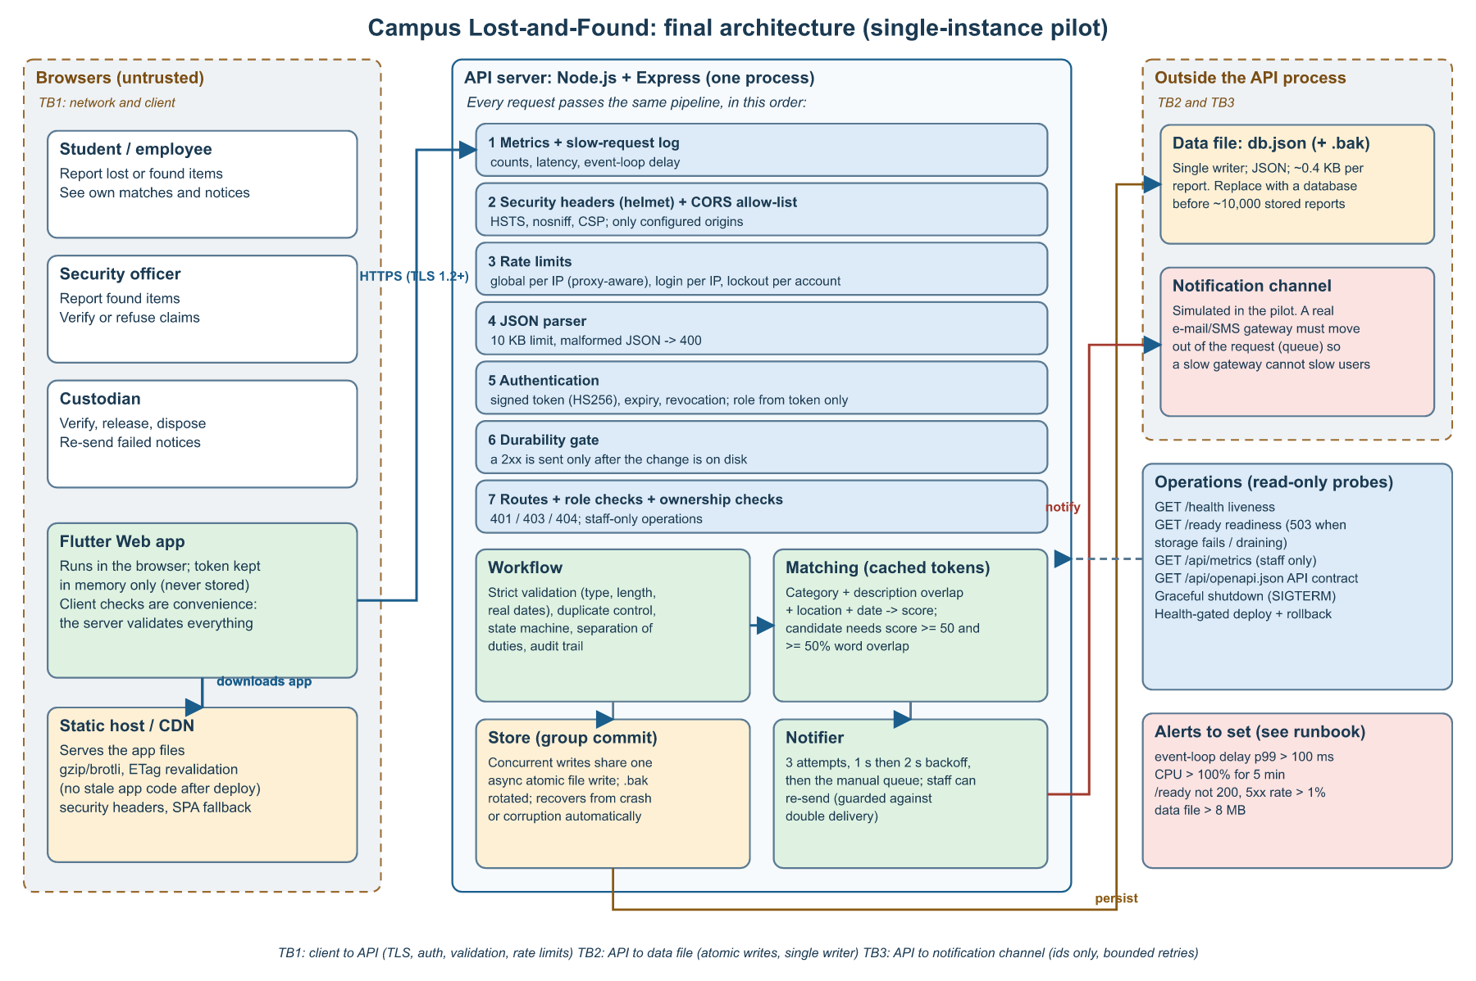
Full-size SVG and PNG: docs/w17/diagrams/architecture.*
Figure 2. Main journey and automation (data flow)
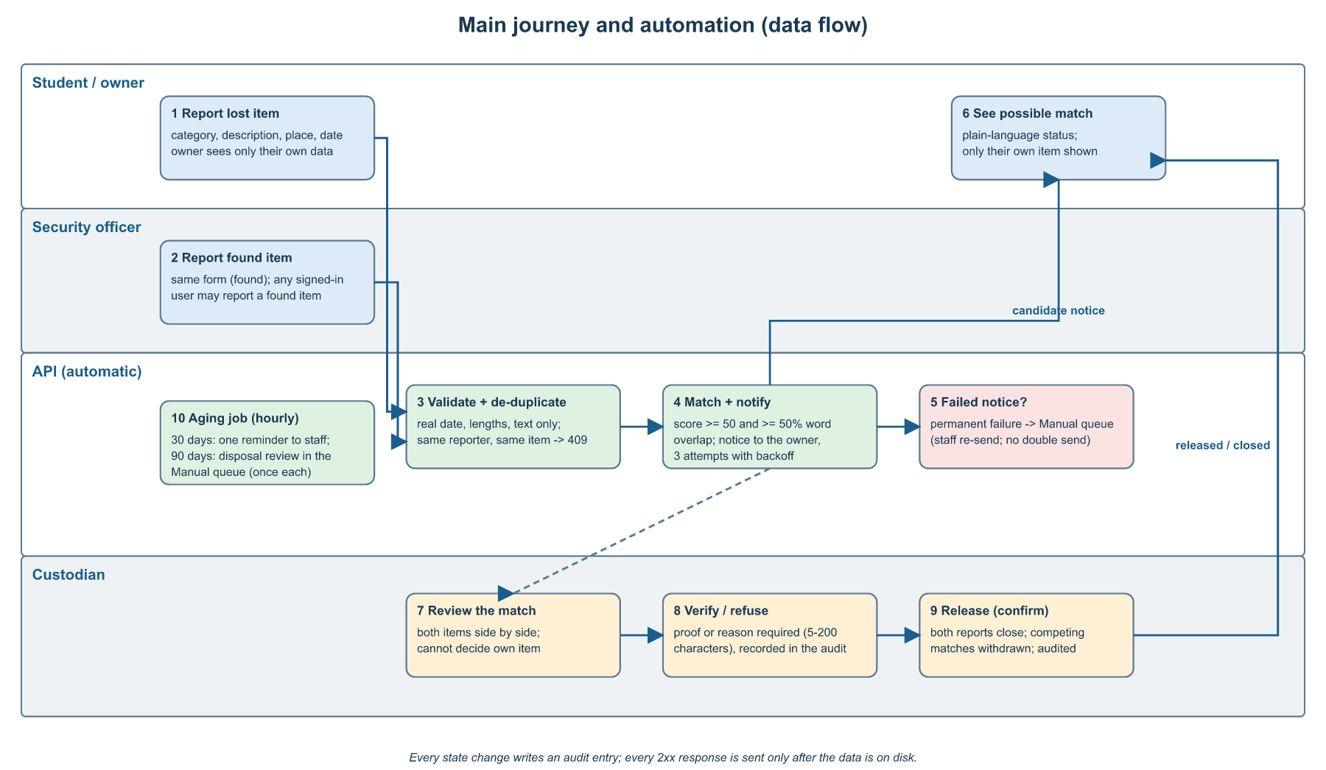
docs/w17/diagrams/data-flow.*
Figure 3. State machines (match, report, notification)
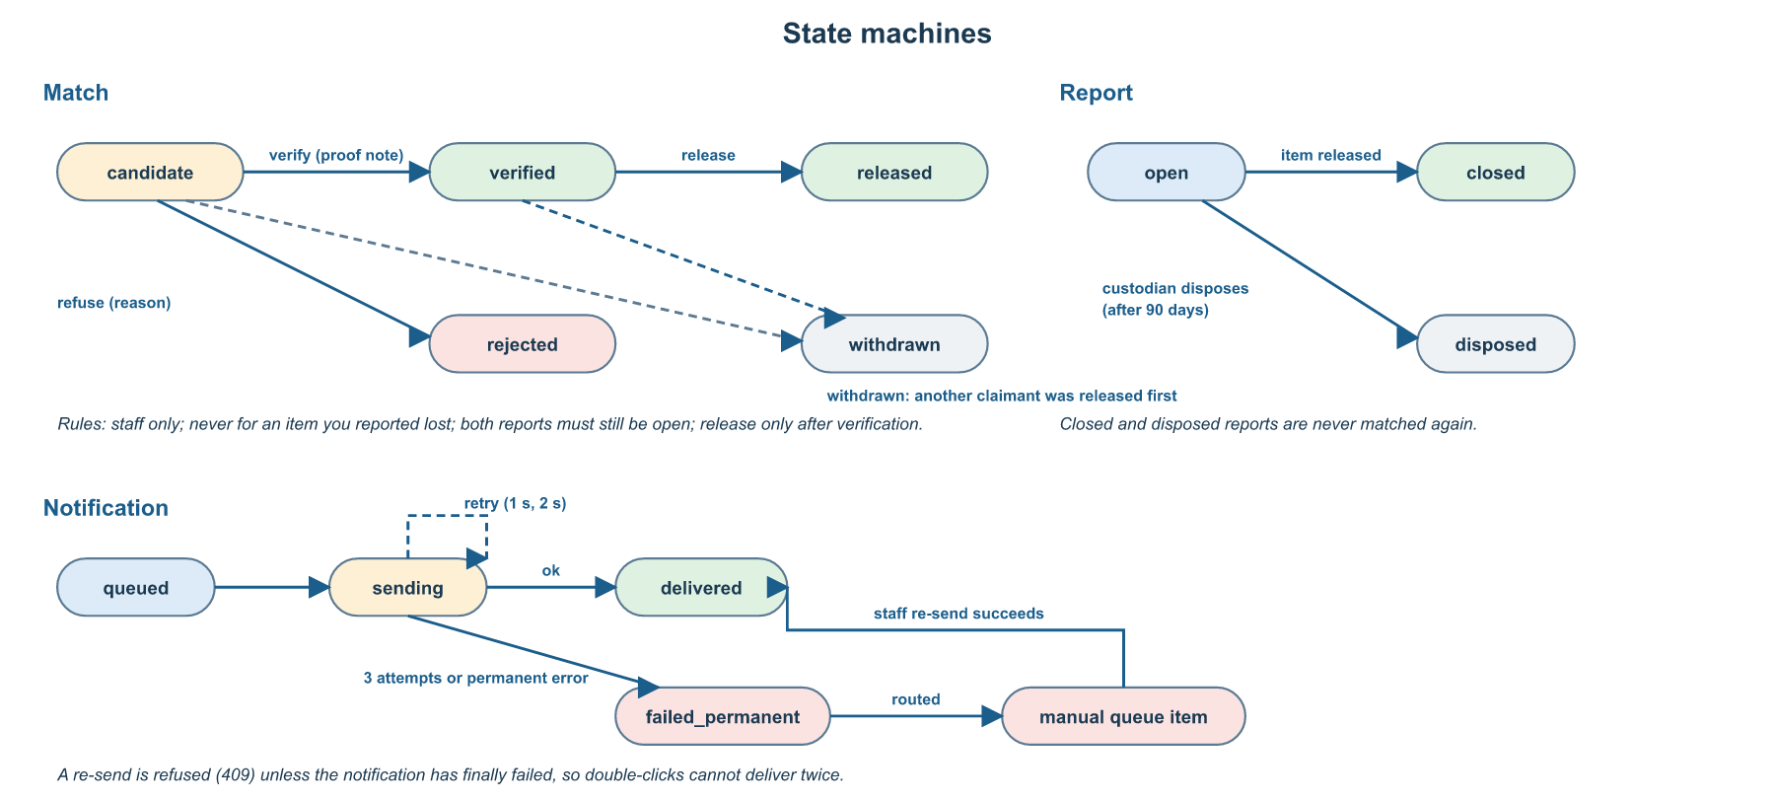
docs/w17/diagrams/state-machines.*

